The User will explore the site/various pages/links mentioned in the Wealthclock-frontend-doc(word file) and if he wants to buy then he should be prompted to Login/Sign Up.

**Login Process**

Following fields are there on login page-

1. Username or Email
2. Password
3. Forgot Password

**Forgot Password**

Following fields are there on forgot page-

1. Email address

Forgot password verification link will be send to user on their registered email id.

When user click on that link he will redirect to **New Password** Page which will have following fields-

1. New Password

2. Re –Type Password

Submit button

After clicking on submit button user will redirect to login page.

**Sign Up Process (User Login)**

- For Sign up purpose we require a form will be required with all mandatory fields

- The Following fields are required in the form (All Fields would be mandatory).

1. Name as on Pancard
2. Mobile Number
3. Email Id
4. Password

- Once the data is submitted 2 emails should be sent

* 1st Mail - An email verification should be sent to the user on the email id to verify and complete the further process.
* The Email verificationlink will directly redirects to sign in page.
* SMS to be sent to the client to verify the account
* 2nd Mail – To the admin that a user has been signed up with the details.

- If the user has not verified the email, within 24 hours a reminder mail along with the SMS would be sent to user to verify the process.

Once the user has verified they should be prompted to complete the BSE onboarding process.

After login on top of the page reset password, Logout, home links are there.

**Reset Password**

Following are fields are there for reset password-

1. Old Password
2. New Password
3. Re – Type Password

Submit Button

After submitting above form a email will send with new password of client for future purpose.

**BSE onboarding process (User Login)**

- For on boarding on to the BSE platform additional information is required for a prefilled format to be generated which is required to be signed along with the cross cheque and the PAN card to be uploaded in the database.

- The additional data required would be as follows which would come in different steps-

1. Mode of Holding
   * There will be three option for selection of mode of holding via
     1. Single (Default)
     2. Joint
     3. Anyone or Survivor
2. Pan Card Information
   * Text Box to enter the Pan Card.
   * In Case the User has selected Joint or Anyone/Survivor as the mode of holding then the additional 2 box would be required for entering the PAN Card Number.
   * Out of the additional 2, 1 would be mandatory and the other would be optional.
3. Address Proof
   * The number address Proof would depend on the Pan Card entered in the previous section
     1. If the User has selected Single as the Mode of the holding then only the 1 users information would be mandatory
     2. In Case the User has selected Joint or Anyone/Survivor as the mode of holding then additional 2 user data has to be captured.
   * Dropdown fields required for Address Proof
     1. Passport
     2. Aadhar Card
     3. Latest Electric Bill
     4. Voter’s Id
   * Text Box for entering the address
     1. Flat/House Number
     2. Floor
     3. Building Name with Number
     4. Address
     5. Nearest Landmark
     6. City
     7. Pincode – When the user inserts the pincode he should be informed that how many wealthclockadvisors customers are there in his city.
     8. State
     9. Country
   * Option is required where the user can copy the same address for the joint holders
4. Personal Information for KYC
   * The number Personal Information for KYC would depend on the Pan Card entered in the previous section
     1. If the User has selected Single as the Mode of the holding then only the 1 users information would be mandatory
     2. In Case the User has selected Joint or Anyone/Survivor as the mode of holding then additional 2 user data has to be captured.
   * Information Required
     1. Date of Birth – Calendar required
     2. Gender (Slider Button)
        1. Male
        2. Female
        3. Father’s/Spouse Name – Text Box
     3. Marital Status - Dropdown
        1. Single
        2. Married
        3. Others
     4. Occupation Status - Dropdown
        1. Private Sector Service
        2. Public Sector Service
        3. Housewife
        4. Student
        5. Business
        6. Agricultural
        7. Others with textbox
     5. Are you politically exposed - Dropdown
        1. Yes
        2. No
        3. Not Applicable
     6. Are you related to politically exposed person - Dropdown
        1. Yes
        2. No
        3. Not Applicable
5. Bank Details
   * Account holders Name as per Cheque
   * Account Number
   * Account Type
   * IFSC code – Require an auto fetch option from where the bank address n all the details can be pulled
   * Bank Address
   * Bank City
   * Bank Name
6. Nominee Details
   * Do you want to register a nominee
     1. Yes
     2. No
   * If Yes is selected then additional details required of Minimum 1 or Maximum 4
     1. Nominee Name
     2. Relationship
        1. Mother
        2. Father
        3. Sibling
        4. Son
        5. Daughter
        6. Other with text box option
     3. Nominee Date of Birth
     4. % Share
        1. The total of all the 4 should be 100%
     5. Tick option is required where the user can copy his address for nominee also
     6. If the address is not same text boxes for address fields will be open on page.
        1. Flat/House Number
        2. Floor
        3. Building Name with Number
        4. Address
        5. Nearest Landmark
        6. City
        7. State
        8. County

* Once the user has filled the above information an auto generated customer id should be created.
* Also a prefilled form should be created with the above mentioned details for printing purpose
* The User can find the prefilled form in the Account Section under the dashboard for view edit purpose
* An Email should be sent to the user containing the form.
* The user will have 2 options to send the form back to us, either they can scan and upload it or schedule a Pick up, this option will be under the dashboard section.
* A form is required where the user can schedule a pickup at its prescribed time and date or uploads the file.
  + A Calendar along with Time is required.
* A Email should be sent to the admin that a schedule has been requested. Also a Mail should be sent to the user that he has scheduled a pickup

There will be facility to approve pickup of client form admin. After approval a mail will send to client with time of pickup.

Also in mail client will get information of documents he has to attach with form like-

1. Form
2. Cheque
3. PAN Card
4. Address Proof (as per the what the user has selected in the address proof in the dropdown)

For uploading, the forms should have the below (This will also be under the Dashboard)

1. Form
2. Cheque
3. PAN Card
4. Address Proof.

* In case the user has login and not completed the BSE onboarding process there should be a prompt to complete the process.
* Till the user has not completed the entire BSE onboarding process he can only aview user on the website.
* On completion he will become an execution type of user who can transact/buy sell.

If the User is already registered user and does a sign in the following are the links that will be display at user end-**(User Login Menu)**

1. **Dashboard**
2. **Transact**
   1. **Wealthclock Recommended**
   2. **Risk Based Recommendation**
   3. **Build Wealth**
   4. **Park Money**
   5. **Regular Income**
   6. **Tax Saving**
   7. **DIY**
3. **Redeem**
4. **My Account**
   1. **Portfolio – option is required for the client to assign a specific investment for a goal.**
   2. **Transaction History**
   3. **Active SIP/STP/SWP**
   4. **Add/Delete Family Member**
   5. **Family View**
   6. **Profile**
5. **Reports (Will discuss it later)**
   1. **Portfolio Performance**
   2. **Consolidated Portfolio**
   3. **Portfolio Insight**
   4. **Dividend Details**
   5. **Taxation Details**
   6. **SIP Summary**
   7. **Account Statement**
6. **Goal Tracker**
7. **Wealthclock Advisory**
   1. **Goal Advisory**
   2. **Top Picks**
8. **Tools**
   1. **Risk Analyser**
   2. **Right amount for your SIP**
   3. **Asset Allocation**
   4. **FD Disorder**
   5. **Price of Delay**
9. **Refer a Friend**
10. **Dashboard**

* This page will have different columns and rows or sections to display overview of products and purchase.

1. In first row PORTFOLIO OVERVIEW (HEADING) option will be there which will have summary of portfolio
   * Total Invested
   * Current Value
   * Gain\loss
   * Gain\Loss(%)

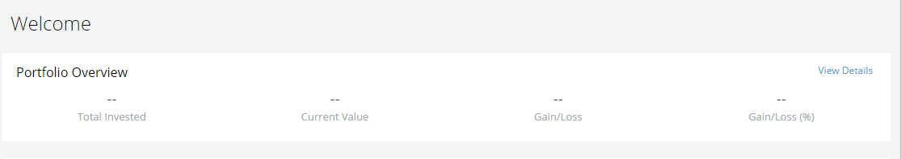

1. In second row QUICK PURCHASE (HEADING) option will be there which will have following link)
   * Purchase
   * SIP
   * Switch
   * STP

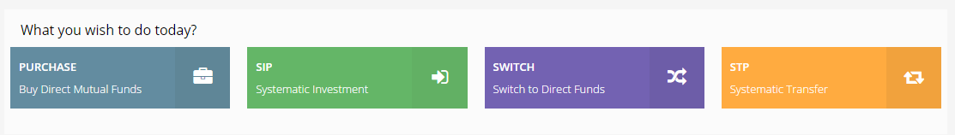

* + PURCHASE – On Clicking A new page will open which will have
    - Buy Mutual Funds (Heading)
    - Choose Fund
      * AMC Name - Drop down - Name of AMC will be pulled from BSE API
      * Fund Name - Drop down - Fund name will come as per AMC selection and name of fund will be pulled from BSE API
    - Investment Details
      * Plan – Drop down - Plan will depend on fund type which will be given by BSE API
      * Amount –Textbox with numbers only - Need suggestion of minimum and maximum amount which we will discuss later.

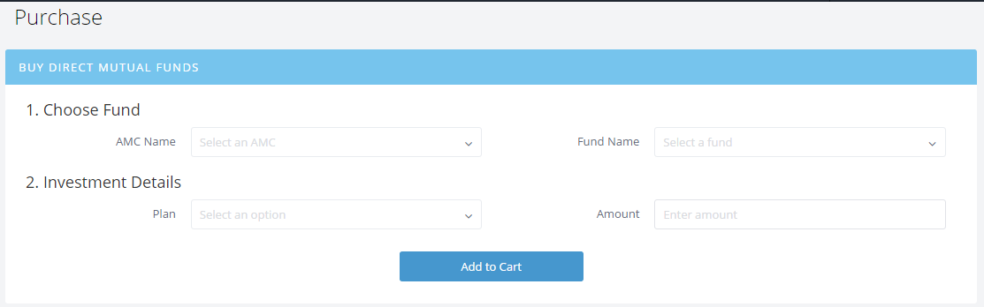

* SIP - A new page will open which will have-
  + - Systematic Investment (Heading)
      * Choose Fund
        + AMC Name – Drop Down
        + Fund Name – Drop Down
      * Investment Details
        + Frequency – Drop Down - Data will come as per selected AMC and Fund.
        + Amount - Text Box (Numbers Only)
        + SIP Debit Date – Drop Down
      * Duration

Start Month – Calendar

End Month – Calendar

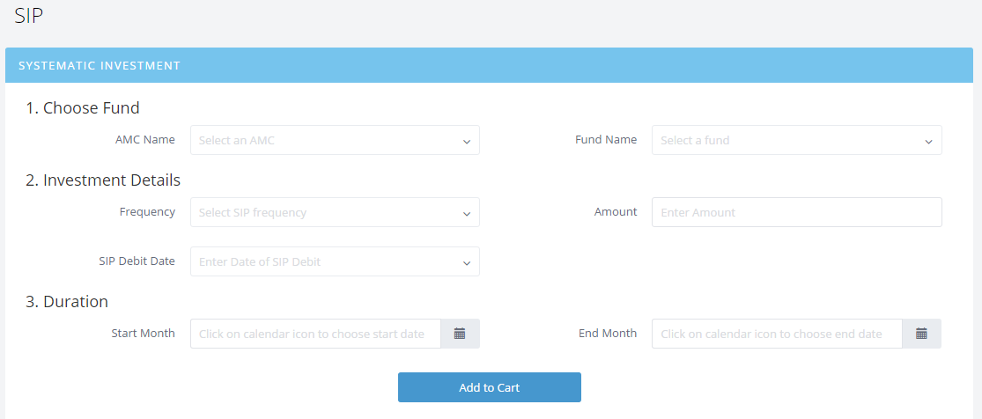

* SWITCH - A new page will open which will have Switch To (Heading)
  + Choose Fund
    - Select AMC –DropDown
  + From Fund Name – Drop Down
  + To Fund Name – Drop Down
    - Value of above two will selected as per AMC selection and once from fund name any fund will be selected so same fund name won’t come on To fund name
  + Investment Details
    - Enter Units – Text Box (Numbers Only
    - There will be one link just after text book named “Know Your Exact Units” which will redirect to portfolio page.

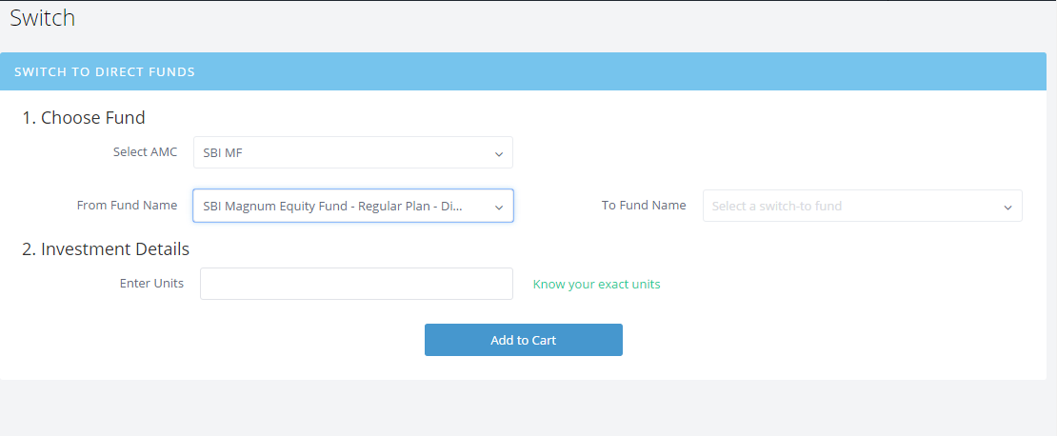

* News Feed links: - A backend `form is required where we can enter the news from the backend.

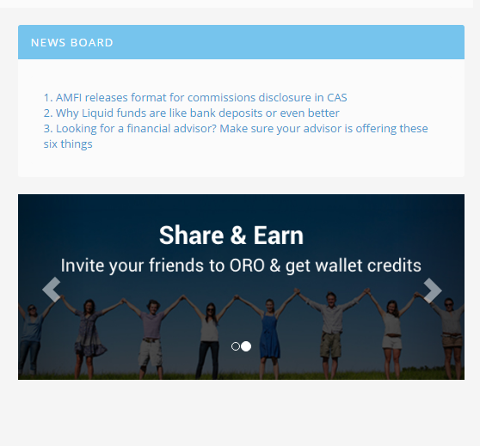

* Support
  + The user can raise a support ticket in case they require any help
  + Admin backend is required to revert the queries.
  + The user will be able to see the summary of the support ticket raised by them via
    - Open
    - In process
    - Closed
    - New
    - Informative

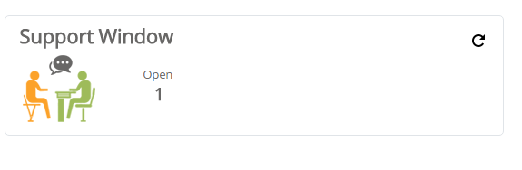

* There would be links for each query
* As soon as a new/existing support is raised a mail to be sent to the client and the admin
* On Clicking the link the user will be able to see the activity history
* Option is required where the user can create a new query/filter

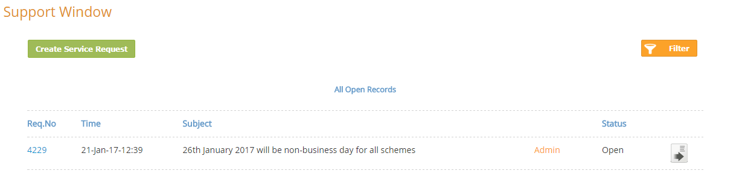

* On Clicking the reference number the user will be able to track the complete history of his queries.

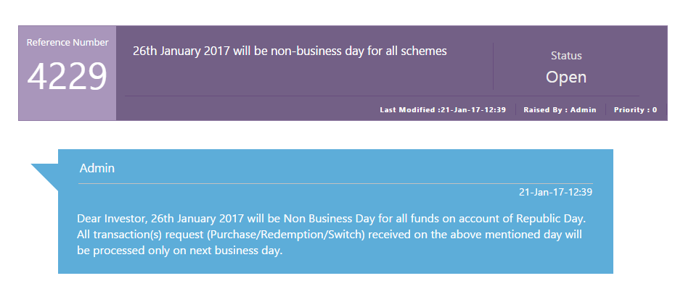

* For Creating a new query a form is required with the following fields
  + Subject
  + Message
  + Upload File.

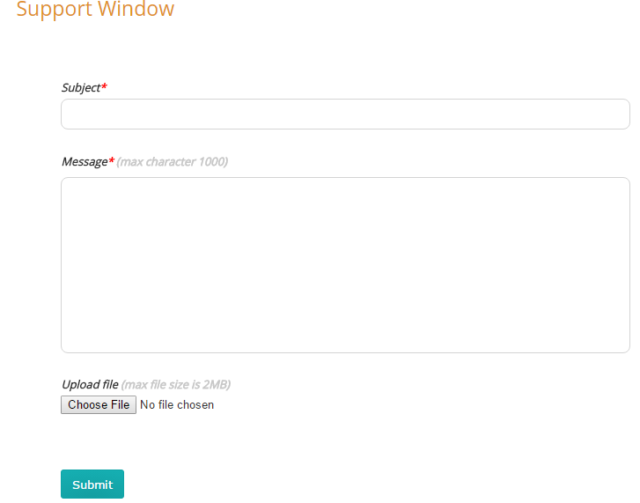

* Support (**Admin Login Part**)
* Schedule a Pick up
  + The user can schedule 4 types of Pickup
    - Account Opening form
    - Investment Form
    - Additional Form
    - Cheque
  + The User here will be able to track the history of the activates
  + As soon as a pickup is scheduled 2 mails should be sent
    - 1st to the user that he has scheduled a Pick up
    - 2nd to the admin id that a pick up is scheduled
* Schedule a Pick up (**Admin Login Part**)
* Upload Documents (**User Login**)
  + The user can upload the following documents
    - Form
    - Cheque
    - PAN Card
    - Address Proof.
    - Investment Form
  + The User here will be able to track the history of the activates
  + As soon as a document is uploaded mails should be sent
    - 1st to the user that he has uploaded the document
    - 2nd to the admin id that a document is uploaded
* Profile
  + Out here the user will be able see the information entered by him at the time of registration and also update the information.
  + The user will be also be able to view the prefilled form
  + Incase of updation the Client ID of the user will not change
  + Once the users information has been accepted from the backend, the user will not be able to make any changes.

**2 Transact**

* Wealth clock Recommendations –Something like bellow screenshot

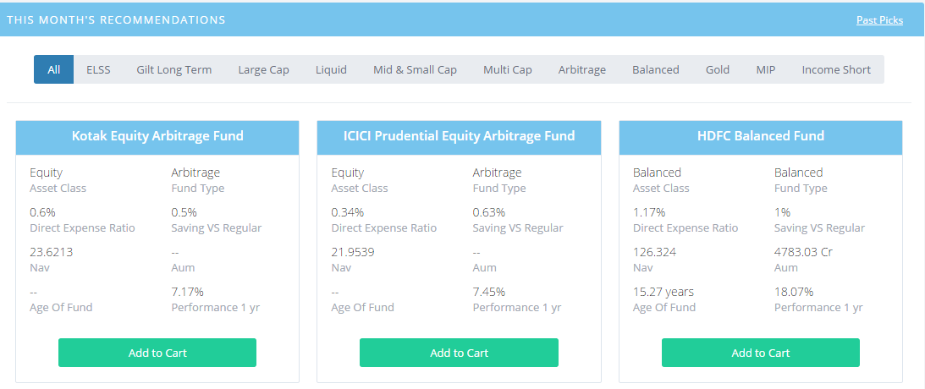

* On Top of the page list of all types of funds will display.
* We would require a back end admin form where we can selected 3 funds of each category with the following data to be inserted
  + Fund Category
  + Asset Class
  + Fund Type
  + Returns
    - 6month / 1 year / 3 year / 5y returns for Equity
    - 1 week / 1month / 3 month / 6 month for Debt
  + Option to buy the fund.

**3. Risk Based Recommendation.**

- Based on the below mention calculation the recommendation list should show.

- Require a CMS/form which from the backend we can insert the recommended list.

There Will be 3 risk Assessments categories viz

1. Conservative - Weightage score between 0 – 4
2. Moderate – Weightage score between 5-6
3. Aggressive – Weightage score between 5-6

Based on the below 5 question, the weightage should generate (addition of individual weightage score/5)

1. Age – For age graphic age scale should be there there
   1. Less than 25 – Weightage 10
   2. 27 – Weightage 9
   3. 29 – Weightage 8
   4. 31 – Weightage 7
   5. 33 – Weightage 6
   6. 35 – Weightage 5
   7. 37 – Weightage 4
   8. 39 – Weightage 3
   9. 41 – Weightage 2
   10. Greater than 42 – Weightage 1
2. Time Horizon
   1. 5 Years and Above – Weightage 10
   2. 3-4.9 years – Weightage 8
   3. 2-2.99 years – Weightage 6
   4. 1-1.99– Weightage 4
   5. Less than 1 year – Weightage 0
3. To What Extent would you expose your Investment to risk, to earn higer returns?
   1. More than 50% - Weightage 10
   2. About 25% -Weightage 8
   3. About 10-25% - Weightage 6
   4. About 10 – Weightage 5
   5. None at all – 0
4. How much are dependent on your income for paying your monthly expenses?
   1. Less than 25 % - Weightage 10
   2. More than 25- 50% - Weightage 7
   3. 50% - Weightage 5
   4. More than 70% - Weightage 2
5. Which of the following best describes your house hold
   1. Dual income – No Dependent – Weightage 10
   2. Single income, no dependent – Weightage 8
   3. Single Income more than 1 dependent – Weightage 6
   4. Retired – Weightage 4
6. What is your Current Investment Allocation? - Specific for this question we require a text box.
   1. Equity
      1. Large Cap
      2. Mid Cap
      3. Small Cap
      4. Sectorial
   2. Debt
      1. Long Term
      2. Short Term
      3. Liquid

Based on the above weightage input by the user, the following recommendation of funds should populate.

We require a function from BSE API where only those funds which we slected are commended based on the scores the user get

If the score is between 9-10 – The recommendation would be – Aggressive

* + Equity – 100%
    1. Large Cap – 0%
    2. Mid Cap – 25 %
    3. Small Cap – 60 %
    4. Sectorial – 15 %
  + Debt – 0
    1. Long Term – 0%
    2. Short Term – 0%
    3. Liquid – 0%

If the score is between 7-8.99 – The recommendation would be – Aggressive

* + Equity – 90%
    1. Large Cap – 10%
    2. Mid Cap – 25 %
    3. Small Cap – 55 %
    4. Sectorial – 10 %
  + Debt – 10%
    1. Long Term – 0%
    2. Short Term – 0%
    3. Liquid – 0%

If the score is between 5-7.99 – The recommendation would be – Aggressive

* + Equity – 90%
    1. Large Cap – 20%
    2. Mid Cap – 30 %
    3. Small Cap – 50 %
    4. Sectorial – 0 %
  + Debt – 10%
    1. Long Term – 10%
    2. Short Term – 0%
    3. Liquid – 0%

If the score is between 4-5.99 – The recommendation would be – Moderate

* + Equity – 65%
    1. Large Cap – 60%
    2. Mid Cap – 25 %
    3. Small Cap – 15 %
    4. Sectorial – 0 %
  + Debt – 35%
    1. Long Term – 100%
    2. Short Term – 0%
    3. Liquid – 0%

If the score is between 3-4.49 – The recommendation would be – Conservative

* + Equity – 35%
    1. Large Cap – 80%
    2. Mid Cap – 20 %
    3. Small Cap – 0 %
    4. Sectorial – 0 %
  + Debt – 65%
    1. Long Term – 60%
    2. Short Term – 40%
    3. Liquid – 0%

If the score is between 0-2.99 – The recommendation would be – Conservative

* + Equity – 0%
    1. Large Cap – 0%
    2. Mid Cap – 0 %
    3. Small Cap – 0 %
    4. Sectorial – 0 %
  + Debt – 100%
    1. Long Term – 30%
    2. Short Term – 70%
    3. Liquid – 0%

Option will come where the user wants to invest as an SIP or Lumpsum

Based on the above algo the recommendation list of funds should come as below.

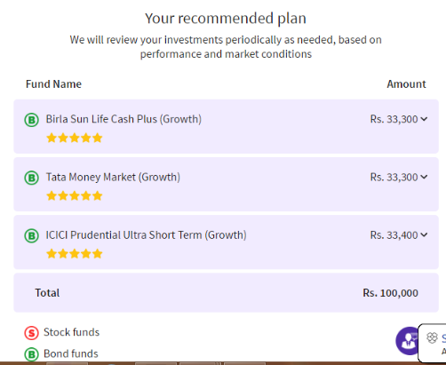

* The next step would be where the user buys the recommended fund.

**4/5/6/7 - Build Wealth / Park Money / Regular Income / Tax Saving**

Step 1

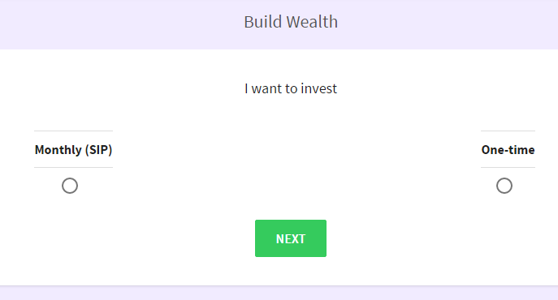

SIP Lumpsum

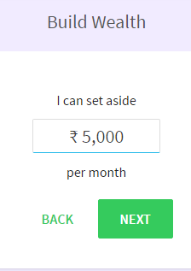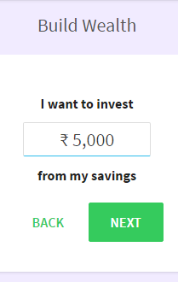

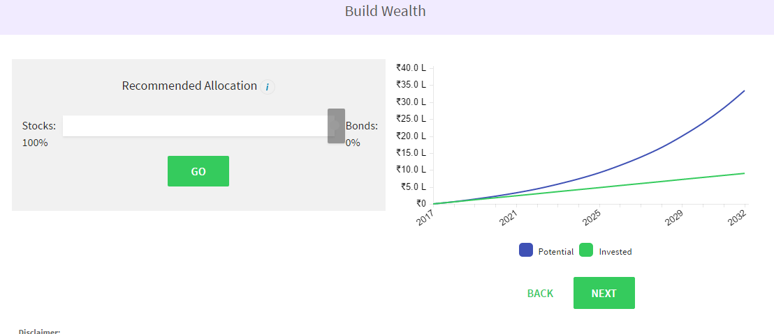

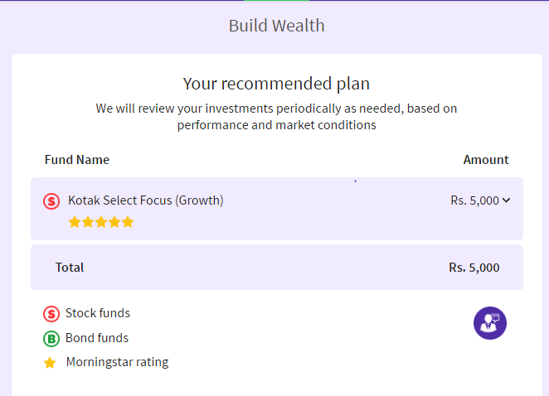

Next Step payment gatway

**DIY**

-The client can do whatever he want to buy



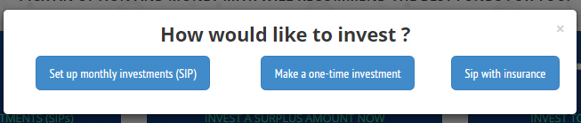

SIP

In this the extra requirments would be

SIP data

SIP frequency

iSIP Mandate

Lumpsum

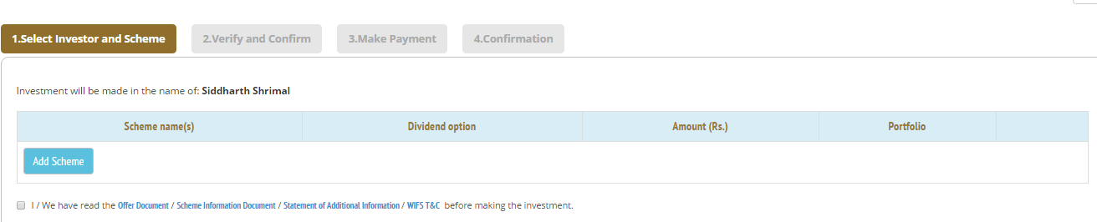

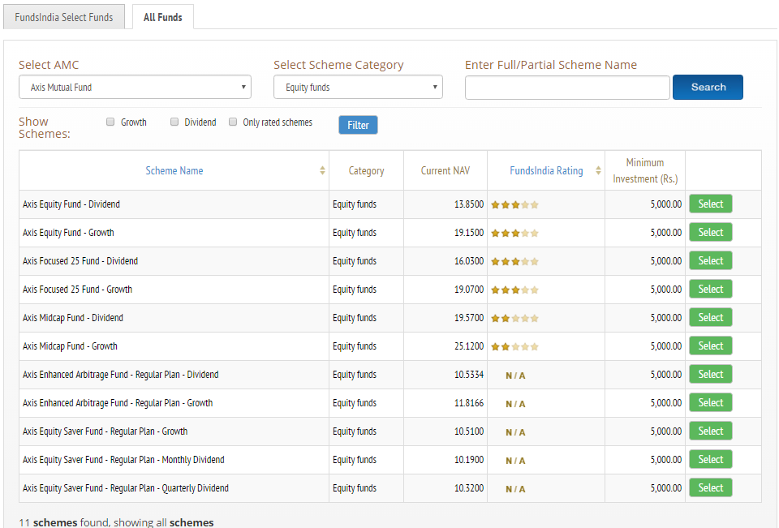

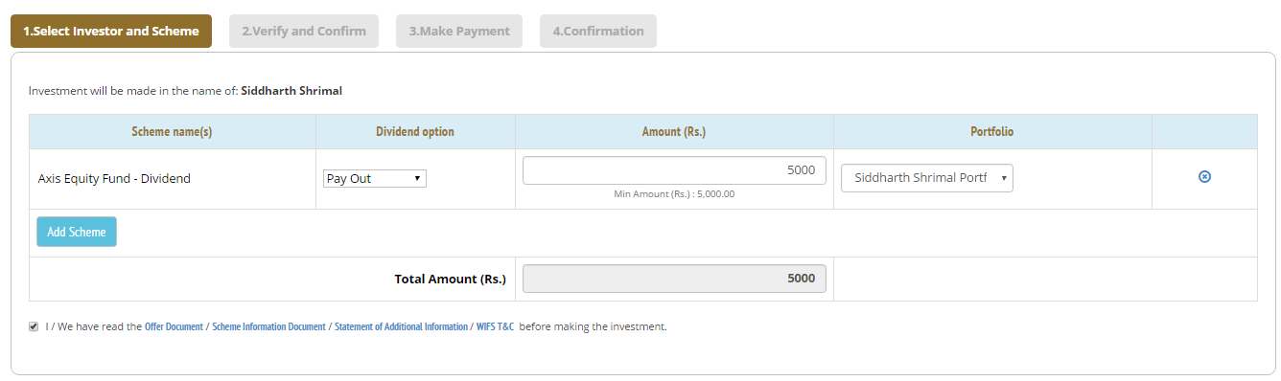

SIP with Insurance

This would be similar to the SIP, but in this only few selected schemes from birla/reliance(currently only these 2 provide) would populate.

**6 Goal Tracking**

Below type of a summary is required of all the goals which the client has added.

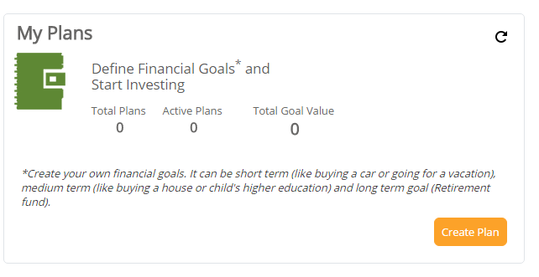

A graphical image of the goal and its completion.

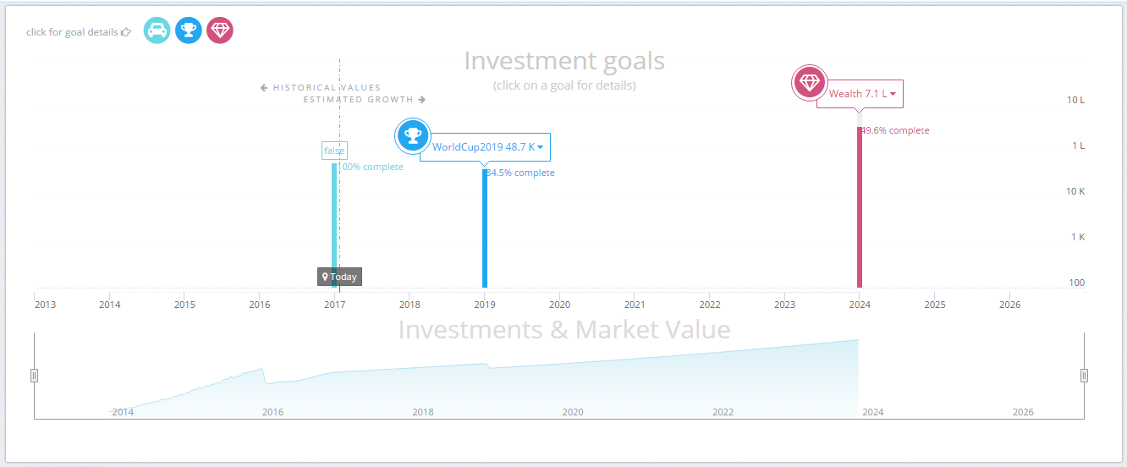

**7 Wealth Clock Advisors.**

Goal Advisory

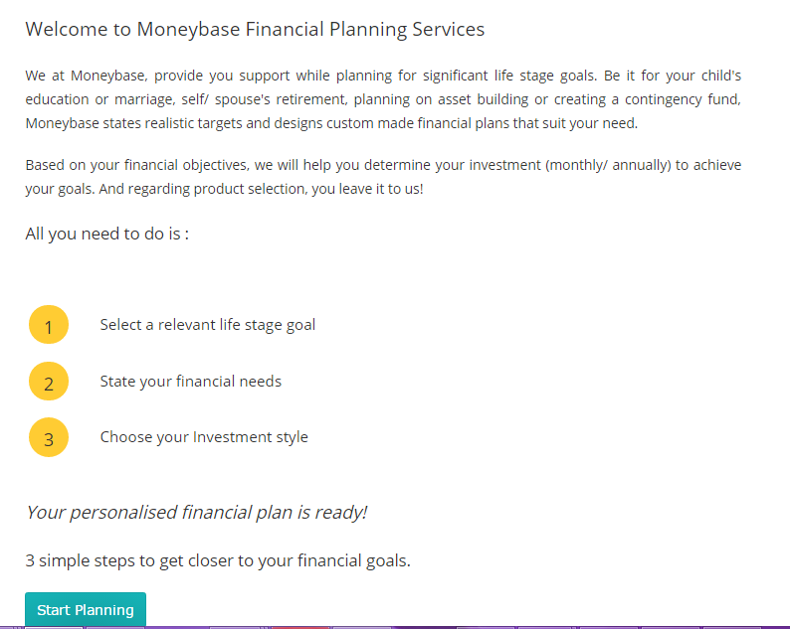

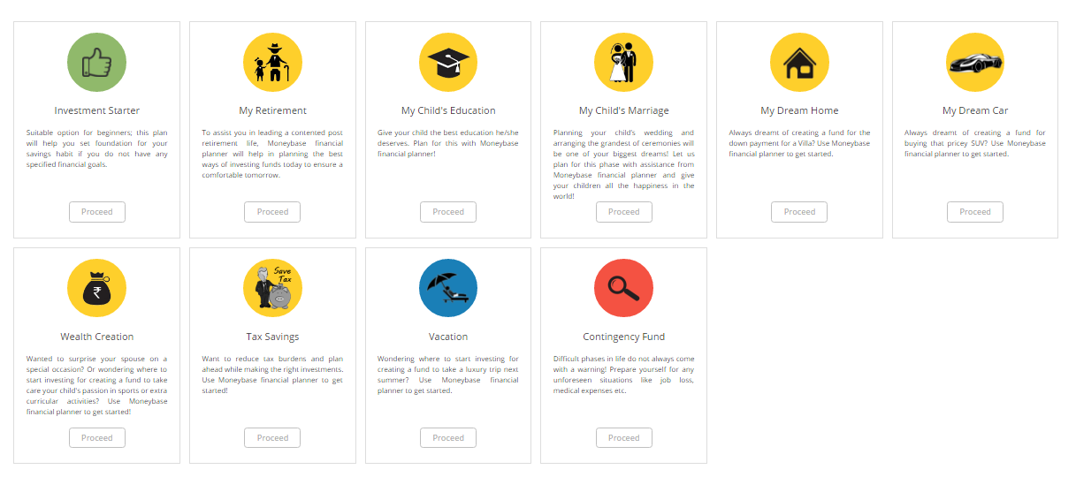

Top Pick

This will be similar to what we have used above in the Wealth clock recommended.



**8. Tools**

* Risk Analyzer
  + It would be similar to the above used in the risked based recommendation. Out here only the current allocation would not be required.
* Right amount for your SIP
  + The following fields are required

|  |  |  |
| --- | --- | --- |
| Field | Field Type | Formula Short cut |
| How much does your goal cost today? (In ₹) | Number | Prinpical (P) |
| When do you want to achieve this goal? | Number | No of Years (N) |
| Cost of your goal in 2026 | Number (through Calucation) | Total Value (CI) |
| Interest |  | Interest (I) |

* The formula would be as - CI=(P*(1+(1+(I/12))^(N*12))
* The Interest Field is not be shown in the front end. A provision is required to be entered at the back end for calculation purpose.
* As soon as calculate is clicked according to the above formula the answer should populate and further a below mentioned option to be provided for the invest to see how much money is required per month to invest in order to achieve that goal

|  |  |  |
| --- | --- | --- |
| Radio button Name | Type | Text |
| Risk Averse | 0% equity : 100% Debt | * If you can’t tolerate any volatility in returns * If you have very short term goals & need easy liquidity * If you want regular income out of your investments |
| Conservative | 25% equity : 75% Debt | * If you can handle some risk but not large losses in the short term * If you want to beat after tax FD returns * If you want to invest for less than 5 years |
| Moderate | 55% equity : 45% Debt | * If you can handle risk and digest large losses in the short term * If you want to get significantly higher returns * If you want to invest for 5 years or more |
| Aggressive | 80% equity : 20% Debt | * If you take risks & can handle losses in the medium term * If you want to create wealth for yourself * If you want to invest for 10 years or more |

* Provision required to enter the interest rate for debt and equity. This is not to be displayed
* The interest rate(i) will be a weightage of debt* debt rate + weightage of equity*equity rate
* The investment amount per month will be a annuity formula as follows
  + (((-i/12)*CI)/(1-(1+(i/12))^(N*12))
* Option is required where the user can click and see what are the assumption behind the above calculation.
* Asset Allocation
  + The Asset Allocation has 2 parts as follows
    - As per Asset Class
      * Debt
        + Liquid
        + Short Term
        + Long term
      * Equity
        + Large Cap
        + Small Cap / Mid Cap
        + ELSS
  + Would require a pie chart to display the result
    - The allocation on default would be would be as follows
      * 50% Debt – 50 % Equity on Asset Class - As per category in the Asset Class
        + Debt

Liquid - 25

Short Term - 50

Long term - 25

* + - * + Equity

Large Cap - 50

Small Cap / Mid Cap - 20

ELSS - 30

* + There will be 4 questions as follows
    - Which of the following determines your age bracket
    - Your Risk Appetiite
    - Investment horizon
    - Do you believe in small caps are better investment than large caps

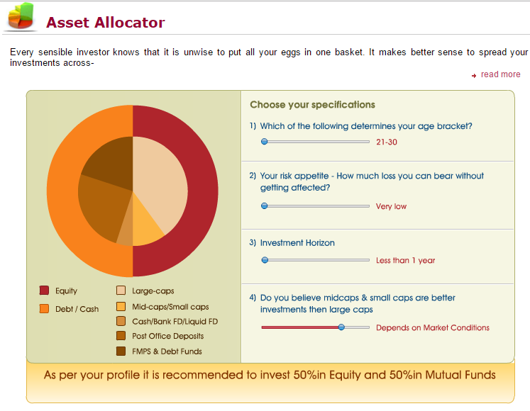

[https://www.icicipruamc.com/asset-allocator.aspx#](https://www.icicipruamc.com/asset-allocator.aspx)

**9.Refer Friends/Family**

* Refer a friend, we would require three fields
  + Name
  + Email
  + Mobile Number
  + Note
* On clicking the submit button and email/sms to be sent the referred friend that the user has referred him to join wealth clock.
  + An email to admin also would be sent.

