**Create thumbnail image by triggering Cloud Function when an image is uploaded into Cloud Storage**

1. Create a topic

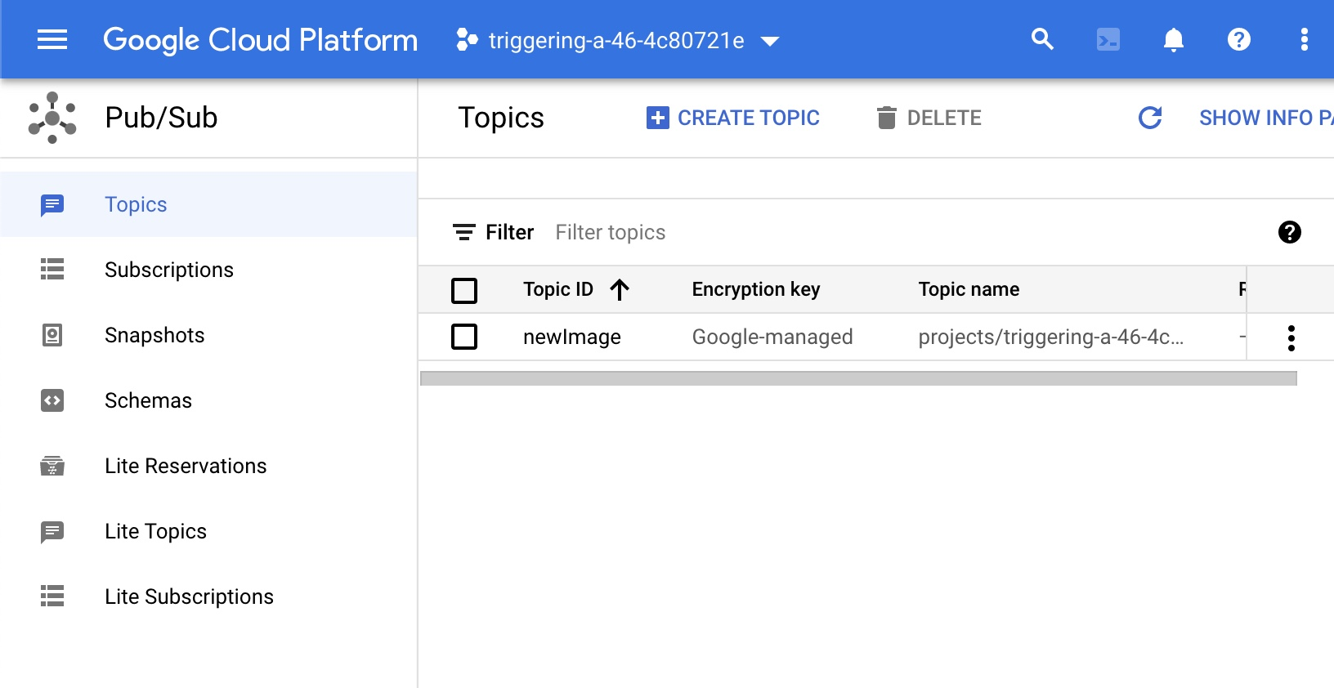

Default subscription will be created with Pull type (no need to be Push type). It is a mandatory.

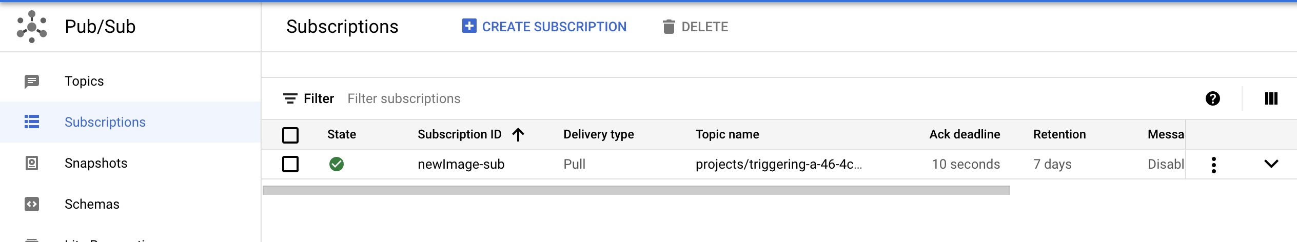

1. Create two buckets (images and thumbnails)

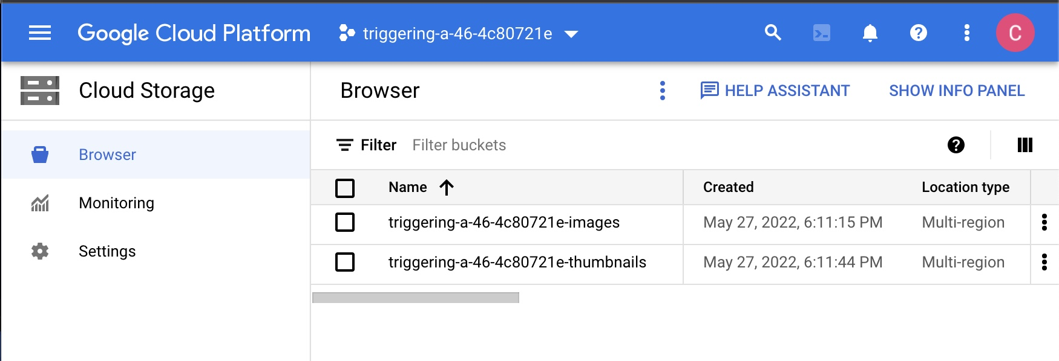

1. Create a notification (no console option) to the topic when an image is saved to the bucket

gsutil notification create -f json -e OBJECT_FINALIZE -t projects/triggering-a-46-4c80721e/topics/newImage gs://triggering-a-46-4c80721e-images

gsutil notification list gs://BUCKET_NAME-images

gsutil notification delete projects/_/buckets/BUCKET_NAME /notificationConfigs/NOTIFICATION_ID

1. Clone git clone https://github.com/manisekharan/gcp_gen_thumbnail.git
2. Replace thumbnail bucket name in main.py and requirements.txt (no changes)
3. To deploy Cloud Function with a Pub/Sub trigger,

gcloud services enable cloudbuild.googleapis.com cloudfunctions.googleapis.com

gcloud functions deploy gcp_gen_thumbnail --runtime python37 --trigger-topic newImage

6.1 once the deployment is completed it creates a bucket and stores the source codes in gcp_gen_thumnail folder

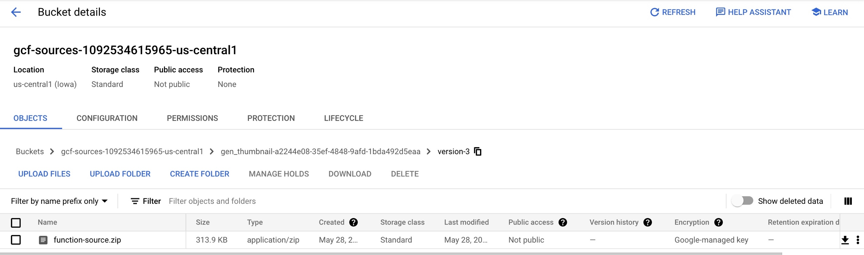

* 1. It creates the artifact as a container image in another bucket

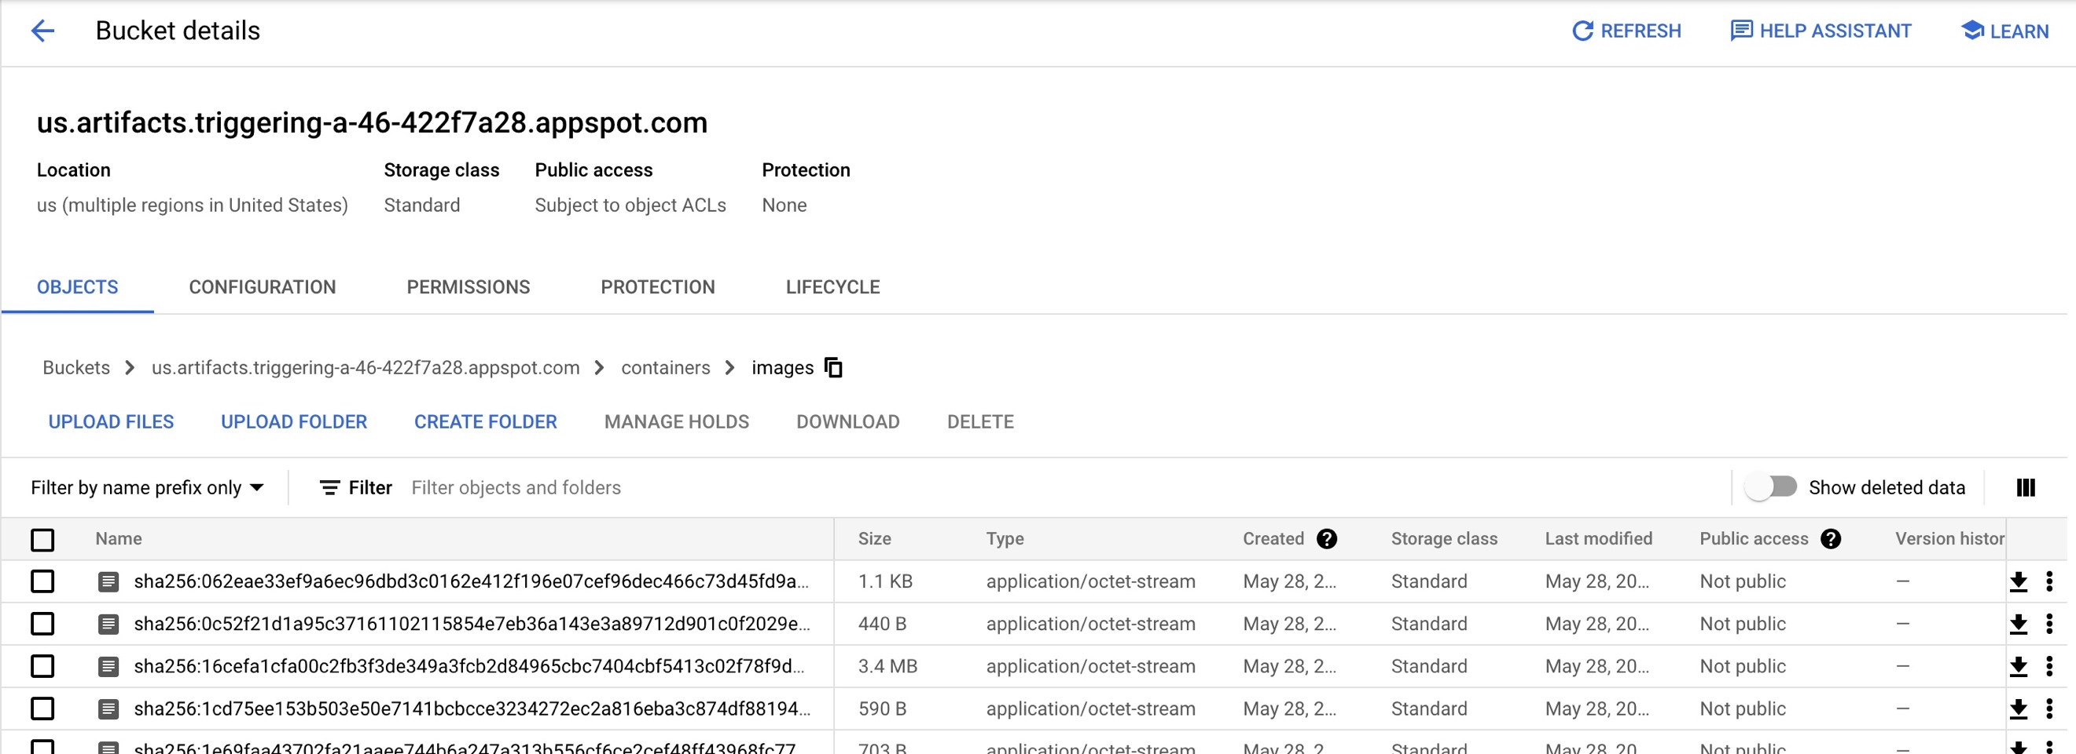

It uses Docker container internally

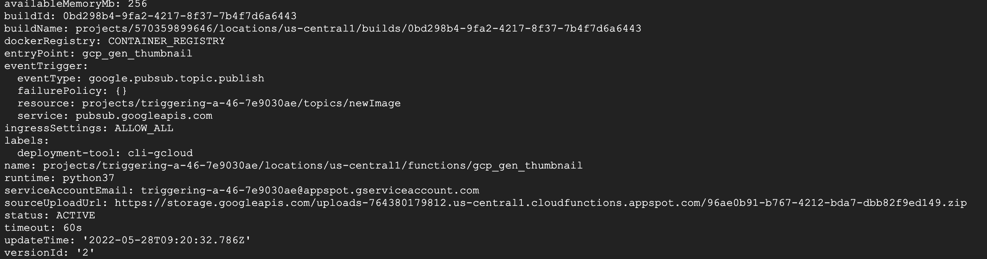

There are no Cloud Build/Run/Deploy versions created in the project like buckets

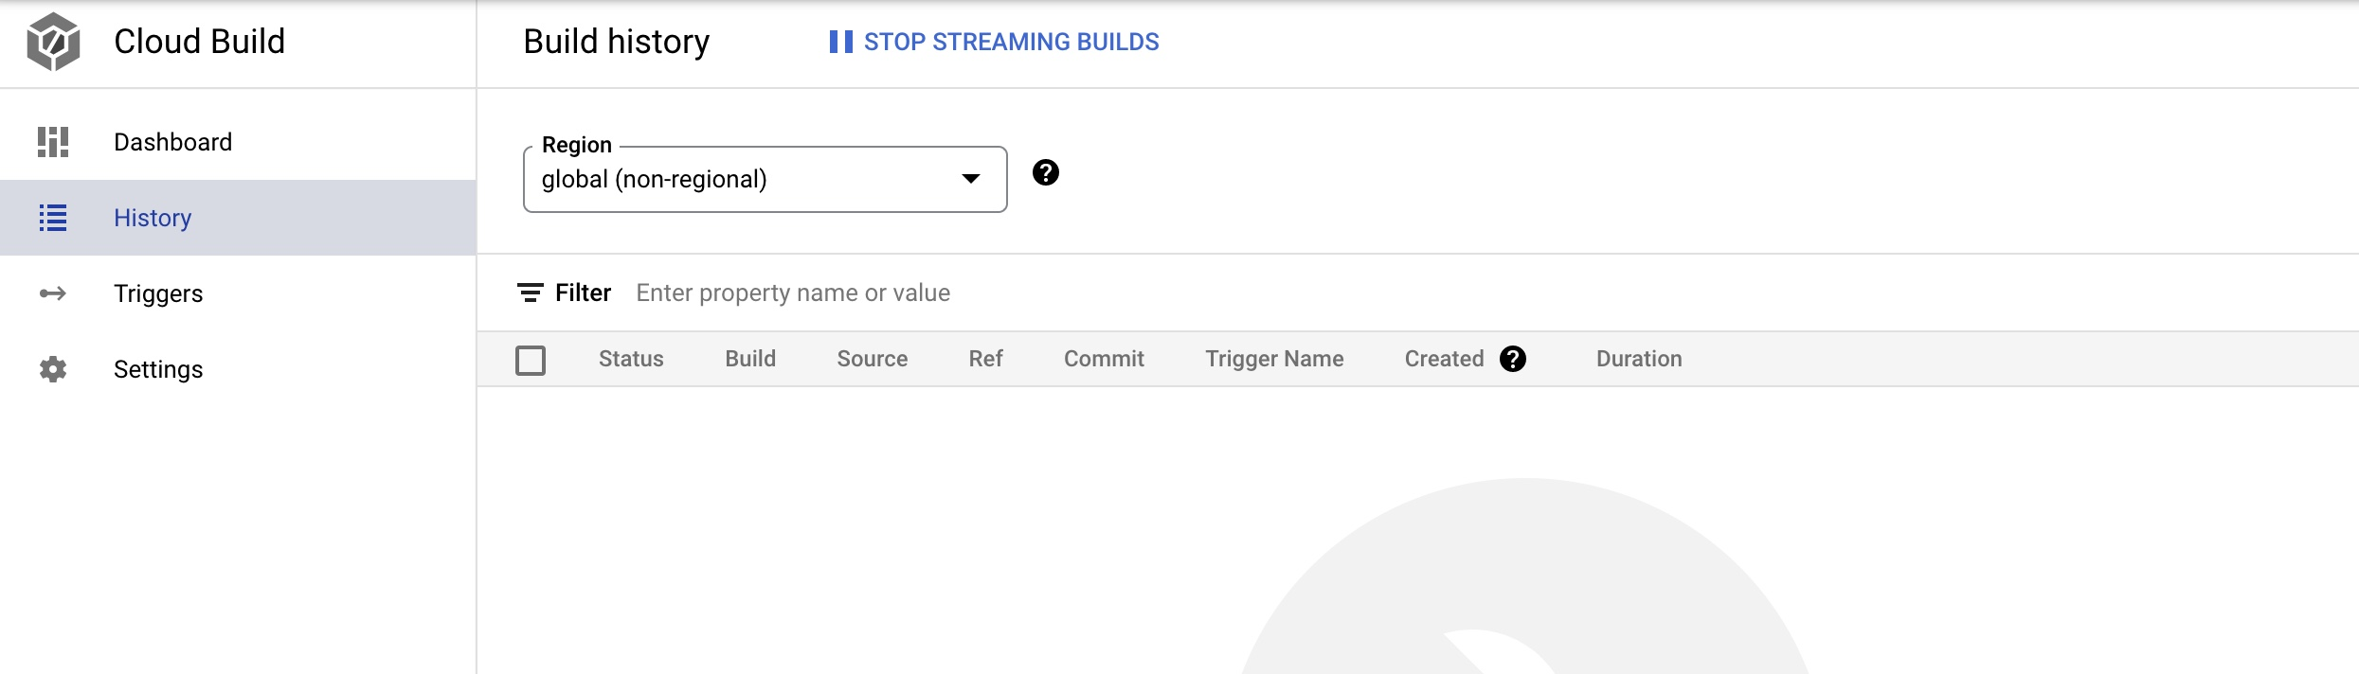

But Logging shows that it used Cloud Build to build the image

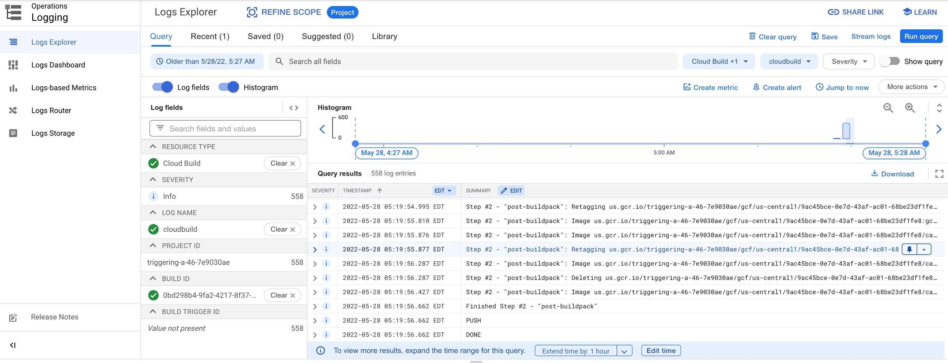

1. Upload an image to image bucket.
2. New thumbnail image is created in 2nd bucket.