
Software Requriment Specification on-
Emergency Medical Service Dispatch & Telematics Platform

Submitted to:

Rajasthan Technical University,Kota (Raj.)
Submitted By:
Rahul Mandal (24EARIT042)
Niraj Mandal (24EARIT036)
Manish Sah (24EARIT030)
Pushkar Priyadarshi (24EARIT040)
Ashutosh Kumar (24EARIT012)

Under the supervision of-
Er.Ram Babu Buri
Associate Professor

Session:2026-27
The Department of Information Technology
ARYA COLLEGE OF ENGINEERING & I.T.
SP-42 ,RIICO INDUSTRIAL AREA,KUKAS,JAIPUR

Contents
1.Introduction 3
1.1 Purpose of the Project 3
1.2 Scope 3
1.3 References 4
1.6 Overview 5
2. Overall Description 6
2.1 Product perspective 6
2.2 Product Functions 6
2.3User Characteristics 7
2.4 Constraints 8
3. System Features / Functional Requirements 11
3.1. Incident Intake & Caller Privacy 11
3.3. Dispatch Optimization 11
3.4. Real-Time GPS Tracking 11
3.5. Hospital Diversion & Ranking 12
3.6. Fleet Redeployment 12
3.7. Cryptographic Audit Ledger 12
4. External Interface Requirements 13
4.1 User Interface (UI Expectations, Forms, Dashboards 13
4.2 Paramedic Mobile App/PWA: 13
4.3 Hardware Interface (Devices, Sensors, Servers) 13
4.5 REST/GraphQL APIs: 13
4.6 Data Formats: 13
5.1 Performance (Response Time, Throughput) 14
5.2 Reliability and Availability 14
53. Security (Authentication, Encryption, Compliance) 14
5.4. Maintainability and Scalability 14
5.5. Usability 14
6.UML DAIGRAM 16
7.1 Compliance with Standards 19
7.2 Legal and Regulatory Constraints 19
7.3 Future Enhancements 19

1.Introduction

1.1 Purpose of the Project
The purpose of the H8 Capability-Aware Emergency Medical Services (EMS) Dispatch & Telematics Platform is to overcome the limitations of traditional Computer-Aided Dispatch (CAD) systems and deliver clinically intelligent, legally auditable, and operationally efficient emergency response. Conventional CAD systems assign ambulances based purely on proximity, often leading to severe mismatches between patient needs and ambulance capabilities. For example, a Basic Life Support (BLS) unit may be dispatched to a cardiac arrest case, lacking the equipment and expertise required to save the patient within the critical “Golden Hour.” Such inefficiencies result in secondary transfers, delayed interventions, and compromised survival outcomes.
This project introduces a capability-aware dispatch engine that integrates multiple factors beyond distance. It computes a composite score for each ambulance based on driving ETA, clinical capability alignment, crew fatigue, suburban coverage preservation, and telemetry freshness. By doing so, it ensures that the most appropriate unit is dispatched to each incident. The platform also incorporates real-time hospital diversion management, enabling ambulances to avoid facilities that are saturated or lack critical specialists, thereby reducing offload delays and improving patient throughput.
Another core purpose is to establish trust and accountability through a cryptographically verifiable audit ledger. Every dispatch decision, override, and clinical triage is immutably recorded, ensuring compliance with HIPAA and DISHA privacy regulations. This not only protects patient confidentiality but also provides legal auditability for malpractice investigations.

Ultimately, the project’s purpose is to enhance emergency medical outcomes by combining advanced algorithms, telematics, and secure data handling. It aims to reduce response times, improve clinical match precision, eliminate unnecessary transfers, and maintain continuous metropolitan coverage. By aligning technology with clinical mission objectives, the H8 EMS platform ensures that emergency care is delivered faster, smarter, and more reliably.

1.2 Scope

The scope of the H8 Capability-Aware Emergency Medical Services (EMS) Dispatch & Telematics Platform encompasses the complete lifecycle of emergency medical response in metropolitan environments. It is designed to provide a unified, intelligent, and secure system that integrates incident intake, ambulance dispatch, real-time tracking, hospital coordination, and audit verification. Unlike traditional CAD systems that rely solely on distance, this platform introduces a multi-factor scoring engine to ensure clinically appropriate unit assignment, thereby reducing mismatches and improving patient outcomes.
The system covers incident management, including anonymized call intake, triage categorization, and lifecycle state transitions. It extends to dispatch optimization, where available ambulances are scored based on ETA, capability alignment, telemetry freshness, and coverage preservation. The platform also supports real-time vehicle tracking, leveraging GPS ingestion and Redis geospatial indexing, as well as road routing through GraphHopper to provide accurate travel times.
On the hospital side, the scope includes capacity telemetry, diversion protocols, and destination ranking to prevent offload delays. Pre-arrival notifications ensure hospitals are prepared before patients arrive. Additionally, the system continuously evaluates coverage using the MEXCLP model, recommending redeployment strategies to maintain balanced citywide readiness.
Beyond functional requirements, the scope integrates non-functional aspects such as performance thresholds (sub-50 ms dispatch scoring), reliability (99.99% uptime), and compliance with HIPAA and DISHA privacy standards. A cryptographic audit ledger ensures immutable record-keeping for legal and clinical accountability.

1.3 References

- IEEE Std 830-1998 – Recommended Practice for Software Requirements Specifications. This standard defines how to structure and write SRS documents, ensuring clarity, completeness, and consistency.
- ISO/IEC/IEEE 29148:2018 – Systems and Software Engineering – Life Cycle Processes – Requirements Engineering. Provides international guidelines for requirements engineering processes, ensuring the project aligns with global best practices.
- HIPAA Security Rule (45 CFR Part 160 and Part 164) – U.S. standards for the privacy of individually identifiable health information. Ensures patient data confidentiality and secure handling of medical information.
- DISHA (Digital Information Security in Healthcare Act, India) – Ministry of Health & Family Welfare, Government of India. Provides Indian regulatory compliance for medical data privacy and security.
- NFPA 1710 / NFPA 1720 – Standards for the organization and deployment of fire suppression and emergency medical operations. Defines operational benchmarks for EMS response times, staffing, and deployment efficiency.

1.6 Overview
The H8 Capability-Aware Emergency Medical Services (EMS) Dispatch & Telematics Platform is an advanced, distributed software system designed to transform emergency medical response in metropolitan regions. Traditional Computer-Aided Dispatch (CAD) systems rely on simplistic distance-based heuristics, often leading to clinical mismatches where ambulances without the required equipment or expertise are dispatched to critical emergencies. This project addresses those inefficiencies by introducing a multi-factor, capability-aware dispatch engine that ensures the right unit is assigned to the right patient at the right time.
The platform integrates several subsystems: incident intake and anonymization, clinical triage and need classification, dispatch optimization with atomic unit reservation, real-time GPS tracking and telematics ingestion, road network routing using GraphHopper, and hospital diversion management with capacity telemetry. It also features fleet redeployment optimization to maintain balanced coverage across the city and a cryptographic audit ledger that immutably records every dispatch decision, ensuring transparency and compliance with HIPAA and DISHA privacy regulations.
Operationally, the system is deployed in Jaipur, India, covering 14 strategically positioned ambulance units and 5 Tier-1 hospitals. It leverages modern technologies such as Java 21, Spring Boot, PostgreSQL/PostGIS, Apache Kafka, Redis, and Keycloak, ensuring scalability, reliability, and high performance. Non-functional requirements emphasize sub-50 millisecond dispatch scoring, ingestion of over 1,000 GPS events per second, and 99.99% uptime.

2. Overall Description

2.1 Product perspective

The H8 Capability-Aware EMS Dispatch & Telematics Platform is conceived as an enterprise-grade, distributed, event-driven system that integrates seamlessly into the broader emergency response ecosystem. Unlike standalone CAD systems that operate in isolation, this platform is designed as a modular, service-oriented architecture built on Java 21, Spring Boot, PostgreSQL/PostGIS, Apache Kafka, Redis, and Keycloak. Each subsystem—incident intake, dispatch optimization, tracking, routing, hospital management, redeployment, and audit—functions independently yet communicates through well-defined APIs and event contracts, ensuring scalability and resilience.
From a product perspective, the system acts as the central nervous system of metropolitan EMS operations. It ingests emergency calls, anonymizes sensitive data, triages incidents, and intelligently matches them with the most suitable ambulance unit. Real-time GPS telemetry and road network routing ensure accurate ETA calculations, while hospital integration prevents offload delays by monitoring bed capacity and diversion status. The redeployment engine continuously evaluates coverage gaps, recommending optimal repositioning of idle units to maintain readiness across the city.
The platform is not limited to Jaipur’s pilot deployment; its architecture is scalable and portable to other metropolitan regions. By adhering to international standards (IEEE 830, ISO/IEC/IEEE 29148) and healthcare privacy laws (HIPAA, DISHA), it ensures compliance and interoperability. The cryptographic audit ledger provides immutable accountability, making the system legally defensible and trustworthy.

2.2 Product Functions
- Incident Intake & Caller Privacy
- Secure ingestion of emergency calls with anonymization of caller data using salted SHA-256 hashing.
- Clinical Triage & Need Classification
- Categorization of incidents into severity levels (Critical, Urgent, Standard, Non-Emergency) and clinical domains (Cardiac, Trauma, Stroke, Pediatric, Respiratory, General).
- Capability-Aware Dispatch Optimization
- Multi-factor scoring engine that matches incidents with the most suitable ambulance unit based on ETA, capability alignment, telemetry freshness, and coverage preservation.
- Atomic Unit Reservation & Concurrency Management
- Ensures ambulance assignment is conflict-free using atomic SQL updates, preventing double booking.
- Real-Time GPS Tracking & Telematics
- Continuous ingestion of vehicle telemetry (location, speed, bearing) with Redis geospatial indexing and dead-reckoning extrapolation.
- Turn-by-Turn Road Routing
- Accurate travel time estimation using GraphHopper road network routing with emergency vehicle profiles.
- Hospital Diversion & Destination Ranking
- Real-time monitoring of hospital capacity, diversion status, and ranking of facilities based on clinical capability and travel time.
- Pre-Arrival Notifications
- Streaming of patient acuity and ETA to hospitals via Server-Sent Events (SSE) for preparedness.
- Dynamic Fleet Redeployment
- Coverage optimization using the MEXCLP model to reposition idle units and maintain balanced citywide readiness.
- Cryptographic Dispatch Audit Ledger
- Immutable SHA-256 hash-chained ledger recording all dispatch events, overrides, and triage decisions for legal and compliance verification.
- Multi-Persona Web & Mobile Consoles
- User interfaces tailored for dispatchers, paramedics, and hospital staff, accessible via progressive web apps (PWAs).

2.3User Characteristics
The H8 Capability-Aware EMS Dispatch & Telematics Platform is designed to serve a diverse set of users, each with distinct roles, responsibilities, and technical expertise.
1.Dispatchers (Public Safety Communications Personnel – 108/911 Operators): These users are trained in emergency call handling and operational workflows. They require intuitive console layouts, rapid incident intake forms, and manual override capabilities. Their priority is speed, accuracy, and the ability to manage multiple incidents simultaneously.
2.Paramedics & Ambulance Crew (BLS and ALS Units): Field responders use rugged mobile devices or Progressive Web Apps (PWAs) to receive dispatch notifications, navigation routes, and hospital assignments. Their skill levels vary from EMT-Basic to Critical Care Paramedics, so the system must adapt to different clinical capabilities. Ease of use, offline resilience, and real-time updates are critical for them.
3.Emergency Department (ED) Staff & Hospital Administrators: These users interact with hospital consoles that display pre-arrival notifications, patient acuity, and estimated arrival times. They rely on accurate telemetry to prepare resources in advance and manage diversion protocols. Their focus is on clinical readiness and minimizing offload delays.
4.Software Engineers & System Architects: They require complete behavioral, interface, and structural specifications to maintain and extend the platform. Their interaction is primarily with system documentation, APIs, and UML models.
5.Compliance Auditors & Legal Authorities: These users verify cryptographic audit trails, privacy compliance, and immutable records. They are less technical but require transparency and trust in the system’s data handling.

2.4 Constraints

1.Technical Constraints
Strict Decoupling of Domain Logic: Core algorithms (DispatchScorer, CoverageModel, DestinationRanker) must remain in pure Java 21, independent of frameworks like Spring or Kafka, ensuring portability.
Atomic Unit Reservation: Ambulance assignment must be handled through atomic SQL updates to prevent concurrency conflicts and double booking.
Idempotent Event Handling: Kafka consumers must deduplicate events to avoid side-effects from re-delivery.
Data Staleness Penalization: Telemetry and hospital capacity data must carry timestamps and TTLs; stale data is penalized or rejected.
Zero Secrets in Version Control: All credentials and keys must be supplied via environment variables or Docker secrets.
2.Regulatory Constraints
HIPAA Compliance (U.S.): No patient identifiable information (PII) can be stored in plaintext; caller phone numbers must be anonymized using salted SHA-256 hashing.
DISHA Compliance (India): Adherence to Indian healthcare privacy laws for secure handling of medical data.
NFPA Standards: Response times and deployment strategies must align with NFPA 1710/1720 benchmarks for EMS operations.
Auditability: Every dispatch decision must be immutably recorded in a cryptographic ledger for legal verification.
3.Hardware/Software Constraints
IoT GPS Transponders & Rugged MDTs: Field units rely on hardware devices with limited bandwidth and must support high-frequency telemetry (up to 1 Hz).
Mobile Devices: Paramedic PWAs must run reliably on Android/iOS with offline resilience.
Hospital Systems: Integration requires compatibility with existing ED consoles and secure communication protocols (TLS 1.3, WebSocket, SSE).
Performance Limits: Dispatch scoring must complete in <50 ms for 50 ambulances; telemetry ingestion must handle ≥1,000 events/sec.

2.5 Assumptions and dependencies
- Operational Assumptions
Emergency calls will always provide sufficient information (location, incident type, caller number) for triage and dispatch.
GPS transponders installed in ambulances will continuously transmit telemetry at required frequencies (up to 1 Hz).
Hospitals will maintain accurate and timely updates of bed capacity, ICU availability, and diversion status.
Dispatchers and paramedics will have access to rugged mobile devices or PWAs with stable connectivity.
The metropolitan region (Jaipur pilot) will maintain a minimum fleet size of 14 ambulances and 5 Tier-1 hospitals integrated into the system.
- Technical Assumptions
All services (incident, dispatch, tracking, routing, hospital, redeployment, audit) will operate within a microservices architecture connected via Kafka event streams.
Redis geospatial indexing and PostgreSQL/PostGIS schemas will handle high-frequency telemetry and spatial queries without performance degradation.
GraphHopper routing engine will remain updated with metropolitan road networks to ensure accurate ETA calculations.
Property-based testing and verification tools (jqwik) will validate concurrency and scoring invariants consistently.
- Regulatory Dependencies
Compliance with HIPAA and DISHA privacy laws requires anonymization of caller PII and secure handling of medical data.
NFPA 1710/1720 standards guide response time thresholds and fleet deployment strategies.
Legal auditability depends on the immutable SHA-256 hash-chained ledger being maintained without tampering.
- Infrastructure Dependencies
Reliable cloud infrastructure must support 99.99% uptime, container orchestration, and automated recovery.
TLS 1.3, WebSocket, and SSE protocols must be available for secure communication between dispatchers, ambulances, and hospitals.
Continuous internet connectivity is assumed for GPS telemetry ingestion and hospital notifications.

3. System Features / Functional Requirements

3.1. Incident Intake & Caller Privacy
- Description: Handles emergency call ingestion, anonymizes caller data, and categorizes incidents.
- Inputs/Outputs: Caller number, location, incident type → anonymized record, triage category.
- Preconditions: Valid call received with minimum required data.
- Postconditions: Incident stored with hashed caller ID, triage assigned.
- Normal Flow: Call → anonymization → triage → incident record created.
- Alternative Flow: Missing data → error response or manual dispatcher entry.
3.2. Clinical Triage & Need Classification
- Description: Categorizes severity (Critical, Urgent, Standard, Non-Emergency) and clinical domain.
- Inputs/Outputs: Incident details → severity level + clinical need tag.
- Preconditions: Incident record exists.
- Postconditions: Incident tagged for dispatch scoring.
- Normal Flow: Incident → triage rules applied → classification stored.
- Alternative Flow: Ambiguous case → manual dispatcher override.

3.3. Dispatch Optimization
- Description: Scores available ambulances using multi-factor algorithm.
- Inputs/Outputs: Incident + fleet data → ranked list of candidate units.
- Preconditions: At least one available ambulance.
- Postconditions: Unit reserved or re-ranked.
- Normal Flow: Candidate scoring → best unit assigned → atomic reservation.
- Alternative Flow: Reservation conflict → re-ranking triggered.

3.4. Real-Time GPS Tracking
- Description: Ingests telemetry, updates Redis geospatial index, extrapolates stale data.
- Inputs/Outputs: GPS stream → current unit position.
- Preconditions: Active GPS transponder.
- Postconditions: Updated location stored and used in scoring.
- Normal Flow: Continuous ingestion → Redis update → ETA calculation.
- Alternative Flow: Telemetry stale → penalty applied.

3.5. Hospital Diversion & Ranking
- Description: Tracks hospital capacity, diversion status, and ranks destinations.
- Inputs/Outputs: Hospital telemetry → ranked hospital list.
- Preconditions: Hospital registered in system.
- Postconditions: Destination assigned with pre-arrival notification.
- Normal Flow: Hospital data → ranker → best hospital selected.
- Alternative Flow: Diversion active → next best hospital chosen.

3.6. Fleet Redeployment
- Description: Optimizes coverage using MEXCLP model.
- Inputs/Outputs: Fleet status → relocation recommendations.
- Preconditions: At least one idle unit available.
- Postconditions: Units repositioned to maintain coverage.
- Normal Flow: Dispatch leaves gap → redeployment engine suggests move-up.
- Alternative Flow: No idle units → coverage gap persists.

3.7. Cryptographic Audit Ledger
- Description: Immutable SHA-256 hash chain records all dispatch events.
- Inputs/Outputs: Dispatch event → ledger entry.
- Preconditions: Valid event triggered.
- Postconditions: Event immutably stored.
- Normal Flow: Event → hash chain update → verification endpoint available.
- Alternative Flow: Ledger verification fails → alert raised.

4. External Interface Requirements

4.1 User Interface (UI Expectations, Forms, Dashboards)
The system must provide intuitive, role‑specific interfaces:
Dispatcher Console: Incident intake forms, triage dashboards, and unit assignment panels with real‑time fleet maps.

4.2 Paramedic Mobile App/PWA:
Simple notification screens, turn‑by‑turn navigation, and hospital assignment updates with offline caching.
Hospital Console: Pre‑arrival dashboards showing patient acuity, ETA, and diversion status.
Auditor Portal: Read‑only dashboards for cryptographic ledger verification and compliance reports.
Interfaces must be responsive, accessible, and usable under high‑stress conditions with minimal training.

4.3 Hardware Interface (Devices, Sensors, Servers)
Ambulance GPS Transponders: IoT devices transmitting telemetry (location, speed, bearing) at 1 Hz.

4.4 Rugged Mobile Devices: Tablets or smartphones used by paramedics, supporting offline resilience.
Hospital Servers: Integration with ED consoles and capacity monitoring systems.
Cloud Infrastructure: Containerized microservices deployed on resilient servers with automated failover.
Software Interface (APIs, Databases, External Systems)

4.5 REST/GraphQL APIs:

For incident intake, dispatch scoring, telemetry ingestion, and hospital updates.
Databases: PostgreSQL/PostGIS for spatial queries, Redis for geospatial indexing, and immutable audit ledger storage.
External Systems: Integration with hospital management systems, public safety CAD systems, and compliance verification tools.
Authentication: Keycloak‑based RBAC for secure access control.
Communication Interface (Network Protocols, Data Exchange Formats)
Protocols: TLS 1.3 for secure communication, WebSocket/SSE for real‑time streaming, and HTTPS for API calls.
4.6 Data Formats:
JSON for API payloads, GeoJSON for spatial data, HL7/FHIR for healthcare interoperability.
Event Streaming: Apache Kafka for asynchronous communication between microservices.
Encryption: SHA‑256 hashing for caller anonymization and AES‑256 for sensitive data storage.
5.Non-Functional Requirements

5.1 Performance (Response Time, Throughput)
- The dispatch service must compute capability-aware ranking scores for up to 50 ambulances in under 50 ms (P95) and 100 ms (P99).
- The tracking service must ingest at least 1,000 GPS telemetry events per second with latency under 15 ms.
- The API gateway overhead must remain below 5 ms per request.These performance thresholds ensure real-time responsiveness in life-critical scenarios.

5.2 Reliability and Availability
- The system must achieve 99.99% uptime, allowing only ~52 minutes of downtime per year.
- Circuit breakers and graceful degradation must be implemented (e.g., fallback to Haversine routing if GraphHopper fails).
- Redundant infrastructure and automated recovery must be in place to handle failures. This guarantees continuous availability of dispatch services during emergencies.

53. Security (Authentication, Encryption, Compliance)
- Caller PII must never be stored in plaintext; anonymization via salted SHA-256 hashing is mandatory.
- All communication must use TLS 1.3 with secure WebSocket/SSE protocols.
- Role-Based Access Control (RBAC) must be enforced via Keycloak.
- Compliance with HIPAA (U.S.) and DISHA (India) privacy regulations is required. Security ensures patient confidentiality, legal compliance, and trustworthiness.

5.4. Maintainability and Scalability
- The system must use modular microservices with clear separation of concerns.
- Property-based testing must validate concurrency and scoring invariants.
- The architecture must scale horizontally to support larger fleets and additional hospitals. This ensures the system can evolve and expand without major redesigns.

5.5. Usability
- Dispatcher consoles must provide intuitive layouts with minimal training required.
- Paramedic PWAs must be mobile-friendly, resilient to connectivity drops, and support offline caching.
- Hospital consoles must display clear pre-arrival notifications and diversion status. Usability ensures that diverse users (dispatchers, paramedics, clinicians) can operate effectively under stress.

6.UML DAIGRAM

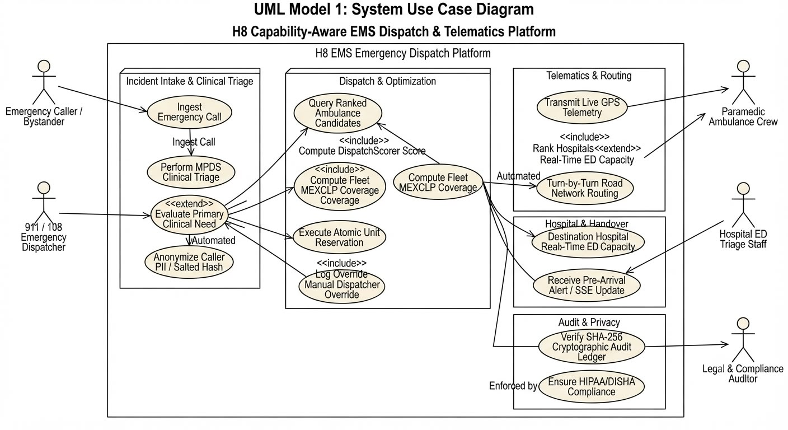

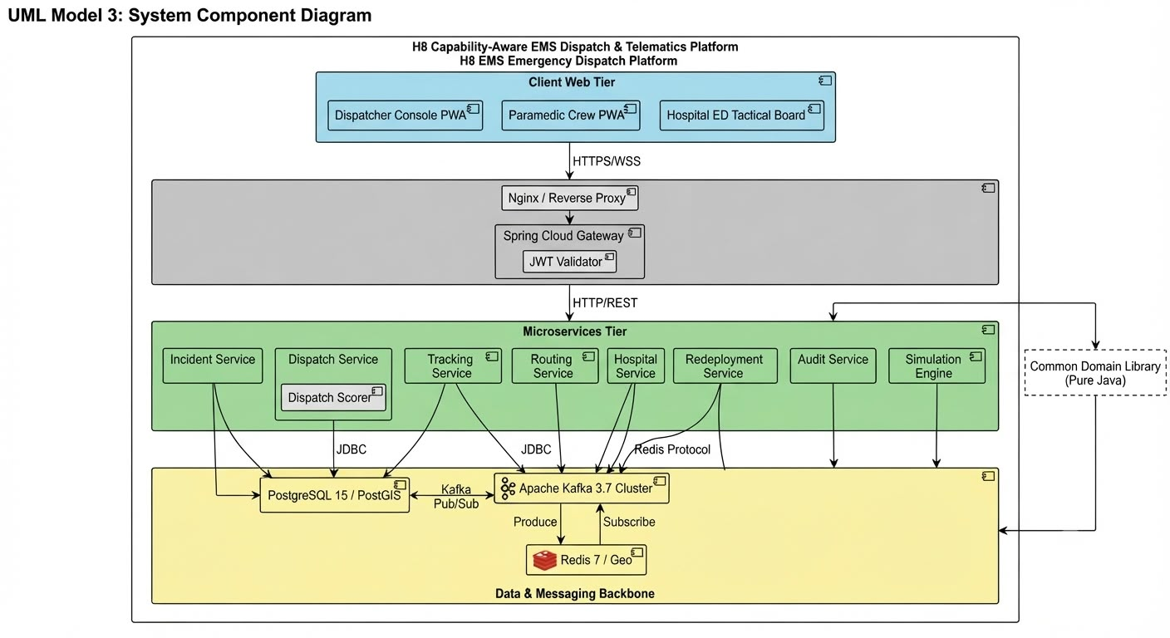
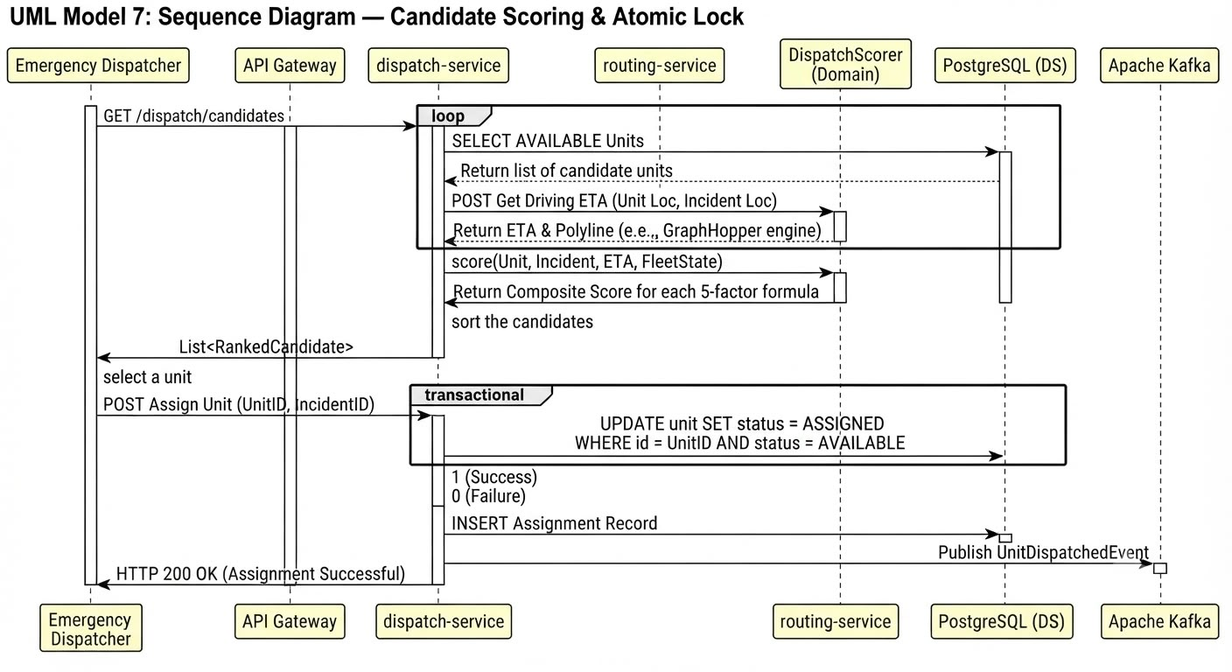

7.Other Requirement

7.1 Compliance with Standards
The system must adhere to internationally recognized software engineering and requirements standards, specifically IEEE Std 830-1998 and ISO/IEC/IEEE 29148:2018. These standards ensure that the SRS is structured, complete, and consistent, providing a formal baseline for design, implementation, and verification. Compliance guarantees that the project aligns with best practices in requirements engineering and can be evaluated against established benchmarks.

7.2 Legal and Regulatory Constraints
Since the platform handles sensitive medical and patient data, strict compliance with healthcare privacy laws is mandatory. In the U.S. context, this includes the HIPAA Security Rule (45 CFR Part 160 and 164), while in India, compliance with the DISHA Act is required. Both frameworks mandate secure handling of personally identifiable information (PII), encryption of sensitive data, and strict access controls. Additionally, operational benchmarks must align with NFPA 1710/1720 standards, which define EMS response times, staffing, and deployment efficiency. These constraints ensure the system is legally defensible, clinically safe, and operationally effective.

7.3 Future Enhancements
The system is designed with scalability and extensibility in mind. Potential future enhancements include:
- AI-driven predictive analytics for demand forecasting and proactive fleet positioning.
- Integration with wearable health devices for real-time patient telemetry during transport.
- Expansion to rural and semi-urban regions, adapting algorithms for low-density coverage.
- Multilingual dispatcher and paramedic interfaces to support diverse populations.
- Cloud-native deployment models for cross-city scalability and disaster recovery.

