**Assignment**

1. **Order quantity by Province:**

**a.Insight question**: Which province shows you maximum orders and what is the ‘exact’ number of orders for this province?

**Province**: Ontario

**Number of orders**: 27840

1. **Total Sales by Customer**

1. Insight question: Which customer had the maximum sales? Specify Name and exact sales amount?

**Customer name**: Grant Carroll

**Sales amount**: 82,990.33

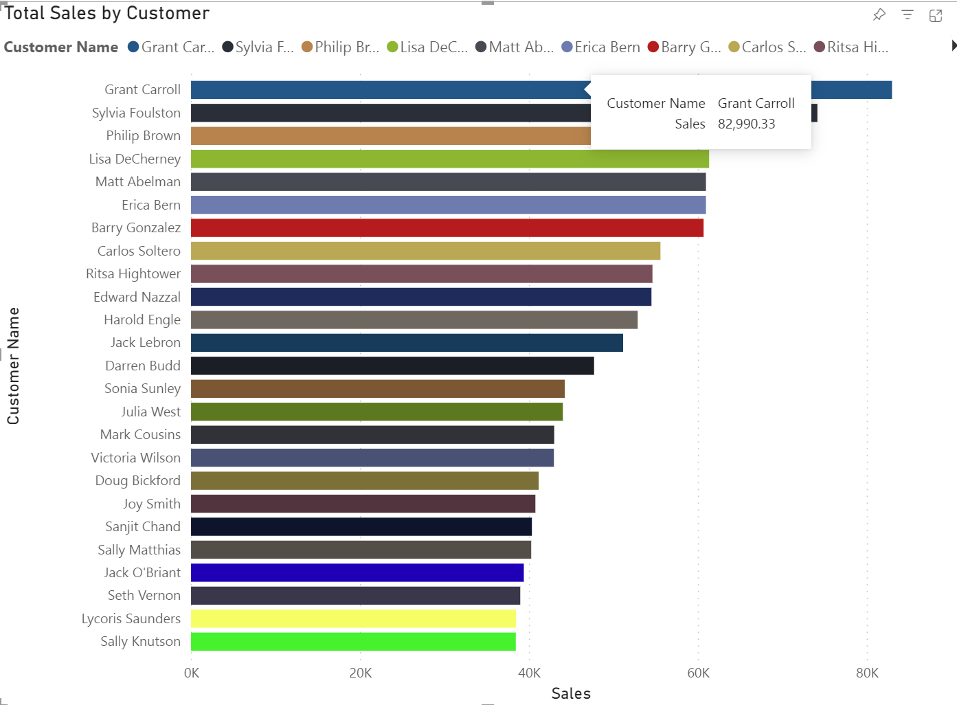

1. **Total Sales by Province using ‘Filled map’ (geographical representation)**

1. **Insight question**: Which province has the maximum sales and what is the exact amount of the sales?

**Province**: Ontario

**Total Sales**: 1,748,758.22

1. **Order Quantity Trend using ‘Area map’ (generally used for trends)**

1. **Insight question**: Which year had the maximum order quantity and what was the exact number of orders?

**Year**: 2010

**Maximum order quantity**: 21588

1. **Created a bar plot showing sales by product sub-category**

1. **Insight question**: Which product sub-category has the highest sales? Name the product sub-category and what is the exact number of sales.

**Product sub-category**: Chairs and Chairmats

**Total number of sales**: 838,111.07

1. **Created a pie chart showing number of sales by year**

1. **Insight question**: which year has the highest sales? What is the exact number of sales?

**Year**: 2010

**Total number of sales**: 1,493,694.13

* Report showing all the visualizations.

* Created Dashboard for visualizations.

Dashboard Showing all the visualizations.

**Questions about the data**:

Q1. Which Province has the lowest sales?

Q2. Which product sub-category has the lowest sales?

Q3. Give the total customer count

Q4. How many sales that the bookcases has?

Q5. Which year has lowest sales?

