PROJECT SUBMISSION FORMAT

1. STUDENT DETAILS
Student Name:- Manish Balgovind Rajak
Course/Program: B.Tech EE (VLSI Design and Technology)
Semester/Year: 5th Semester, 3rd Year
Domain: Electronics
Email ID: manish.rajak2406@gmail.com
2. PROJECT DETAILS
Problem Statement No.: ELEC_5S_2
Project Title: PCA9555 Design and Simulation
3. WORK DONE
A) PCA9555 Overview
The PCA9555 is a 16-bit I²C-based General Purpose Input/Output (GPIO) expander that increases the number of available input and output pins for a microcontroller. It communicates through the I²C protocol and provides two 8-bit I/O ports. The device supports programmable inputs, outputs, polarity inversion, and interrupt generation, making it suitable for embedded and digital hardware applications.
B) Architecture
The PCA9555 design is organized into multiple Verilog modules that work together to implement GPIO expansion functionality.
The architecture consists of:
- Top-level integration module (PCA9555)
- I²C slave interface
- Register file
- I/O port controller
- Interrupt generation logic
The I²C slave receives commands from the master device and updates internal registers. The register file stores configuration and data values, while the I/O controller manages external GPIO pins. Interrupt logic monitors input changes and generates interrupt signals whenever required.
C) Module Descriptions
pca9555.v
Acts as the top-level module and connects all internal blocks of the design. It coordinates communication between the I²C interface, registers, and GPIO ports.
i2c_slave.v
Implements the I²C slave communication protocol. This module detects START and STOP conditions, receives addresses and data, and handles read/write operations.
reg_file.v
Stores internal control and configuration registers. It maintains GPIO data, polarity settings, and configuration information.
io_ports.v
Controls the input and output ports of the PCA9555. It provides the interface between internal registers and external GPIO pins.
int_logic.v
Monitors GPIO input changes and generates interrupt signals whenever a change is detected according to the configured settings.
tb_pca9555.v
Serves as the testbench for functional verification. It applies test vectors, generates I²C transactions, and validates device behavior during simulation.
D) Verification Summary
Functional verification of the PCA9555 design was performed using ModelSim.
The following verification activities were completed:
- Compilation of RTL design files
- Compilation of testbench files
- Simulation of I²C communication
- Verification of START condition detection
- Verification of STOP condition detection
- Analysis of state machine transitions
- Verification of interrupt generation behavior
- Waveform analysis of internal and external signals
- Validation of testbench execution results
Simulation waveforms were observed and analyzed to confirm proper operation of the design.
E) Results
The simulation was executed successfully using ModelSim.
Verification Results
- Total Test Cases Executed: 71
- Errors Detected: 0
- Simulation Status: PASSED
Key observations:
- START conditions were detected correctly.
- STOP conditions were detected correctly.
- State machine transitions occurred as expected.
- Interrupt signals were generated properly.
- I²C communication was successfully verified.
- All test cases completed without functional failures.

F) Learnings
Through this project, the following concepts were learned and reinforced:
- Fundamentals of the I²C communication protocol
- Verilog HDL module organization
- RTL design structure and hierarchy
- ModelSim compilation and simulation flow
- Testbench-based verification methodology
- State machine analysis using waveforms
- Interrupt generation mechanisms
- Digital system debugging and waveform inspection
- GitHub repository management and project documentation

4. OUTPUT / SCREENSHOTS
Screenshot 1:- Full Simulation Overview
Description:- Complete waveform showing PCA9555 communication and simulation activity.
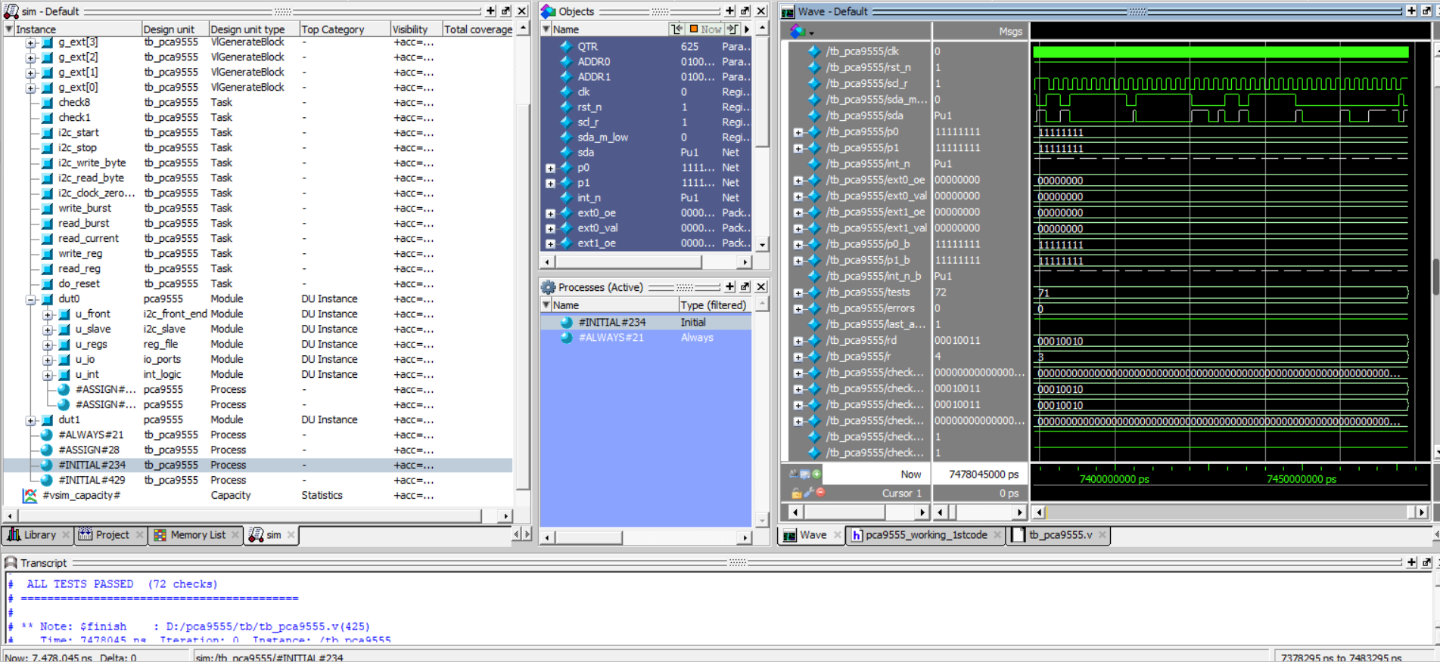
Screenshot 2:- State Machine Analysis
Description:- Analysis of state transitions during I²C transactions.

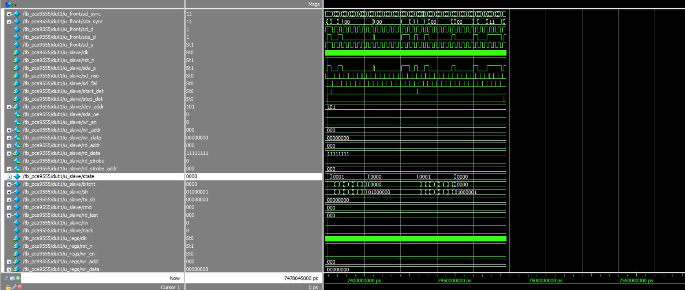

Screenshot 3: Interrupt Verification
Description: Verification of interrupt generation upon GPIO input change.
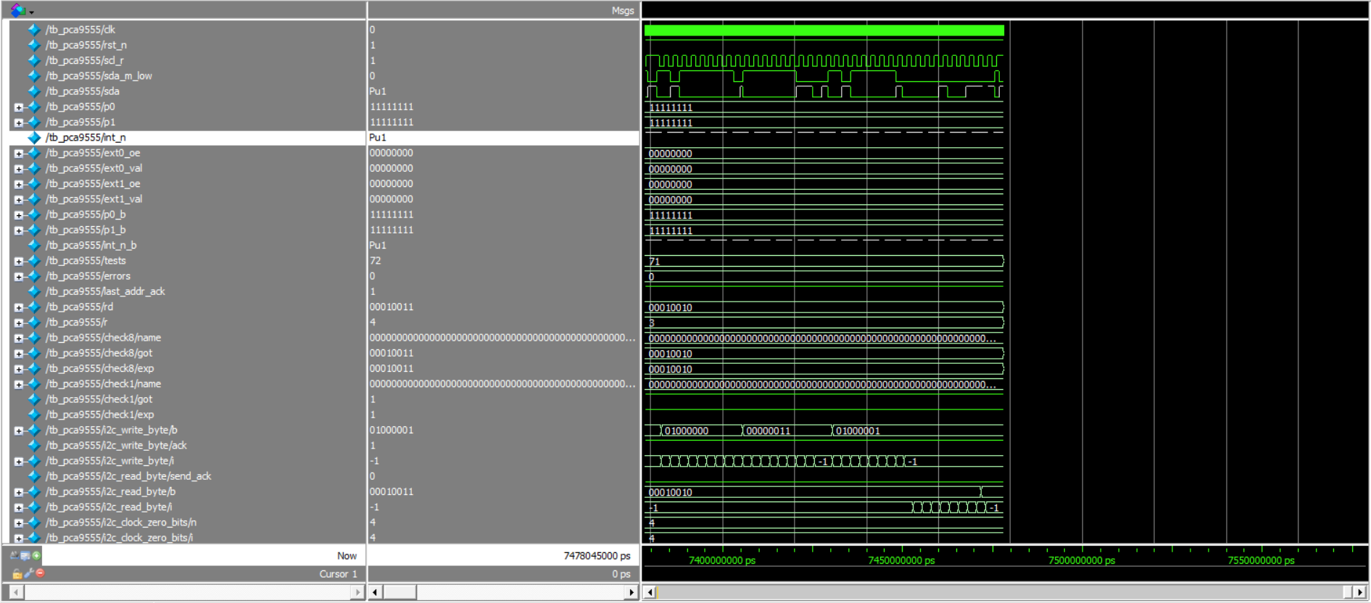
Screenshot 4: Functional Verification Results
Description: Successful execution of all test cases without errors.
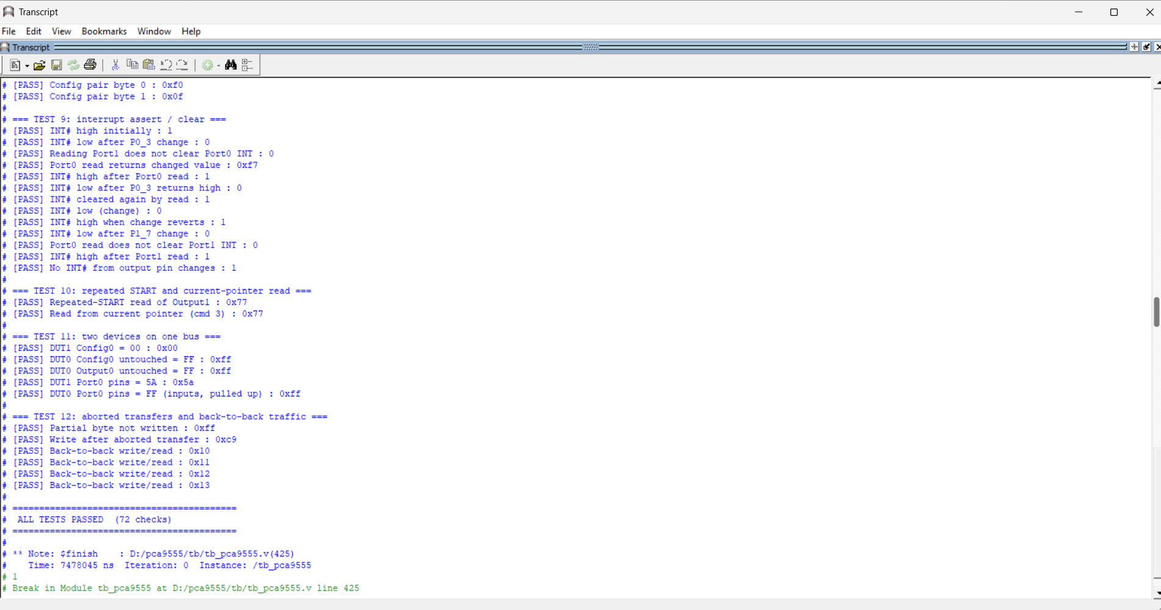
Additional File 1: GitHub Repository Link

Repository URL: https://github.com/manish-2424/PCA9555-IC-GPIO-Expander
Repository name: pca9555-design-simulation
Project Outcome:
The PCA9555 GPIO Expander design was successfully studied and verified using Verilog HDL and ModelSim. All verification tests passed successfully, confirming correct implementation of I²C communication, register operations, state machine functionality, and interrupt generation. This project provided valuable practical experience in digital design verification and simulation-based validation.

