Leave Management System
Design Requirements Document (DRD)

Document Version | 1.0
Date | April 2026
Document Type | Design Requirements Document
Project | Leave Management System
Team Size | 5 Members
Status | Draft

Internship Project · Confidential

1. Purpose & Scope

1.1 Purpose
This Design Requirements Document (DRD) defines the design goals, interface standards, component specifications, and visual design guidelines for the Leave Management System (LMS). It is intended to guide all 5 internship team members to build a cohesive, consistent, and user-friendly product.

1.2 Scope
This document covers UI/UX design principles, page-level layout requirements, component library standards, colour and typography guidelines, and role-specific interface requirements for the Employee, Manager, and HR Admin personas.

1.3 Design Goals
# | Goal | Description
G-1 | Simplicity | Minimise clicks needed to complete any primary action to 3 or fewer.
G-2 | Consistency | All pages share the same navigation, colour palette, and component library.
G-3 | Responsiveness | Layouts adapt seamlessly to desktop (1280px+), tablet (768px), and mobile (375px).
G-4 | Accessibility | Comply with WCAG 2.1 AA guidelines — colour contrast, keyboard nav, screen-reader support.
G-5 | Feedback | Every user action shall produce visible feedback within 300 ms.

2. Design Tokens

2.1 Colour Palette
All colours are defined as design tokens. Components shall only use these defined values — hard-coded hex values in component code are not permitted.

Token Name | Hex Value | Swatch | Usage
color-primary | #2E75B6 |  | Primary buttons, active nav, links
color-primary-dark | #1E3A5F |  | Headings, icon fills, borders
color-primary-light | #BDD7EE |  | Table header rows, hover states, chips
color-success | #70AD47 |  | Approved status, success toasts
color-warning | #ED7D31 |  | Pending status, warning banners
color-danger | #C00000 |  | Rejected status, error messages
color-neutral-50 | #F9FAFB |  | Page background
color-neutral-200 | #E5E7EB |  | Dividers, input borders
color-text-primary | #111827 |  | Body text, labels
color-text-secondary | #6B7280 |  | Placeholder, helper text, meta

2.2 Typography Scale
Token | Font Size | Font Weight | Usage
text-display | 30px | 700 Bold | Page hero titles
text-heading-1 | 24px | 700 Bold | Section headings
text-heading-2 | 18px | 600 SemiBold | Card titles, sub-headings
text-body-lg | 16px | 400 Regular | Primary body copy
text-body | 14px | 400 Regular | Labels, table cells
text-sm | 12px | 400 Regular | Helper text, captions

Primary font: Inter (Google Fonts). Fallback: system-ui, sans-serif. Monospace (for code/IDs): JetBrains Mono.

2.3 Spacing & Grid
- Base unit: 4px. All spacing values shall be multiples of 4 (4, 8, 12, 16, 24, 32, 48, 64).
- Page layout: 12-column grid with 24px gutters and 64px horizontal page padding on desktop.
- Content max-width: 1280px; centred on larger screens.
- Border radius: sm = 4px | md = 8px | lg = 12px | pill = 9999px.
- Card shadow: 0 1px 3px rgba(0,0,0,0.10), 0 1px 2px rgba(0,0,0,0.06).

3. Component Library

3.1 Buttons
Variant | When to Use | Specification
Primary | Main CTA | bg: color-primary | text: white | hover: darken 10%
Secondary | Secondary action | bg: white | border: 1px color-primary | text: color-primary
Danger | Destructive | bg: color-danger | text: white | use with confirmation dialog
Ghost | Low emphasis | bg: transparent | text: color-primary | hover: bg: color-primary-light
Disabled | Inactive state | opacity: 0.5 | cursor: not-allowed | no hover effect

All buttons shall have a minimum click target of 44x44px (WCAG 2.5.5). Loading state shall replace button text with a spinner and disable further clicks.

3.2 Form Inputs
- Text Input: height 40px, border 1px color-neutral-200, border-radius 8px, focus ring 2px color-primary.
- Date Picker: native browser datepicker enhanced with a custom calendar popup. Blocked dates (weekends, holidays) shown in grey.
- Select / Dropdown: custom styled, keyboard accessible, supports search for lists > 8 items.
- Textarea: auto-resize up to 4 rows; max-height 200px with scroll.
- All inputs shall display an inline error message below the field on validation failure.
- Required fields shall be marked with a red asterisk (*).

3.3 Status Badges
Status | Badge Colour | Used In
Pending | Orange (ED7D31) | Leave request list, manager queue
Approved | Green (70AD47) | Leave history, team calendar
Rejected | Red (C00000) | Leave history, notification list
Cancelled | Grey (6B7280) | Leave history

3.4 Navigation
- Global sidebar navigation on desktop (collapsed to icon-only at < 1024px).
- Bottom tab bar on mobile (max 5 items).
- Active nav item: bold text, color-primary left border 3px.
- Breadcrumb trail on all sub-pages (e.g., Dashboard > Leave Requests > New Request).
- Notification bell icon with unread badge count in the top-right header.

3.5 Cards & Tables
- Data cards: white background, 16px padding, md border-radius, subtle drop shadow.
- Data tables: sticky header, zebra striping (white / color-neutral-50), hover highlight.
- Tables shall be sortable by clicking column headers.
- Tables with more than 10 rows shall include pagination (10 / 25 / 50 per page).
- Empty state: centred illustration + short message + primary CTA button.

4. Page-Level Design Requirements

4.1 Login Page
- Centred card layout, max-width 420px.
- Company logo at the top of the card.
- Email and password fields with show/hide password toggle.
- "Forgot Password?" link below the password field.
- Primary "Sign In" button — full width inside card.
- Clear error message on invalid credentials (no detail about which field is wrong — security best practice).

4.2 Employee Dashboard
- Welcome message with employee name and current date.
- Leave balance summary cards (one per leave type): total, used, remaining.
- Quick action button: "Apply for Leave" — prominently displayed.
- Recent leave requests table: last 5 requests with status badges.
- Upcoming approved leaves mini-calendar widget.
- Notifications panel showing latest 3 unread notifications.

4.3 Leave Application Form
- Step 1 — Select Leave Type (radio buttons with description of each type).
- Step 2 — Choose Dates (date range picker; working days automatically calculated).
- Step 3 — Provide Reason (text area; minimum 10 characters required).
- Step 4 — Review & Submit (summary card + confirmation checkbox).
- Progress stepper shown at the top of the form.
- Live balance preview: "After this leave, your remaining balance will be: X days."

4.4 Manager Dashboard
- Pending Approvals section at the top — card list with employee name, leave type, dates, days count.
- Quick Approve / Reject buttons on each card; clicking opens a modal with optional comment field.
- Team Leave Calendar below — monthly view with colour-coded leave blocks per employee.
- Filter by: employee name, leave type, date range.
- Conflict warning banner when 3+ team members are on leave simultaneously.

4.5 HR Admin Panel
- User Management: table of all users with role, department, status; actions: Edit, Deactivate.
- Leave Policy Management: CRUD interface for leave types and rules.
- Holiday Calendar: upload or manually add public holidays per year.
- Reports Tab: date-range selector, filter by department/type, Export PDF/CSV buttons.
- System Activity Log: paginated table of all admin actions with timestamp and actor.

5. Interaction Design Requirements

5.1 Notifications & Feedback
- Toast notifications: slide in from top-right, auto-dismiss after 5 seconds.
- Success toast: green background (color-success).
- Error toast: red background (color-danger).
- Loading states: skeleton loaders for tables and cards (not spinners — avoid layout shift).
- Confirm dialogs required for: Delete, Reject, Cancel Leave actions.

5.2 Responsive Breakpoints
Breakpoint | Width Range | Layout Behaviour
Mobile | < 640px | Single-column, bottom nav bar, stacked cards
Tablet | 640px – 1023px | Two-column cards, collapsible sidebar
Desktop | 1024px – 1279px | Expanded sidebar, three-column card grids
Wide | >= 1280px | Max-width 1280px, centred, expanded data tables

5.3 Accessibility Requirements
- Minimum colour contrast ratio: 4.5:1 for normal text, 3:1 for large text (WCAG AA).
- All interactive elements reachable via keyboard (Tab, Enter, Space, Arrow keys).
- All form inputs have associated <label> elements or aria-label attributes.
- Focus indicators shall always be visible — never suppressed with outline: none without a custom replacement.
- ARIA live regions used for dynamic content updates (new notifications, form errors).
- Images and icons include descriptive alt text or aria-hidden if decorative.

6. Team Responsibilities & Work Allocation
The following table outlines a suggested split of responsibilities across the 5-member internship team. Responsibilities may be adjusted based on individual strengths.

Member | Role | Responsibilities
Member 1 | Frontend Lead | Design system setup, Employee Portal, component library
Member 2 | Frontend | Manager Dashboard, HR Admin Panel, responsive layouts
Member 3 | Backend Lead | REST API architecture, Auth service, Leave service
Member 4 | Backend | Notification service, Reports service, database schema
Member 5 | QA & DevOps | Testing strategy, CI/CD pipeline, deployment, documentation

6.1 Shared Standards
- Version control: Git with feature-branch workflow (main → develop → feature/xxx).
- Pull requests require at least 1 peer review before merging to develop.
- All components documented with usage examples in the component storybook.
- Weekly sync meeting to review progress, resolve blockers, and update task board.

7. Architecture & Data Diagrams

7.1 System Architecture
The system follows a three-tier architecture separating the presentation, business logic, and data layers, enabling independent scaling of each tier.

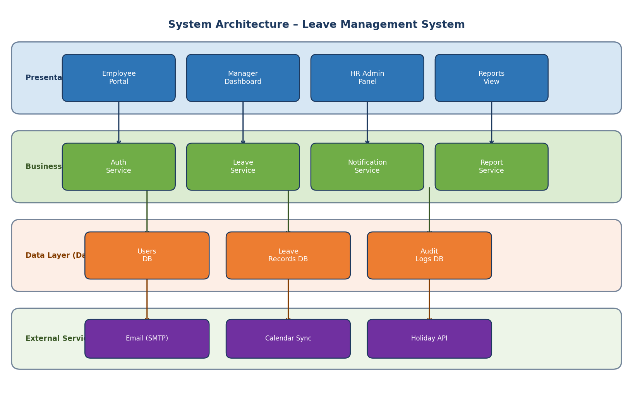
Figure 1 — System Architecture Diagram

7.2 Leave Application Flow
The flowchart below illustrates the complete leave request lifecycle from application through notification, showing all decision points and system actions.

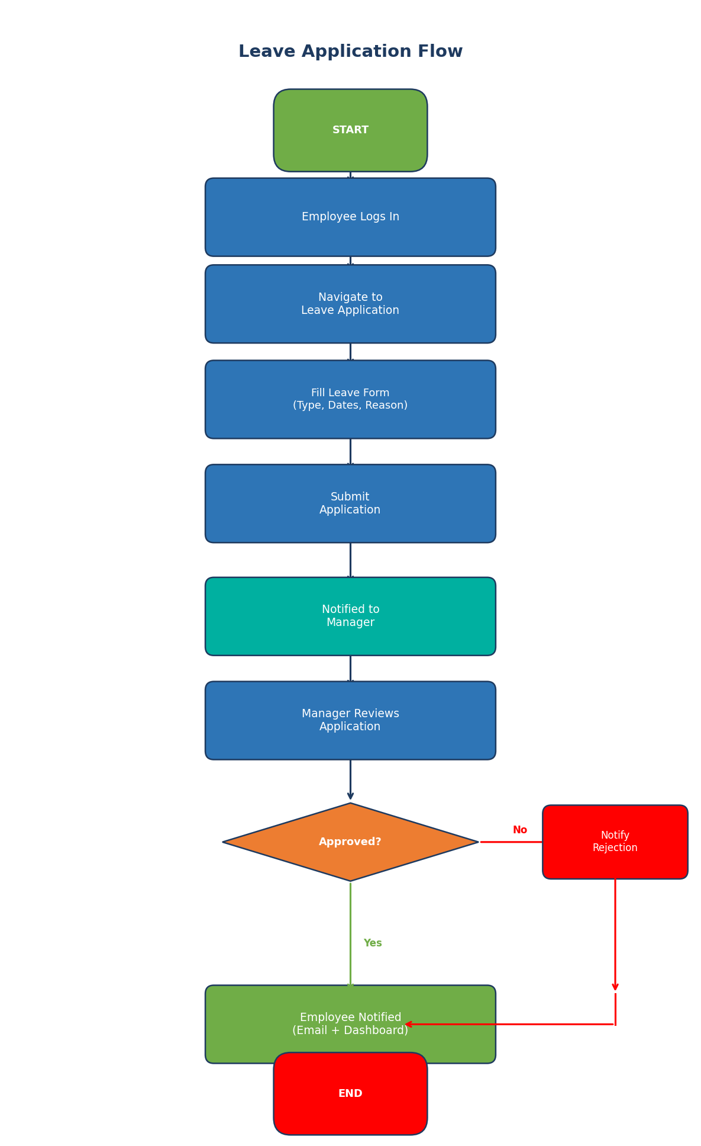
Figure 2 — Leave Application Workflow

7.3 Entity Relationship Diagram
The data model centres on the LEAVE_REQUEST entity. Each request links to a user, a leave type, and generates approval log and balance update records.

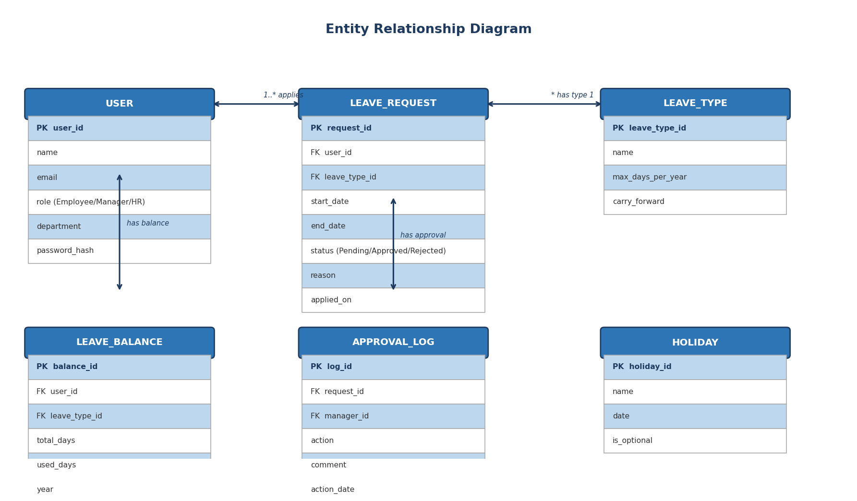
Figure 3 — Entity Relationship Diagram

8. Revision History
Version | Date | Description | Author
1.0 | Apr 2026 | Initial release — all sections | Internship Team

