

Department of Computer Applications

COURSE DESIGN, DELIVERY AND ASSESMENT
Semester: III
Course Code: MCA32
Course Name: Design and Analysis of Algorithms
Course Faculty: Dr. S. AJITHA

Sl# | Section | Course Faculty Name | Signature | Date
1 | - | Dr. S.AJITHA |  | 27-08-2018

Course Coordinator | Signature | Date
Dr. S. AJITHA |  | 27-08-2018

Program Coordinator | Signature | Date
Dr. D. Evangelin Geetha |  | 27-08-2018

Head of Department (Sign & Date)

COURSE DESIGN, DELIVERY AND ASSESMENT
Course code and Title : MCA32  Design and Analysis of Algorithms | Course Credits :3:0:1
CIE : 50 Marks | SEE : 100 Marks
Total No of Theory / Toutoral / Lab Hours: 44 Theory and 28 Lab hours
Prepared by : Dr.S.Ajitha | Date : 27-08-2018
Reviewd by : Dr.Madhu Bhan | Date : 29-08-2018

Prerequisites
Prerequisite Courses with codes
Data Structures using C(MCA24)

Course Outcomes:

Students will be able to

CO1. Describe the fundamentals of algorithms and compute the efficiency of algorithms in terms of asymptotic notations
CO2. Demonstrate the brute force and divide and conquer approaches for designing algorithm and determining their order of growth.
CO3. Demonstrate the decrease and conquer and transform and conquer approach for designing and determining the order of growth of algorithms.
CO4. Demonstrate the algorithm design technique dynamic programming and determine the time and space tradeoffs for algorithm.
CO5. Demonstrate the greedy technique and back tracking approach for algorithm design and determining their order of growth.

Course Contents:
UNIT I
Introduction: Notion of Algorithm, Fundamentals of Algorithmic Problem Solving, Important Problem Types, Basics of data Structures
Fundamentals of the Analysis of Algorithm Efficiency: Analysis Framework, Asymptotic Notations and Basic efficiency classes, Mathematical analysis of Recursive and Non recursive algorithms, Examples

UNIT II
Brute Force: Selection Sort, String Matching, Exhaustive Search
Divide-and-Conquer: Merge sort, Quick sort, Binary Search, Multiplication of large integers
Principles of Parallel Algorithm Design: Preliminaries-Decomposition, tasks, and Dependency graphs, Granularity, Concurrency and Task-Interaction, Decomposition Techniques

UNIT III
Decrease-and-Conquer: Insertion Sort, Depth First and Breadth First Search, Topological sorting, Algorithms for Generating Combinatorial Objects
Transform-and-Conquer: Presorting, Heaps and Heap Sort
UNIT IV
Space and Time Tradeoffs: Sorting by Counting, Input Enhancement in String Matching, Hashing
Dynamic Programming: Warshall’s and Floyd’s Algorithms
Greedy Technique: Kruskal’s Algorithm, Dijkstra’s Algorithm, Huffman Trees

UNIT V
Backtracking:n-queens problem, Hamiltonian Circuit Problem, Subset-Sum Problem, General Remarks
Branch-and-Bound: Knapsack problem, Traveling Salesman Problem
P, NP-Completeness and Approximation Algorithms: Introduction, P and NP Problems, NP-complete problems, Approximation algorithms for the travelling salesman problem, Approximation algorithms for Knapsack problem

Laboratory
Programs that supplement the theory concepts are to be implemented.

Text Books:
- Anany Levitin: Introduction to the Design and Analysis of Algorithms, 2nd Edition, Pearson Education, 2009.
Chapters 1.1-1.4, 2.1-2.4, 3.1, 3.2, 3.4, 4.1-4.3, 4.5, 5.1-5.4, 6.1, 6.4, 7.1-7.4, 8.2, 9.2 to 9.4, 11.3, 12.1-12.3
- Ananth Grama, Anshul Gupta, George Karypis, Vipin Kumar: Introduction to Parallel Computing, 2nd Edition, Pearson Education, 2003.
Chapters 3.1.1, 3.1.2, 3.2

References:
- Horowitz E., Sahani S., Rajasekharan S.: Fundamentals of Computer Algorithms, 2nd Edition, Universities Press, 2007.
- Thomas H. Cormen, Charles E. Leiserson, Ronal L. Rivest, Clifford Stein: Introduction to Algorithms, 3rd Edition, PHI, 2010.
- Study Materials.

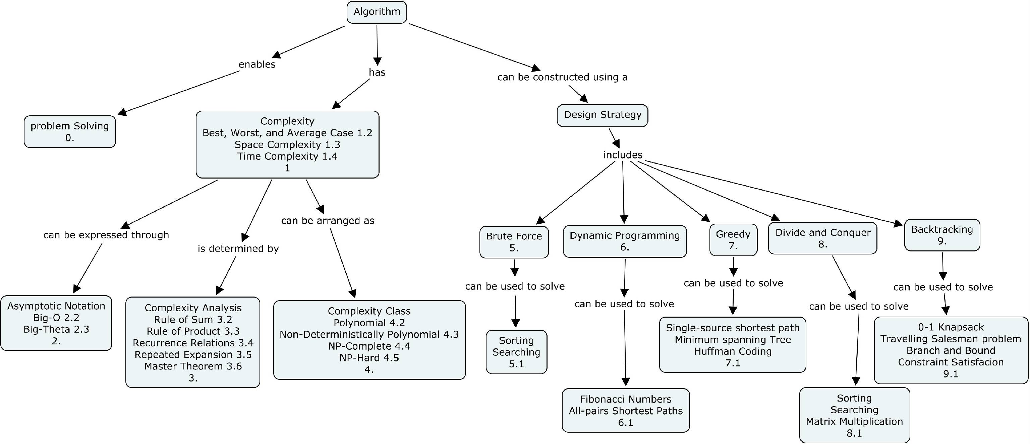
Concept map

Course Contents and Lecture Schedule
Lesson No -Session No | Topics | No. of hrs
1. | Notion of Algorithm, Fundamentals of Algorithmic Problem Solving | 55mts
2. | Important Problem Types | 55mts
3. | Fundamental data Structures | 55mts
4. | Fundamental data Structures – contd. | 55mts
5. | Fundamentals of the Analysis of Algorithm Efficiency , Analysis Framework | 55mts
6. | Asymptotic Notations | 55mts
7. | Basic efficiency classes | 55mts
8. | Mathematical analysis of Non-recursive algorithms, Examples | 55mts
9. | Mathematical analysis of Recursive algorithms | 55mts
10. | Brute Force - Selection Sort | 55mts
11. | String Matching | 55mts
12. | Exhaustive Search | 55mts
13. | Divide-and-Conquer – Merge sort | 55mts
14. | Quick sort | 55mts
15. | Binary Search tasks | 55mts
16. | Multiplication of large integers | 55mts
17. | Principles of Parallel Algorithm Design: Preliminaries-Decomposition | 55mts
18. | Dependency graphs | 55mts
19. | Granularity, Concurrency and Task-Interaction, | 55mts
20. | Decomposition Techniques | 55mts
21. | Decrease-and-Conquer - Insertion Sort | 55mts
22. | Depth First and Breadth First Search | 55mts
23. | Topological sorting | 55mts
24. | Algorithms for Generating Combinatorial Objects | 55mts
25. | Transform-and-Conquer - Presorting | 55mts
26. | Heaps and Heap sort | 55mts
27. | Space and Time Tradeoffs - Sorting by Counting | 55mts
28. | Input Enhancement in String Matching | 55mts
29. | Hashing | 55mts
30. | Dynamic Programming - Warshall’s Algorithms | 55mts
31. | Floyd’s Algorithms | 55mts
32. | Greedy Technique - Kruskal’s Algorithm | 55mts
33. | Dijkstra’s Algorithm | 55mts
34. | Huffman Trees | 55mts
35. | Backtracking - n-queens problem | 55mts
36. | Hamiltonian Circuit Problem ,Subset-Sum Problem, General Remarks | 55mts
37. | Branch-and-Bound- Knapsack problem | 55mts
38. | Traveling salesman problem | 55mts
39. | Introduction, P and NP Problems, NP-complete problems | 55mts
40. | Approximation algorithms for the traveling salesman problem | 55mts
41. | Approximation algorithms for the, Knapsack problem | 55mts
42. | Revision | 55mts
Laboratory

1. | Design and implement a program in C/C++ to find GCD of two integers using three different procedures. | 110mts
2. | Develop a program to find the number of binary digits in the binary representation of a positive decimal integer using non-recursive and recursive methods. | 110mts
3. | Implement Linear search algorithms and determine the time required to search an element. Repeat the experiment for different values of n and plot a graph of the time taken versus n. Design an algorithm which will improve the complexity of Linear search algorithm. Justify the improvement. | 110mts
4. | Sort a given set of elements using Bubble sort and determine the time required to sort elements. Repeat the experiment for different values of n and plot a graph of the time taken versus n. | 110mts
5. | Sort a given set of elements using Selection sort and determine the time required to sort elements. Repeat the experiment for different values of n and plot a graph of the time taken versus n. | 110mts
6. | Develop a program to find the maximum element in a list of elements and determine its time requirement. Prove that its time complexity is ѳ(n) | 110mts
7. | Sort a given set of elements using Merge sort method and determine the time required to sort the elements. Repeat the experiment for different values of n and plot a graph of the time taken versus n. | 110mts
8. | Sort a given set of elements using Quick sort method and determine the time required sort the elements. Repeat the experiment for different values of n and plot a graph of the time taken versus n. | 110mts
9. | Construct a heap of elements and implement an algorithm to sort the elements using heap sort and determine the time required to sort the elements. | 110mts
10. | Sort a given set of elements using insertion sort method and determine the time required to sort the elements. Repeat the experiment for different values of n and plot a graph of the time taken versus n. | 110mts
11. | Implement All Pair Shortest paths problem using Floyd's algorithm. | 110mts
12. | From a given vertex in a weighted connected graph, find shortest paths to other vertices using Dijkstra's algorithm | 110mts
13. | Compute the transitive closure of a given directed graph using Warshall’s algorithm. | 110mts
14. | Find Minimum Cost Spanning Tree of a given undirected graph using Kruskal’s algorithm | 110mts

Mapping Course Outcomes with Program Outcomes:

Course Outcomes  /  Program Outcomes | PO1 | PO2 | PO3 | PO4 | PO5 | PO6 | PO7 | PO8 | PO9 | PO10 | PO11 | PO12
CO1 | M | M
CO2 |  | L
CO3 | L | M | L
CO4 |  | L | L
CO5 |  | M | L

Course Assessment and Evaluation:
 | What |  | To whom | When/ Where (Frequency in the course) | Max marks | Evidence collected | Contributing to Course Outcomes
Direct Assessment Methods | CIE | Theory  Internal assessment | Students | Thrice (Average of the best two will be computed) | 30 | Blue books | CO1, CO2, CO3, CO4, CO5
Direct Assessment Methods | CIE | Assignment | Students | Twice | 10 | Report | CO1,CO5
Direct Assessment Methods | CIE | Laboratory test | Students | Twice(Average of two will be computed) | 10 | Blue books /Scores | CO1,CO2, CO3, CO4, CO5
Direct Assessment Methods | SEE | Standard  examination | Students | Once  End of course  (Answering ONE question out of TWO From each UNIT ) | 100 | Answer Scripts | CO1, CO2, CO3, CO4, CO5
Indirect Assessment | Students feedback |  |  | Middle of the course | - | Feedback Results | CO1, CO2, CO3,
Indirect Assessment | Course End Survey |  |  | End of the course |  | Question-naire | CO1, CO2, CO3, CO4, CO5

Questions for CIE and SEE will be designed to evaluate the various educational components (Bloom’s taxonomy) such as:
CIE and SEE evaluation
Sl. No. | Levels of Bloom’s Taxonomy | IA Test1 | IA Test2 | IA Test3 | Team / Class Assignment | Lab  Test I | Lab  Test II | SEE  %
1 | Remember | 20 | 10 | 10 | 20 | 0 | 0 | 10
2 | Understand | 30 | 25 | 20 | 15 | 30 | 0 | 30
3 | Apply | 20 | 25 | 30 | 25 | 20 | 40 | 30
4 | Analyze | 20 | 20 | 20 | 20 | 50 | 40 | 20
5 | Evaluate | 10 | 10 | 10 | 10 | 0 | 10 | 10
6 | Create | 0 | 10 | 10 | 10 | 0 | 10 | 0

 | Name | Signature with Date
Prepared by | Dr.S.Ajitha
Reviewed by | Dr.Madhu Bhan

COURSE ASSESSMENT
Course Code | MCA32 | Programme
Course Name | Design and Analysis ofAlgorithms | Semester | III
Credits | 3:0:1

