B.Sc. Computer Science
────────────────────────────────────────────────────────────
Study Project — Phase 2
Design & Proof of Concept
────────────────────────────────────────────────────────────
Talk to Jesus
A Spiritual Companion Mobile Application

Student Name: | Manish Rachakonda
Student ID: | 2023EBCS668
Project Advisor: | Swapnil Saurav
Course: | B.Sc. Computer Science
Date of Submission: | February 17, 2026

Table of Contents
1. Introduction
2. System Overview
3. Functional Requirements
4. Non-Functional Requirements
5. System Architecture and Design
6. Technology Stack and Justification
7. Proof of Concept (PoC)
8. Testing and Validation Strategy
9. Risks, Challenges, and Mitigation
10. Phase 2 Outcomes and Readiness for Phase 3
11. Supervisor Review and Approval

1. Introduction

Purpose
This document presents the Phase 2 deliverables for the "Talk to Jesus" study project. Phase 1 established the problem definition, motivation, high-level objectives, and feasibility analysis. This phase translates those findings into a concrete system design, defines detailed functional and non-functional requirements, selects and justifies the technology stack, and demonstrates feasibility through a working Proof of Concept (PoC).

Scope of Phase 2
- Complete system architecture with module-level design.
- Detailed functional and non-functional requirements specification.
- Database schema design with entity relationships.
- Data flow design for the core conversation pipeline.
- Technology stack selection with justification for each choice.
- Working Proof of Concept demonstrating core feasibility.
- Testing and validation strategy for Phase 3 implementation.

Recap of Phase 1 Outcomes
Phase 1 identified the core problem: existing spiritual apps offer only static content and lack interactive, AI-powered, multilingual guidance. The project proposes building "Talk to Jesus" — a cross-platform mobile app with voice-based AI conversations, bilingual support (English & Telugu), spiritual music, Bible reading, and subscription-based access. The feasibility analysis confirmed that all required technologies are mature, well-documented, and available within free/test tiers for development. The backend is planned for deployment on Google Cloud Run for auto-scaling.

2. System Overview

Product Perspective
Talk to Jesus is a standalone mobile application with a dedicated backend API server. The system follows a client-server model where the Flutter-based mobile app communicates with a Node.js backend hosted on Google Cloud Run. The backend orchestrates interactions with multiple external services (AI, speech, payments) and a cloud-hosted PostgreSQL database. The system is designed for independent deployment and scaling — the mobile app is distributed as APK/IPA, while the backend auto-scales as a serverless container on Google Cloud Run.

Major System Functions
Function | Description | Key Components
Authentication | Google OAuth 2.0 login with JWT session management | Firebase Auth, Google Sign-In, Backend JWT middleware
AI Conversation | Voice-to-voice spiritual dialogue with a Jesus persona | OpenAI Whisper (STT), GPT-4o (AI), ElevenLabs (TTS)
Multi-Language | Bilingual operation in English and Telugu | App-wide language state, language-specific system prompts
Music Library | Curated spiritual songs with streaming playback | Audio player, song search, pagination
Bible Reading | Scripture navigation with local caching | Book/chapter/verse browser, SQLite cache
Subscriptions | Freemium model with payment integration | Razorpay gateway, webhook lifecycle, free tier (3 conversations)
Observability | Error tracking and product analytics | Sentry crash reporting, PostHog event analytics

User Classes
End Users (Believers): Primary users who interact with the AI companion, listen to music, read the Bible, and manage subscriptions. They access the system exclusively through the mobile app.
Free-Tier Users: Users who have not subscribed. They receive 3 free AI conversations and full access to music and Bible features. After 3 conversations, they are prompted to subscribe.
Premium Subscribers: Users with an active Razorpay subscription. They have unlimited AI conversations and all app features.
Tester Accounts: Development/QA accounts with hardcoded tokens for testing without real authentication.
External Systems/APIs: Third-party services that the backend communicates with: OpenAI (GPT-4o, Whisper), ElevenLabs (TTS), Razorpay (payments), Supabase (database), Firebase (auth).

3. Functional Requirements
The following detailed functional requirements define what the system must do. These expand on the high-level requirements identified in Phase 1.

Authentication & User Management
FR1: The system shall allow users to sign in using Google OAuth 2.0, supporting Web, iOS, and Android client IDs.
FR2: The system shall generate JWT tokens with configurable expiry for session management.
FR3: The system shall create a new user record on first login and update the last-login timestamp on subsequent logins.
FR4: The system shall provide an endpoint to retrieve the authenticated user's profile.

Conversation System
FR5: The system shall accept voice messages as multipart file uploads (supporting mp3, wav, webm, m4a, ogg formats; max 10MB) with a language parameter.
FR6: The system shall transcribe voice input using OpenAI Whisper with automatic language detection.
FR7: The system shall generate AI responses using OpenAI GPT-4o with a language-specific system prompt that includes culturally appropriate addressing (e.g., "My child" in English, "na bidda" in Telugu).
FR8: The system shall synthesize AI responses into speech using ElevenLabs Multilingual v2 with embedded emotional tags ([gentle], [warmly], [reverently]).
FR9: The system shall return the user's transcribed message, AI text response, and base64-encoded audio response in a single API response.
FR10: The system shall track per-user conversation count and enforce a free tier limit of 3 conversations.

Subscription & Payments
FR11: The system shall expose an endpoint returning available subscription plans filtered by environment (dev/prod).
FR12: The system shall create Razorpay subscriptions via a dedicated API endpoint.
FR13: The system shall verify subscription access by checking status (active/authenticated) and validating the last charged date with a grace period.
FR14: The system shall handle Razorpay webhook events (subscription.charged, .activated, .cancelled, .paused, .resumed, .halted, .completed, .pending) with HMAC SHA256 signature verification.
FR15: The system shall allow subscription cancellation at end of billing cycle.

Music & Bible
FR16: The system shall provide a songs endpoint with pagination and optional search functionality.
FR17: The mobile app shall provide an audio player with play/pause, progress seeking, and album art display.
FR18: The mobile app shall provide Bible reading with book/chapter/verse navigation, multiple translation support, and local caching.

Multi-Language Support
FR19: The mobile app shall support app-wide language switching between English and Telugu, updating all UI elements dynamically.
FR20: The conversation API shall accept a language parameter and use language-specific system prompts and emotional expressions.

4. Non-Functional Requirements

Performance
NFR1: The full conversation pipeline (transcription + AI generation + TTS synthesis) shall complete within 5 seconds under normal load.
NFR2: Music streaming shall begin playback within 2 seconds of user action.
NFR3: App launch to interactive state shall take under 3 seconds on mid-range devices.

Security
NFR4: All protected API endpoints shall require a valid JWT token in the Authorization header.
NFR5: Razorpay webhook payloads shall be verified using HMAC SHA256 with timing-safe comparison.
NFR6: API keys and secrets shall be managed via environment variables, never hardcoded in source code.
NFR7: The database shall enforce Row Level Security (RLS) policies on all tables.

Usability
NFR8: The UI shall follow Material Design 3 guidelines with animations for visual feedback.
NFR9: The app shall support accessibility features: high contrast mode, focus management, and text scaling (0.8x–1.4x).
NFR10: Language switching shall update all visible UI elements without requiring app restart.

Scalability
NFR11: The backend shall run on Google Cloud Run with auto-scaling from 0 to N instances based on traffic.
NFR12: The API shall be stateless, enabling horizontal scaling without shared in-memory state.
NFR13: The database schema shall support additional languages without structural changes.

Maintainability
NFR14: The frontend shall follow Clean Architecture with separated core, data, domain, and presentation layers.
NFR15: The backend shall follow MVC pattern with separated controllers, services, routes, and middlewares.
NFR16: TypeScript shall be used on the backend for compile-time type safety.
NFR17: Structured logging shall be implemented with configurable log levels per environment.

Observability
NFR18: Sentry shall capture runtime errors with environment-specific sample rates.
NFR19: PostHog shall track key product events: app open, navigation, conversation start, and subscription conversion.

5. System Architecture and Design

High-Level Architecture
The system follows a three-tier architecture with clear separation between the mobile client, backend API, and data/external services:
┌───────────────────────────────────────────────────────────────┐
│ PRESENTATION TIER │
│ Flutter Mobile App │
│ ┌──────────┐ ┌──────────┐ ┌────────┐ ┌───────────────┐ │
│ │ Jesus │ │ Music │ │ Bible │ │ Subscription │ │
│ │ Page │ │ Player │ │ Reader │ │ Management │ │
│ └──────────┘ └──────────┘ └────────┘ └───────────────┘ │
│ Riverpod State Management Layer │
│ API Client / Auth Service / Token Service │
└────────────────────────────┬────────────────────────────────┘
│ HTTPS (REST API)
┌────────────────────────────┴────────────────────────────────┐
│ APPLICATION TIER │
│ Google Cloud Run (Node.js / Express v5) │
│ ┌──────────┐ ┌──────────┐ ┌────────┐ ┌───────────────┐ │
│ │ Auth │ │ Conver- │ │ Songs │ │ Subscription │ │
│ │ Module │ │ sation │ │ Module │ │ + Payments │ │
│ └──────────┘ └──────────┘ └────────┘ └───────────────┘ │
│ JWT Middleware / Multer / Winston / Zod Validation │
└──────┬─────────┬──────────┬──────────┬─────────────────────┘
│ │ │ │
┌──────┴───┐ ┌───┴─────┐ ┌─┴──────┐ ┌┴────────────┐
│ Supabase │ │ OpenAI │ │ Eleven │ │ Razorpay │
│ Postgres │ │ GPT-4o │ │ Labs │ │ Payments │
│ │ │ Whisper │ │ TTS │ │ Webhooks │
└──────────┘ └─────────┘ └────────┘ └─────────────┘
DATA TIER

Backend Module Design
Authentication Module: Handles Google OAuth token verification (supporting Web, iOS, Android client IDs), user creation/retrieval in Supabase, JWT token generation, and last-login tracking. Endpoint: POST /api/auth/create-or-get-user.
Conversation Module: Orchestrates the full voice conversation pipeline: receives multipart audio upload, transcribes via OpenAI Whisper, generates response via GPT-4o with language-specific system prompt, synthesizes speech via ElevenLabs, and returns the combined response. Enforces free-tier limits via conversation count. Endpoint: POST /api/conversation/send-message.
Subscription Module: Manages subscription creation, status checking, and cancellation through Razorpay. Validates access based on subscription status and last-charged date with grace period. Endpoints: POST /create, GET /current, POST /cancel.
Plans Module: Retrieves available subscription plans filtered by environment (dev/prod flag). Endpoint: GET /api/plans.
Songs Module: Provides paginated song listings with optional search. Endpoint: GET /api/songs.
User Module: Returns authenticated user profile data. Endpoint: GET /api/user/me.
Webhook Module: Receives and verifies Razorpay webhook events using HMAC SHA256, then updates subscription state in the database. Handles the full subscription lifecycle. Endpoint: POST /api/webhook/razorpay.

Frontend Architecture (Clean Architecture)
Core Layer: App configuration (flavor: dev/prod), constants (API URLs, colors, strings), Riverpod providers (auth, app state, audio, connectivity, analytics), navigation router, accessibility utilities, and reusable widgets (error boundary, shimmer, toast).
Data Layer: API client (singleton HTTP handler with token management), auth service (Google Sign-In + backend JWT), conversation service (recording, transcription, playback), payment service (Razorpay integration), token service (JWT persistence via shared preferences), and Bible cache service.
Domain Layer: Data models (UserModel, Plan, Subscription, ConversationResponse, BibleBook, BibleTranslation) and repository interfaces for audio, songs, and Bible content.
Presentation Layer: Pages: Login, Jesus (conversation), Bible, Audio Songs, Audio Player, Loading. Each page has dedicated widget components for modular UI composition.

Conversation Data Flow
The core conversation pipeline flows as follows:
1. User taps the record button and speaks into the microphone.
2. Audio is recorded in m4a format using the Record package.
3. The app sends a multipart POST to /api/conversation/send-message with the audio file and language parameter.
4. Backend middleware validates the JWT token.
5. Subscription service checks access: conversation_count < 3 (free tier) OR active subscription with valid last_charged_at.
6. OpenAI Whisper transcribes the audio to text (auto-detecting language).
7. OpenAI GPT-4o generates a scripture-based response using a language-specific system prompt with emotional expression guidance.
8. ElevenLabs Multilingual v2 synthesizes the response text into speech with embedded emotional tags.
9. Backend increments conversation_count and returns: { user_message, assistant_text, assistant_audio (base64) }.
10. The mobile app decodes the base64 audio and plays it back to the user.

Database Design
The system uses Supabase (PostgreSQL) with 4 core tables and Row Level Security enabled:
Table | Key Columns | Relationships | Purpose
users | id (UUID PK), email (UNIQUE),  display_name, photo_url,  conversation_count (default 0),  created_at, last_login_at | Referenced by  subscriptions.user_id | User profiles and  free-tier usage tracking
plans | id (UUID PK), name, price  (integer in paise),  razorpay_plan_id,  interval, period, cycles,  is_prod (boolean) | Referenced by  subscriptions.plan_id | Subscription plan definitions  (dev/prod separated)
subscriptions | id (UUID PK), user_id (FK),  razorpay_subscription_id  (UNIQUE), plan_id (FK),  status, last_charged_at,  charge_at, paid_count,  total_count | FK to users.id  FK to plans.id | Active subscription state  and billing lifecycle
songs | id (UUID PK), title,  duration, image_url,  audio_url, created_at | Standalone | Spiritual music library

Cloud Deployment Architecture
The backend is designed for deployment on Google Cloud Run, providing serverless auto-scaling and independent scalability:
Containerization: The backend is packaged as a Docker container using a multi-stage build. Stage 1 (Builder) compiles TypeScript with Node.js 20 Alpine. Stage 2 (Runtime) copies only the compiled output and production dependencies, resulting in a minimal image.
Auto-Scaling: Cloud Run scales from zero instances (no traffic) to multiple instances based on demand. This ensures cost efficiency during low-traffic periods and reliable performance during peak usage.
Stateless Design: The API is fully stateless — each request carries its own JWT token and connects directly to Supabase. This enables true horizontal scaling without shared in-memory state between instances.
CI/CD Pipeline: Google Cloud Build is configured via cloudbuild.yaml for automated container builds and deployments on every push to the repository.
Environment Separation: Dev/prod configurations are separated via environment variables for API keys, database credentials, Razorpay keys, plan visibility (is_prod flag), and observability settings (Sentry sample rates, log levels).

6. Technology Stack and Justification
The following technologies have been selected based on maturity, documentation quality, community support, cost (free tiers), and alignment with project requirements:
Layer | Technology | Version | Justification
Frontend | Flutter / Dart | 3.x | Single codebase for Android & iOS; rich widget library; hot reload for fast iteration
State Mgmt | Riverpod | 2.5 | Compile-safe, testable, supports app-wide reactive state without boilerplate
Local DB | SQLite | 2.4 | Lightweight embedded database for offline caching on device
Backend | Node.js | 20 LTS | Non-blocking I/O ideal for API servers; massive ecosystem; LTS stability
API Framework | Express.js | 5.1 | Minimal, flexible REST framework; Express v5 adds native async error handling
Language | TypeScript | 5.9 | Type safety prevents runtime errors; better maintainability and IDE support
Database | Supabase (PostgreSQL) | Latest | Managed PostgreSQL with RLS, built-in auth helpers; generous free tier
Auth | Google OAuth 2.0 + JWT | — | Trusted identity provider; JWT enables stateless auth for Cloud Run scaling
Conv. AI | OpenAI GPT-4o | Latest | Most capable multilingual model; handles Telugu & English; scripture-aware via prompting
STT | OpenAI Whisper | Latest | Best-in-class speech recognition; auto-detects language; supports multiple audio formats
TTS | ElevenLabs Multilingual v2 | Latest | Emotionally expressive multilingual speech; supports embedded emotional tags
Payments | Razorpay | 2.9 | India-focused payment gateway; complete subscription lifecycle API; test mode available
Hosting | Google Cloud Run | — | Serverless containers; auto-scales to zero; pay-per-use; no server management
Container | Docker | — | Multi-stage build for minimal images; reproducible builds; Cloud Run native
CI/CD | Google Cloud Build | — | Native GCP integration; auto-deploy on push; no separate CI server needed
Errors | Sentry | 9.6 | Real-time crash reporting; Flutter and Node.js SDKs; configurable sampling
Analytics | PostHog | 5.5 | Open-source product analytics; event tracking; no vendor lock-in
Logging | Winston | 3.18 | Structured JSON logging; multiple transports; configurable levels per environment
Validation | Zod | 4.1 | TypeScript-first schema validation; runtime input checking at API boundaries

7. Proof of Concept (PoC)

PoC Objective
The Proof of Concept demonstrates the feasibility of the core value proposition: a user can speak to the app and receive a voice response from an AI-powered Jesus persona. The PoC validates that the end-to-end voice conversation pipeline works and that the chosen technology stack is suitable for full implementation.

Components Demonstrated
Component | What Was Built | What It Validates
Google OAuth Login | Authentication flow with multi-platform client IDs | Users can sign in; JWT tokens are generated and persisted
Voice Recording | Audio capture using Record package with permission handling | Microphone input works on mobile; audio saved in processable format
Speech-to-Text | OpenAI Whisper integration via backend API | English and Telugu audio can be transcribed; language auto-detected
AI Response Generation | GPT-4o with language-specific system prompts | Scripture-based responses generated in both languages with appropriate tone
Text-to-Speech | ElevenLabs Multilingual v2 with emotional tags | Natural-sounding voice output with emotional expression; base64 audio returned
End-to-End Pipeline | Full speak → transcribe → AI → TTS → play loop | Complete voice conversation cycle works with acceptable latency
Cloud Run Deployment | Docker container deployed to GCP us-central1 | Backend is accessible at production URL; auto-scaling functions

Demo
A video demonstration of the PoC is available showing the complete user experience including Google OAuth login, real-time AI conversations with voice input/output in both English and Telugu, and the subscription flow.
Demo Video
A complete video demonstration of the Talk to Jesus app is available at the following link:
https://drive.google.com/file/d/1zEaOE2A78sAy2iPQp8LM1efWzoOa5GCm/view?usp=sharing
The video demonstrates:
- Complete user experience across all features
- Google OAuth authentication flow
- Real-time AI conversations with voice input/output
- Multi-language support (English & Telugu)
- Subscription and payment integration
Application Screenshots
The following screenshots demonstrate the key features implemented in the Proof of Concept:
Authentication Flow
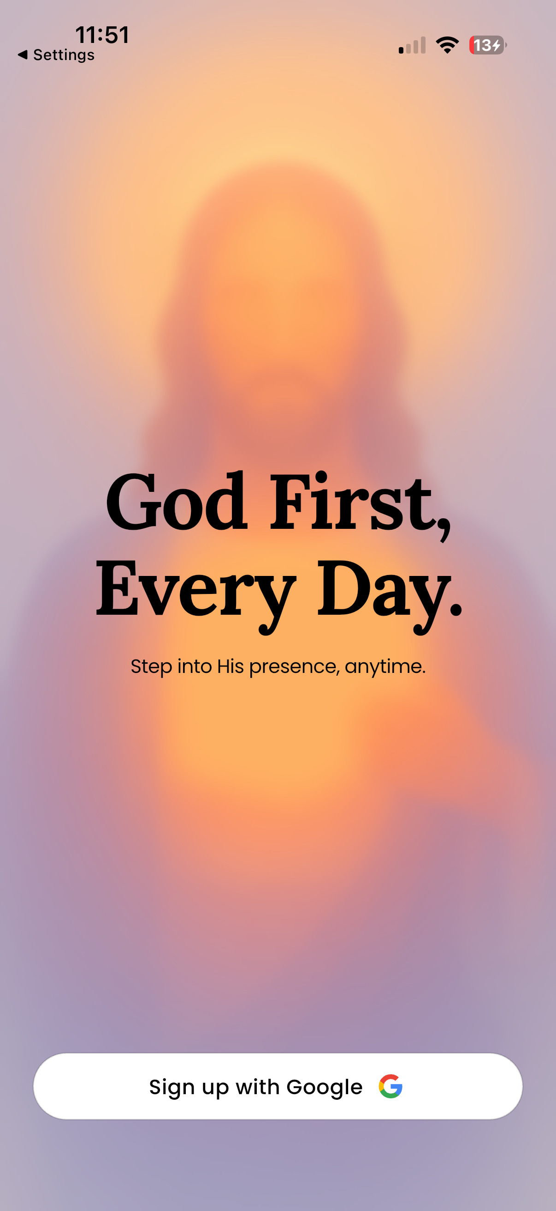
Figure 1: Welcome Screen — Google OAuth Login
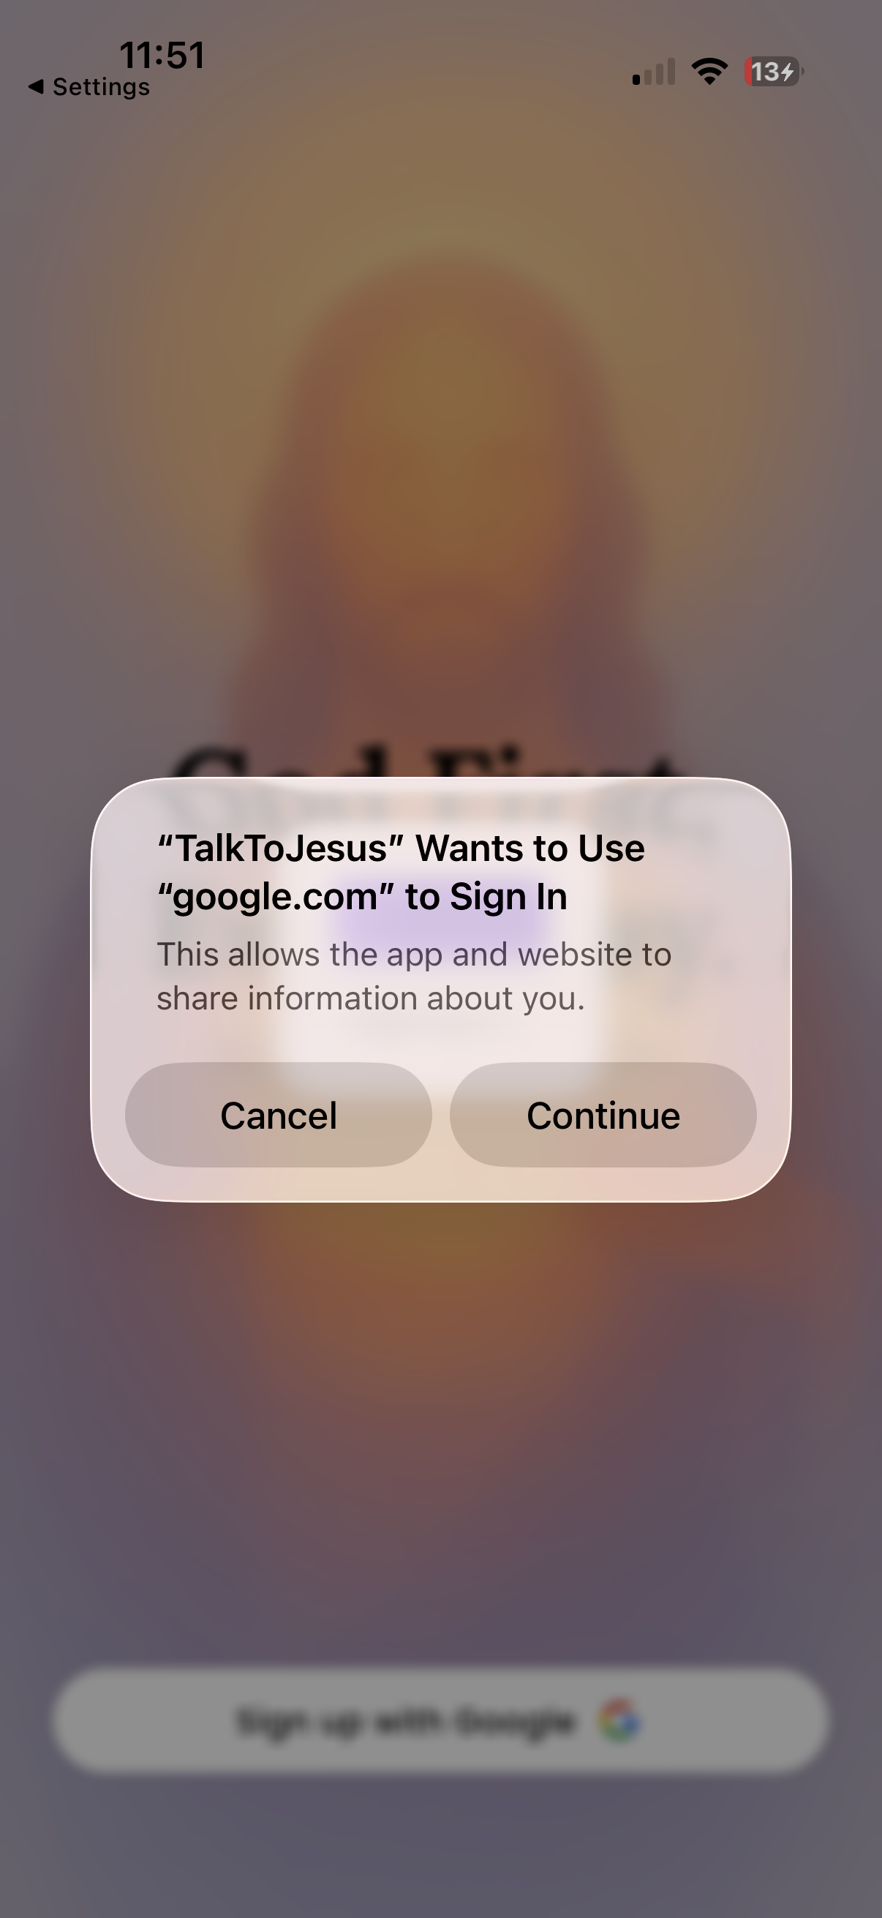
Figure 2: Google OAuth Consent Dialog
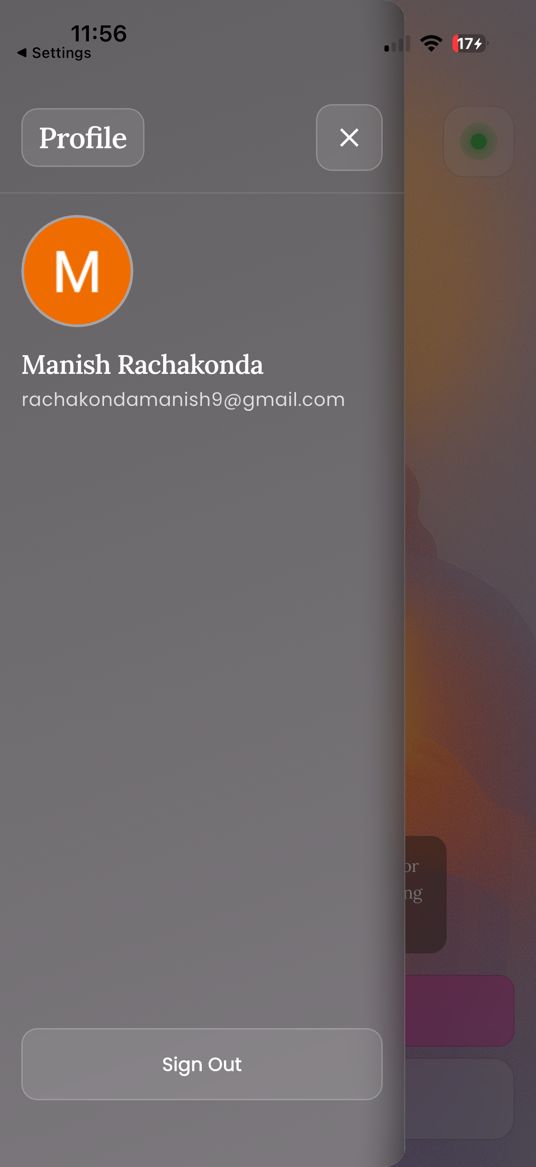
Figure 3: User Profile Panel with Google Account Details
AI Conversation Interface
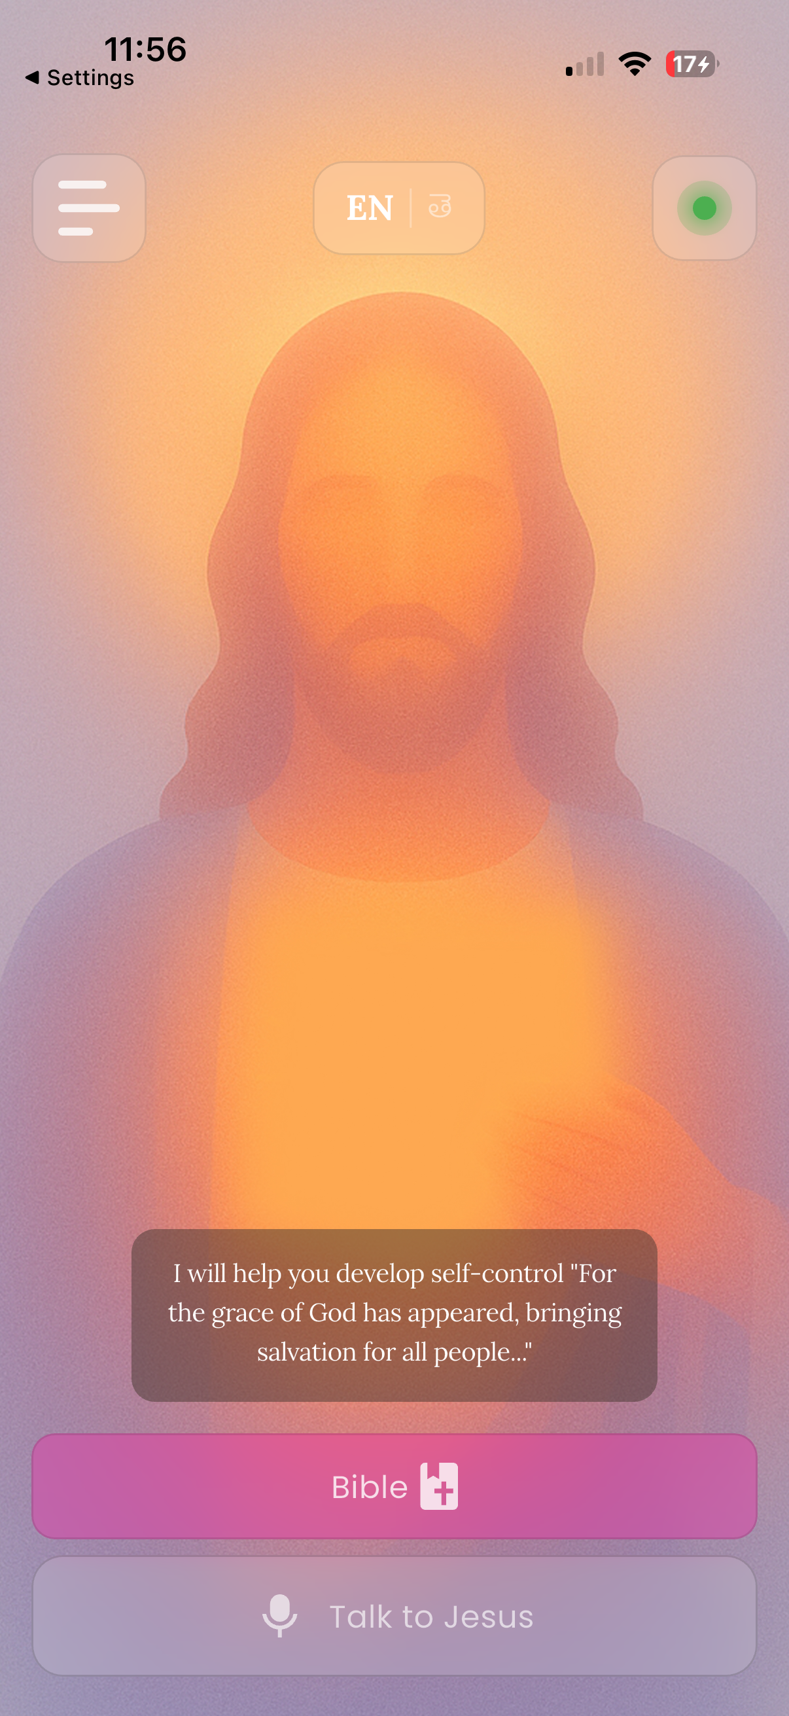
Figure 4: Home Screen — AI Conversation Interface with Language Toggle
Bible Reading Feature
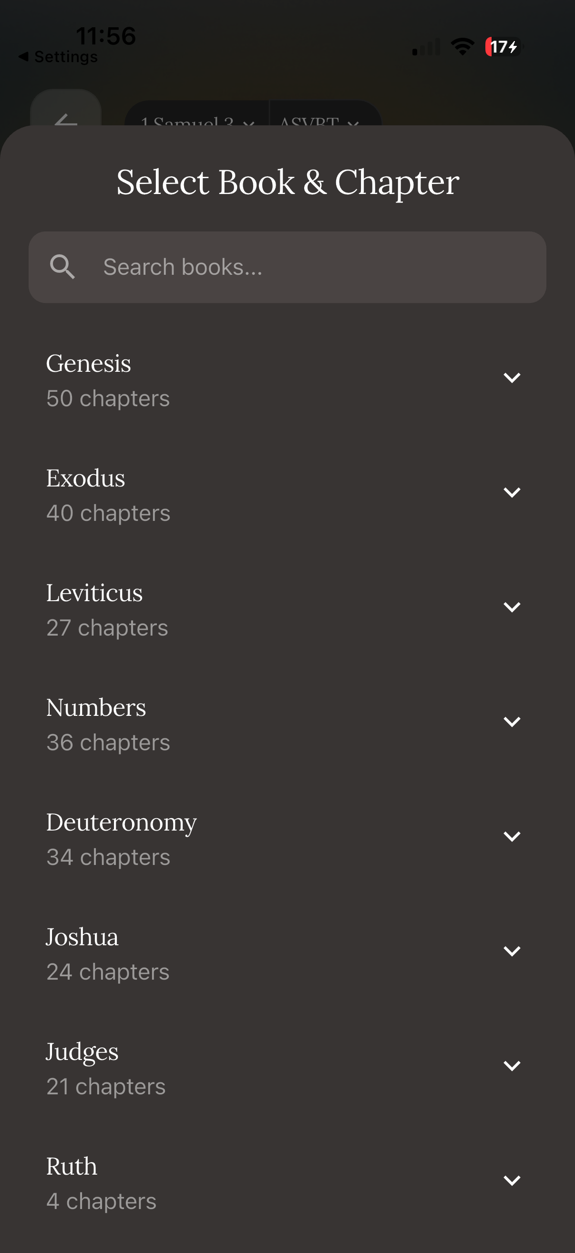
Figure 5: Bible — Book and Chapter Selection
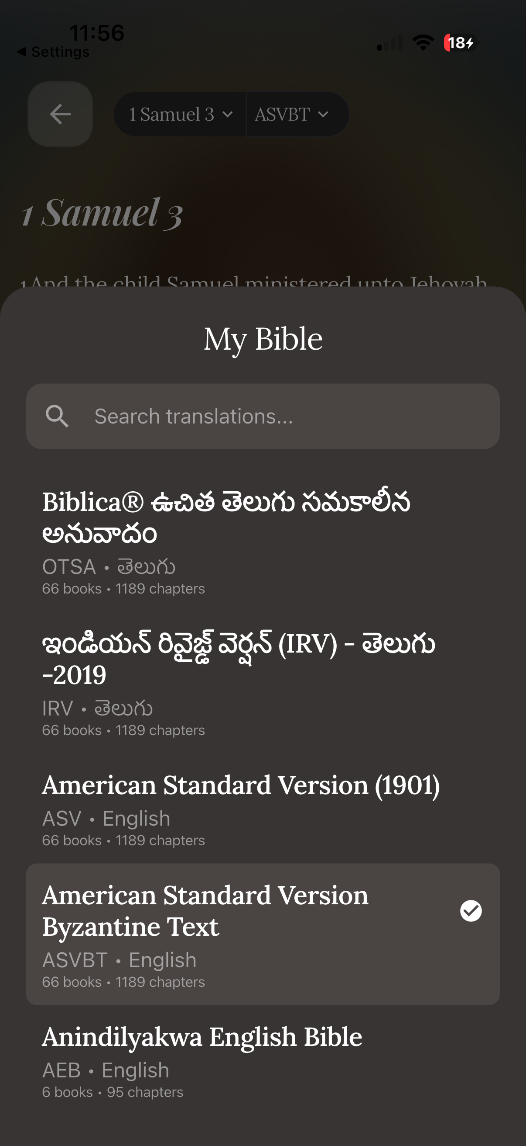
Figure 6: Bible — Multi-Language Translation Selector (English & Telugu)
Subscription and Payment Flow
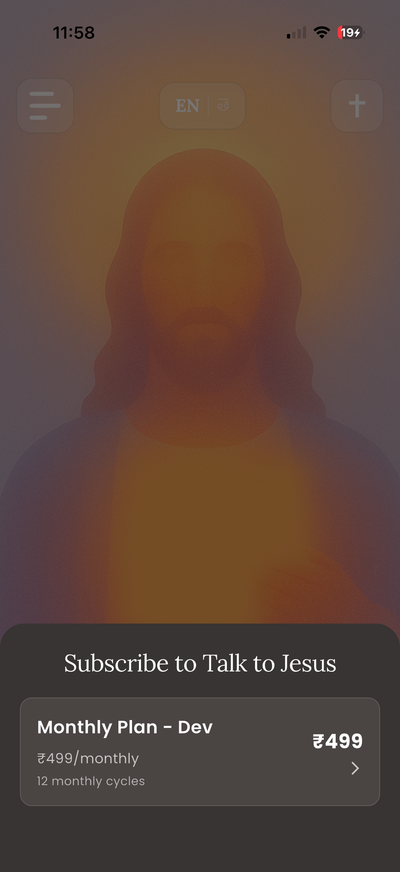
Figure 7: Subscription Screen — Monthly Plan
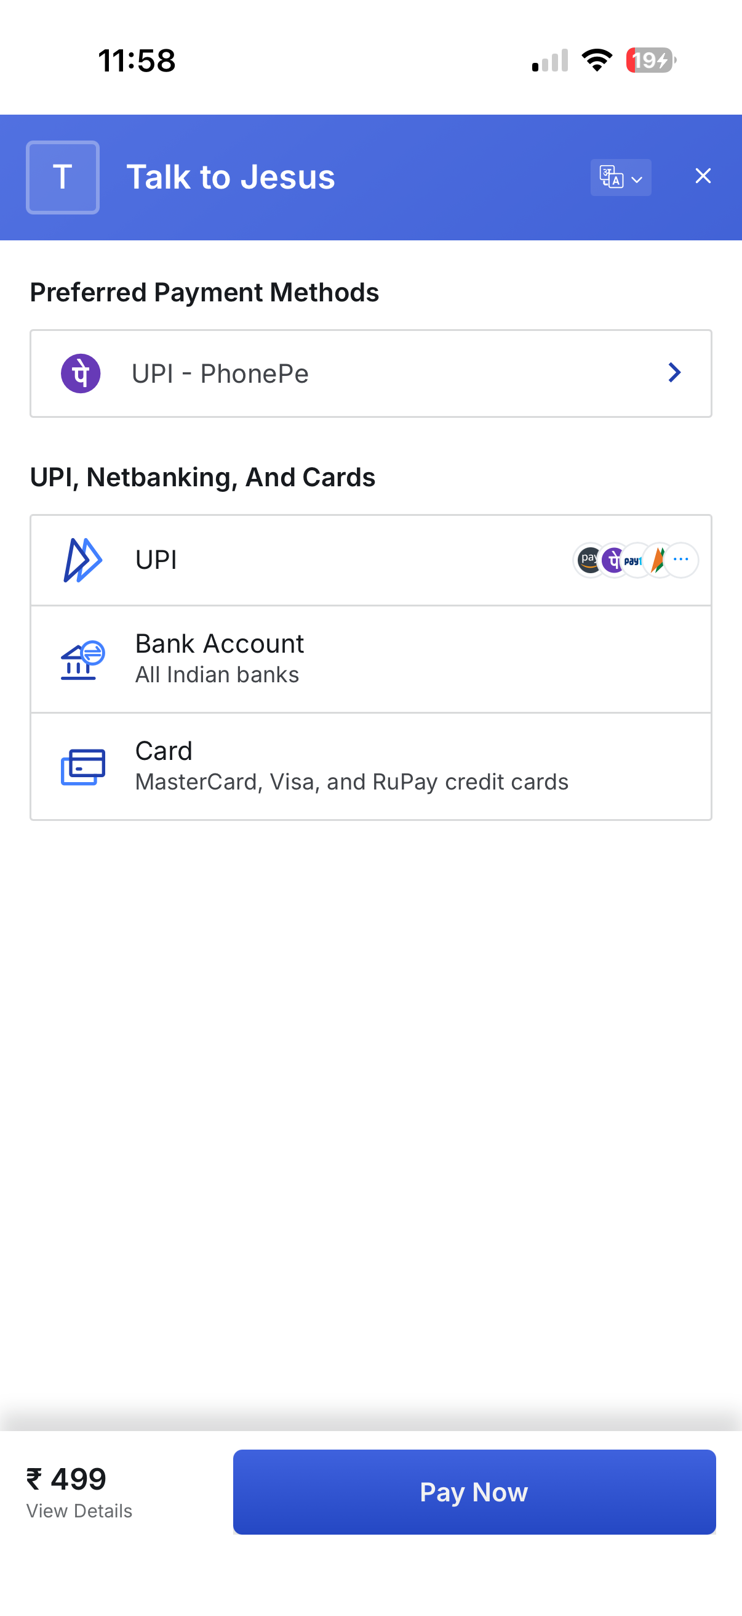
Figure 8: Razorpay Payment Gateway Integration

PoC Scope Boundaries
The PoC is intentionally scoped to validate feasibility, not to deliver a polished product. The following areas are deferred to Phase 3 for full implementation:
- Production-quality UI polish and animation refinement.
- Bible content population (navigation structure is in place).
- Song library seeding with production content.
- Comprehensive accessibility feature implementation.
- Full analytics and error tracking integration.

8. Testing and Validation Strategy
The following testing strategy will guide validation during Phase 3 implementation. Detailed test results and pass/fail analysis will be reported in the Phase 3 document.

Testing Approaches
Manual / Exploratory Testing: Primary testing approach during the Study Project. Each feature will be tested across user flows: happy path, edge cases (network loss, invalid input, expired token), and cross-platform behavior (Android & iOS simulators).
API Testing: Backend endpoints will be tested using tools like Postman/curl with valid and invalid JWT tokens, various audio formats, and different language parameters. Webhook handling will be validated using Razorpay test mode events.
Integration Testing: End-to-end flow testing from mobile app through backend to external APIs. Key flows: authentication → conversation → subscription → payment webhook.
Tester Accounts: Hardcoded tester tokens allow QA testing without requiring real Google accounts, enabling rapid iteration during development.

Key Test Scenarios Planned
Scenario | Expected Behavior
Google Sign-In on Android/iOS | User authenticates and receives JWT token; profile stored
Voice conversation (English) | Audio recorded, transcribed, AI responds in English, TTS plays
Voice conversation (Telugu) | Telugu audio transcribed, AI responds in Telugu, Telugu TTS plays
Free tier limit (4th conversation) | User blocked with subscription prompt after 3 conversations
Razorpay subscription creation | Payment page opens, subscription created on success
Webhook: subscription.charged | Subscription record updated with new last_charged_at
Network disconnection during use | Graceful error message shown to user
Invalid/expired JWT token | API returns 401; app redirects to login
Language switch mid-session | All UI elements update to selected language without restart
Song search and playback | Songs filtered by search term; audio plays with controls

9. Risks, Challenges, and Mitigation
With the system design complete and PoC demonstrating core feasibility, the following risks are assessed for the Phase 3 implementation phase:
Risk | Likelihood | Impact | Mitigation
API Cost Escalation  during full implementation | Medium | High | Free tier limits are sufficient for dev/testing. Free-tier conversation limit (3 conversations) controls usage per user. Monitor OpenAI and ElevenLabs dashboards for spend tracking.
Telugu TTS Quality  in production | Medium | Medium | ElevenLabs Multilingual v2 performs well in PoC testing for Telugu. Continue iterating on emotional tag placement and prompt phrasing. Collect feedback from Telugu-speaking testers during Phase 3.
Subscription Edge Cases  (failed payments, retries) | Medium | Medium | Design webhook handler to cover all Razorpay lifecycle events including halted and pending states. Implement grace period (30+1 days) to prevent false access denials. Test extensively in Razorpay sandbox.
Cloud Run Cold Starts | Low | Low | Cold start adds ~2 seconds on first request after scale-to-zero. Acceptable for this application. Can configure minimum instances if needed for production.
Time Pressure  for Phase 3 completion | Medium | Medium | Core pipeline is validated via PoC. Remaining work is incremental: UI polish, content population, accessibility, analytics. MVP approach ensures core is solid before extras.

10. Phase 2 Outcomes and Readiness for Phase 3

What Has Been Completed
- Complete three-tier system architecture (mobile client, Cloud Run backend, data services).
- Detailed functional requirements (FR1–FR20) covering all system capabilities.
- Non-functional requirements (NFR1–NFR19) specifying performance, security, scalability, and maintainability targets.
- Database schema design with 4 tables, relationships, and RLS policies.
- Technology stack selected and justified for every layer (19 technologies).
- Working Proof of Concept demonstrating the core voice conversation pipeline end-to-end.
- Backend deployed on Google Cloud Run with Docker containerization and CI/CD.
- Testing and validation strategy defined for Phase 3.

System Readiness for Phase 3
The system is ready for full implementation in Phase 3. The core conversation pipeline (voice → STT → AI → TTS → playback) has been validated end-to-end through the PoC. The backend is deployed and accessible on Cloud Run. Authentication, subscription, and payment flows are functional. Phase 3 will focus on completing all frontend screens with production-quality UI, populating Bible and song content, implementing accessibility features, integrating analytics and error tracking, executing the test plan, and preparing final documentation.

Key Inputs for Phase 3
- Finalized system architecture and module designs from this document.
- Validated PoC codebase as the foundation for full implementation.
- Detailed requirements (FR1–FR20, NFR1–NFR19) as acceptance criteria.
- Testing strategy and key scenarios to execute during validation.
- Risk mitigation strategies to guide development priorities.

11. Supervisor Review and Approval

Advisor Feedback

______________________________________________________________________

______________________________________________________________________

______________________________________________________________________

Supervisor Comments and Recommendations

______________________________________________________________________

______________________________________________________________________

______________________________________________________________________

Supervisor Name: Swapnil Saurav
Signature: ___________________ | Date: ___________________

