Test and Validation Report
TalkToJesus — A Bilingual Voice-First AI Spiritual Companion
Manish Rachakonda (2023EBCS668) · BSc Computer Science (Online Mode) · BITS Pilani Supervisor: Swapnil Saurav · Academic Year 2025–2026
This document is also Chapter 3 of the final project report. Section numbers are retained from that report so the two can be read together. Figure numbers refer to the report’s figure list, indexed at docs/figures/FIGURES.md.

3.1 Test plan

3.1.1 Strategy
Testing operates at three levels, and the report is explicit about what each level can and cannot establish.
Automated unit tests cover pure logic and the decision points where a mistake is silent — entitlement resolution, signature verification, percentile arithmetic, token expiry, and the parsing of every model that crosses the network boundary. These run in continuous integration on every push and are the only level that runs unattended.
Manual functional verification covers the paths that cross a real network to a paid third party. The complete subscription flow — plan selection, Razorpay checkout, UPI authorisation, webhook reconciliation and the resulting change of application state — cannot be exercised automatically without either mocking away the thing under test or spending real money on every continuous integration run. It was therefore executed by hand on physical hardware and recorded; Figures 15 through 18 are frames from that recording.
Instrumented measurement covers performance. Rather than timing the pipeline externally, the application records the duration of each stage of every turn into the database, and the administrative console reports the percentiles. This is the only level that produced a result contradicting the project’s own prior documentation.

3.1.2 Tools
Layer | Tool | Invocation
Backend unit | Jest 30 with ts-jest | npm test -- --ci
Frontend unit | flutter_test | flutter test
Static analysis | tsc --noEmit via build; flutter analyze | in CI
Continuous integration | GitHub Actions | on push and pull request to main
Container verification | Docker | asserts built artefacts exist in the image
Measurement | In-application instrumentation, read via the console | continuous
The backend suite is hermetic. A setup file stubs every environment variable the modules read at import time, so the suite requires no credentials and no network. This was not the original state: an earlier version passed locally and failed in continuous integration precisely because module-level initialisation read variables that existed only on the developer’s machine.

3.2 Requirement verification

3.2.1 Functional requirements
All twenty functional requirements defined in Phase 2 are implemented. Two carry qualifications.
Table 1 — Functional requirements and their implementation status
ID | Requirement (abbreviated) | Status | Evidence
FR1 | Google OAuth sign-in across web, iOS and Android client IDs | Met | Figures 1–2; BE-052 to BE-054
FR2 | JWT with configurable expiry | Met | BE-041 to BE-047
FR3 | Create user on first login, update last-login after | Met | BE-053
FR4 | Endpoint returning the authenticated user’s profile | Met | GET /api/user/me
FR5 | Voice upload, multipart, ≤ 10 MB, with language parameter | Met | Figure 6
FR6 | Whisper transcription with automatic language detection | Met | Section 2.4.2
FR7 | GPT-4o reply under a language-specific persona prompt | Met | Figure 8
FR8 | ElevenLabs synthesis with emotional tags | Met, with defect | Figure 8; D-01 in Section 3.7
FR9 | Single response carrying transcript, text and base64 audio | Met | Section 2.1.2
FR10 | Per-user conversation count with a three-conversation free tier | Met | BE-021 to BE-033
FR11 | Plans endpoint filtered by environment | Met | Figure 15
FR12 | Razorpay subscription creation | Met | Figures 16–17
FR13 | Entitlement check by status with a grace period | Met | BE-021 to BE-033
FR14 | Webhook handling with HMAC-SHA256 verification | Met | Figure 21; BE-034 to BE-040
FR15 | Cancellation at end of billing cycle | Met | POST /api/subscription/cancel
FR16 | Songs endpoint with pagination and search | Met | BE-056 to BE-060
FR17 | Audio player with play, pause, seek and artwork | Partially met | Figure 14; previous and next are unimplemented stubs
FR18 | Bible reading with navigation, translations and caching | Met | Figures 9–12
FR19 | Application-wide language switching without restart | Met | Figures 3 and 5; FE-001 to FE-006
FR20 | Language parameter drives prompt and emotional expression | Met | Section 2.4.3
FR17 is recorded as partially met: the player renders previous and next controls, but both are unimplemented and emit only an analytics event. A control that appears functional and does nothing is a defect rather than an omission, and it is listed as such in Section 3.7.

3.2.2 Non-functional requirements
This table is where the project’s honest assessment lives.
Table 2 — Non-functional requirements and their verification status
ID | Requirement (abbreviated) | Status | Basis
NFR1 | Full pipeline within 5 seconds under normal load | Not met | Measured 27,457 ms p50. Section 3.5
NFR2 | Music playback begins within 2 seconds | Met | Observed on device
NFR3 | Launch to interactive under 3 seconds | Met | Observed on device
NFR4 | Protected endpoints require a valid JWT | Met | BE-006 to BE-011
NFR5 | Webhook HMAC-SHA256 with timing-safe comparison | Met | BE-048 to BE-051
NFR6 | Secrets in environment variables, never hardcoded | Not met | A long-lived JWT, a PostHog key and a Sentry DSN are committed. Section 3.8
NFR7 | Row-level security enforced on all tables | Partially met | RLS is enabled, but no policies are defined and the API’s service-tier key bypasses it. Section 2.1.1
NFR8 | Material Design 3 with animated feedback | Met | Figures 3–18
NFR9 | High contrast, focus management, text scaling 0.8×–1.4× | Partially met | Scaling and contrast are implemented; screen-reader optimisation is not complete
NFR10 | Language switch updates all UI without restart | Met | Figures 3 and 5
NFR11 | Cloud Run autoscaling from zero | Met | Section 4.2
NFR12 | Stateless API permitting horizontal scaling | Met | Section 2.1.1
NFR13 | Schema supports additional languages without change | Met | language is a free text column
NFR14 | Clean Architecture on the client | Met | core / data / domain / presentation
NFR15 | Layered controllers, services, routes, middleware on the server | Met | Section 2.3
NFR16 | TypeScript for compile-time safety | Met | strict mode; build gates CI
NFR17 | Structured logging with per-environment levels | Met | Winston with LOG_LEVEL
NFR18 | Sentry captures runtime errors | Partially met | Initialised, but the flavour configuration is hardcoded rather than read from the build-time defines
NFR19 | PostHog tracks key product events | Met | Initialised and firing
Three requirements are not met and three are partially met. NFR1 is the significant one and is treated separately in Section 3.5.

3.3 Automated test results
Both suites were executed for this report. The captured output is in docs/evidence/.
Table 7 — Automated test suite composition
Tier | File | Cases | Area
Backend | admin.middleware.test.ts | 5 | Administrative access gate
Backend | consoleAdmin.auth.test.ts | 4 | Console administrator identity
Backend | jwt.test.ts | 7 | Token signing, expiry and verification
Backend | webhook.service.test.ts | 6 | Razorpay event handling
Backend | adminStats.service.test.ts | 14 | Percentile, revenue and conversion arithmetic
Backend | auth.middleware.test.ts | 6 | Bearer token authentication
Backend | song.service.test.ts | 5 | Catalogue pagination and search
Backend | razorpay.test.ts | 4 | HMAC signature verification
Backend | subscription.service.test.ts | 12 | Entitlement resolution and grace period
Backend | auth.service.test.ts | 3 | Google token verification and user upsert
Frontend | app_strings_test.dart | 6 | Bilingual string-table completeness
Frontend | conversation_response_test.dart | 4 | Conversation response parsing
Frontend | app_state_provider_test.dart | 10 | Application state and language switching
Frontend | bible_cache_test.dart | 8 | Cache entry expiry and LRU accounting
Frontend | subscription_model_test.dart | 13 | Subscription status matrix
Frontend | user_model_test.dart | 13 | User parsing including the admin flag
Frontend | bible_data_test.dart | 7 | Book and translation reference data
Frontend | song_test.dart | 7 | Song value semantics
Frontend | plan_model_test.dart | 7 | Paise-to-rupee conversion and formatting
Total | 19 files | 141
Backend: Test Suites: 10 passed, 10 total. Tests: 66 passed, 66 total. Time: 2.045 s.
Frontend: +75: All tests passed! across 9 files.
Total: 141 automated tests, 141 passing, none skipped, none failing.
A note on this figure, because it differs from every other document in the project. TESTING.md, the demonstration script and the presentation deck all state 62 backend tests and 137 in total. That was correct when written and is now stale: four cases covering the console administrator identity were added subsequently. The Phase 3 document states 40 backend tests with two failing, which is further out of date still. The number to quote is 141.
Table 8 — Full automated test case list
ID | Suite | Case | Result
BE-001 | admin.middleware.test.ts | Admin Middleware - should return 401 when no user is attached to the request | Pass
BE-002 | admin.middleware.test.ts | Admin Middleware - should return 404 when the user is not an admin | Pass
BE-003 | admin.middleware.test.ts | Admin Middleware - should return 404 when is_admin is missing entirely | Pass
BE-004 | admin.middleware.test.ts | Admin Middleware - should reject a truthy-but-not-true is_admin value | Pass
BE-005 | admin.middleware.test.ts | Admin Middleware - should call next() for an admin user | Pass
BE-006 | consoleAdmin.auth.test.ts | Console admin authentication - authenticates a console token without reading the users table | Pass
BE-007 | consoleAdmin.auth.test.ts | Console admin authentication - passes the admin gate once authenticated | Pass
BE-008 | consoleAdmin.auth.test.ts | Console admin authentication - rejects a console token once ADMIN_EMAIL is removed | Pass
BE-009 | consoleAdmin.auth.test.ts | Console admin authentication - does not let a forged claim through without a valid signature | Pass
BE-010 | jwt.test.ts | JWT Utility - signToken - should return a valid JWT string | Pass
BE-011 | jwt.test.ts | JWT Utility - signToken - should embed the payload in the token | Pass
BE-012 | jwt.test.ts | JWT Utility - signToken - should set expiration to 70 days | Pass
BE-013 | jwt.test.ts | JWT Utility - verifyToken - should return decoded payload for a valid token | Pass
BE-014 | jwt.test.ts | JWT Utility - verifyToken - should return null for an invalid token | Pass
BE-015 | jwt.test.ts | JWT Utility - verifyToken - should return null for a token signed with a different secret | Pass
BE-016 | jwt.test.ts | JWT Utility - verifyToken - should return null for an expired token | Pass
BE-017 | webhook.service.test.ts | Webhook Service - should handle subscription.charged and set last_charged_at | Pass
BE-018 | webhook.service.test.ts | Webhook Service - should handle subscription.cancelled | Pass
BE-019 | webhook.service.test.ts | Webhook Service - should handle subscription.authenticated and set last_charged_at from current_start | Pass
BE-020 | webhook.service.test.ts | Webhook Service - should ignore non-subscription events gracefully | Pass
BE-021 | webhook.service.test.ts | Webhook Service - should handle missing subscription data in payload | Pass
BE-022 | webhook.service.test.ts | Webhook Service - should handle subscription.activated and set last_charged_at as fallback | Pass
BE-023 | adminStats.service.test.ts | Admin Stats Service - percentile - returns null for an empty set | Pass
BE-024 | adminStats.service.test.ts | Admin Stats Service - percentile - returns the only value for a single sample | Pass
BE-025 | adminStats.service.test.ts | Admin Stats Service - percentile - computes the median of an odd-length set | Pass
BE-026 | adminStats.service.test.ts | Admin Stats Service - percentile - interpolates the median of an even-length set | Pass
BE-027 | adminStats.service.test.ts | Admin Stats Service - percentile - computes p95 near the top of the range | Pass
BE-028 | adminStats.service.test.ts | Admin Stats Service - percentile - does not mutate the input array | Pass
BE-029 | adminStats.service.test.ts | Admin Stats Service - computeMrrRupees - returns 0 with no subscriptions | Pass
BE-030 | adminStats.service.test.ts | Admin Stats Service - computeMrrRupees - converts paise to rupees | Pass
BE-031 | adminStats.service.test.ts | Admin Stats Service - computeMrrRupees - sums across subscriptions | Pass
BE-032 | adminStats.service.test.ts | Admin Stats Service - computeMrrRupees - treats a missing or null plan as zero rather than throwing | Pass
BE-033 | adminStats.service.test.ts | Admin Stats Service - computeConversionRate - returns 0 when there are no users, without dividing by zero | Pass
BE-034 | adminStats.service.test.ts | Admin Stats Service - computeConversionRate - computes a percentage to one decimal place | Pass
BE-035 | adminStats.service.test.ts | Admin Stats Service - computeConversionRate - returns 100 when every user pays | Pass
BE-036 | adminStats.service.test.ts | Admin Stats Service - computeConversionRate - returns 0 when nobody pays | Pass
BE-037 | auth.middleware.test.ts | Auth Middleware - should return 401 when no authorization header | Pass
BE-038 | auth.middleware.test.ts | Auth Middleware - should return 401 when authorization header is not Bearer | Pass
BE-039 | auth.middleware.test.ts | Auth Middleware - should return 401 when JWT token is invalid | Pass
BE-040 | auth.middleware.test.ts | Auth Middleware - should return 401 when user is not found in database | Pass
BE-041 | auth.middleware.test.ts | Auth Middleware - should set req.user and call next() on valid auth | Pass
BE-042 | auth.middleware.test.ts | Auth Middleware - should return 500 on unexpected error | Pass
BE-043 | song.service.test.ts | Song Service - should return paginated songs with correct offset | Pass
BE-044 | song.service.test.ts | Song Service - should apply search filter when provided | Pass
BE-045 | song.service.test.ts | Song Service - should not apply search filter when not provided | Pass
BE-046 | song.service.test.ts | Song Service - should throw on database error | Pass
BE-047 | song.service.test.ts | Song Service - should calculate correct offset for first page | Pass
BE-048 | razorpay.test.ts | Razorpay Utility - verifyWebhookSignature - should return true for a valid signature | Pass
BE-049 | razorpay.test.ts | Razorpay Utility - verifyWebhookSignature - should return false for an invalid signature | Pass
BE-050 | razorpay.test.ts | Razorpay Utility - verifyWebhookSignature - should return false for a signature with wrong length | Pass
BE-051 | razorpay.test.ts | Razorpay Utility - verifyWebhookSignature - should return false for tampered body | Pass
BE-052 | subscription.service.test.ts | Subscription Service - hasActiveSubscription - should return true when user is within free tier (count < 3) | Pass
BE-053 | subscription.service.test.ts | Subscription Service - hasActiveSubscription - should respect a custom free tier limit | Pass
BE-054 | subscription.service.test.ts | Subscription Service - hasActiveSubscription - should return false when user exceeds free tier and has no subscription | Pass
BE-055 | subscription.service.test.ts | Subscription Service - hasActiveSubscription - should return true for an active subscription | Pass
BE-056 | subscription.service.test.ts | Subscription Service - hasActiveSubscription - should prefer an active subscription over a stale created one | Pass
BE-057 | subscription.service.test.ts | Subscription Service - hasActiveSubscription - should return true for an authenticated subscription | Pass
BE-058 | subscription.service.test.ts | Subscription Service - hasActiveSubscription - should return true for a created subscription inside the 24h grace period | Pass
BE-059 | subscription.service.test.ts | Subscription Service - hasActiveSubscription - should return false for a created subscription past the 24h grace period | Pass
BE-060 | subscription.service.test.ts | Subscription Service - hasActiveSubscription - should return false when user not found | Pass
BE-061 | subscription.service.test.ts | Subscription Service - getUserSubscription - should return the latest subscription | Pass
BE-062 | subscription.service.test.ts | Subscription Service - getUserSubscription - should return null when no subscription exists | Pass
BE-063 | subscription.service.test.ts | Subscription Service - incrementConversationCount - should increment and return the new count | Pass
BE-064 | auth.service.test.ts | Auth Service - should create a new user when not found in DB | Pass
BE-065 | auth.service.test.ts | Auth Service - should return existing user and update last_login_at | Pass
BE-066 | auth.service.test.ts | Auth Service - should throw on invalid Google token | Pass
FE-001 | app_strings_test.dart | AppStrings every English key has a Telugu translation | Pass
FE-002 | conversation_response_test.dart | ConversationResponse fromJson parses all fields | Pass
FE-003 | app_strings_test.dart | AppStrings returns the translated string for each language | Pass
FE-004 | conversation_response_test.dart | ConversationResponse fromJson handles null/missing fields with defaults | Pass
FE-005 | app_strings_test.dart | AppStrings English and Telugu values actually differ | Pass
FE-006 | conversation_response_test.dart | ConversationResponse toJson produces snake_case keys | Pass
FE-007 | app_strings_test.dart | AppStrings falls back to the key itself for an unknown key | Pass
FE-008 | conversation_response_test.dart | ConversationResponse fromJson/toJson round-trip | Pass
FE-009 | app_strings_test.dart | AppStrings getAll returns a non-empty map for both languages | Pass
FE-010 | app_strings_test.dart | AppStrings covers the screens used in the demo flow | Pass
FE-011 | app_state_provider_test.dart | AppState has correct default values | Pass
FE-012 | app_state_provider_test.dart | AppState copyWith updates only specified fields | Pass
FE-013 | app_state_provider_test.dart | AppStateNotifier initial state has default values | Pass
FE-014 | app_state_provider_test.dart | AppStateNotifier setLanguage updates the language | Pass
FE-015 | app_state_provider_test.dart | AppStateNotifier toggleHighContrastMode toggles the mode | Pass
FE-016 | app_state_provider_test.dart | AppStateNotifier setAudioPermission sets the permission flag | Pass
FE-017 | app_state_provider_test.dart | AppStateNotifier incrementCounter increases counter by 1 | Pass
FE-018 | app_state_provider_test.dart | AppStateNotifier resetCounter sets counter back to 0 | Pass
FE-019 | app_state_provider_test.dart | AppLanguage english has correct code and displayName | Pass
FE-020 | app_state_provider_test.dart | AppLanguage telugu has correct code and displayName | Pass
FE-021 | bible_cache_test.dart | BibleCacheEntry toMap/fromMap round-trip preserves all fields | Pass
FE-022 | subscription_model_test.dart | Subscription fromJson parses all fields correctly | Pass
FE-023 | bible_cache_test.dart | BibleCacheEntry fromMap handles missing optional fields with defaults | Pass
FE-024 | bible_cache_test.dart | BibleCacheEntry isExpired returns false for future expiry | Pass
FE-025 | bible_cache_test.dart | BibleCacheEntry isExpired returns true for past expiry | Pass
FE-026 | bible_cache_test.dart | BibleCacheEntry copyWithAccess increments access count | Pass
FE-027 | bible_cache_test.dart | BibleCacheEntry copyWith updates only specified fields | Pass
FE-028 | subscription_model_test.dart | Subscription fromJson parses nested plan when present | Pass
FE-029 | bible_cache_test.dart | ReadingPosition toMap/fromMap round-trip preserves all fields | Pass
FE-030 | bible_cache_test.dart | ReadingPosition positionKey combines translationId and bookId | Pass
FE-031 | subscription_model_test.dart | Subscription toJson produces correct keys | Pass
FE-032 | subscription_model_test.dart | Subscription toJson includes plan when present | Pass
FE-033 | subscription_model_test.dart | Subscription isActive returns true for active status | Pass
FE-034 | subscription_model_test.dart | Subscription isActive returns true for authenticated status | Pass
FE-035 | subscription_model_test.dart | Subscription isActive returns false for cancelled status | Pass
FE-036 | subscription_model_test.dart | Subscription isCancelled returns true for cancelled status | Pass
FE-037 | subscription_model_test.dart | Subscription isPaused returns true for paused status | Pass
FE-038 | subscription_model_test.dart | Subscription isPastDue returns true for past_due status | Pass
FE-039 | subscription_model_test.dart | CreateSubscriptionResponse shortUrl returns value from razorpaySubscription | Pass
FE-040 | subscription_model_test.dart | CreateSubscriptionResponse shortUrl returns null when razorpaySubscription is null | Pass
FE-041 | subscription_model_test.dart | CurrentSubscriptionResponse fromJson handles null subscription | Pass
FE-042 | user_model_test.dart | UserModel fromJson parses all fields correctly | Pass
FE-043 | user_model_test.dart | UserModel fromJson handles null optional fields | Pass
FE-044 | user_model_test.dart | UserModel toJson produces correct snake_case keys | Pass
FE-045 | user_model_test.dart | UserModel fromJson/toJson round-trip preserves data | Pass
FE-046 | user_model_test.dart | UserModel copyWith creates a new instance with updated fields | Pass
FE-047 | user_model_test.dart | UserModel isAdmin defaults to false when the field is absent | Pass
FE-048 | user_model_test.dart | UserModel isAdmin parses true from the backend | Pass
FE-049 | user_model_test.dart | UserModel isAdmin survives a toJson/fromJson round-trip | Pass
FE-050 | user_model_test.dart | UserModel copyWith can toggle isAdmin without touching other fields | Pass
FE-051 | user_model_test.dart | UserModel isTester returns true for tester user ID | Pass
FE-052 | user_model_test.dart | UserModel isTester returns false for regular user | Pass
FE-053 | user_model_test.dart | CreateOrGetUserResponse fromJson parses nested user and token | Pass
FE-054 | user_model_test.dart | CreateOrGetUserResponse fromJson handles null token | Pass
FE-055 | bible_data_test.dart | BibleData books list is not empty | Pass
FE-056 | bible_data_test.dart | BibleData Genesis is the first book with 50 chapters | Pass
FE-057 | bible_data_test.dart | BibleData Psalms has 150 chapters | Pass
FE-058 | bible_data_test.dart | BibleData all books have positive chapter counts | Pass
FE-059 | bible_data_test.dart | BibleData versions list contains expected translations | Pass
FE-060 | bible_data_test.dart | BibleData versions list has 6 entries | Pass
FE-061 | bible_data_test.dart | BibleBook can be constructed with name and totalChapters | Pass
FE-062 | song_test.dart | Song copyWith updates specified fields only | Pass
FE-063 | song_test.dart | Song copyWith with no args returns equal copy | Pass
FE-064 | song_test.dart | Song equality works for identical songs | Pass
FE-065 | song_test.dart | Song equality fails for different songs | Pass
FE-066 | song_test.dart | Song hashCode is consistent for equal objects | Pass
FE-067 | song_test.dart | Song toString includes all fields | Pass
FE-068 | song_test.dart | Song handles null optional fields | Pass
FE-069 | plan_model_test.dart | Plan fromJson parses all fields correctly | Pass
FE-070 | plan_model_test.dart | Plan toJson produces correct keys | Pass
FE-071 | plan_model_test.dart | Plan fromJson/toJson round-trip preserves data | Pass
FE-072 | plan_model_test.dart | Plan priceInRupees converts paise to rupees | Pass
FE-073 | plan_model_test.dart | Plan priceInRupees handles fractional amounts | Pass
FE-074 | plan_model_test.dart | Plan formattedPrice returns rupee symbol with amount | Pass
FE-075 | plan_model_test.dart | Plan formattedPrice truncates decimals | Pass

3.4 Functional verification on device
The following was executed by hand on an iPhone against the live backend and recorded. Timestamps refer to the demonstration recording.
Table 9 — Functional verification on device
# | Scenario | Expected | Observed | Status
M-01 | Sign in with Google | Account created, home screen shown | As expected | Pass
M-02 | Open profile drawer | Name, address and navigation shown | As expected (00:05) | Pass
M-03 | Switch to Telugu | All visible strings change without restart | As expected (00:27) | Pass
M-04 | Read Genesis 1 in Telugu | Telugu text renders correctly | As expected (00:13) | Pass
M-05 | Change translation | Six translations offered, selection applied | As expected (00:17) | Pass
M-06 | Select book and chapter | Searchable list, chapter grid | As expected (00:25) | Pass
M-07 | Open hymn library | Twelve hymns with artwork | As expected | Pass
M-08 | Play a hymn | Playback starts, seek bar advances | As expected | Pass
M-09 | Use previous / next in the player | Track changes | No effect | Fail — D-02
M-10 | Record a voice message | Recording indicator, cancel and stop | As expected (01:00) | Pass
M-11 | Receive a spoken reply | Text and audio returned | As expected, after ~28 s | Pass, but see NFR1
M-12 | Exceed the free tier | Paywall presented | As expected (02:37) | Pass
M-13 | Complete Razorpay checkout by UPI | Payment succeeds | As expected (03:24) | Pass
M-14 | Subscription state reflected in app | Badge turns active | As expected (03:36) | Pass
M-15 | Open conversation history | Previous turns listed with language and age | As expected, with D-01 | Pass, with defect
M-16 | Administrative console as a non-admin | Access refused without confirming the surface exists | 404 returned | Pass
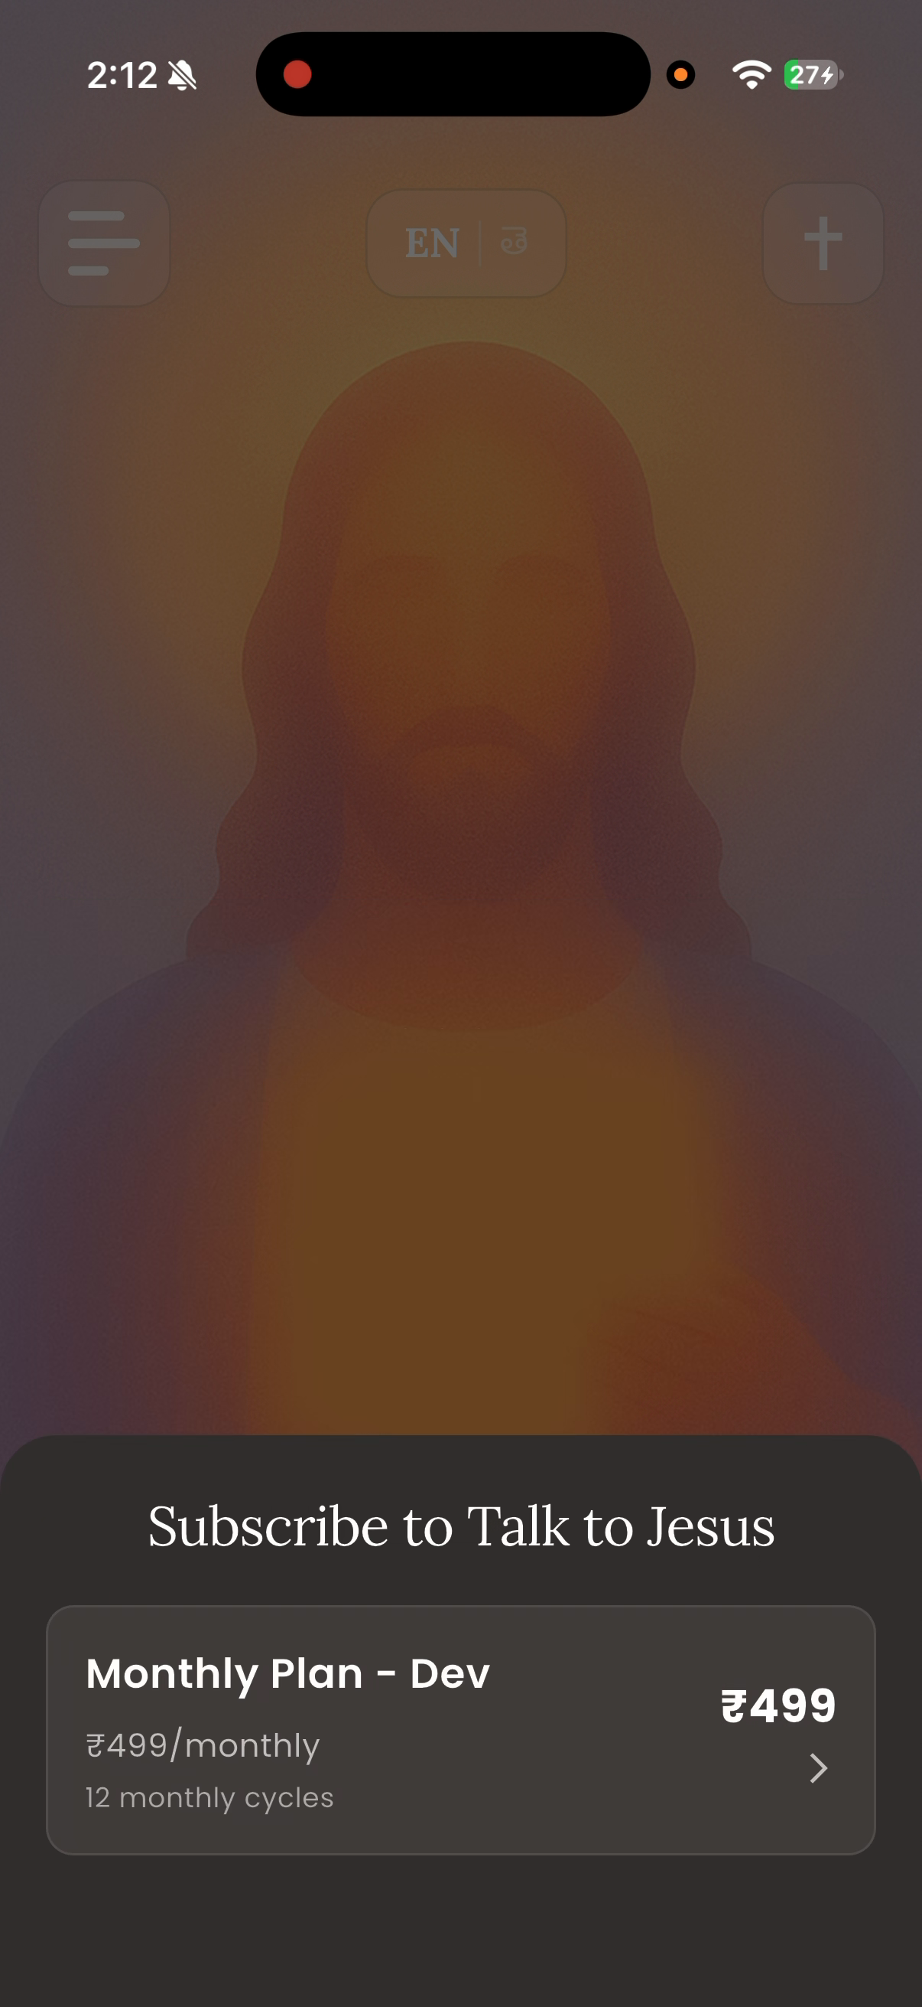
Figure 15 — The paywall after the free tier is exhausted.
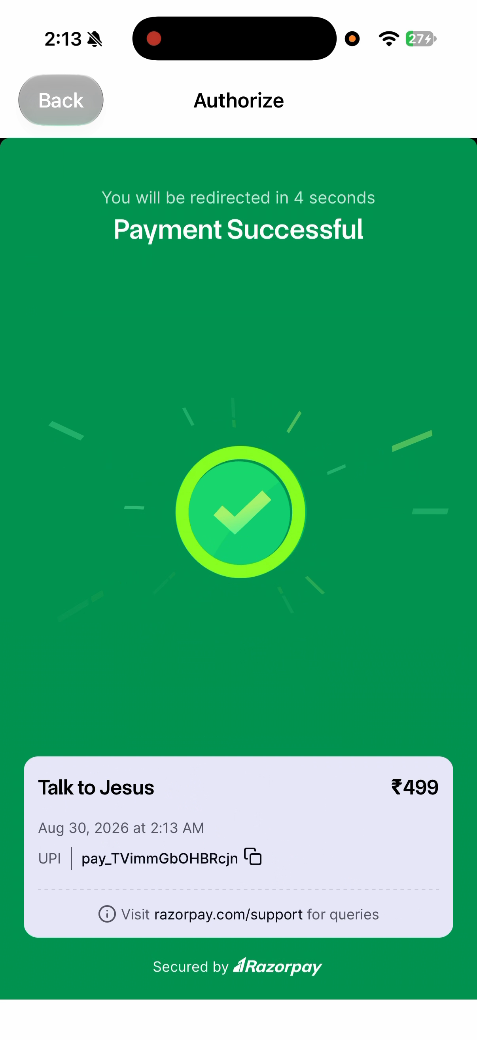
Figure 17 — Payment confirmed, with the Razorpay payment identifier.
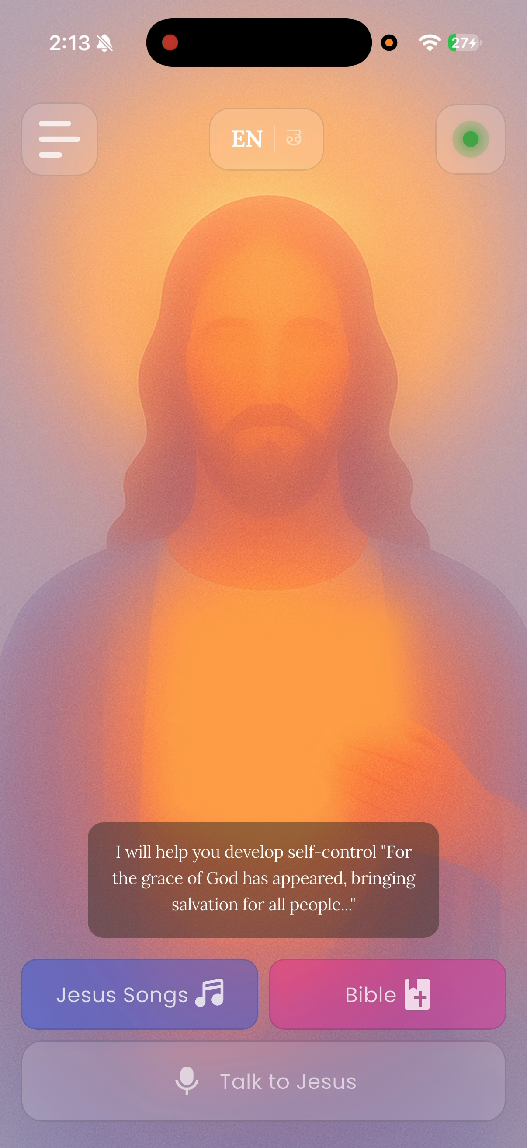
Figure 18 — The home screen after payment. The badge at the top right is now active.

3.5 The latency result
This is the project’s principal measured finding, and it contradicts the project’s own earlier documentation.
Table 10 — Measured pipeline latency, live instance
Stage | p50 | p95 | Share of p50 total
Speech to text (Whisper) | 4,004 ms | 4,715 ms | 15 %
AI response (GPT-4o) | 3,471 ms | 3,546 ms | 13 %
Text to speech (ElevenLabs) | 19,618 ms | 20,252 ms | 71 %
End to end | 27,457 ms | — | 100 %
Sample: the last two turns, both voice, zero text.
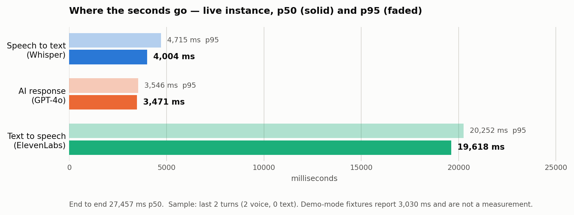
Figure 29 — Measured per-stage latency, live instance.
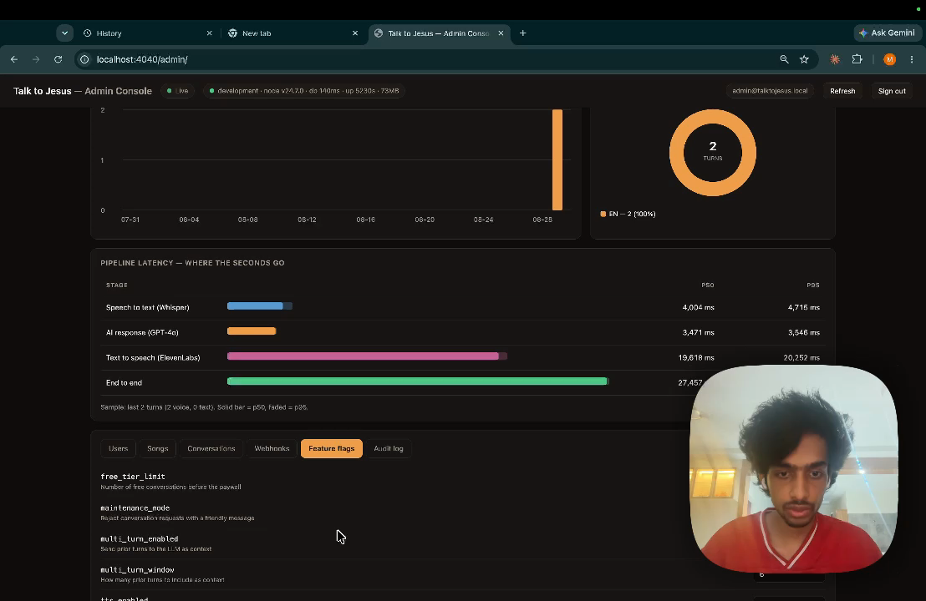
Figure 25 — The same measurement as reported by the administrative console.
Where the earlier figure came from. Phase 3 and the presentation deck state a three-to-six second pipeline. The administrative console’s demonstration mode reports an end-to-end p50 of 3,030 ms over a fixture sample of 500 turns. That number is a hand-written fixture in the console’s JavaScript. It was never a measurement, and the resemblance between it and the figure quoted in the earlier documents is the likely explanation for how the claim entered those documents.
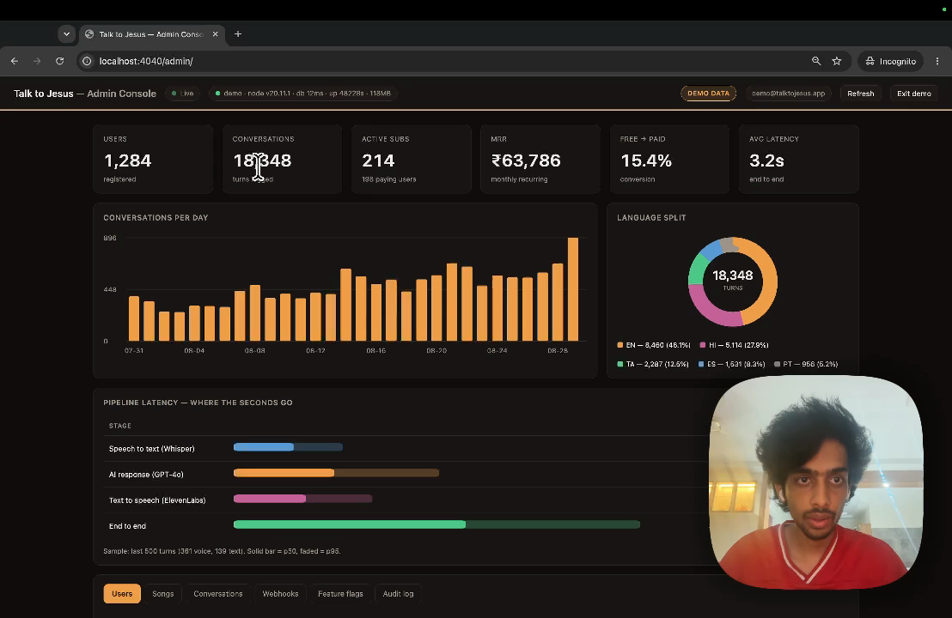
Figure 19 — Demonstration mode, showing the fixture data. The DEMO DATA badge is visible at the top right, and the end-to-end fixture reads 3,030 ms.
What the measurement means. Three observations follow, and they are separable.
First, the sample is two turns. Two turns cannot establish a distribution, and the p95 column is arithmetically meaningless at that sample size. What two turns can establish is an order of magnitude, and the order of magnitude is seconds-times-ten, not seconds. NFR1 specifies five seconds. The measurement is 27.5. No plausible sampling error closes a gap of that size.
Second, the distribution across stages is the useful part. Transcription and generation together account for 7.5 seconds; synthesis alone accounts for 19.6. Any optimisation effort directed at the model or the transcriber is misdirected. The latency is a speech synthesis problem.
Third, synthesis time scales with the length of the text being synthesised, and Section 2.3.3 records that the persona prompt specifies a two-to-four sentence reply while the model actually produces three paragraphs. The most probable single cause of the 19.6 seconds is therefore not the synthesis vendor but the prompt: the system is asking a speech engine to render four to five times more text than the design intended. Section 6.4 proposes the experiment that would confirm this.
The honest summary is that the system works and is too slow, that the instrumentation is what revealed it, and that the same instrumentation identifies where to look.

3.6 Correcting the Phase 3 document
Phase 3 was accurate when submitted. Several of its statements are no longer true, and one was incorrect at the time.
Table 13 — Corrections to the Phase 3 document
Phase 3 states | Current position
38 of 40 backend tests pass; 2 fail | 66 of 66 pass across 10 suites
65 frontend tests across 8 files | 75 across 9 files
Root cause of the failures: “the mock returns subscription data but the resolved user row evaluates to null or 0” | Incorrect. The test helper made only .single() awaitable, while the function under test awaits the query builder directly to obtain an array. Every “expect false” assertion was passing for the wrong reason
Conversation history and multi-turn context are future work | Both implemented
Cloud Run cold start approximately 2 s | Measured 4.4 s cold, ~0.4 s warm
Pipeline 3–6 s | Measured 27.5 s p50; the 3–6 s figure traces to demonstration fixtures
No mention of the administrative console, feature flags, webhook audit or CI | All four exist
The second row is worth dwelling on. The original diagnosis was plausible and wrong, and the tests it described as failing were, in the passing cases, succeeding for a reason unrelated to the behaviour they claimed to verify. A test that passes for the wrong reason is more dangerous than one that fails.

3.7 Defects identified
Table 12 — Defects identified
ID | Severity | Defect | Status
D-01 | Medium | Emotional-control tags ([gently], [comfortingly], [prayerfully]) are rendered verbatim to the user in the conversation history and in the reply toast. They are markup for the speech engine and should be stripped before display | Open
D-02 | Medium | The audio player’s previous and next controls are unimplemented; they appear functional and emit only an analytics event | Open
D-03 | Medium | Replies run to three paragraphs against a persona prompt specifying two to four sentences, which is the probable principal cause of the synthesis latency in Section 3.5 | Open
D-04 | Low | incrementConversationCount is a read-modify-write with no atomic database increment; two concurrent turns from one account can lose an increment | Open
D-05 | Low | The inspirational verse on the home screen is a hardcoded string rather than dynamic content | Open
D-06 | Low | The connectivity provider is a stub that always reports connected; its own comment says so. The real connectivity check is used only inside the Bible repository | Open
D-07 | Low | Two Bible cache implementations exist; only the smaller is wired in. The larger is dead code | Open
D-08 | Low | The application has no about or credits screen, which the bundled hymn licensing requires. See Appendix E | Open
D-09 | Informational | The Android application identifier is still the scaffold default com.example.talktojesus, which would block a Play Store submission | Open

Figure 8 — Defect D-01. The bracketed tags are direction for the speech engine and were never intended to reach the reader.

3.8 Properties not verified
The following were not tested. They are listed because a report that omits them implies a coverage that does not exist.
Table 11 — Properties not verified
Not verified | Reason | Consequence
Scriptural accuracy of citations | Requires theological review beyond the scope of this project | The model generates citations from its parameters with no retrieval step (Section 2.4.4). A citation could be misattributed and nothing in the system would detect it
Behaviour under concurrent load | ElevenLabs quota made repeated load runs impractical | Throughput and the behaviour of the pipeline under contention are unknown
Telugu transcription accuracy in noise | No controlled acoustic test was performed | Degradation in a noisy environment is expected but unquantified
Controllers and the pipeline end to end | The automated suite covers services, middleware and utilities only | An error in request handling or response shaping would not be caught by the suite
Any user interface behaviour | No widget or integration tests exist | Every screen is verified only by manual inspection
Authorization isolation between users | No automated test asserts that one user cannot read another’s conversations | Given that the database’s row-level security is bypassed by the service key (Section 2.1.1), this is the single most valuable test the project does not have
Token revocation | Not implemented, so not tested | A seventy-day token cannot be invalidated before expiry; rotating the administrator password does not revoke tokens already issued
Rate limiting | Not implemented | No protection against abuse of the paid pipeline beyond the free-tier counter
Cross-origin restrictions | CORS is configured fully open | Any origin can call the API with a valid token
Secret hygiene in the repository | Reviewed, not enforced | A long-lived test JWT, a PostHog key and a Sentry DSN are committed to source control, and three .env backup files sit untracked in the working directory. These must be removed before any code submission
Personal data handling | No retention or redaction policy exists | Conversation transcripts are personal and sometimes sensitive; they are stored indefinitely with no deletion path
The authorization row deserves emphasis. Because the API holds a key that bypasses row-level security, every user-scoped query depends on application code filtering correctly. That property is currently guaranteed by inspection alone.

