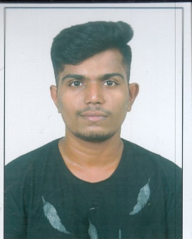**NAME : Manish Mahendra Pawar**

**Qualification :** Bachelor’s Degree ,Computer engineering

**E-mail** : pawarmanish99999@gmail.com

**Mobile no** : 7045283058

**“I am looking for the job of an software developer or web developer”**

**Fields of Interest-**

* **Web developer**
* **Software developement**

**Projects-**

* **E-maid booking websites where user can book maid for some duration according to there needs (using Django and python, bootstrap 4, jquery ajax ).**
* **Detection of fishing websites (using machine learning and python) .**
* **Mini project (6th sem) :- Employee task management (using html ,css ,bootstrap ,jdbc & servlet).**
* **Website design (5th sem WD project –using html ,css ,bootstrap ,javascript)**

**Educational Degree-**

**B.E.** B. R. Harne college of Engineering and Technology, Computer Engineering

Mumbai University.

Upto sem-7 **Agg. Pointer 7.2/10 CGPI**

**JUNIOR**  Sahyadri Jr. college bhandup(w), **State Board HSC-73%**  
**COLLEGE** June 2014-March 2016

**PRIMARY &** Parag vidyalaya bhandup(w), **State Board SSC-90.20%**

**SECONDARY** March 2014

**SCHOOL**

**Courses Attended-**

* **HTML & CSS**
* **JAVA & Advance JAVA**
* **.NET (full stack)**

**Skills-**

* **Effective Technical skills**
* **Teamworking skills**
* **The ability to work under pressure**
* **Commercial awareness**

**Personal-**

Address :- 1/13 , Kalawati niwas ,Samarth nagar , Bhandup west ,Mumbai-78 ,Maharashtra.

Date of birth :- August 22 ,1998.

Place of birth :- Bhandup ,Maharashtra.

Language Known :- Marathi ,English ,Hindi.

Hobbies :-Playing kabbadi ,Watching TV.

**Declaration-**

I hereby declare that whatever I mentioned above is true information as per my knowledge.

**Manish Mahendra Pawar.**