Note: For run the project please follow README.md file from react-app directory.

Album Page

* Album page will open first with the image, title and username.
* Image is fixed here but generating dynamic background color according to the username
* .
* Implemented the pagination on the page and user will have option to shown record at one time (20, 30 or 50) by default 20 records will show.
* Once user will click on album row then photo page will show according to the album ID.
* Please refer screen shot.

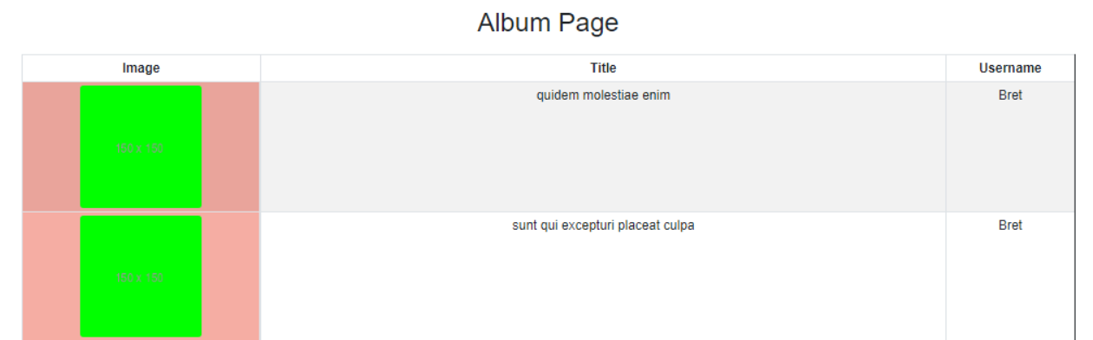

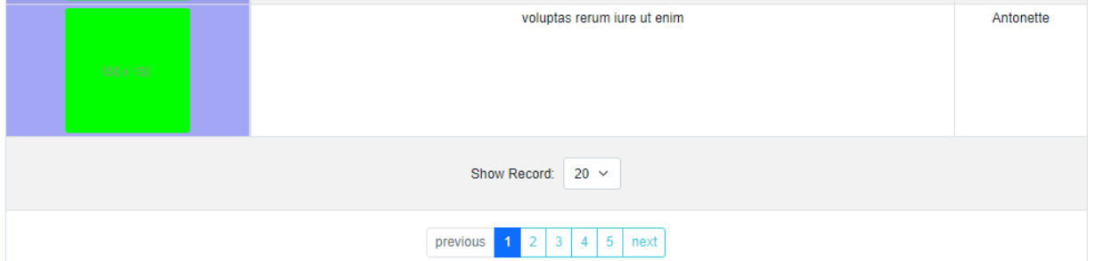

Photo Page

* Photo page will open once user will click on album Id. On this page displaying title and username.
* Images are coming from the API and displaying accordingly.
* Implemented the pagination on the page and user will have option to shown record at one time (20, 30 or 50) by default 20 records will show.
* Once user will click on thumbnail image then full image will show on modal.
* Please refer screen shot.

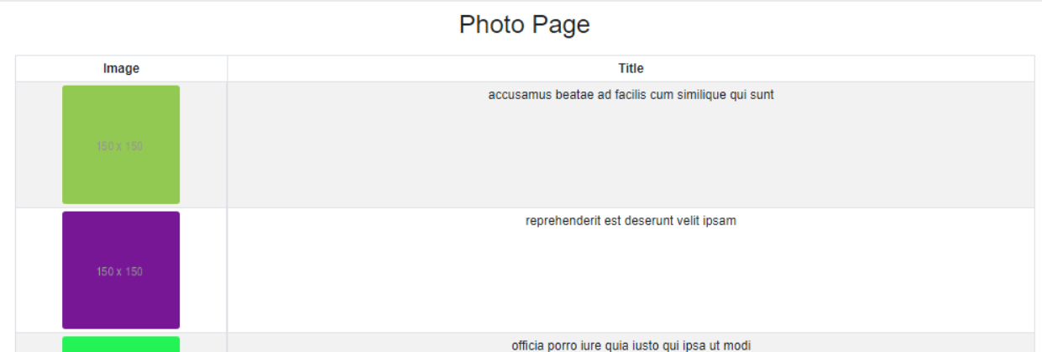

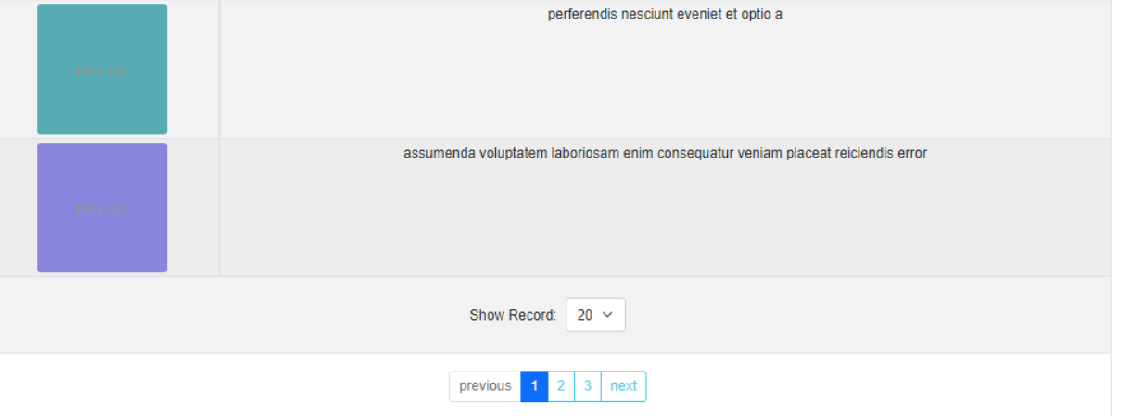

Modal

* Once user will click on thumbnail image on photo page then full image will show on modal.
* Please refer screen shot.

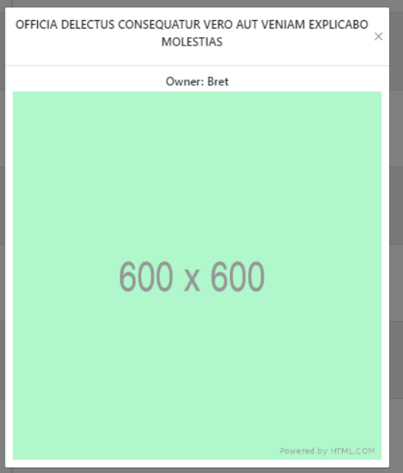

Thanks

* Thank you for go through the documentation ☺.