

WEEK 9

**NAME:** T S Manish

**ROLLNO:** 22R21A3358 **DATE:** 13/11/24

**LAB:** CLOUD AND DEVOPS LAB

**PROBLEM STATEMENT :** Create a docker image and push docker image into AWS ECR.

**PROCEDURE:**

1. 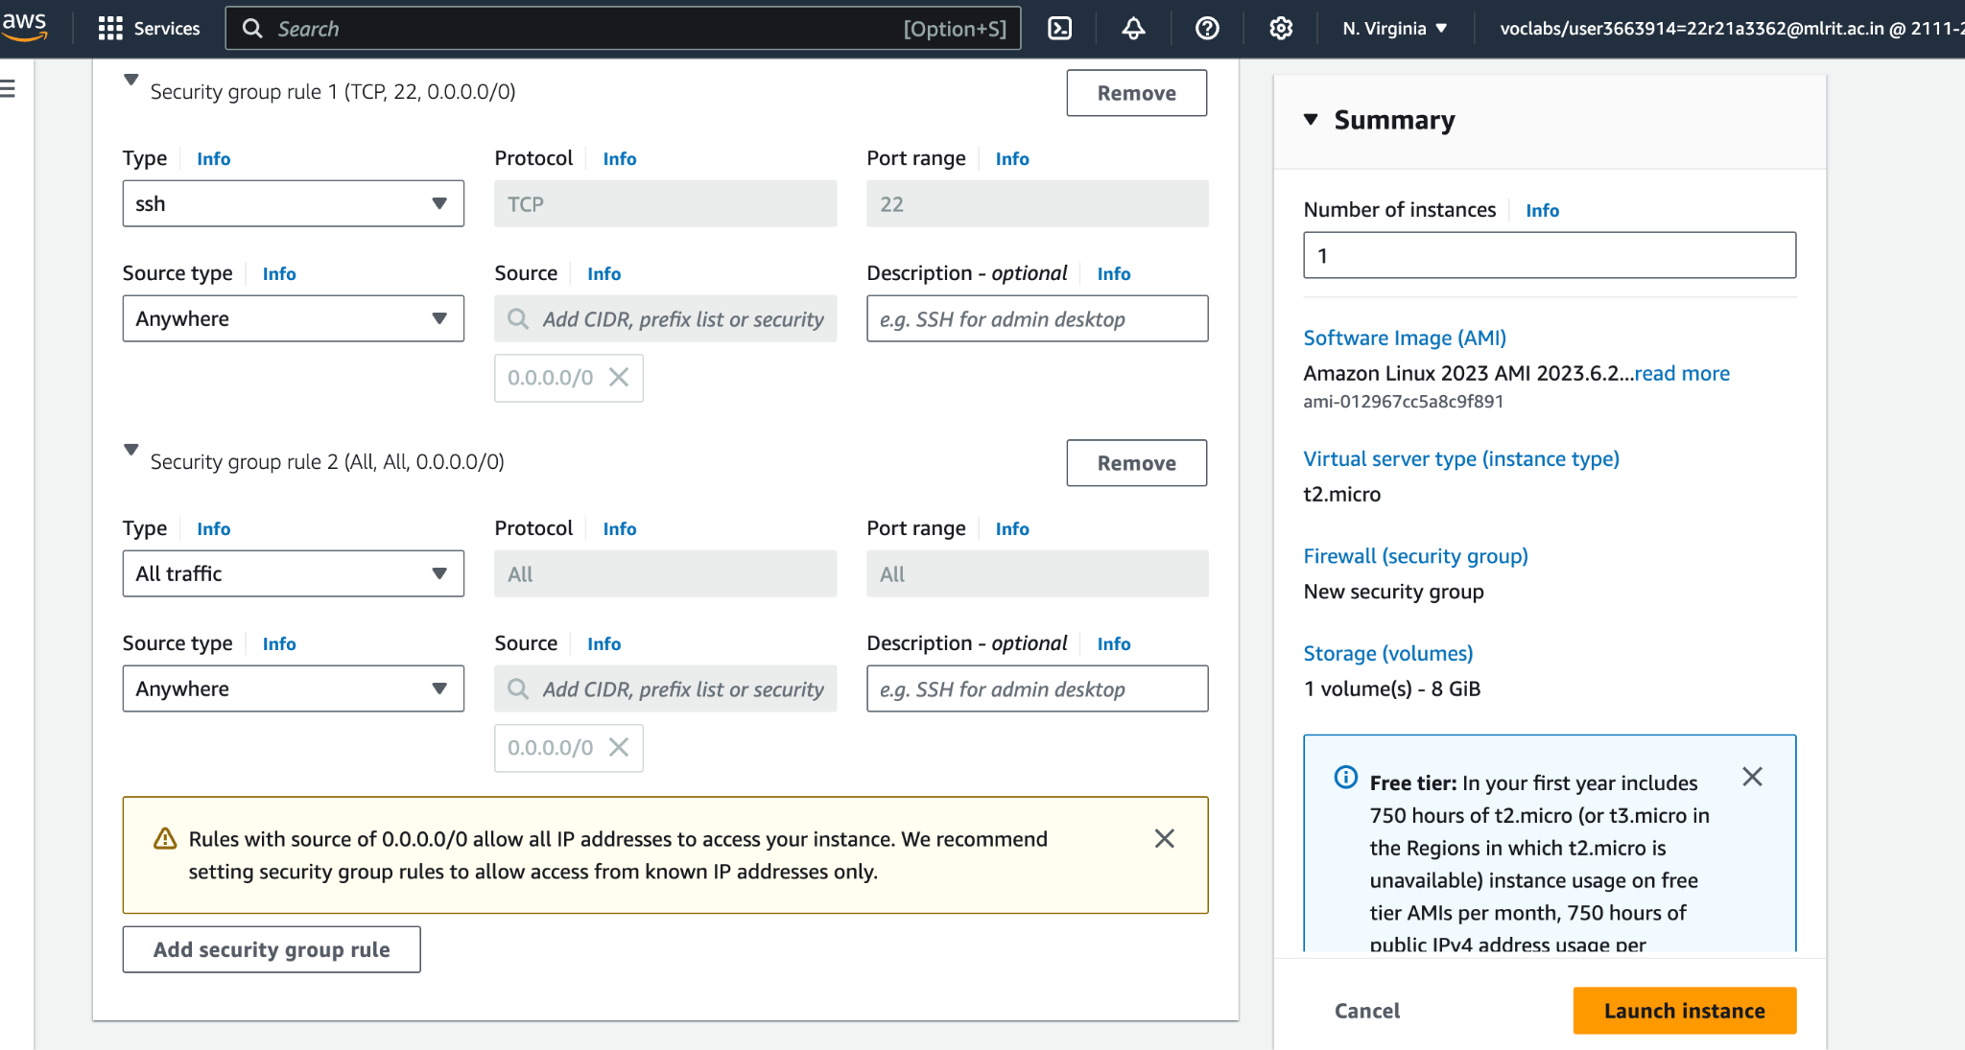Sign into your AWS account and create your Linux AWS account with slight modifications to the network settings.
2. Launch your linux instance

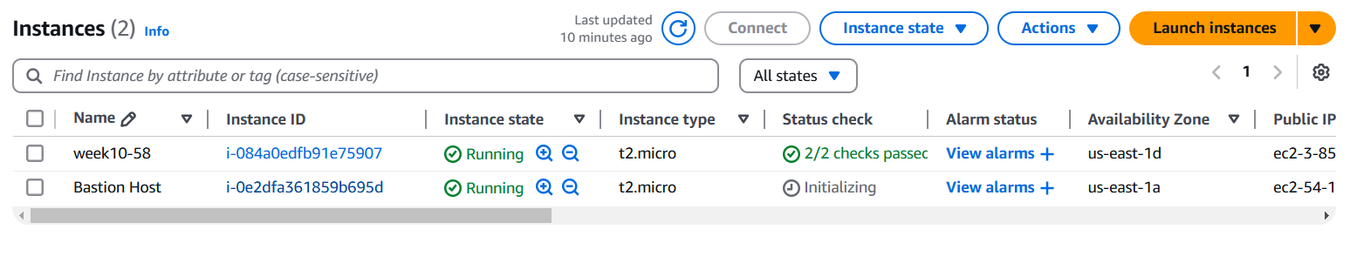

1. And use sudo–i command to switch to root user
2. Use “yum install docker –y” command to install docker

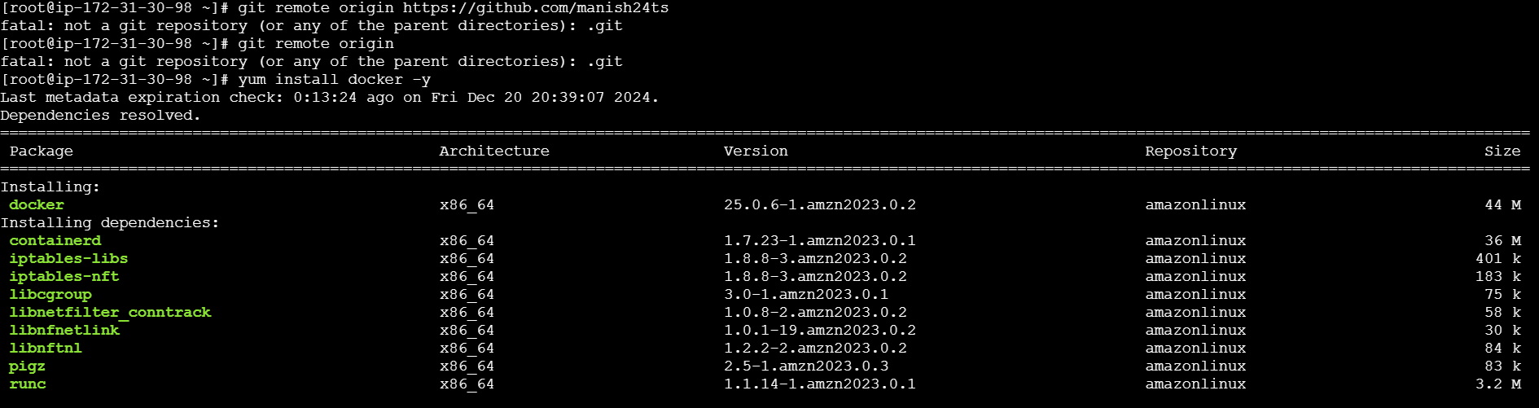

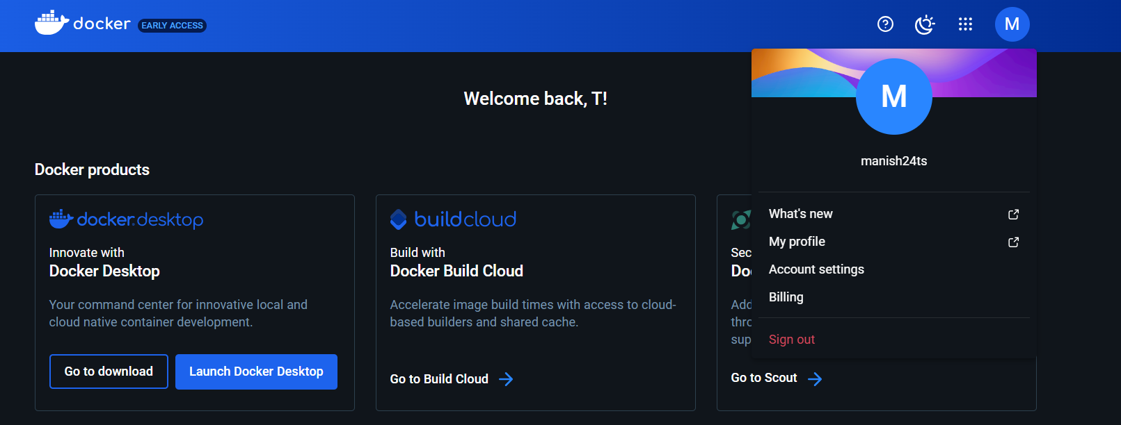

1. To enable the docker use the command “systemctl restart docker.service” and to restart the docker use the command “systemctl status docker.service”
2. Now paste the copied command of ubuntu from docker website and run.
3. Now running the command “docker images”, we get information about images
4. You can directly install or create image by using command docker run <image name>;
5. After using command docker images to get all the images type the command “docker ps” to check any container list is present or not.
6. Then use command “docker ps –a” to check any active processes are there or not and then use
7. command docker run –it ubuntu and type exit.
8. Then type “docker ps –a” to get the list of containers in the system.
9. To create a new name for container use command “docker run –it --name manish58 ubuntu” and to change the command use “docker run –it –manish58 ubuntu /bash”
10. Use commands docker start/stop <container name> for starting or stopping container.
11. Use command docker attach <containername> to attach containers after starting them only.
12. Use command docker rm <containername> to remove them.