DT – Dvoretsky-Theory

Contents

**PAWN ENDGAMES** 4

**Key Squares** 4

**The Rule of the Square** 8

**Pawn Race** 12

**The Outside Passer** 16

**The protected passed pawn** 18

**Rook vs. Pawn** 29

**Moving Downstairs** 29

**Cutting the King Off** 29

**Pawn Promotion** 30

**Gain of Tempo** 31

**Shouldering** 31

**Outflanking** 32

**Rook vs. Separated Pawns** 33

Endgame theory is not a complicated subject to study!

All one needs is

* Thorough knowledge of a limited number of “precise”(elementary) positions plus
* Some of the most important principles, evaluations, and standard techniques.

In the endgame, plans must be found all the time - so it sharpens our strategic eye as well.

Human memory is limited, so there is no sense in filling it up with rarely-seen positions that will probably never occur in our actual games. One should study relatively few positions, the most important and most probable, but study and understand them perfectly. One should not remember long and perplexing analyses. We may never have an opportunity to reproduce them in our games, and we will certainly forget them sooner or later. Our basic theoretical knowledge must be easy to remember and comprehend.

Some complicated positions are also important, but we may absorb their general evaluations and basic ideas, plus perhaps a few of their most important lines only.

Endgame ideas.

These represent, of course, the most significant part of endgame theory.

Study of certain endgame types can be almost fully reduced to absorbing ideas (**general principles**, **standard** **methods** and **evaluations**) rather than to memorizing precise positions.

When discussing precise positions, we will certainly point out the endgame ideas in them. But many standard ideas transcend any particular precise position. These ideas should be absorbed with the help of schemata – very simple positions where a technique or a tool works in a distilled form and our attention is not distracted by any analysis of side lines. Over the course of time we may forget the precise shape of a schema but will still remember the technique. Another method of absorbing endgame ideas is to study practical games or compositions where the ideas have occurred in the most attractive form.

In a manual, it should be explained how one can discover the correct solution, which ideas are involved.In a handbook, a solution of a position is all one needs

In chess (as in any other sphere of human activity), a confident retention of theory cannot be accomplished solely by looking at one example: one must also get some practical training with it. For this purpose, additional examples are helpful.

Formal definition of “endgame” is: the stage of a chess game when at least one side has no more than one piece (in addition to the king).

Self-training develops one’s ability to calculate lines deeply and precisely; this skill is essential for every player.

Studying endgame theory is not a very labor-intensive process, but analysis of a particular endgame, or practical play under time restriction in a tournament, can be a much more sophisticated and complicated matter.

Therefore, my readers will find corrected versions of many interesting endgame analyses,plus some entirely new analyses that are important for endgame theory.

You will see instructive examples where the basic theoretical knowledge you have just studied is applied in a practical situation.

The connection between the theory and the practical case will not always be direct and obvious.

It is not always easy to notice familiar theoretical shapes in a complicated position, and to determine which ideas should be applied in this concrete case.

On the other hand, a position may resemble the theory very much but some unobvious details exist; one should discover them and find how this difference influences the course of the fight and its final outcome.

The database also has two Theme Keys. One can be found from the list window by clicking the Endgame Tab.

The contents of the endgame key are generally devoted to the different material configurations.

The other key is found in the General Theme tab. This key resembles the table of contents of the book, with this key one can easy follow the text from the book at his computer, correct some positions, add his own instructive examples,or even create and add subkeys. Therefore one can construct his own endgame database with a more practical structure than the formal arrangement according to material relations. So it is a very useful tool for the users personal work with the book. It will enable users to immediately find all positions on a desirable topic (such as Zugzwang, Stalemate, or King's Activity).

# 

# **PAWN ENDGAMES**

Pawn endings are very concrete - even the tiniest change in the position generally alters the shape and outcome of the struggle. Here you can rarely get along on “general principles” - you must know how to **calculateaccurately**.

The study of pawn endings chiefly boils down, not to the memorization of exact positions, but to the assimilation of standard techniques, which considerably eases our search for a solution and the calculation of variations.

Many pawn endings are clearly defined **tempo-battles**. In these endgames, **speed** is everything: which pawn will queen first, will the king come in time to stop the passed pawn or get to the other side of the board in time. And there are other pawn endings in which a war of manoeuvre predominates, and in which **zugzwang** assumes paramount importance.

“Maneuvering” endgames are generally more complex than “rapid” ones; but we shall begin with them, in order to acquire the vital concept of “**corresponding squares**”. Then we shall switch to studying the ideas involved in “rapid” endgames, before returning once again to the “maneuvering”.

## **Key Squares**

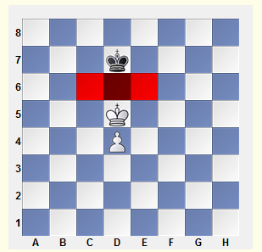Key Squares are what we call those squares whose occupation by the king assures victory, regardless of whose turn it is to move. In other types of endgame, we may also speak of key squares for other pieces besides the king.

The d5-square on which the king now stands is not a key square - White to move does not win. The key squares are c6, d6 and e6. Black to move must retreat his king, allowing the enemy king onto one of the key squares. With White to move, the position is drawn, since he cannot move to any key square.

Illustrative Example 1-1

**Corresponding squares**

Corresponding squares are squares of reciprocal zugzwang. We may speak of corresponding squares for kings, for kings with pawns, and with other material, we may speak of correspondence between any pairs of pieces.

The most commonly seen cases of corresponding squares are:

* The opposition,
* Mined squares, and
* Triangulation.

**Opposition**

Opposition is the state of two kings standing on the same file with one square separating them (“close” opposition; three or five squares between is called “distant” opposition); the opposition may be vertical, horizontal, or diagonal.

“To get the opposition” means to achieve this standing of the kings one square apart with the opponent to move (that is, to place him in zugzwang); “to fall into opposition” means, conversely, to fall into zugzwang oneself.

Return to Example 1-1, where we see the simplest case of the opposition (close, vertical). With White to move, there is no win: 1 Kc5 Kc7‡; or 1 Ke5 Ke7‡. Black to move loses, because he must allow the enemy king onto one of the key squares: 1...Kc7 2 Ke6; or 1...Ke7 2 Kc6.

When we are speaking of the opposition, it is usually not just one pair of squares, but several, which are under consideration: c5 and c7, d5 and d7, e5 and e7.

The stronger side gets the opposition in **order to execute an outflanking** (where the enemy king retreats to one side, and our king then attacks the other way). The weaker side gets the opposition in order to **prevent this outflanking**.

**Mined (untouchable) Squares**

Sometimes, it is a single pair of squares that correspond; these squares are referred as “mined.”

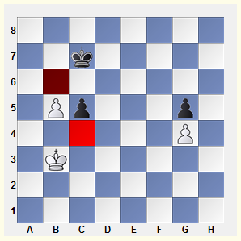Donot be the first to step on a mined square, or you’ll be “blown up” - that is, fall into zugzwang. You must either wait next to the mined square, or move forward, accurately avoiding it.

Here we have “untouchable pawns”. White’s king shuttles between b3, c3 and d3, while the Black king goes from c7 to b7 to a7, neither of them able to attack the pawn - the squares c4 and b6 are mined.

**Triangulation**

Triangulation refers to a king manoeuvre which aims to lose a tempo, and leave the opponent with the move.

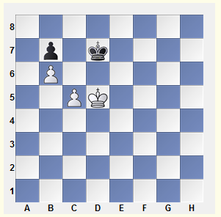

The d5- and d7-squares are in correspondence. The mobility of Black’s king is restricted - he must watch for the c5-c6 break, and also avoid being pressed to the edge of the board. It’s not surprising, therefore, that White can easily “lose” a tempo and place his opponent in zugzwang.

**Other Cases of Correspondence[VVI]**

Situations with corresponding squares come in all shapes and sizes - from the most elementary to cases so complex that most of the unoccupied squares on the board turn out to be squares of reciprocal zugzwang.

How is the correspondence between squares determined?

There is no special formula. The sensible way is

* To find key squares,
* Examine the possible plans for both sides, and
* Calculate the simplest variation.

This preliminary analysis may uncover some reciprocal zugzwang situations; from there, you may go on to define an entire network of corresponding squares.

This examples demonstrate how to make a logical analysis of a position.

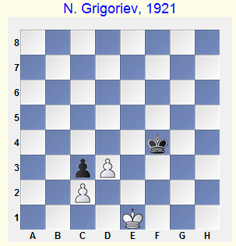Black is obliged to defend the key squares e2 and f2, which he can do either by 1...Ke3 or 1...Kf3. The first appears more natural (the opposition!); but let’s not be too hasty about drawing our conclusion.

White’s king will attempt to break through on the queenside, by occupying the key square b3 - this too must be prevented. With White’s king at a2, Black‘s king is obliged to occupy the b4-square (a4 would be too far from the kingside). Immediately, we have the whole packet of corresponding squares: a2 - b4, b1 - c5, c1 - d4, d1 - e3 and e1 - f3. As it turns out, the routine 1... Ke3? loses - after 2 Kd1, Black would be in zugzwang. But 1...Kf3! 2 Kd1 Ke3 draws easily.

I gave this example, not because it was especially important, but in order to underscore that a system of **corresponding squares** certainly **does not** have to always be “straightline”, as with the **opposition**. Each case demands concrete analysis. You may only take the opposition after having ensured that this will place your opponent in zugzwang, not yourself.

And if, as in the present example, you must instead cede the opposition to your opponent, I call such cases of corresponding squares the “anti-opposition”. This term seems more exact than the term, “knight’s-move opposition” I have seen used (after all, the entire idea of “opposition” is for the kings to be standing on the same line, not on adjoining lines).

## **The Rule of the Square**

Imagine a square having for one of its sides the path from the pawn to its queening square. If the king stands within the square of the passed pawn, or can reach it on his move, he can stop it; otherwise, the pawn will queen.

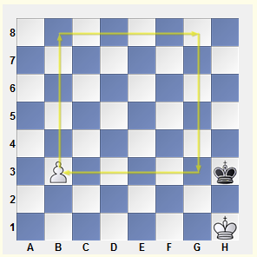Black to move gets inside the square and draws (1...Kg4 or 1...Kg3). If it’s White’s move, then after 1 b4 the side of the new square becomes the f-file, which Black’s king cannot reach in time.

If the pawn stood on b2, then because the pawn can move two squares, the square should still be constructed from the b3-square.

Obstacles in the path of the king: It sometimes happens that even though the king is located within the square, it still can’t stop the passed pawn, because its own pawns get in the way.

**The Floating-square**

There are cases in which the king must do battle with two separated passed pawns; in these cases, a useful rule is the floating-square rule, suggested by A. Studenecki in 1939.

* If a square whose two corners are occupied by pawns (on the same rank) reaches the edge of the board, then one of those pawns must queen.
* If the square does not reach the edge of the board, then the king can hold the pawns.
* If there are two files between the pawns, the king can capture both;
* If the distance is any greater, he can only prevent their further advance.

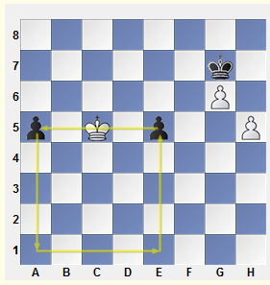

The square having reached the edge of the board, the pawns will queen, regardless of whose move it is.

1...a4 2 Kb4 e4 3 Kxa4 e3-+

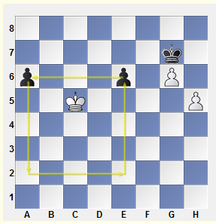Let’s shift the pawns to a6 and e6. The square now reaches only to the 2nd rank, and the position becomes a draw.

In fact, 1...a5? would be bad: 2 Kb5 e5 3 Kxa5+-

and so is1...Kh6? 2 Kd6! a5 3 Kxe6 a4 4 Kf7 a3 5 g7 a2 6 g8Q a1Q 7 Qg6#.

Black must play 1...Kf6 2 Kc6 ...e5 3 Kd5 (but not 2 Kb6? e5 3 Kc5 a5-+) 2...Kg7 (2 a5 4 g7 Kxg7 5 Kxe5= is possible, too) 3 Kc5=.

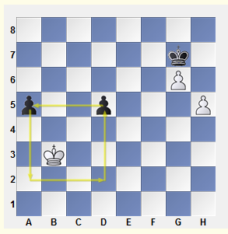

This square doesn’t reach the edge of the board, and the distance between the pawns is the most unfavourable: two files. This means the pawns are lost, regardless of who is on the move.

1 Ka4 d4 2 Kb3 Kh6 3 Kc4 a4 4 Kxd4+-

Let’s examine one more substantive case.

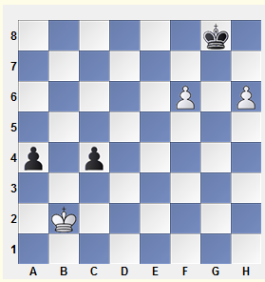

On the queenside, the square doesn’t reach the edge of the board, so the pawns can be held: 1 Kc3 a3 2 Kc2.

On the kingside, however, the pawns are already quite far advanced. True, the king can prevent them from queening - so far; but because of zugzwang, he will soon be forced to let them through.

**Reti’s Idea**

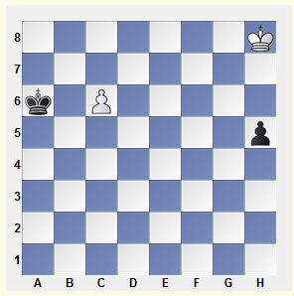It sometimes happens that a king outside the square of a passed pawn can still catch it. The win of the missing tempo (or even several tempi) is accomplished by the creation of accompanying threats, most often (though not exclusively) involved with supporting one’s own passed pawn.

Black’s king lies within the square of the c6-pawn, while White is short two tempi needed to catch the h5-pawn. Nevertheless, he can save himself - the trick is “to chase two birds at once”. The king’s advance is dual-purpose: he chases after the h-pawn, while simultaneously approaching the queen’s wing.

**Three connected pawns**

It’s difficult for the king to fight three connected passed pawns.

He has no chance at all, if the enemy has any moves in rese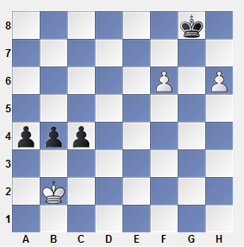rve. If not, then a situation of reciprocal zugzwang could arise.

White to move wins by 1 Kb1! (1...b3 2 Kb2‡; 1...a3 2 Ka2 c3 3 Kb3‡; 1...c3 2 Kc2 a3 3 Kb3‡). Any other first move by White leads to the opposite result.

But this is loss because Black has reverse tempi.

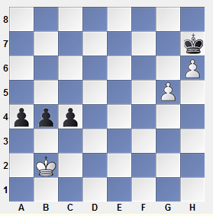

## **Pawn Race**

Let’s examine the sort of situation where both players advance simultaneously, and queen at the same time, or almost at the same time. Here, the following outcomes are possible:

1) One rook’s pawn prevents the other rook’s pawn from queening;

2) The pawn queens with check, and thereby prevents the enemy pawn from queening; or

3) We get a “queen vs. pawn (or pawns)” endgame.

Or, if both pawns queen, then:

4) One queen is lost to a “skewer” check along the file or diagonal;

5) Mate follows;

6) The queens are exchanged, after which we once again have a pawn ending; or

7) We get a queen ending (either an elementary one, or one with some play to it).

Quite often, the chief problem of a position is either to draw the enemy king onto a bad square, or to avoid such a square with one’s own king.

**Active King: Zugzwang**

**King activity** is the most important factor in any endgame. But in pawn endgames, where there are no other pieces on the board, this is perhaps an especially important factor.

Here, we examine two vitally important means of exploiting an active king’s position:

* playing for zugzwang, and
* The widening of the beachhead.

**Zugzwang**

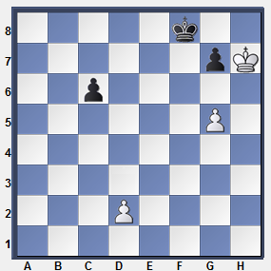

Black to move

…Kf7 [if …c5 2. g6! 3.c4 Kh8] 2.d4! ZuzgwangKf8 3.g6 +

White to move

1.g6! 2.c5 d3+

Widening the Beachhead

Click below for the Widening the Beachhead examples.

**King Routes: Zigzag**

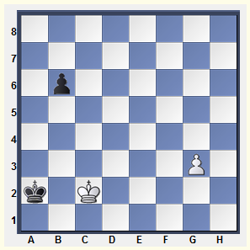The laws of geometry, have no relevance on the chessboard. If the king follows a broken-line path, it is by no means longer. This phenomenon is exploited both in the **Réti idea**, and in the “**shoulder block**” .

Here, we shall speak of a technique closely connected with the simultaneous advance of pawns we just studied. To be more exact: we shall be speaking of two techniques, which look very similar. Let’s call them “zigzag”.˜

The direct 1. g4? leads only to a draw b5 2. g5 b4 3. g6 b3+4. Kc3 b2 5. g7 b1=Q 6. g8=Q+ Ka1 =

**1.Kc3! Ka3 2.Kc4 Ka4 3.g4 b5+ 4.Kd3!** {Here's the zigzag! The king returns to c2, while avoiding the pawn check. Compare it with **Reti's idea**}

**Ka3 5.g5 b4 6.g6 b3 7.g7 b2 8.Kc2!** {drawing the king into check} Ka2 9.g8=Q+ 1-0

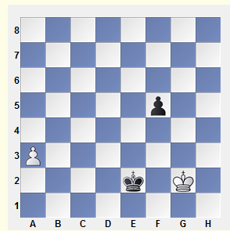**The Pendulum**

**1 Kg3! Ke3 2 Kg2! Ke2** (2...f4 3 Kf1) **3 Kg3**=

This elementary defensive technique appears frequently.

**Shouldering**

One must choose a route for the king such that it gives a “shouldering” to the enemy king - that is, it prevents the enemy from arriving in time at an important part of the board.

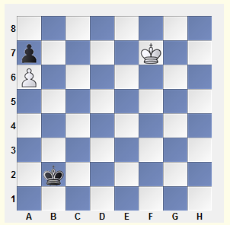

White must inevitably win the pawn at a7. Black can save himself only if he can succeed in locking the White king into the corner with ...Kc7.

The game was drawn after 1 Ke6 Kc3 2 Kd6? Kd4 3 Kc6 Ke5 4 Kb7 Kd6 5 Kxa7 Kc7.

Maizelis demonstrated a win for White by 1 Ke6! Kc3 2 Kd5!+-

White’s king approaches the a7-pawn while simultaneously “shouldering” the enemy king, keeping it from approaching the c7-square.

**Breakthrough**

A Breakthrough occurs when one or more pawns are sacrificed in order to create a passed pawn and promote it.

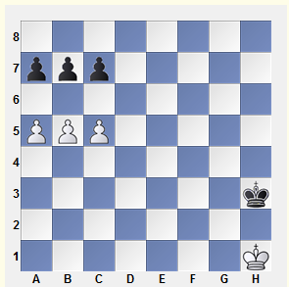

White to move wins by 1 b6! cb (1...ab 2 c6) 2 a6! ba 3 c6

Black to move has only one way to parry the threatened breakthrough: by 1...b6! (both 1...a6? 2 c6! and 1...c6? 2 a6! are bad).

Let’s add one more White pawn at c4.

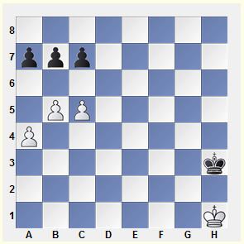

In this case, Black can stop the breakthrough for good by playing 1...c6! 2 a5 a6!

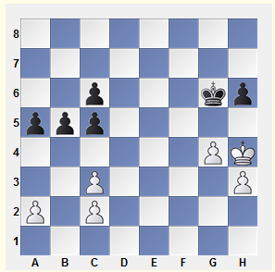

This is the sort of structure we find in the Ruy Lopez Exchange Variation. Black to move can create a passed pawn by 1...c4! 2 Kg3 c5, followed by b5-b4, a5-a4 and b4-b3. (Formally the term “breakthrough” isn’t really appropriate here, since no pawn sacrifice is involved; but the effect is just the same.)

White to move can stabilize the situation on the queenside by 1. c4!, which guarantees him a decisive advantage, thanks to the outside passed pawn he will create on the opposite side of the board.

## **The Outside Passer**

An outside passed pawn usually means a positional advantage sufficient to win. This pawn will draw off the enemy king, allowing our own king to be the first to attack the enemy pawns.

Black(Defender) meet the threat of an outside passed pawn with the activation of his king, which sometimes even won for him.

**Two Rook's Pawns with an Extra Pawn on the Opposite Wing**

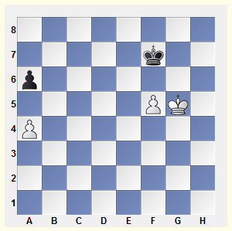Positions in which two rook’s pawns are facing each other, with one side having a distant passed pawn, are fairly common in practice; so it’s useful to have a quick and accurate way of evaluating them.

The **plan** for win:the king will go after the rook’s pawn. His opponent, meanwhile, must eliminate the pawn on the other wing, and then rush his king over to the corner where he can stop the rook’s pawn. Under what circumstances can he succeed?

White to move wins: 1 a5! Kg7 2 Kf4 Kf6 3 Ke4 Kf7 4 Kd5 Kf6 6 Kc6 Kxf5 6 Kb6 Ke6 7 Kxa6 Kd7 8 Kb7

If it’s Black to move, after 1...a5! The position is drawn, as you may easily determine: Black’s king has enough time to get to c8.

But let’s say that we move the kings and the f-pawn one rank down, or one file to the left; then, once again, Black loses. But what if we also move the queenside pawns one rank down?

Of course, with the position standing in front of us, any question is easily answered. But in practice, such situations often occur at the end of long calculations, and extending such calculations a few moves further yet could be most difficult. It would be good to have a definite evaluation of this position immediately, as soon as we lay eyes on it.

Rules of quickly evaluating this sort of position.

1) If the rook’s pawn of the stronger side has **crossed** the middle of the board, it’s always a win.

2) We shall designate a “normal” position, in which:

* + The rook’s pawns, which block one another, are separated by the middle of the board; and
  + Black’s king, aiming for the c8-square, can reach it (c8) without loss of time. This is because the passed pawn has either traversed the key diagonal h3-c8, or stands upon it.

The “normal” position is drawn.

3) For the kingside passed pawn, every square behind the h3-c8 diagonal is a **reserve tempo** for White. For example:

* The pawn at f4 means one reserve tempo;
* The pawn at e4 - two.
* And if the king is not beside the passed pawn, but in front of it, that’s another reserve tempo.

And every square the queenside pawns are **behind the “normal” position** is a **reserve tempo**for the defending side.

* With pawns at a3/a4, Black has a reserve tempo in his favor;
* With pawns at a2/a3 - two.

White wins only if the relative number of tempi calculated by the means shown above is in his favor.

The formulation may seem a bit ungainly; but once memorized, it’s quite easy to apply. For example:

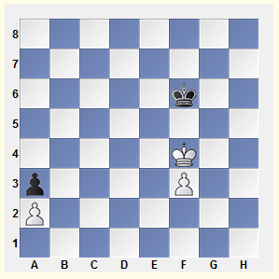In the following diagram, White of course is on the move (if it were Black to move, the f-pawn would queen). White wins, because the count is 3:2 in his favor.

Black has two tempi, because the queenside pawns are two squares behind the “normal” position;

and White’s f3-pawn being two squares behind the h3-c8 diagonal (the f5-square), and his king being in front of the pawn, gives him three tempi.

1 Ke4! Ke6 2 Kd4(d3)+-

1 Ke3? Ke5(f5)= would be a terrible blunder, because then we would have a position where the tempi are 2:2 (White’s king is no longer in front of the f-pawn, but next to it) - which makes it a draw.

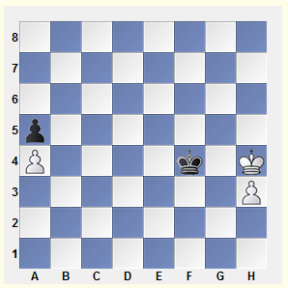One more useful addendum to the rule. Let’s suppose that White’s passed pawn is a rook’s pawn, with the king in front of it, but the enemy king is boxing his opposite number in on the rook file. This situation is the same as the one in which the king is next to his pawn.

According to the rule formulated above, this is a draw. And in fact, after 1...Kf5 2 Kh5 (2 Kg3 Kg5 is the “normal” position), Black does not play 2...Kf6? 3 Kg4, when White has a reserve tempo, because his king is in front of his pawn, but 2...Kf4! 3 h4 (3 Kg6 Kg3) 3...Kf5 4 Kh6 Kf6 5 Kh7 Kf7(f5) 6 h5 Kf6!, etc.

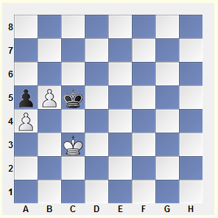

It must be noted here that this last rule is inoperative with the pawn on its starting square.

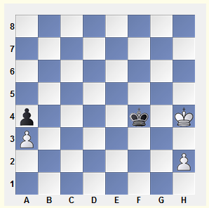In the following diagram, Black has one tempo (since the queenside pawns are one rank back), but if it’s his move, he still loses. The problem lies in the fact that the standard 1...Kf3 is impossible, in view of 2 Kg5 Kg2 3 h4; while after 1...Kf5 2 Kg3 Kg5, White has not one, but two tempi (the pawn is below the c8-h3 diagonal, and the king is in front of the pawn).

With White to move, the position is drawn, even if the queenside pawns are placed as in the “normal” position, because the h-pawn will have to go to h3: 1 Kh5 Kf5 2 h3 (2 Kh6 Kg4=) 2...Kf4!=.

Let’s look at some more complex examples, in which understanding my proposed rule considerably simplifies the calculation of variations.

## **The protected passed pawn**

The protected passed pawn, like the outside passed pawn, is usually a most definite positional advantage. The enemy king cannot leave its square, and cannot capture it, whereas our king has full freedom of movement.

**Two Pawns to One**

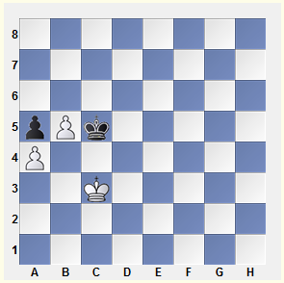 These positions are generally won.

1 Kd3 Kd5 2 Ke3 Ke5 3 Kf3 Kd5 4 Kf4 Kd6 5 Ke4 Ke6 6 Kd4 Kd6 7 Kc4 (Black must give up the opposition) 7...Kc7 8 Kd5!

8 Kc5?! is inaccurate: 8...Kb7, and White cannot continue 9 b6? because of 9...Ka6! 10 Kc6 stalemate.

8...Kb6 9 Kd6 Kb7 10 Kc5‡ Kc7 11 b6+ Kb7 12 Kb5+-

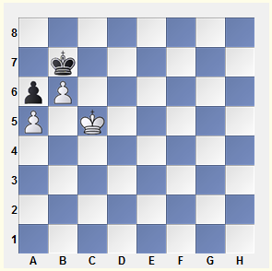Now let’s look at the two most important drawn positions.

First position:

The first is an elementary one, but it comes up rather regularly.

Black plays 1...Kb8 2 Kc6 Kc8=.

Move the whole position one file to the right, and White wins easily by sacrificing the pawn and then winning the enemy’s last pawn.

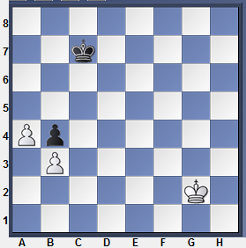Second position:

The second is less likely to occur, but it’s very instructive.

The key squares are c4, d4, and e4. Black can protect them, if he can control the opposition when the enemy king approaches.

Let's determine the corresponding squares. With White's king on d3, f3 or h3, Black's king must occupy d5; the e3- and g3-squares correspond to e5. When the king advances further, Black must keep the lateral opposition, maneuvering along the d- and e-files.

When White's king is on the second rank, Black's king must stay next to the d5- and e5-squares - specifically, on d6 or e6. So the first move - as well as all the play that follows - now becomes clear:

**1... Kd6!** [But not 1... Kc6? 2. Kg3! Kd6 (2... Kc5 3. Kg4 Kd4 4. Kf4 +-) 3. Kf4! Kd5 4.

Kf5 +-]**2. Kh3** (2. Kf2 Ke6! 3. Ke2 Kd6!) **2... Kd5 3. Kg3 Ke5 4. Kh4 Kd4 5. Kh5 Kd5 6. Kg6 Ke6! =**

**Multi-Pawn Endgames**

The next example features a typical plan for exploiting the advantage:

**Undermining**

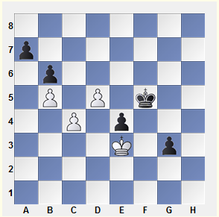Sometimes the pawns are too strong to be successfully attacked by the king. In such cases, Undermining can be used successfully - the exchange of a pair or two of pawns, with the aim of weakening the pawn chain.

Grigoriev demonstrated the simplest winning method, involving an undermining on the queenside.

1...Ke5! 2 Ke2 Kd6 3 Ke3 Kc7 4 Ke2 Kb7 5 Ke3 a6 (5...a5) 6 ba+ Kxa6 7 Ke2 Kb7 (7...b5?? 8 d6 Kb6 9 cb=) 8 Ke3 Kc7 9 Ke2 Kd6 10 Ke3 b5! 11 cb Kxd5-+

On the other hand, Alekhine’s plan of going into a queen endgame was also quite strong.

1...Kg4!? 2 d6 g2 3 Kf2 Kh3 4 d7 e3+! 5 Kf3 g1Q 6 d8Q Qf2+ 7 Ke4 e2 8 Qd7+ Kg2 9 Qg4+ Kf1 White resigned.

**Connected Passed Pawns** B. Horwitz, J. Kling, 1851

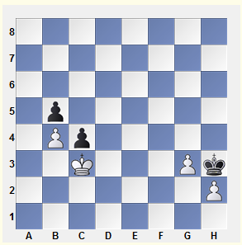Here we have a typical situation with two connected passed pawns. The draw would appear to be inescapable, since the White king is tied to the square of the protected passed pawn at c4. But in fact, in such cases White can sometimes leave the square to help his pawns queen or checkmate his opponent.

White’s plan usually consists of the following elements:

* The furthest possible advance of the pawns
* The optimum placement of the pawns - “ready to roll”
* Choosing the best time for the king’s decisive advance

Let’s watch this plan in action. In the first stage the king, without leaving the square of the c4-pawn (which ends at f4), aids in the advance of his pawns.

1 Kd4 Kg4 2 h4 Kh5 3 Ke3 Kg4 4 Ke4 Kh5 5 Kf4 Kh6 6 g4 Kg6 7 h5+ Kh6 8 Kf3 Kg5 9 Ke4 Kh6 10 Kf4

Triangulation is White’s most important weapon in this ending.

10...Kh7 11 g5 Kg7 12 g6!

The ideal pawn array! The erroneous 12 h6+? would throw away the win.

12...Kf6 13 Ke4 Kg7 14 Kf3 Kf6 15 Kf4 Kg7

Now that White has strengthened his position to its utmost, it’s time for the decisive advance!

16 Kg5! c3 17 h6+ Kg8 18 Kf6 c2 19 h7+ Kh8 20 g7+ (or 20 Kf7 c1Q 21 g7+) 20...Kxh7 21 Kf7 c1Q 22 g8Q+ Kh6 23 Qg6#.

**The Stalemate Refuge**

When there are only a very few pieces left on the board, stalemate becomes one of the most important defensive resources - remember the “king and pawn vs. king” ending, if nothing else.

Out of the many possible stalemate situations, it’s worth noting the following:

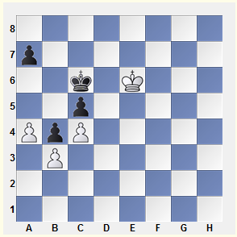

The loss of the c5-pawn appears inevitable; however, Black can still save himself.

1...Kb6! 2 Kd5 a6! 3 Kd6 Ka5!, and the pawn is untouchable, because of the stalemate.

Transposition of moves by 1...a6?? would be a grievous error - White would reply 2 a5!, eliminating the king’s stalemate refuge.

"Semi-Stalemate"

- is situation when the king is stalemated (on the edge or in the corner of the board), but there are still pawn moves left to make. Instead of stalemate, what we get is zugzwang - usually, a fatal one for the stalemated side.

See the game: Marshall-Reti, New York 1924 and the Study: J. Kling, B. Horwitz 1851.

**Reserve Tempi: Exploiting Reserve Tempi**

Exploiting Reserve Tempi

We have already seen more than once how the outcome of a game may hinge on one side’s store of reserve pawn tempi. This is not surprising, considering that zugzwang is the fundamental weapon in the majority of pawn endings.

The rules involved in the use of reserve tempi are simple and self-evident:

1) Use every chance to accumulate reserve tempi and to deprive your opponent of his;

2) Hold onto them - don’t waste them except under absolute necessity.

Let’s observe these rules in action. The first is illustrated in the following two examples.

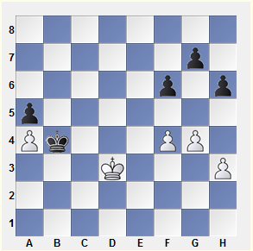

**1 f5!**

This move secures White two reserve pawn tempi - just enough to squeeze the enemy king at the edge of the board.

**1...Kxa4 2 Kc4 Ka3 3 Kc3 a4 4 h4 Ka2 5 Kc2 a3** (5...h5 6 gh a3 7 h6 gh 8 h5 is zugzwang) **6 h5‡ Ka1 7 Kc1**=B

**Steinitz's Rule**

Wilhelm Steinitz’s paradox: **the pawns stand best on their original squares.**

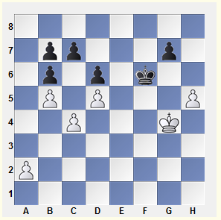His explanation: In the endgame, it is useful to have a choice of whether to advance a pawn one or two squares.

The analysis given below was made by ArturYusupov when he was still quite young, with the assistance of your author.

We can see at once the idea of a pawn breakthrough on the queenside, after a2-a4 and c4-c5. Obviously, it will have no chance of succeeding unless the Black king is taken far enough away.

First, it is necessary to put Black on the move; it is also important to leave the a-pawn where it is, since from its original square, it has the choice between moving one or two squares forward.

**g- and h-Pawns vs. the h-Pawn**

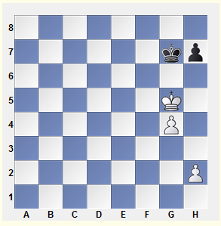

With Black’s pawn on its starting square, the only winning plan becomes a king invasion at h6. Even the conquest of the h6-square, however, only guarantees victory in the event that one of White’s pawns remains on the 2nd rank, in order to have the choice between moving one or two squares.

* Black to move loses
* But with White to move, the position is drawn

**f- and h-Pawns vs. the h-Pawn**

We shall analyse the basic ideas of such positions by using the following study as an example.

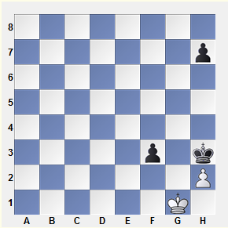If White plays 1 Kh1? (naively hoping for 1...f2?? stalemate) , then after 1...Kg4, his position is lost.

Black’s plan is elementary: his king goes to e3, and then he advances f3-f2, forcing the advance of White’s h-pawn. The fact that Black can choose whether to move his h-pawn one or two squares forward allows him to place his opponent in zugzwang.

For example: 2 Kg1 Kf4 3 Kf2 Ke4 4 Kf1 (4 Ke1 Ke3 5 Kf1 f2 6 h4 h5!) 4...Ke3 5 Ke1 f2+ 6 Kf1 Kf3! 7 h3 h5! 8 h4 Kg3, or 7 h4 h6! 8 h5 Kg3.

1 Kf2! Kg4 2 Ke3!‡

Thanks to zugzwang, the pawn must leave the h7-square; the position is now a draw. White must only make sure he chooses the right back-rank square for his king (corresponding to the position of Black’s h-pawn).

2...h6 3 Kf2 Kf4 4 Ke1! Ke3

Or 4...h5 5 Kf2 Ke4 6 Kf1!

5 Kf1 h5

5...f2 6 h3! Kf3 7 h4 Kg3 8 h5‡=

6 Ke1 f2+

6...h4 would be met by 7 Kf1! f2 8 h3=. But not the hasty 7 h3?, which would be a terrible blunder here, leading to the Fahrni - Alapin ending we know so well. Just a reminder: Black wins by triangulating with his king: 7...Ke4 8 Kf1 Ke5 9 Ke1 Kf5! 10 Kf1 Ke4‡.

7 Kf1 Kf3 8 h3! Kg3 9 h4=

So the stronger side wins only if the rook’s pawn is on the starting square.

**Both Sides have Reserve Tempi**

In many cases, it is not hard to establish the number of reserve tempi available for both sides (as it was, for example in the ending Kachiani - Maric). However, there are far more complex situations as well.

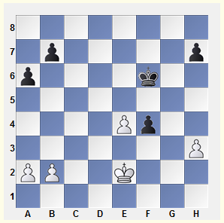

Steinitz’s rule tells us that, as far as reserve tempi go, White stands better on the queenside, while Black is better on the kingside. The following bit of advice will help you select the optimal strategy for such situations: Try to equalize, as quickly as possible, the situation on your “unfavorable” side.

Whoever has the move in the above position will succeed in executing the principle outlined above, and will win.

Šveida – Sika - Brno 1929

Let’s suppose it’s Black to move.

1...Ke5 2 Kf3 a5!

The pawns retaining the right to move either one or two squares should be left alone.

3 h4

3 a4 h6! and 3 b3 b5! 4 h4 b4 5 h5 h6 are no better.

3...a4 4 h5 h6 5 b4 ab (5...a3 6 b5 b6) 6 ab b6! 7 b4 b5-+

Now let’s see what happens with White to move.

1 Kf3 Ke5 2 h4! (but not 2 b4? h6!) 2...a5 3 h5 a4 (3...h6 4 a4) 4 h6! b6 (4...a3 5 ba b5 6 a4 ba 7 a3) 5 b4! ab (5...a3 6 b5) 6 ab b5 7 b4‡ Ke6 (7...Kf6 8 Kxf4 Kg6 9 Ke5! Kxh6 10 Kf6+-) 8 Kxf4 Kf6 9 e5+ Kg6 10 Ke4 Kxh6 11 Kd5 Kg7 12 Kd6 h5 13 e6+-