Contents

**Rook vs. Pawn** 5

**Moving Downstairs** 5

**Cutting the King Off** 5

**Pawn Promotion** 6

**Gain of Tempo** 7

**Shouldering** 7

**Outflanking** 8

**Rook vs. Separated Pawns** 9

**Knight VS Pawns**

**King in the Corner - Mate**

If the defender’s king is trapped in the corner, sometimes even a lone knight is able to mate.

White to move wins by

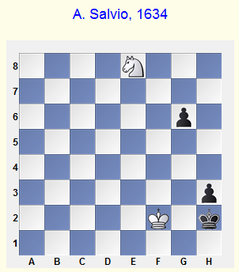1 Nf6 Kh1 2 Ng4 g5 3 Kf1‡ h2 4 Nf2#.

But even withBlack to move, the game lasts a littlelonger.

**1...Kh1**

[1...g5 2 Nf6 g4 3 Nxg4+ Kh1 4 Kf1‡ h2 5 Nf2#.]

**2 Nf6 Kh2**

[A - 2...h2 3 Ng4 g5 4 Ne3! g4 5 Nf1 g3+ 6 Nxg3#;

B - 2...g5 3 Ng4‡ h2 4 Ne3!]

**3 Ng4+ Kh1 4 Kf1 g5 5 Kf2‡ h2 6 Ne3 g4 7 Nf1 g3+ 8 Nxg3#**

**Drawn Positions**

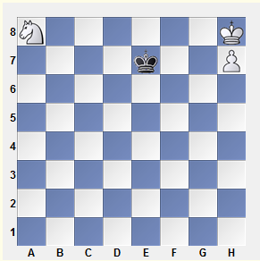Knight and pawn win easily against a lone king (that is, of course, so long as the pawn is not lost). But there are exceptions.

Black saves himself by squeezing the opposing king in the corner. He must only be careful to choose the correct square for his king. 1...Kf8? loses after 2 Nc7 Kf7 3 Ne6‡.

**1...Kf7! 2 Nc7 Kf8 3 Ne6+ Kf7=.**

It’s useful to note that the knight (as opposed to the rest of the pieces) cannot “lose” a move in order to give the move to the opponent - **the knight can’t triangulate**.

Knight vs. Rook Pawn

The closer the passed pawn to the edge of the board, the more difficulty the knight has in dealing with it. The rook pawns are especially dangerous. Here is a simple, yet instructive example.

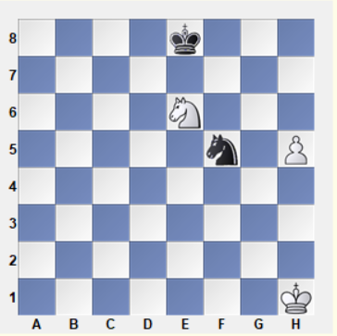

1 Ng7+! Nxg7 2 h6 Kf7 3 h7+-.

Note, that with White’s king at g2, the position would be drawn: the pawn is stopped after, for instance, 2...Ne6 3 h7 Nf4+ and 4...Ng6. In many instances, the knight can win the necessary tempo with a check to the enemy king.

The knight can hold a rook pawn without the king’s help, if it “touches” any square in its path, except the final, corner square.

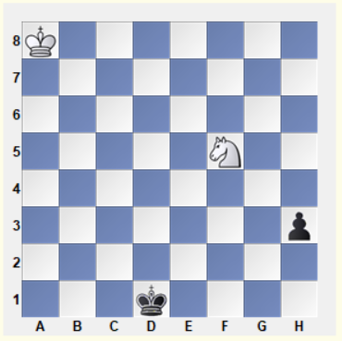

1 Ng3?? h2 2 Kb7 Ke1 3 Kc6 Kf2 is hopeless. The knight should aim for h2, not h1.

1 Ne3+! Ke2 2 Ng4 Kf3 3 Nh2+ Kg2 4 Ng4 Kg3 5 Ne3! Kf3 (5...h2 6 Nf1+) 6 Nf1, etc.

I should also point out that even with the knight in the corner, the position is certainly not always hopeless. True, the knight can no longer deal with the pawn by itself; but sometimes the

king can come to its rescue in time.

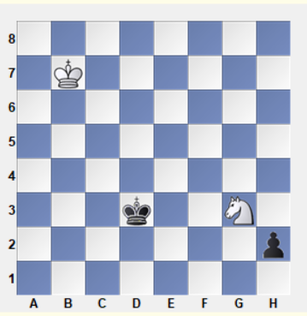Beauty of this position:

The knight has set up a barrier against the enemy king, who not only can’t cross the e2- and e4-squares, but also e3 and d2 (because of the forking Nf1+). Knight forks are a vital technique in knight endgames.

In order to attack the knight, the king will have to lose time with the outflanking Kc2-d1-e1-f2, or Kd4-e5-f4.

2...Kd4 3 Kc6 Ke5 4 Kc5 Kf4 5 Nh1 Kf3 6 Kd4 Kg2 7 Ke3 Kxh1 8 Kf2=.

2...Kc2 3 Kc6 Kd1 4 Kd5 Ke1 5 Ke4 Kf2 6 Kf4= (or 6 Nh1+ Kg2 6 Ke3=).

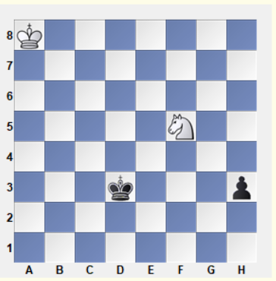Using the above theory White can draw this game!!

Ng3!!

Now the knight cannot get to h2 (1 Nh6? h2 2 Ng4 h1Q+ - the pawn queens with check). So White has to play 1 Ng3 (threatening 2 Nf1) 1...h2 2 Kb7.

**Bishop VS Pawns**

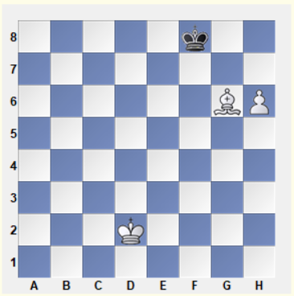

Black to play easy draw …Kg8!

White to play win – Bh7!

Some unusual draw positions

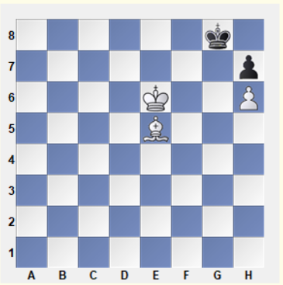

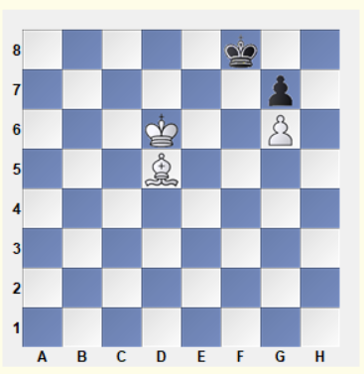

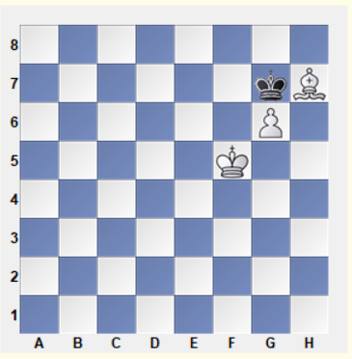

# **Rook vs. Pawn**

Practically all these endings are “rapid”; the outcome of the fight depends, as a rule, on a single tempo. We shall study typical techniques; mastering them does not free us from the necessity of deep and precise calculations, but makes this job much easier.

## **Moving Downstairs**

Pawn is stronger than a rook.

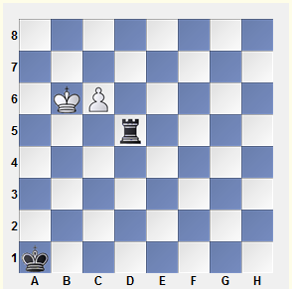**1 c7 Rd6+ 2 Kb5! (2 Kc5? Rd1) 2...Rd5+ 3 Kb4 Rd4+ 4 Kb3 Rd3+ 5 Kc2**

This maneuver, which helps the king to avoid checks, is what we call “moving downstairs.” However the fight is not over for the moment.

**5...Rd4!**

If 6 c8Q? then 6...Rc4+! 7 Qxc4 Stalemate.

**6 c8R!!** (… 7 Ra8+) **6...Ra4 7 Kb3!+-**

## **Cutting the King Off**

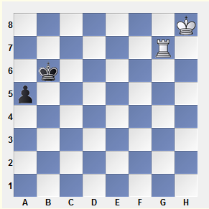

Rg5!+-

When the black pawn reaches a3 it will be abolished by means of Rg3 (the pawn may come even to a2 and then perish after Rg1 followed by Ra1. Ra3!).

With Black on move, after **1...Kb5(c5)!**the position is drawn, because cutting the king off along the 4th rank brings nothing.

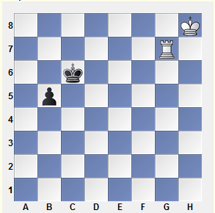The strongest move is still **1 Rg5!,**

But Black can respond with **1...Kb6**.

However the king transfer to the a-file loses time, and its position is less favorable there than on the c-file (where it “gives a shoulder kick” to the rival king).

After **2 Kg7 Ka5 3 Kf6**

White arrives in proper time to stop the pawn.

**Pawn Promotion** to a Knight

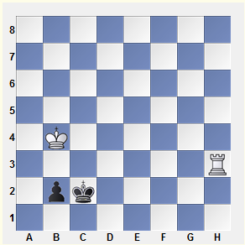

**1 Rh2+ Kc1 2 Kc3 b1N+! 3 Kd3 Na3 4 Ra2 Nb1!** leads to a draw.

It is worth mentioning that the erroneous 4...Nb5? loses the knight. In rook-versus-knight endings, one should not separate the knight from the king.

Black can also save himself by stalemate**:**

**1...Kb1! 2 Kb3 Ka1! 3 Rxb2.**

However, with a bishop or a central pawn his only drawing possibility is pawn-to-knight promotion.

If he has a **rook pawn**, this method **does not work**.

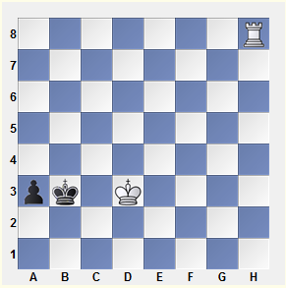Stalemate has practical value.

1...a2? 2 Rb8+ Ka3 3 Kc2! a1N+ 4 Kc3 Ka2 5 Rb7‡ is hopeless.

Correct is **1...Kb2! 2 Rb8+** (2 Rh2+ Kb3!, rather than 2...Kb1? 3 Kc3) **2...Kc1! 3 Ra8 Kb2 4 Kd2 a2 5 Rb8+ Ka1!**

**Gain of Tempo** - by an Intermediate Check

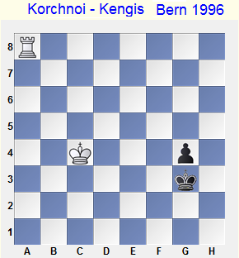Classic winning position:

**1...Kf2 2 Rf8+!**

2 Kd3? g3 3 Rf8+ Ke1! leads only to a draw.

**2...Ke2 3 Rg8! Kf3**

Due to the intermediate check, White succeeded in driving the opposite king back one square, from f2 to f3.

4 Kd3 g3 5 Rf8+ Kg2 6 Ke2+-

## **Shouldering**

1...Kb1? is erroneous in view of 2 Kb3 a1N+ 3 Kc3.

Black achieves a draw by not allowing the white king to approach the pawn.

**1 Rh2+ Ka3!**

## **Outflanking**

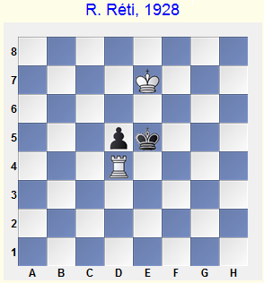

**1 Rd2(d3)!! d4 2 Rd1! Kd5 3 Kd7!**

Black is in zugzwang: if 3...Kc4, then 4 Ke6 and if 3...Ke4, 4 Kc6.

1 Rd1? is erroneous:

1...d4 2 Kd7 (2 Kf7 Ke4 3 Ke6 d3) 2...Kd5! (Black prevents an outflanking) 3 Kc7 Kc5! (3...Kc4? 4 Kd6! d3 5 Ke5), and it is White who has fallen into zugzwang.

If two black pawns are placed on the 3rd rank, or one pawn has reached the 2nd rank while the other is on the 4th rank, a rook cannot stop them. Sometimes, however, White can save himself by creating checkmate threats, when the black king is pressed to an edge of the board.

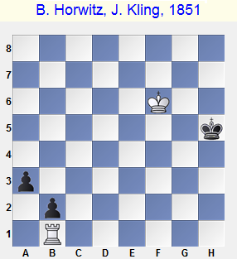

1 Kf5 Kh4 2 Kf4 Kh3 3 Kf3 Kh2 4 Ke3! Kg2

Or 4...Kg3 5 Rg1+ Kh4 6 Kf4 Kh3 7 Kf3, and here 7...Kh2?? 8 Rb1 even loses for Black in view of zugzwang.

5 Kd3 Kf3 6 Kc3 a2 7 Kxb2 (or 7 Rf1+) with a draw.

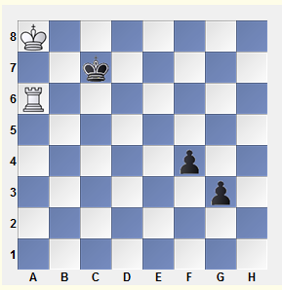In a battle against two connected passed pawns, the best position for the **rook is behind the more advanced pawn**.

1 Rg6! Kd7 2 Rg4! g2! 3 Rxg2 Ke6 4 Rg5! and White wins because the black king is cut off from the pawn along the 5th rank.

## **Rook vs. Separated Pawns**

If four files separate the pawns, then the rook can stop them without help of its king.

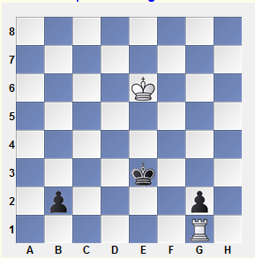

1 Rb1! (parrying the threat 1...Kf2) 1...Kd3 (… 2...Kc2) 2 Rg1!=

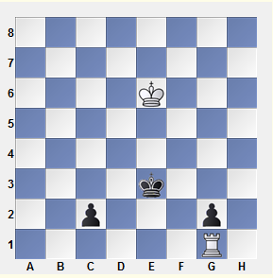

Move the b2-pawn to c2. Now the position is lost.

1 Rc1 Kd2-+

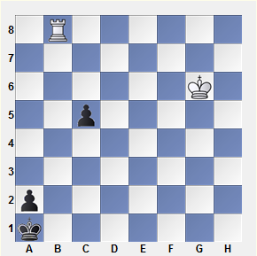

**1...c4 2 Kf5**

2 Rc8 c3!, and if 3 Rxc3, then Kb2 and the a-pawn promotes.

**2...c3 3 Rc8**

After 3 Ke4 c2 4 Rc8 Kb2 5 Rb8+ Kc3 6 Rc8+ both 6...Kd2 and 6...Kb4 win.

**3...Kb2 4 Rb8+ Kc2**(a3) **5 Ra8 Kb3 6 Rb8+ Kc4 7 Ra8 c2-+**

**Queen vs. Pawns**

The only cases which have significant practical importance are those elementary endings in which a queen plays against a pawn which has reached the next-to-last rank.

* The queen generally wins against either a center or knight pawn.
* With a rook or bishop’s pawn - a stalemate defense appears.

Of course, there are exceptions, in which the standard evaluations and techniques are no longer sufficient.

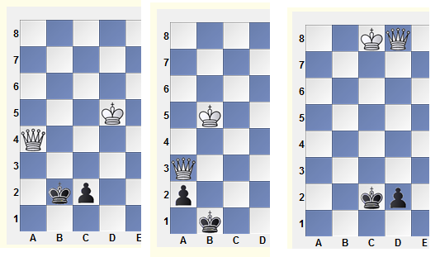

**QUEEN VS. ROOK**

The side that has a rook tries, except for very rare cases, to build a fortress.

We shall study the most important theoretical positions here, both drawn and winning. Sometimes one must play dozens of precise moves in a row in order to destroy the opponent’s line of defence. However, the winning plans that we should know are mostly standard, even when they are quite complicated tactically.

Master V. Khenkin has greatly contributed to the theory of this sort of endgame; he wrote the corresponding section for Averbakh’s endgame treatise and, for this purpose, analyzed a huge number of new positions.

**A Solitary Rook**

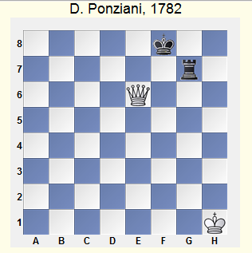

A queen wins against a solitary rook. The cases when a king cannot escape from checks in view of a stalemate or a loss of a queen are exceptions.

1...Rh7+ 2 Kg2 Rg7+ 3 Kf3 Rf7+ 4 Kg4 (4 Ke4 Re7) 4...Rg7+ 5 Kf5 Rf7+ 6 Kg6 Rg7+ 7 Kh6 (**7 Kf6 Rg6+!**) 7...Rh7+!

A standard winning method is shown in the following classical endgame.

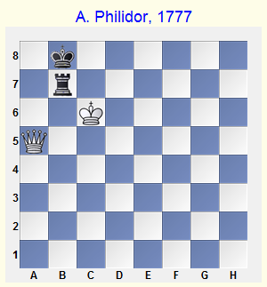

White’s pieces are ideally placed. Now he should cede the necessity to move to his opponent by means of a triangular maneuver by the queen.

1 Qe5+ Ka7(a8) 2 Qa1+ Kb8 3 Qa5!

**Zugzwang!** The rook must abandon the black king. As a result, it inevitably becomes a victim of a double attack.

3...Rb1 (3...Rh7 4 Qe5+ Ka8 5 Qa1+ Kb8 6 Qb1+) 4 Qd8+ Ka7 5 Qd4+ Ka8 6 Qh8+ Ka7 7 Qh7+ and 8 Qxb1.

The methods in this elementary example (zugzwang, triangulation as a tool for passing the obligation to move, and double attack) are standard for almost all queen-versus-rook endings, with or without pawns.

If the defender’s king is standing in the centre, the stronger side gradually drives him to an edge of the board to create mating threats. However this mission is not elementary, since the rook may sometimes be placed far away from the king without fear of being lost immediately.

Under time controls that are characteristic for modern chess, queen-versus-rook endings usually occur when the both sides are suffering from time shortage. For example, grandmaster P. Svidler, playing against B. Gelfand at the World championship-2001 in Moscow, had a few minutes (plus an additional 10 seconds after every move) and failed to outplay his opponent over 50 moves; thereafter the arbiters duly declared a draw.

In order to avoid such an unpleasant occurrence, one can practice with a computer program that is designed for this sort of endgame; it defends against the queen in a most tenacious way.

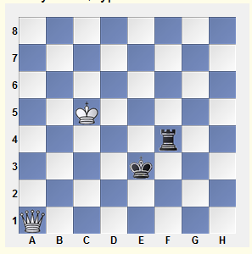The study of the following position is based upon computer-generated lines that indicate the best moves for both sides (of course, these are not the only moves one can play). Naturally, there is no sense in remembering these lines by heart; typical ideas behind the moves are much more important.

1...Rf8!? 2 Qd4+ Ke2 3 Qg4+ Ke3 4 Qe6+ Kf3 5 Kd4 Rd8+ 6 Kc3 Rf8 7 Qc6+

If White had played this two moves earlier, Black could have replied with 5...Ke3. Now, 7...Ke3? is impossible in view of the double attack Qc5+.

7...Kg4 8 Qg6+ Kf3 9 Qh5+!

An excellent square for the queen.

**The Rook Behind the Pawn:**

The further the pawn is advanced the greater are the chances for a draw. For instance, Black wins in all cases when his king blocks a white pawn that has not crossed the middle line. Almost all positions with the pawn on the 5th rank are won. However if the pawn has reached 6th or 7th rank, a draw is quite probable.

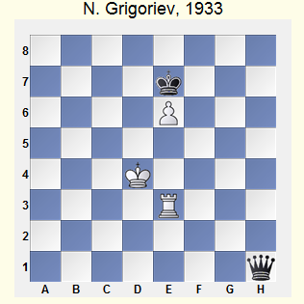It is good for White to keep his king on the lower ranks. He would have had no problems if his king were standing on e2; then Black could not create a zugzwang.

With White on move, a draw can be achieved by means of 1 Kd3! Qd1+ 2 Kc3!‡.

An important position of reciprocal zugzwang. After 2...Kf8 (2...Qd5 3 Kc2 is useless) 3 e7+ Ke8 4 Re4 Qf3+ 5 Kd4 Qb3 6 Re3 Qc2 7 Re4 White is out of danger.

However with Black on move, the evaluation differs. He manages to press White’s pieces out, by means of zugzwang, closer to the pawn, which means closer to the black king. The king then joins the queen at an appropriate moment with decisive effect.

1...Qb1! 2 Kc3

2 Kd5 Qa2+ 3 Ke5 Qb2+ 4 Kf4 Qf2+ loses even faster.

2...Qd1!‡

The familiar zugzwang position has arisen, but this time with White on move.

3 Re4 (3 Kc4 Qc2+ 4 Kd4 Qd2+) 3...Qf3+ 4 Kd4 Qb3‡ 5 Ke5

If 5 Re3 then 5...Qc2! 6 Re4 Kd6! 7 Ke3 (7 e7 Qd2+ 8 Kc4 Qd5+) 7...Kd5!-+. After the king move, a similar finale happens on the other wing.

5...Qb2+ 6 Kf4 (6 Kd5 Qc3!‡ 7 Re5 Qd3+ 8 Kc5 Qd6+) 6...Qf2+ 7 Kg4 (7 Ke5 Qf6+ 8 Kd5 Qc3!‡) 7...Qg2+ 8 Kf4 Kf6! 9 Ke3 (9 e7 Qf2+ 10 Kg4 Qf5+) 9...Kf5!-+

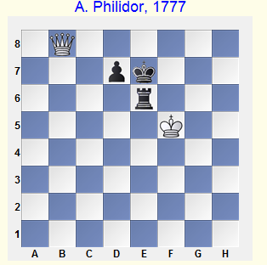**The Pawn on the 7th Rank**

1 Qh8 Rc6=

Black holds his king on the 7th and 8th ranks, preventing the white queen from entering the important d8-square. The rook has two protected squares at its disposal (e6 and c6); therefore a zugzwang cannot be created.

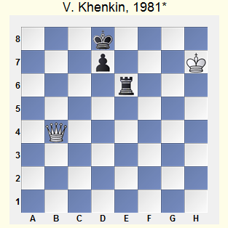

If the white king has crossed the 6th rank, Black’s position is not fool-proof anymore. For example, this case depends on who is on move.

Black on move achieves a draw after 1...Kc7(c8)!. He should keep a distance between the kings in order to avoid mate threats.

White on move wins.

1 Qb8+! Ke7 2 Kg7 (… 3 Qf8#) 2...Rc6 (2...Rd6 3 Qb4) 3 Qf8+ Ke6 4 Qf6+

4 Qb4!‡ Kd5 5 Kf7 Re6 6 Qb7+ Kd6 7 Qb6+ Kd5 8 Qc7 is also good.

4...Kd5 5 Qd8 Kd6 6 Kf7

The queen has occupied the important d8-square, and now the king can attack the pawn. His opponent, forced to stand in front of the pawn, only hinders his own rook.

6...Rc5 7 Qb6+ Rc6 8 Qb8+ Kd5 9 Ke7+-