Contents

**Theory – Highlevel Overview** 3

**Lucena Position** 4

**Philidor position** 7

**The Umbrella** 8

**Vancura position** 11

**Lasker’s Idea** 16

Rook and Pawn vs. Rook

Rook endings are perhaps the **most important** and **most difficult** kind of endgame.

* Most important, because they occur in practice much more often than other endings.
* Most difficult, because, because one must absorb and remember a much greater volume of knowledge than in endings with other material relationships.

The reason is that, in other endgames, situations with a minimum number of pawns on the board are either elementary or not very important. Therefore one needs only to remember a very limited number of precise positions; as it is highly improbable that one would meet them in practical play. So, mastering the basic ideas and methods is fully sufficient in those cases.

In rook endings, however, a sophisticated theory of positions with reduced material exists (for example, those with R+P against R), and these situations occur very often in practice. This means that we cannot omit studying a considerable number of precise positions.

**Theory – Highlevel Overview**

Rear checks:

* As soon as pawncrosses 5th rank, attacker king loses the pawn-shelter and perpetual checks by rook from rear ensures draw.
* Exception cases - when the rook must stay on the back rank in view of mate threats.
* If King (defending) stands in front of the pawn, **a draw** can be **easily** achieved.

Side checks:

* Useful when the king of the defender side is cut off from the pawn.
* A rook pursuit of the enemy king can only be successful when the rook and the pawn are separated at minimum by 3 lines.
* Defending side must keep the rook on the long side and king on the short side. So that king doesn’t come in the way of check.

Frontal attack

* Useful when rook and the pawn are separated by at least three rows. Ie. rook on b8 and white pawn stands on at least b4.
* And therefore pursuing (following) the king by the rook gives chances for a draw.

Defending-King Positions:

* Best if it is in front of pawn.
* King on the short side of the pawn-file. So that king doesn’t come in the way of check from side-check of rook from long side.

Two extra connected pawns can be most easily exploited if the king supports them. However, sometimes they can go ahead for queening even when a rook alone supports them.

two extra pawns are sufficient for a win. However exceptions occur now and then. They are caused either by the stronger side having badly placed pieces while the defender’s pieces are active,

**LucenaPosition**:The Pawn on the 7th Rank

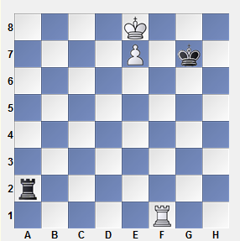If White is on move he wins:

**1 Rg1+ Kh7 2 Rg4!**

2 Kf7 is premature in view of 2...Rf1+ 3 Ke6 Re1+ 4 Kf6 Rf1+, and the king has only one way to take refuge from rook checks: by returning to e8. The rook move prepares an interference at e4. This method is called building a bridge, or simply bridging.

**2...Rd2** (2...Ra8+ 3 Kf7) **3 Kf7 Rf2+ 4 Ke6 Re2+ 5 Kf6 Rf2+ (**If 5...Re1, then 6 Rg5 … 7 Re5.) **6 Ke5 Re2+ 7 Re4+-**

It is worth mentioning that White has other winning options:

* **1 Re1!+-**
* **1 Rg1+ Kh7 2 Re1!+-**
* The immediate **1 Rd1** is also good**2...Kg7 3 Kd7 Ra7+ 4 Ke6 Ra6+ 5 Rd6 Ra8 6 Rd8+-.**

Black is on move with above position.

**1...Ra8+ 2 Kd7 Ra7+ 3 Kd6 Ra6+ 4 Kc7** (4 Kc5 Re6) **4...Ra7+** with a draw.

Let us shift all the pieces except for the black rook a single file to left.

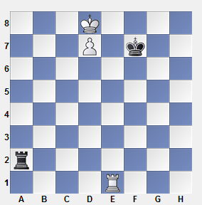

Then the side checks do not help anymore because the rook is not remote enough from the white pawn: 1...Ra8+ 2 Kc7 Ra7+ 3 Kc8 Ra8+ 4 Kb7+-.

Hence we can conclude:

* If the pawn is on the 7th rank, multiple winning methods exist.
  + The most important ones are building a bridge for protection from checks along files
  + A rook maneuver for protection from side checks along ranks.
* When the king of the weaker side is cut off from the pawn, the only defensive technique consists in side checks.
* A rook pursuit of the enemy king can only be successful when the rook and the pawn are separated at minimum by 3 lines. As we shall see later, this rule does not only pertain to side checks.
* A central or a bishop pawn divides the chessboard into two unequal parts: one is “long,” another is “short.” The correct positioning of forces for the weaker side is to keep the king on the short side, and the rook – on the long side.

Pawn on the 6th Rank

First let us examine the situation when the king of the weaker side is placed in front of the pawn.

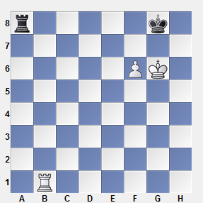

Black’s rook must remain passive, staying on the 8th rank. White wins easily by bringing his rook to h7.

1 Rb7 Rc8 2 Rg7+! (2 Rh7 Rc6) 2...Kf8 3 Rh7 Kg8 4 f7+

It is worth mentioning that Black can hold the game when he is on move and his rook stands on a7: 1...Rg7+! 2 Kf5 (2 fg stalemate) 2...Rg2. Also, White cannot win in the case when his king is placed on the other side of the pawn, at e6:

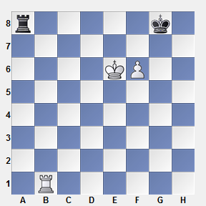

1 Rb7 Kf8 (there are other possibilities as well) 2 Kf5 Ra1!=.

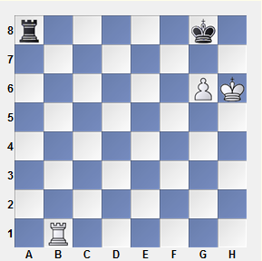

**1 Rb7 Rc8 2 Rg7+ Kh8!** (2...Kf8?? is erroneous in view of 3 Kh7+-) **3 Rh7+ Kg8=**

Conclusion: passive defense holds against a knight pawn but loses against a bishop pawn or a central pawn.

Note: When the stronger side has two knight pawns, then passive defence does not help.

**Philidor position**: the correct method of defence

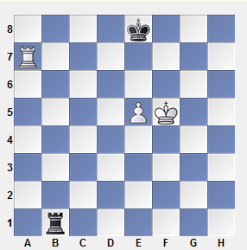

**1...Rb6!** (preventing a penetration of the white king to the 6th rank) **2 e6 Rb1=**

If the pawn stood at e5 the white king would have had a refuge from vertical checks. But, as soon as the pawn has stepped forward, the refuge does not exist anymore.

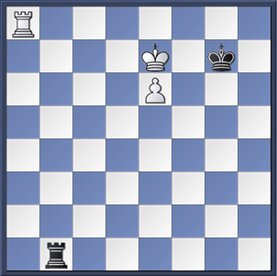If White is to move in the initial position, then, as Philidor thought, 1 Kf6 wins, and his explanation was 1...Rf1+ 2 Ke6 Kf8 3 Ra8+ Kg7 4 Ke7 Rb1 5 e6 (see diagram) 5...Rb7+ 6 Kd6 Rb6+ 7 Kd7 Rb7+ 8 Kc6+-.

Later on, the second defensive method in the Philidor position was discovered: an attack from the rear that helps Black to hold as well. If the rook fails to occupy the 6th rank “a la Philidor,” it must be placed in the rear of the white pawn.

1...Re1! 2 Ke6 Kf8! 3 Ra8+ Kg7

Now we can evaluate the position of the black rook. First, it prevents both 4 Ke7 and 4 Kd7. Secondly, Black can meet 4 Kd6 with 4...Kf7!, and White must retrace his steps: 5 Ra7+ Ke8 6 Ke6 Kf8! etc. If he tries 4 Re8, preparing 5 Kd7, the black rook occupies the long side: 4...Ra1!=.

The move 2...Kf8! is undoubtedly correct (the king goes to the short side, leaving the long side for the rook), but 2...Kd8?! 3 Ra8+ Kc7 does not lose either.

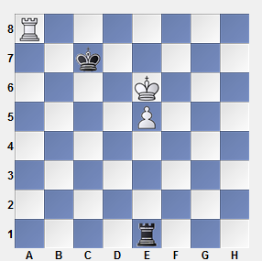

4 Re8 (4 Kf6 Kd7!) 4...Rh1! (rather than 4...Re2? 5 Kf7 Rh2 6 Rg8! Rh7+ 7 Rg7 Rh8 8 Ke7 Kc6 9 e6 Kc7 10 Rg1+-) 5 Rg8 Re1! 6 Rg2 Kd8=.

# **The Umbrella**

Let us refresh our memory about the methods we have already seen, of sheltering the king from rook checks.

1) The king approaches the rook – an effective method when the rook is not too far away from the king and the pawn.

2) “Bridge” – the rook gives protection to the king.

3) “Refuge” – the king hides himself behind his own pawn.

It is a good time to show one more method. Sometimes an enemy pawn can serve as a sort of umbrella that protects the king from checks, as in the next diagram.

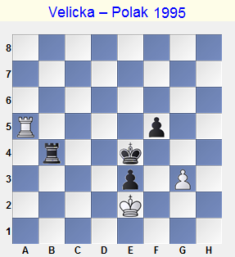

1...f4! 2 gf Rb2+ 3 Kf1 Kf3-+

White’s own f4-pawn prevents him from saving himself with a check on f5.

4 Ra1 Rh2 5 Kg1 Rg2+ 6 Kh1 Rg8 7 Kh2 e2 8 f5 Kf2 9 Kh3 Rg5! White resigned.

Pawn Hasn’t Crossed the Mid-line

In this section, we shall learn one more defensive method, the one that is called “the frontal attack.”

If, say, the white pawn stands on b5, it makes no sense for Black to keep his rook on b8 because it is too close to the pawn. However when the pawn has not crossed the middle line, such a rook position is justified, because the rook and the pawn are separated by no less than three rows, and therefore pursuing the king by the rook gives chances for a draw.

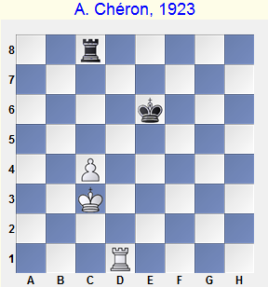

This is a typical case of an easy draw due to a frontal attack.

**1 Kb4** (… 2 c5+-) **Rb8+ 2 Ka5 Rc8!**

2...Ra8+? is erroneous in view of 3 Kb6+-

**3 Kb5 Rb8+ 4 Ka6 Rc8 5 Rd4 Ke5 6 Rh4 Kd6=**

In the initial position, the rook is placed best at c8 where it prevents a pawn advance. However Black holds with a rook at h8, too. He meets 1 c5 with either 1...Ke7 2 Kc4 Rd8= or 1...Rh4 (cutting the king off the pawn) 2 c6 Ke7 3 c7 Rh8=. Horizontally cutting the king off from the pawn is a useful defensive method.

Another important tip: in this sort of position, the black king should stay on the 5th or 6th rank. If he doesn’t Black usually loses.

The King is in Front of his Own Pawn

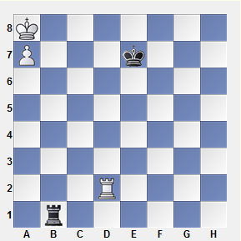

A draw is inevitable. The only possible attempt to free the king from custody is the transfer of the rook to b8, but then Black’s king will stand in for the black rook on guard.

1 Rh2 Kd7 2 Rh8 Kc7 3 Rb8 Rc1 (or 3...Rh1 4 Rb7+ Kc8 5 Rb2 Rc1) 4 Rb2 Rc3, and White cannot progress.

Let us move the black king and the white rook one file away, as in the next diagram.

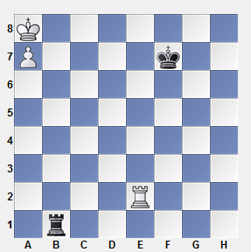White wins, because the black king fails to reach c7 in time.

**1 Rh2 Ke7 2 Rh8 Kd6**

If 2...Kd7, then 3 Rb8 Ra1 4 Kb7 Rb1+ 5 Ka6 Ra1+ 6 Kb6 Rb1+ 7 Kc5. With Black’s king on d6, the square c5 is not available for escaping, so White must find another itinerary.

**3 Rb8 Ra1 4 Kb7 Rb1+ 5 Kc8 Rc1+ 6 Kd8 Rh1 7 Rb6+ Kc5**

Both 8 Re6? Ra1 and 8 Ra6? Rh8+ 9 Kd7 Rh7+ 10 Ke8 Rh8+ 11 Kf7 Ra8 are useless now.

8 Rc6+! Kb5 (8...Kd5 9 Ra6 Rh8+ 10 Kc7 Rh7+ 11 Kb6) 9 Rc8 Rh8+ 10 Kc7 Rh7+ 11 Kb8+-

Rook is in Front of the Pawn and the Pawn is on the 7th Rank

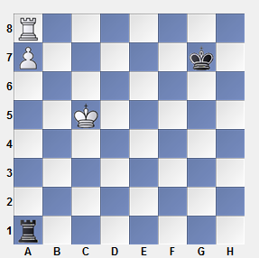A standard defensive formation: Black’s rook is behind the hostile pawn, while the king is placed on g7 or h7. White’s rook is riveted to the pawn and cannot leave a8. If 1 Kb6, then 1...Rb1+. The white king cannot escape from vertical checks. Black’s rook drives the king away and returns to a1.

Other defensive systems occur much less frequently. The black king can hide in the “shadow” of his opponent, or (with the black rook on the 7th rank) in the “shadow” of his own rook. We just mention these ideas but do not study them here. Sometimes they are sufficient for a draw, and sometimes not. For example, if we move the black king from g7 to c3, the move 1 Rc8! wins. A drawn position is one with the white king on c7 and the black king on c5.

Back to the last diagram, let’s add a white pawn on h5. For the outcome, there will be no change: Black simply ignores its existence. The same is valid for a g5-pawn and even for 2 or 3 white pawns on the g-file.

However an f5-pawn wins.

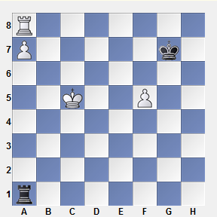

1 f6+ Kf7 (1...Kxf6 2 Rf8+; 1...Kh7 2 f7) 2 Rh8, and Black loses his rook.

# **Vancura position**

**Rook is in Front of a Pawn on the 6th Rank**

The main difference between this position and those discussed above, is the fact that here White’s king has a refuge from vertical checks: the a7-square. The king hides there in order to free his rook from the job of protecting the pawn.

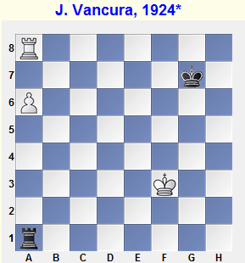

The black king, in contrast, fails to reach the queenside: 1...Kf7? 2 Ke4 (2 a7? Kg7 would have been premature) 2...Ke7 3 a7! Kd7(f7) 4 Rh8+-.

2...Ra5 (instead of 2...Ke7) is also hopeless: 3 Kd4 Kg7 4 Kc4 Kf7 5 Kb4 Ra1 6 Kb5 Rb1+ 7 Kc6 Ra1 8 Kb7 Rb1+ 9 Ka7 Ke7 10 Rb8 Rc1!? 11 Kb7 (rather than 11 Rb6? Kd7) 11...Rb1+ 12 Ka8 Ra1 13 a7+-. Black’s king fails to reach c7 in time (see Illustrative Example 9-35).

Because of this analysis, the diagrammed position had been considered winning for a long time. **However a saving plan was finally discovered.** This plan is based on the fact that the a6-pawn gives the king a refuge from vertical checks, but cannot hide him from side checks. Therefore Black should bring his rook to f6.

1...Rf1+! 2 Ke4 Rf6!. This is the so-called “**Vancura position**.” Black follows the same “pawn in the crosshairs” method found in endings with bishops of opposite colors. The rook attacks the pawn in order to prevent the enemy’s rook from leaving a8. What can White do? If a6-a7, Black always has Ra6 (his king will obviously never leave the g7- and h7-squares). If White defends the pawn with his king, a series of checks follows, and then the rook returns to f6. For example, 3 Kd5 Rb6 4 Kc5 Rf6! (the best place for the rook!) 5 Kb5 Rf5+!, etc.

**a- and h-Pawns**

In the Vancura position, let us add a white pawn on the h-file. It is easy to see that the evaluation remains unchanged. The defensive method is precisely the same as before: the rook maintains the pawn in the crosshairs from the side and does not release the hostile rook from the corner.

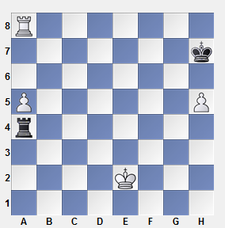

1...Re4+! 2 Kd3 Re5 3 Kc4 Rf5!

The best policy is to pay no attention to the h-pawn at all. 3...Rxh5? loses to 4 a6 Rh6 5 Kb5 Rh5+ 6 Kb6 Rh6+ 7.Kb7.

4 a6 (4 Kb4 Rf4+) 4...Rf6! 5 Kb5 Rf5+ 6 Kc6 Rf6+ 7 Kd5 Rb6 etc.

Rook and Two Pawns vs. a Rook

As S. Tarrasch once said, “all rook endings are drawn.” These endings are rife with drawish tendencies, and even as large a material advantage as two extra pawns is often not sufficient for a victory.

Doubled Pawns

If the king of the weaker side stands in front of the pawns, a draw can usually be easily achieved (except for those cases when the rook must stay on the back rank in view of mate threats). The applicable ideas here are familiar to us from the Philidor position.

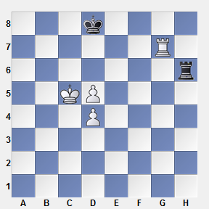

**1 Rb7 Rg6** (1...Kc8!?) **2 Rb6 Rg4!**

Black goes over to the second defensive method in the Philidor position (if 3 Kc6 then 3...Rxd4 4 Rb8+ Ke7=). 2...Rg1? loses to 3 Kc6 Rc1+ 4 Kd6. 2...Rg7? is also bad on account of 3 Rb8+! Kc7 4 Ra8 Rg6 5 d6+ Kd7 6 Ra7+ Kd8 7 Kc6+-.

3 d6 Rg1!

The rook prepares itself for giving rear checks because the white king has no refuge at d6 anymore.

4 Kc6 Rc1+ 5 Kd5 Rh1 6 Rb8+ Kd7 7 Rb7+ Kd8 8 d7 Rh5+ (8...Ke7) 9 Kc6 Rh6+ 10 Kc5 Rh5+ 11 d5 Rh6!=

And again, Black returns to the defensive method suggested by Philidor.

**Connected Pawns**

Two extra connected pawns can be most easily exploited if the king supports them. However, sometimes they can go ahead for queening even when a rook alone supports them.

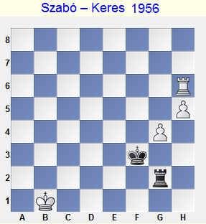

**1 Rg6**

White is planning 2 h6, 3 g5, 4 Rg7, 5.h7 etc. This simple plan cannot be prevented. Such pawns are sometimes called “self-propelled.”

1...Ke4 2 h6 Rh2 3 g5 Kd3 4 Rg7 Kc3 5 h7 (… g6, Rg8) 5...Kb3 6 Rb7+ Black resigned.

f- and h-Pawns

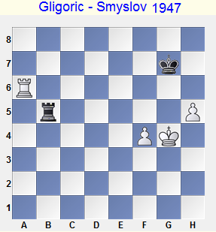Endings with these pawns are mostly drawn. Their theory is rather complicated and that is why we will explain only the basic ideas here. The following example from practical play shows how one should defend these positions.

The black rook is excellently placed on the 5th rank: it prevents an advance of the hostile king. If 1 f5, then 1...Rb1, threatening a series of checks from the rear.

1 Rg6+ Kf7!

1...Kh7 was not losing, but Black would have had more problems than in the game.

2 Rg5 Rb1!

A typical retreat for this sort of situation: the rook maintains opportunities for checks from various directions, both from the side and rear.

3 Rc5

In case of 3 h6, 3...Rg1+? is erroneous: 4 Kf5 Rh1 5 Rg7+ Kf8 6 Kg6 Rg1+ 7 Kh7! Rf1 8 Ra7! (8 Rg4 Kf7) 8...Rxf4 9 Kg6 Rg4+ 10 Kf6! Rf4+ (10...Kg8 11 Rg7+!) 11 Kg5 Rf1 12 Ra8+ Kf7 13 h7i.

The waiting move 3...Ra1! helps, for example: 4 Rh5 (4 Kf5 Ra5+; 4 h7 Rg1+ 5 Kf5 Rh1) 4...Kg8 5 f5 Kh7.

Other Pairs of Disconnected Pawns

As a rule, two extra pawns are sufficient for a win. However exceptions occur now and then. They are caused either by the stronger side having badly placed pieces while the defender’s pieces are active, or by inattention (when the stronger side anticipates a quick win too nonchalantly). This last case is illustrated by all the practical examples that follow.

Tragicomedies

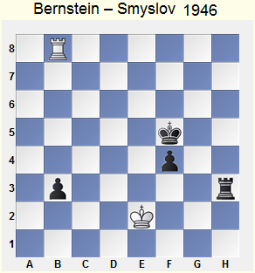

1...b2?? (both 1...Ke5 and 1...Ke4 won elementarily) 2 Rxb2! Kg4

The planned 2...Rh2+ turned out to be ineffective because of the stalemate after 3 Kf3 Rxb2.

3 Kf1

Draw. The Philidor position has arisen.

Far Advanced Passed Pawn

Transition to a Rook vs. Pawns Endgame

It often happens that a passed pawn is so strong that the opponent must inevitably give a rook away for it. In such cases, one should know well and take into account the methods we have learned from studying rook versus pawns endgames.

Black’s actions in the following endgame were based on two typical methods: shouldering and cutting off the king.

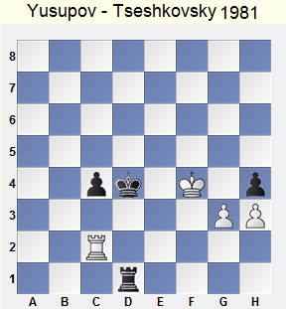

In case of the straightforward 1...hg? (1...Kd3? 2 Rf2! or 2 Rg2! has the same consequences) 2 Kxg3 Kd3 3 Ra2 c3 4 h4 c2 5 Rxc2 Kxc2 White, of course, cannot play 6 h5?? Rd4!, but 6 Kg4? Kd3 7 h5 Ke4 8 Kg5 Ke5 9 Kg6 Ke6 10 h6 Rg1+ also loses. It is shouldering that helps here: 6 Kf4! Kd3 7 h5 Rh1 8 Kg5 Ke4 9 h6 Ke5 10 Kg6 Ke6 11 Kg7! (rather than 11 h7? Rg1+ 12 Kh6 Kf7 13 h8N+ Kf6 14 Kh7 Rg2‡-+) 11...Ke7 (11...Rg1+ 12 Kf8) 12 h7 Rg1+ 13 Kh8!=.

Deliberating over his next move, V. Tseshkovsky recognized White’s defensive plan and found how to prevent its realization.

1...Rf1+!! 2 Kg4 hg

Now, after 3 Kxg3 Kd3 4 Ra2 c3 5 h4 c2 6 Rxc2 Kxc2, the white king cannot go to f4, and White loses.

3 Rd2+ Ke3 4 Rg2

4 Rc2 Rf4+! 5 Kxg3 Rd4 6 h4 Kd3 changes nothing.

4...Rf4+!

White could hold after 4...c3? 5 Rxg3+ Kd4 6 Rg2 Kd3 7 h4 (compared with the line 3 Kxg3 Kd3 he would have an extra tempo). Alas, Black wins easily by means of cutting off the king along the 4th rank.

5 Kxg3 c3 6 h4 Rc4 7 Rc2 Kd3 8 Rc1 c2 9 h5 Kd2 10 Rh1 c1Q 11 Rxc1 Kxc1! White resigned.

# **Lasker’s Idea**

An interestingand instructive rook-and-pawn endings idea with a single pawn on each side, the second world champion introduced it.

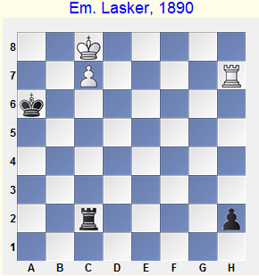

Were Black on move, he could hold the game by playing 1...Ka7! or 1...Rb2!. But it is White who is on move, and he sets into motion a mechanism that gradually drives the black king as far away as the 2nd rank.

1 Kb8! Rb2+ 2 Ka8 Rc2 3 Rh6+ Ka5 4 Kb7 Rb2+ 5 Ka7 Rc2 6 Rh5+ Ka4 7 Kb7 Rb2+ 8 Ka6 Rc2 9 Rh4+ Ka3 10 Kb6 Rb2+ 11 Ka5! Rc2 12 Rh3+ Ka2 13 Rxh2+-

Rook and Two Pawns vs. a Rook and Pawn

All Pawns are on the Same Wing

If all pawns are grouped on the same wing then a draw is the most probable outcome. Even when there is a passed pawn, defence is, as a rule, not too difficult.

Smyslov – Keres

USSR ch, Moscow 1949

Black is planning 1...f4+ and 2...Kh4. A reliable method of preventing a king invasion is a rook check from h8.

1 Rb8! f4+ 2 Kg2 Rc2+ 3 Kf3!

3 Kg1? loses to 3...Kh4 4 Rb3 Re2 … 5...Re3.

3...Rc3+

There is no danger for White in 3...Rh2 4 Rh8+ Kg6 5 Rg8+ Kf6 6 Rh8 Kg7 7 Rh5 Kg6 8 Rh8 Kf6 9 Kg4! (9 Rh5? Kf5 10 Rh8 Rxh3+!) 9...Rg2+ 10 Kf3 Rg3+ 11 Kf2, and 11...Kg6 can be met, besides the waiting 12 Kf1, even with 12 h4 g4 13 Rg8+ (or 13 Rf8 Rf3+ 14 Kg2).

4 Kg2 Rg3+ 5 Kh2 Re3 6 Kg2

6 Rh8+ Kg6 7 h4! g4 8 Rg8+ Kf5 (8...Kh5 9 Rh8+) 9 Rg5+ Ke4 10 Rxg4=

6...Kg6 7 Rf8!

The simplest solution: White cuts off the enemy’s king from the center of the board.

Pawns on Opposite Wings

A common situation is when one side has two connected passed pawns while the adversary has a far-advanced pawn on the opposite wing. In these endgames, correct placement of one’s pieces is highly important.

N. Grigoriev, 1936*

White has so-called self-propelled pawns. However a lot of time is required for promotion, so Black manages to create counterplay in time.

1 b6 (… 2 Ra5+, 3 Rb5)

1 Rd6 Rb2+ 2 Ke3 h4 does not bring any success, too.

1...Kf4 2 a5 Rb2+ 3 Ke1 (3 Kg1 Kg3) 3...h4 4 Ra7 h3 5 Rh7 h2 6 Rxh2

6 Kd1 is met by 6...Kg3! 7 Kc1 Rb5.

6...Rxh2 7 b7

A typical situation: the rook cannot stop the pawns, but Black nevertheless manages to hold by pursuing the hostile king, which is pressed to the edge of the board.

7...Ke3 8 Kf1 (8 Kd1 Kd3 9 Kc1 Kc3 10 Kb1?? Rb2+) 8...Kf3 9 Ke1=

The careless 9 Kg1?? even loses: 9...Rg2+! 10 Kh1 (10 Kf1 Rb2) 10...Rb2 11 a6 Kg3.

In this example, White’s pieces were “engaged in a strange role reversal.” As a rule, the king should support his own connected passed pawns while the rook’s mission is to hinder the hostile pawn.

The rook’s placement is extremely important. If the rook of the stronger side is placed passively (in front of the enemy’s pawn) a draw can be achieved simply by placing the king in front of the connected pair of pawns.

Disconnected Pawns, One of them is Passed

If one or two files separate pawns of the stronger side, the position is most often a draw. We shall analyze cases of more interest and practical value here: when the distance between pawns is great enough.

The defender must aspire for active counterplay. If his rook must merely defend his own pawn or protect the king from checks, his salvation is very problematic.

Miles – Webb

Birmingham 1975

1 Ra6 Rc7 2 Kg5 Kg7 3 f5 Rd7 4 a5 Rc7 5 Rd6!

White has improved his position to the maximum degree. Now he has in mind a typical plan for this sort of position, a usurpation of the 7th rank (a5-a6 and Rd6-d8-b8-b7).

5...Kf8 6 Rd8+ Ke7 7 Rh8 Kd6 8 Kg6 Rc1 9 Ra8

A wise technique: White combines the threat of advancing the f-pawn with an attack against the a-pawn.

9...Ke5 10 Re8+ Kf4 (10...Kd6 11 Re6+ Kd7 12 Ra6+-) 11 f6 Rg1+ 12 Kf7 Ra1 13 Kg7 Kf5 14 f7 Rg1+ 15 Kf8 Kg6 16 Re6+ Black resigned.

I would like to draw your attention to the fact that if the queenside pawns were placed not on the same file, but on adjacent files (for example, the white pawn on the b-file), the black rook would have been less passive. It could then combine its defensive mission with a counterattacking one, and the drawing chances would have been considerably greater.

Four Pawns vs. Three on the Same Wing

If all pawns are on the same wing, bringing the advantage home is frequently impossible (it is more precise to say, it should not be possible against correct defense). The fewer pawns, the easier the defense is.

Say, with 3 pawns against 2 or even with 4 against 3, in case of standard pawn structures, the task of the defender is not too difficult (once in a lightning tournament I managed to hold two such endings: against Tal and Vasiukov). As for the case of five pawns against four, the probability of losing is rather great.

Petrosian – Keres

USSR ch, Moscow 1951

1...h5!

In this way Black makes his task of reaching a draw considerably easier. The defender should advance his h-pawn. The stronger side, whenever possible should prevent this by means of g3-g4!.

The explanation consists in the fact that White’s most logical plan is an advance of his e- and f-pawns in order to create a passed pawn. To accomplish this plan, he must sooner or later play g3-g4, allowing a pawn exchange on g4. But, as we know, pawn exchanges are usually favorable for the weaker side, and improve the drawing chances. Without h7-h5, the h-pawns would have stayed on the board.

In this game, T. Petrosian gradually carried out another plan: h2-h4 followed with f2-f3 and g3-g4, but also could not obtain victory.

Balance on One Wing and an Extra Pawn on Another

Situations with an extra remote passed pawn occur now and then, therefore it is very important to learn their correct evaluation and handling. The decisive factor in this sort of endgame is the position of the rook of the stronger side. In majority of cases the rook is placed best “a la Tarrasch,” behind its own passed pawn; sometimes its sideways position is preferable.

Quite often, however, we lack free choice, so the rook mostly stands in front of the pawn in practical games. Therefore we shall pay more attention to these cases.

The Rook Behind its Own Pawn

Botvinnik – Boleslavsky

Leningrad/Moscow 1941

1 Rb1!

The rook has occupied its correct position behind the pawn. After 1 h3? Rb2! 2 Re4 Black could have achieved a draw.

1...Kf7?

The passed pawn should be blocked as soon as possible. Black had to play 1...Rc6! 2 b5 Rb6. I do not think this was enough for a draw but, anyway, his opponent would have then been faced with more complicated problems. After a king’s march to the queenside Black removes his rook from b6 either for protecting his own pawns or for attacking the hostile ones.

2 b5 Ke6 3 b6 Rc8 4 h3

4 b7? Rb8 is erroneous because it allows Black to eliminate the b-pawn and thereafter to bring his king back to the kingside in time. For example, 5 Kg1 Kd6 6 Kf2 Kc6 7 Ke3 Rxb7 8 Rxb7 Kxb7 9 Ke4 Kc6 10 Ke5 Kd7=.

4...Rb8 5 Kh2 Kd5

If the black king stays with his pawns, his adversary heads to the b-pawn. Black cannot prevent this by means of the opposition because White can make a waiting rook move; Black will then be obliged to give way to the white king because his rook has no waiting moves. This clearly demonstrates the difference between the rook positions.

6 Kg3 Kc6 7 Kg4 Kb7

A capture on b6 is impossible now; therefore Black blocks the pawn with his king, releasing the rook from this duty. A standard and often quite useful method; but alas, it does not bring any relief to Black in this particular case.

8 Re1!

Excellently played! While the rook was pinning the black rook down it was superbly placed on b1, but now it will be more active when placed sideways. In case of 8...Kxb6 9 Rb1+ Black loses the pawn endgame.

8...Rg8 9 Re6 Ka6 10 Kg5 Kb7 11 h4

The rest is simple. White attacks on the kingside, having an extra piece there.

Rook in Front of the Pawn, with the Pawn on the 7th Rank

We have seen a section with an identical title in the theory of “a rook and a rook pawn versus a rook” endgames. The ideas from that section will be useful for our current considerations.

If the rook of the stronger side is placed in front of the pawn and the hostile rook is behind the pawn, a pawn advance to the 7th rank absolutely chains the opponent’s forces. However, if there are no vulnerable points in his camp, the game is still drawn because a king march to the pawn is useless: no refuge from rook checks from behind is provided.

The pawn position on the 7th rank has sense in the following situations:

a) When it can be traded for enemy’s pawns, achieving a winning endgame with pawns on one side;

b) When a rook can be gained at its cost. As a rule, a passed pawn on the opposite wing is required for this purpose; it will push the hostile king away from a safe square. A reminder: an advance of a bishop pawn can do the job, while a knight or a rook pawn is mostly useless;

c) When we can give the passed pawn away in order to exchange the rooks (by means of a check along the 7th rank), transposing into a winning pawn endgame.

Unzicker – Lundin

Amsterdam ol 1954

1 f3+! (1 a7 Ra2+ … 2...Kf3) 1...Kf5 2 a7! Ra2+

The same is 2...Ra6 3 Kd3 Rd6+ 4 Kc4 Rd7 5 Kc5 Re7 6 Kd6! Re6+ (6...Rb7 7 Rb8! Rxa7 8 Rb5#) 7 Kd7 Ra6 8 Ke7.

3 Kd3 Ra1 4 Kd4

Observe the following tactical trick: 4 g4+ hg 5 fg+ Kxg4 6 h5!. However in this particular position it fails because 4 g4+? can be met with 4...Kf4!.

4...Ra5 5 Kc4 Ra3 6 Kc5

When Black’s pawn stands on f7, his king can return to f6 or g7 with an absolutely drawn position. Here, however, White has a clear plan: a king transfer to h6 followed by an exchange of the a7-pawn for Black’s kingside pawns. Black has nothing to oppose this plan.

Rook in Front of the Pawn, with the Pawn on the 6th Rank

If a pawn advance to a7 makes no sense, White leaves the pawn on a6 and brings his king to the queenside where a refuge against checks from the rear exists. But it is a long way to go; the black rook has enough time to kill one or two pawns. Thereafter it will be sacrificed for the passed pawn, and the resulting rook versus pawn(s) endgame is usually drawn.

Please note that Black’s pieces are optimally placed: the rook holds the f-pawn in the crosshairs, while the king occupies the most active available square.

1 Ra7!?

After 1 Kd4 Rxf2 2 Rf8 Ra2 3 Rxf7+ Kg4= or 1 f3 Ra3+ 2 Kd4 Rxf3 3 Rf8 Ra3 4 Rxf7+ Kg4 5 Rf6 Kxg3 6 Rxg6+ Kxh4 7 Kc5 Kh3 8 Kb6 h4= (both lines by N. Kopaev), Black’s task is much easier.

1...f6!

1...Kf6 has been considered a prelude to an easy draw for many years. For example, 2 Kd4! Rxf2 3 Rc7 Ra2 4 a7 Kf5 4 Rxf7+ Kg4 5 Kc5 Kxg3 6 Kb5! Rb2+! (6...Kxh4?? 7 Rc4+ and 8 Ra4) 7 Kc6 Ra2 8 Kb7 Kxh4 9 Rf6 Rxa7+ with equality (V. Kantorovich).

However in 2003 the evaluation of this position was radically changed due to an excellent suggestion by J. Steckner: 5 Kc4!!.

The two last examples prompt us to make the following useful conclusions:

Quick activation of the king is a high priority for the weaker side.

In case of a standard pawn structure, posting the rook on a6, with the idea of confining the black king to g7, is no less dangerous in a practical sense than a pawn advance to a6.

The weaker side has a rather good counter-plan at his disposal: f7-f6 followed with g6-g5.

A Knight Pawn

If a passed pawn stands on the b-file, a king saves a tempo when heading towards it – and another tempo when returning after winning a rook for the pawn. Therefore the stronger side is almost always successful in practical endings. But a detailed postmortem analysis usually shows that the defense could have been improved and the defender’s claims of a missed draw have not been groundless.

Hollis – Flórián

olcr 1972

A. Hollis pretended in his comments that his win had been a natural phenomenon. Later on, Y. Averbakh demonstrated how Black could survive. A Moscow player, V. Kantorovich, has made a precious contribution to our understanding of this sort of ending; he suggested a new, purely positional defensive method.

1 Kf1 Rb2 2 Ke1 Kf6 3 f3 Rb3 4 Kd2 Rxf3 5 Kc2

The threat is 6 Rxf7+ Kxf7 7 b7. A weaker option is 5 Rc7 Rb3 6 b7 Kf5 7 Kc2 Rb6 8 Rxf7+ (8 Kc3 f6! 9 Rc5+ Ke6=) 8...Kg4 9 Rd7, and here 9...Kh3!= (Dvoretsky) rather than 9...Kxg3? 10. Rd3+ Kxh4 11 Rb3+- (Kantorovich).

5...Re3!

The only way to survive. After bringing the rook to the 8th rank Black will not be afraid of an interference along the b-file, and his king can rush ahead. All other defensive plans are inadequate.

The Rook at the Side of the Pawn

As we have already seen, placement of the rook alongside the pawn makes sense when the pawn is too far advanced, or when it is blocked by the king. Here we shall discuss another case: the rook should be placed alongside the passed pawn when this piece protects pawns on the opposite wing simultaneously.

I. Rabinovich – Ragozin

USSR ch, Tbilisi 1937

1...Rf5! 2 g4 Rg5 3 Kg3 a5-+

After this maneuver, the king goes to the passed pawn in order to support its advance to the promotion square. The adversary lacks counterplay because the rook securely protects all the pawns.

4 Kf3 Ka7 5 Ra4 Kb6 6 Ke3 Rd5!

It is important to cut the king off from the queenside. After 6...Kb5?! 7 Rd4 a4 8 Kd3 winning would have been more complicated.

Observations about Endgames with Many Pawns

The Rook’s Activity

The rook’s activity is the main principle for evaluation and practical play in rook-and-pawn endgames. It can take various forms: attacking the enemy’s pawns, supporting its own passed pawns, cutting the opponent’s king off, or pursuing the king.

It also happens that the rook must sometimes behave passively, its functions being limited purely to defense. But in these cases one should relentlessly seek for opportunities to activate the rook, even at cost of pawn sacrifices or deteriorated king’s position.

The following classical ending illustrates this principle excellently.

Flohr – Vidmar

Nottingham 1936

White has an obvious positional advantage, but as for a win, it is surely a long way off. The outcome of the game depends on the endgame artistry of the players.

1 Ke2!

First of all, to centralize the king. In case of 1 Ra5? Black sacrifices a pawn to activate his rook: 1...c5! 2 Rxa6 c4 with excellent chances for a draw. 1 b4? is also not precise: 1...Ke7 2 Ke2 Kd6 3 Kd3 Rb8!? (3...Kc7) 4 a3 Rb5.

1...Ke7 2 Kd3 Kd6 3 Ra5!

Rather than 3 Kd4? in view of 3...Rb8 4. Ra5 c5+! 5 Kd3 Rb6.

3...Ra8 4 Kd4

Black must reckon with e3-e4 now.

4...f5!? 5 b4

S. Flohr strengthens his control over weak squares on the queenside. Black is faced with a problem: which defensive plan to choose.

5...Rb8?

Too passive: the rook will be forced back to the unenviable role of bodyguard to the a-pawn as early as on the next move.

He should have protected the pawn with the king: 5...Kc7! (… Kb6). Oh yes, the king would have gone away from the center, the white king – in contrast – would have had an open road for invasion, but the rook could enjoy freedom. And, as we have said, the rook’s activity in rook-and-pawn endings is paramount!

King’s Activity

The importance of an active king position does not require detailed explanations. A few practical examples are enough.

Flear – Legky

Le Touquet 1991

1...Kf6!

King activity is more important than material gain! 1...Rb5? 2 Kf4 Kf6 3 g4 is too passive, 1...Rxg2? 2 Rxa5 Rxh2 3 Ra7+ Kf6 4 Rd7 Ke5 5 Re7+ leads to an immediate draw.

2 Rxa5?

As N. Legky wrote, White could deny the king access to e5 by 2 Kf4!! Rf2+ 3 Ke3! (3 Kg3? Rf1! $ 4...Ke5) 3...Rxg2 4 Rxa5, and after 4...Ke5 4 Ra7 Black, in contrast to the game continuation, has no check along the 3rd rank. If 4...Rxh2 then 5 Ra7 Rh6 6 Rd7 Kg7 7 e5!? de 8 Ke4, and White’s activity compensates him for two missing pawns.

2...Ke5! 3 Ra7 Rb3+ 4 Kf2 Kxe4 5 Rxf7

5 h4 loses to 5...Rb2+ 6 Kg3 c4 7 h5 c3 8 Rc7 Kd3! 9 h6 c2 10 h7 Rb8. However 5 g4!? f6 6 Rf7 deserved attention, as after 6...Rb2+ 7 Kg3 the king does not stand in the way of his pawn.

5...Rb2+ 6 Kg3 c4!

There is no sense in capturing the d5-pawn, the rapid advance of his own passed pawn is more important.

King on the Edge

A king on the edge of the board is unfavorably placed and not only because the king is far away from the focal point of events. Quite often the opponent creates checkmate threats by sending his own king to attack. This strategy can enable him to bring home an advantage or save a difficult position.

Capablanca – Tartakower

New York 1924

1 Kg3!

White can exploit the poor position of the black king only by implementing A. Nimzovitch’s principle of the collective advance. The white king must take part in the attack, and one should not grudge a few pawns for this purpose. An unclear position arises after the primitive 1 Rd7? Rxc3+ 2 Ke2 Ra3 3 Rxd5 Rxa4 4 Rxf5+ Kg7.

1...Rxc3+ 2 Kh4 Rf3?

Simplifies White’s task. Nor is 2...Rc1 any better: 3 Kh5! c5 (3...Rh1+ 4 Kg6) 4 Rd7! cd (4...c4 5 Kg6) 5 Rxd5 Rd1 6 Kg6 d3 7 Kf6 Ke8 8 g6 (R. Fine).

V. Goldin suggested the toughest defense, which is 2...a6! There has been a lively analytical discussion on this subject in Russian chess magazines.

An important technique in rook-and-pawn endings is cutting the hostile king off from strategically important areas. From his own pawns that need protection, or from our pawns that he could attack. From our passed pawn that could otherwise be stopped by him or from his passed pawn that could be assisted by the king.

Janetschek – U. Geller

Skopje ol 1972

1 Rf2!

Cutting the king off from the passed pawn, White considerably aggravates the threat of its advance.

1...Ra2?

Black wants to devour one of White’s queenside pawns but ignores his fundamental problem. Only a defense by frontal checks could give him chances for salvation: 1...Rb8! 2 g4 Rh8+ 3 Kg3 Rg8. To achieve progress, White should have played Rh2, but then the black king comes to the f-file. Only then the rook might go ahead against White’s pawns.

2 g4 Ra3 3 Kh4 Rxc3 4 g5 Re3 5 g6 Re1 6 Rf7+ Kd6 7 g7 Rg1 8 Kh5 Black resigned.

As S. Tartakower wrote, “Rubinstein is a rook ending of a chess game that was started by God a thousand years ago.” I want to conclude the chapter on rook-and-pawn endings with an example from the creative work of the outstanding Polish grandmaster. It is rumoured that after the game finished (a final stage of which we shall study) Rubinstein’s admired opponent, grandmaster R. Spielmann, shouted: “Akiba, if you lived in the Middle Ages you would have been burned at the stake: what you do in rook endgames can only be called witchcraft!”

Spielmann – Rubinstein

St Petersburg 1909

A positional disadvantage that occurs often is an abundance of “pawn islands.” White has four islands against Black’s two; this means that White has more vulnerable pawns that cannot protect each other. Therefore his position is inferior.

1...Ra8!

The first stage of Black’s plan is to attack White’s pawns so that the white rook will be chained to their protection. Chasing after material gain with 1...Rb3? would have been a grave error, because after 2 Ra2 Rd3 3 a4 Rxd4 4 a5 Rc4 5 a6 the white rook is actively placed behind a passed pawn while the black rook must stand passively on a8.

2 Rc3

Spielmann thinks that the rook stands even worse on a2.