Hibernate Architecture

There are 4 layers in hibernate architecture

* java application layer,
* hibernate framework layer,
* backhand api layer and
* database layer

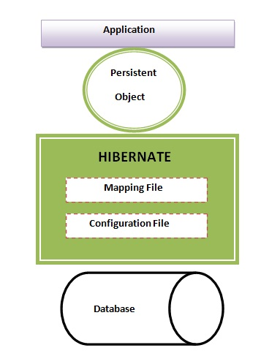

Hibernate framework uses many objects along with existing Java API such as JDBC (Java Database Connectivity), JTA (Java Transaction API) and JNDI (Java Naming Directory Interface).

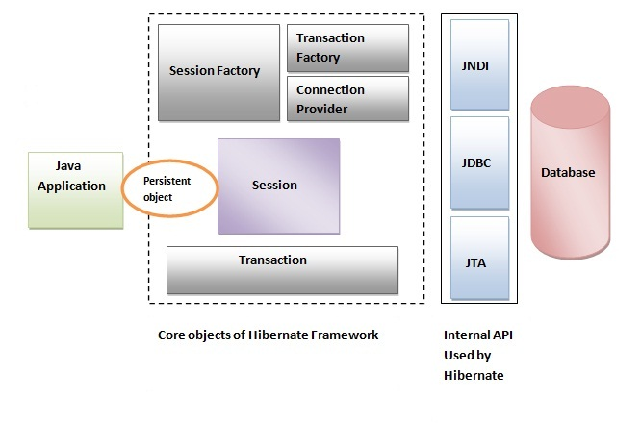

Elements of Hibernate Architecture

SessionFactory The SessionFactory is a factory of session and client of ConnectionProvider.

It holds second level cache (optional) of data.

The org.hibernate.SessionFactory interface provides factory method to get the object of Session.

Session The session object provides an interface between the application and data stored in the database.

It is a short-lived object and wraps the JDBC connection.

It is factory of Transaction, Query and Criteria.

It holds a first-level cache (mandatory) of data.

The org.hibernate.Session interface provides methods to insert, update and delete the object.

It also provides factory methods for Transaction, Query and Criteria.

Transaction The transaction object specifies the atomic unit of work. It is optional.

The org.hibernate.Transaction interface provides methods for transaction management.

ConnectionProvider It is a factory of JDBC connections. It abstracts the application from DriverManager or DataSource. It is optional.

TransactionFactory It is a factory of Transaction. It is optional.