**Starting Up the Database:**

Oracle Database Express Edition (Oracle Database XE) starts up **automatically** immediately after installation and after **each system restart**.

You can start it anyway, if it is closed for some reason

* Click Start,
* point to Programs (or All Programs / **All apps** see following pics),
* point to Oracle Database 11g Express Edition, and then
* Select Start Database.

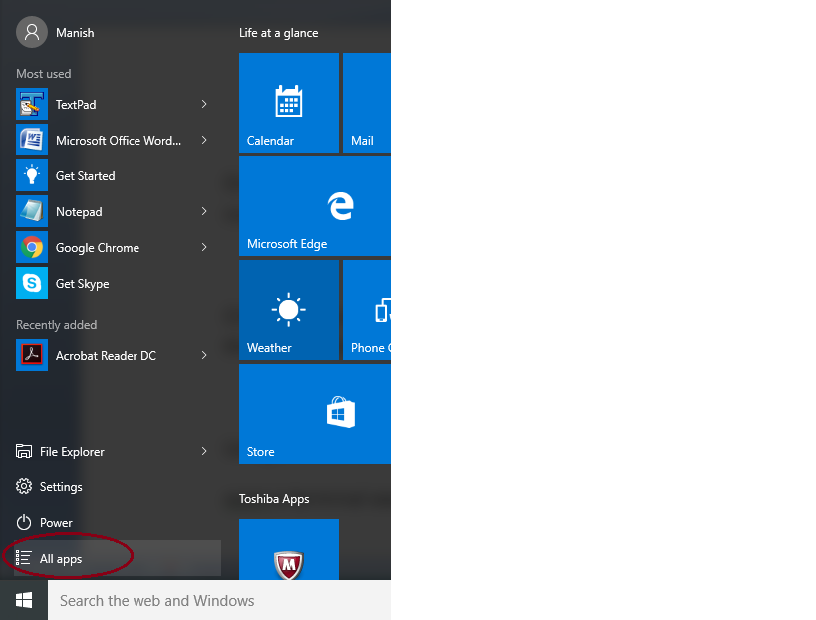



Click “Oracle Database 11 g Ex” to expand and select (or click) Start Database/ Stop Database.

**Shutting Down the Database:**

Oracle Database Express Edition (Oracle Database XE) shuts down automatically when you shut down the computer

* Before shutting down Oracle Database XE, it is best to ensure that all users and applications have completed their work and logged out. See "Monitoring Sessions"

Sometimes you need to shutdown manually just to release system memory etc:

* Click Start,
* point to Programs (or All Programs i.e. All apps),
* point to Oracle Database 11g Express Edition, and then
* Select Stop Database.

**Starting the SQL Command Line:**

* Click Start,
* point to Programs (or All Programs),
* point to Oracle Database 11g Express Edition, and then
* Select Run SQL Command Line.

At the SQL Command Line prompt, enter the following command to connect to database:

CONNECT username/password

open a terminal session or command window.

At the operating system prompt, enter the following command to start the SQL Command Line and connect to the database:

sqlplus / as sysdba

The slash (/) indicates that the database should authenticate you with operating system authentication.

At the SQL Command Line prompt, enter the following command:

SQL> STARTUP

**Connecting to the Database**

To interact with Oracle Database XE, you must typically connect to the database as a database user. The interaction might be through the SQL Command Line, through SQL Developer, or through utilities invoked from the system command line.

Oracle Database XE supports connections between the SQL Command Line (SQL*Plus) and the database either locally, or remotely over a TCP/IP network.

Connecting locally means running the SQL Command Line (or any other Oracle command-line utility) on the same host computer where Oracle Database XE is installed and then initiating a database connection from the SQL Command Line (or other utility), or using SQL Developer to connect as a local database user. To connect locally, you must supply only a database user name and password.

Connecting remotely means running the SQL Command Line (or any other Oracle command-line utility) on a computer other than the Oracle Database XE host computer, and then initiating a database connection from the SQL Command Line over the network.

Oracle command-line utilities (and your applications) connect to the database through **Oracle client software.**

**Oracle Client Software**

The remote computer must have Oracle client software installed. Oracle Database XE accepts connections from all of the following types of Oracle client software:

* Oracle Database Express Edition Client
  + This is installed at host computer while installing Oracle Database XE.
  + You need to install Oracle Database XE separately on remote computers.
* Instant Client
* Oracle client software for Oracle Database Enterprise Edition or Standard Edition

All **Oracle client software** includes **Oracle Net,** which is the Oracle network software that enables client applications on one computer to connect to databases on another computer over a network.

Setting Environment Variables on the Windows Platform

On the Windows platform, environment variables are stored in the Windows registry, and are automatically set for you.

Setting Environment Variables on the Linux Platform

On the Linux platform, before running the SQL Command Line or other Oracle utilities from a terminal session, you must set some environment variables for that session.

Local Connection

For Bourne, Korn, or Bash shell:

source /u01/app/oracle/product/11.2.0/xe/bin/oracle_env.sh

For C shell:

source /u01/app/oracle/product/11.2.0/xe/bin/oracle_env.csh

Remote Connection

For Bourne, Korn, or Bash shell:

source /usr/lib/oracle/xe/app/oracle/product/11.2.0/client/bin/oracle_env.sh

For C shell:

source /usr/lib/oracle/xe/app/oracle/product/11.2.0/client/bin/oracle_env.csh

**Creating/Managing users**

Administrative Accounts

The following administrative user accounts are automatically created when you install Oracle Database Express Edition (Oracle Database XE).

They are both created with the password [ruylopez] that you supplied upon installation.

* SYSTEM : user account used to perform all administrative functions other than starting up and shutting down the database.
* SYS : All base tables and views for the database data dictionary are stored in the SYS schema.
  + These base tables and views are critical for the operation of Oracle Database XE.
  + To maintain the integrity of the data dictionary, tables in the SYS schema are manipulated only by the database. They should never be modified by any user or database administrator.
  + You must not create any tables in the SYS schema. There is no reason to log in as user SYS.

**The SYSDBA System Privilege**

SYSDBA is a system privilege that is assigned only to user SYS. It enables SYS to perform high-level administrative tasks such as starting up and shutting down the database.

SQL > connect sys/password as sysdba

If you want to log in as SYS with the SQL Command Line (SQL*Plus), you must connect to the database "AS SYSDBA." Connecting AS SYSDBA invokes the SYSDBA privilege.

If you omit the AS SYSDBA clause when logging in as user SYS, the SQL Command Line rejects the login attempt.

There are three ways to log in to Oracle Database Express Edition (Oracle Database XE) to perform administrative tasks:

* Log in as user SYSTEM
  + For routine administrative tasks like managing memory and managing users.
* Log in as a user who has been granted the DBA role
  + For routine administrative tasks like managing users.
* Log in and connect to the database as SYSDBA using the SYS user name and password, or using operating
  + For high-level administrative tasks like starting up and shutting down the database, and changing the SYS password.

Managing Database Users : use SQL Developer or the SQL Command Line (SQL*Plus) you can

* Create Users
* Alter Users
* Lock and Unlock User Accounts
* Expire a User Password
* Drop Users

To perform these operations, in the SQL Developer Connections navigator,

* open a connection to the SYSTEM user.
* In the nodes under this SYSTEM connection, expand Other Users.
* To create a new database user, right-click the Other Users node in the Connections navigator and select Create User.
  + "Configuring Privilege and Role Authorization"
  + 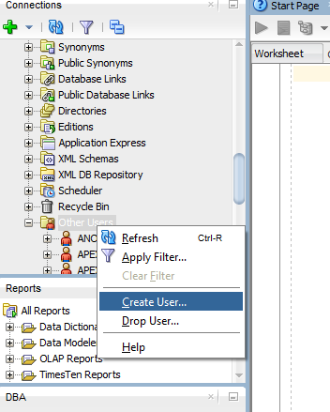
* To perform an action (Edit/ Drop) on a database user, right-click that user in the hierarchy and select the appropriate command (Edit User or Drop User).
  + Before you can drop a user, you must first drop all the user’s schema objects. Or,
  + you can use the cascade feature of the drop operation, which simultaneously drops a user and also that user’s schema objects.



Password expired : When you expire a user password, the user is prompted to change the password at the next login.

Account Lock: To temporarily deny access to the database for a particular user while preserving the user’s schema objects, you can lock the user account.

Under no circumstances should you attempt to drop the SYS or SYSTEM users, or any other internal user accounts. Doing so could cause Oracle Database XE to malfunction.

**Managing Database Memory**

To support database operation, Oracle Database XE needs to start a set of background processes, and needs to allocate some memory in the host computer. The background processes and allocated memory together make up an Oracle instance.

Oracle instance = background processes+ allocated memory

Allocated memory = SGA + PGA

There are two types of memory that the Oracle instance allocates:

* System global area (SGA)—A shared memory area that contains **data buffers** and **control information** for the instance. The SGA is divided into separate buffer areas and data pools.
* Program global area (PGA)—A memory area used by a single Oracle server process.
  + An Oracle server process is a process that services a client’s requests.
  + Oracle Database XE creates a new server process whenever it receives a new database connection request.
  + Each new server process then allocates its own private PGA area. The PGA is used to process SQL statements and to hold logon and other session information.

The amount of memory allocated to the SGA and PGA directly affects the performance of your database. The SGA and PGA sizes are configured automatically when you install Oracle Database XE.

Oracle Database XE uses automatic memory management, which cannot be disabled.

With automatic memory management, the database dynamically exchanges memory between SGA and PGA as needed to meet processing demands.

The database also dynamically tunes the sizes of the individual SGA components and the sizes of the individual PGAs.

The SGA has several components, listed below.

* Buffer cache: SGA component that acts as the buffer to store any data being queried or modified.
  + All clients connected to the database share access to the buffer cache.
  + The buffer cache helps avoid repeated access from the physical disk, a time-consuming operation.
* Shared pool : The shared pool caches operational information and code that can be shared among users. For example:
  + SQL statements are cached so that they can be reused.
  + Information from the data dictionary, such as user account data, table and index descriptions, and privileges, is cached for quick access and reusability.
  + Stored procedures are cached for faster access.
* Redo log buffer : The redo log buffer improves performance by caching redo information (used for instance recovery) until it can be written at once and at a more opportune time to the physical redo log files that are stored on disk.
* Large pool : An optional area that is used for buffering large I/O requests for various server processes.

Oracle Database XE automatically tunes the individual sizes of these components for optimal performance.

* The default sizes for the SGA and PGA are set upon installation, based on the total amount of physical memory in system.
  + The maximum amount of memory that Oracle Database XE allows for the SGA and PGA Aggregate is 1 gigabyte (GB).
  + If the sum of the SGA size and PGA Aggregate size attempted to exceeds 1 GB, Oracle Database XE issues an error message.
* Rather than changing the sizes of individual SGA components, change the overall size of the SGA by setting a parameter called SGA Target, and the sizes of the individual SGA components, will be adjusted(tuned) continuously to optimize performance.
* Similarly, you can change the total amount of memory allocated for the collection of PGAs, and Oracle Database XE adjusts individual PGA sizes as needed.
  + The collection of PGAs is known as the PGA Aggregate. You change the PGA Aggregate maximum size by setting a parameter called PGA Aggregate Target.

**Managing Database Storage**

Oracle Database XE is composed of the following storage structures:

* Logical structures - Tablespaces
  + Created and recognized by the database only.
  + Not known to the operating system.
* Physical structures - the physical files that store data on disk
  + This can be seen and operated on from the operating system.
* Recovery-related structures - redo logs and database backups
  + Used to recover the database after an operating system failure, Oracle instance failure, or media (disk) failure.
  + Recovery-related structures are stored in an automatically managed disk storage area called the flash recovery area.

Oracle Database XE completely automates the management of its logical and physical structures and flash recovery area storage.



Database

* The database is the collection of logical and physical structures that together contain all the data and metadata for your applications.
* The database also contains control structures (such as control files) that it needs for startup and operation.
* The Oracle Database XE instance works with a single database only and accommodates multiple applications by enabling you to separate data into different schemas.

Tablespace: A tablespace is a logical grouping of one or more physical datafiles or tempfiles, and is the primary structure by which the database manages storage.

A database consists of one or more tablespaces.

* SYSTEM - This tablespace is automatically created when Oracle Database XE is installed.
  + It contains the data dictionary, which is the central set of tables and views used as a read-only reference for the database.
  + It contains various tables and views that contain administrative information about the database.
  + These are all contained in the SYS schema, and can be accessed only by user SYS or other administrative users with the required privilege.
* SYSAUX - Automatically created upon installation.
  + This is an auxiliary tablespace to the SYSTEM tablespace.-
  + Some database components and products use this tablespace.
* TEMP - This tablespace stores temporary data generated when processing SQL statements.
  + For example, this tablespace is used for sort work space.
  + The TEMP tablespace is specified as the default temporary tablespace for every user.
* UNDO - This is the tablespace used by the database to store undo information.
* USERS - This tablespace is used to store permanent user objects and data.
  + In Oracle Database XE, USERS is the assigned default tablespace for all users except the SYS user, which has the default permanent tablespace of SYSTEM.
* **Datafiles** : These are the operating system files that hold database data.
  + The data is written to these files in an Oracle-proprietary format that cannot be read by programs other than an Oracle database.
* Tempfiles : a special class of datafiles that are associated only with temporary tablespaces.
  + Temporary tablespaces provide workspaces to help process queries.
* Control file : A binary file that tracks the names and locations of the physical components of the database, and maintains other control information, including records of all database backup-related files.
  + It is essential to the functioning of the database.
* The server parameter file (SPFILE): contains initialization parameters that Oracle Database XE uses at startup to determine the settings and run-time resources for the database.
  + You can change initialization parameter values by submitting ALTER SYSTEM commands with the SQL Command Line.
* Password file : Authenticate a user who is logging in remotely as user SYS.
  + Contains the SYS password (encrypted).
  + Automatically created when you install Oracle Database XE.

**Flash recovery area**

Flash recovery area is a directory, separate from the database itself, where recovery-related structures are stored. These recovery-related structures include:

* Backups of the physical files that make up the database (datafiles, the control file, and the server parameter file (SPFILE))
* Online redo logs: The online redo log files record all changes made to the database. They can be used to reconstruct data in the event of a failure.
* Archived redo logs: If you enable log archiving, filled redo log files are archived (copied) in the flash recovery area before being reused. The online and archived logs together constitute a record of all changes committed to the database since the last backup was taken.

Oracle database backup and recovery is based on protecting the physical files of the database, rather than individual database objects such as tables.

Backups are stored in collections called backup sets. A backup set consists of one or more backup pieces, which are files in a proprietary archival format that can be accessed only by an Oracle database.

The database automatically manages all contents of the flash recovery area.

You must not directly manipulate files within the flash recovery area using OS commands.

Flash Recovery Area Default Locations : default location is the same disk as your database files

* Linux : /usr/lib/oracle/xe/app/oracle/flash_recovery_area/
* Windows : c:\oraclexe\app\oracle\flash_recovery_area\

Where data protection is essential, change the location of the flash recovery area so that it is stored on a different disk.

redo log files

If an Oracle instance failure or operating system failure prevents modified data from being permanently written to the datafiles, the changes can be recovered from the redo log so that committed data updates are not lost.

A redo log is made up of redo entries, which are also called redo records.

The primary function of the redo log is to record all changes made to data in the database.

The database writes to the redo log files in a circular fashion.

When the current redo log file fills, the database begins writing to the next available redo log file.

When the last available redo log file is filled, the database returns to the first redo log file and writes to it, starting the cycle again.

Multiplexed Redo Log: two or more identical copies of the redo log can be automatically maintained in separate locations.

Multiplexing is implemented by creating groups of redo log files.

A group consists of a redo log file and its multiplexed copies.

When the database writes to the current log file, all members in that log file’s group are update d so that they remain identical.

The default installation of Oracle Database XE does not use multiplexing.

online redo log files

The current and inactive redo log files and all their members taken together, are called the online redo log files, to distinguish them from archived redo log files