Changing the git user/credentials i.e. using different account.

<https://stackoverflow.com/questions/15381198/remove-credentials-from-git>

Type credential manager in windows-search.

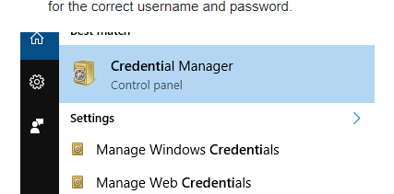

Click credential manager

