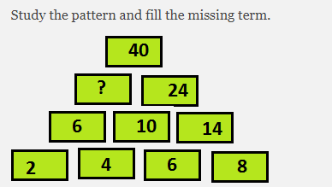

[Copyright © www.www.doorsteptutor.com](https://www.www.doorsteptutor.com/)  
Some students were building a castle with blocks. The pictures below show the number of blocks they used per day in building the castle.   
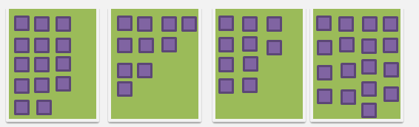

[Copyright © www.www.doorsteptutor.com](https://www.www.doorsteptutor.com/)  
After 5 days castle was completed. How many blocks in all were used to make the castle? 

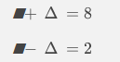

Find the value of triangle



[Copyright © www.www.doorsteptutor.com](https://www.www.doorsteptutor.com/)  
If one blue square represents TEN, then what number represents the given addition? 

