[Copyright © www.www.doorsteptutor.com](https://www.www.doorsteptutor.com/)  
1. What is the fraction of prime numbers in the given table?

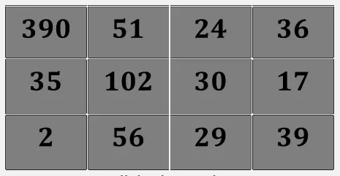

[Copyright © www.www.doorsteptutor.com](https://www.www.doorsteptutor.com/)  
2. What part of the square is shaded?

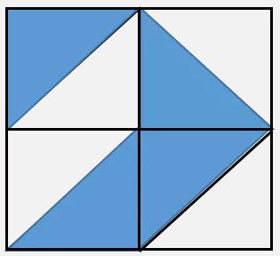

[Copyright © www.www.doorsteptutor.com](https://www.www.doorsteptutor.com/)

3.

How many more parts must be shaded to make the figure 2/3 shaded?

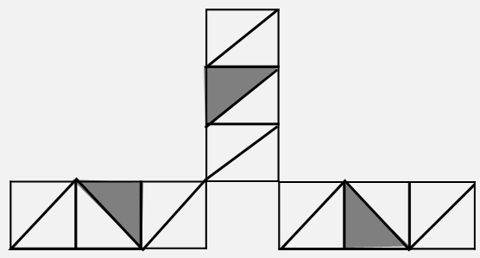

[Copyright © www.www.doorsteptutor.com](https://www.www.doorsteptutor.com/)  
4.

Vamshi has a bag that contains 3 red, 1 blue, 6 green and 2 yellow marbles. What fractional part of the bag of marbles is red?

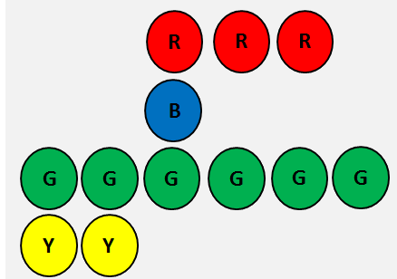

5.

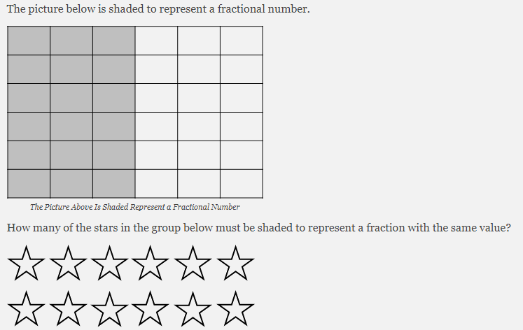

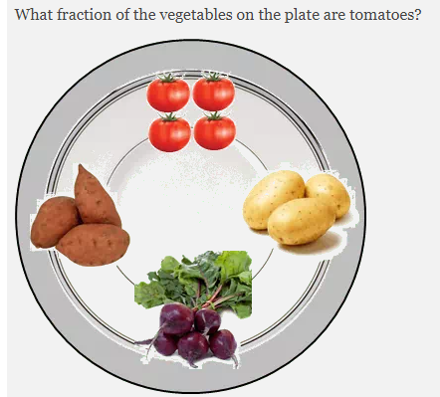

[Copyright © www.www.doorsteptutor.com](https://www.www.doorsteptutor.com/)  
What is the fraction of composite numbers in the given table?

