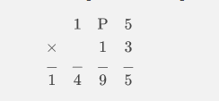

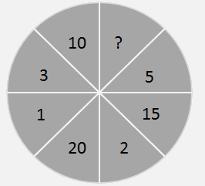

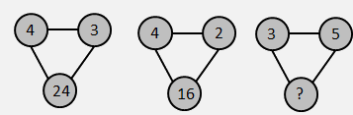

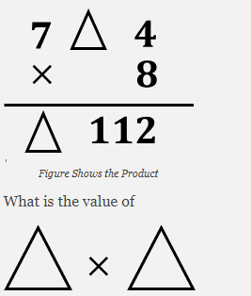

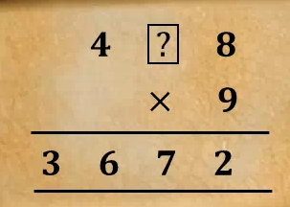

[Copyright © www.www.doorsteptutor.com](https://www.www.doorsteptutor.com/)  
The expression you will prefer to represent the total number of dolls are:  
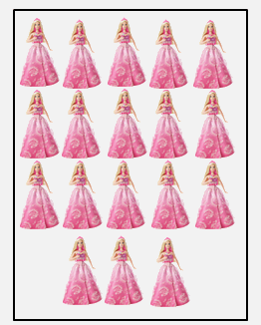

[Copyright © www.www.doorsteptutor.com](https://www.www.doorsteptutor.com/)  
If the product of all the three numbers in any row, column or diagonal is same, then 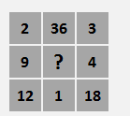

[Copyright © www.www.doorsteptutor.com](https://www.www.doorsteptutor.com/)

If the cost of 2 packets of BOURBON biscuits is Rs. 15, how many packets can I get for Rs. 60 with the FREE OFFER shown?  
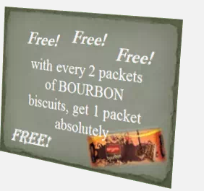

[Copyright © www.www.doorsteptutor.com](https://www.www.doorsteptutor.com/)  
If the product of all the four numbers in any row is same, then find the missing term in the given square?

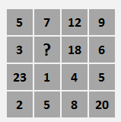

[Copyright © www.www.doorsteptutor.com](https://www.www.doorsteptutor.com/)