1. 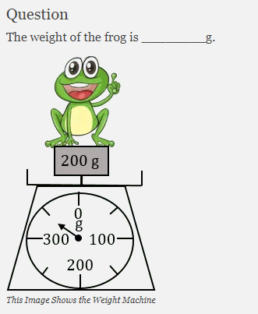
2. 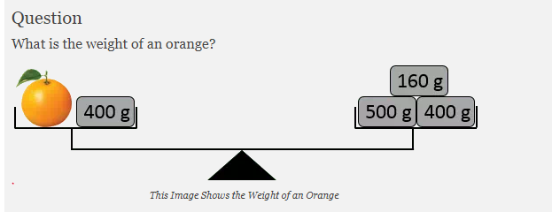
3. 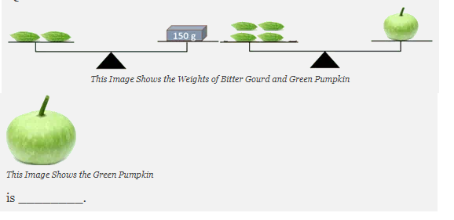
4. 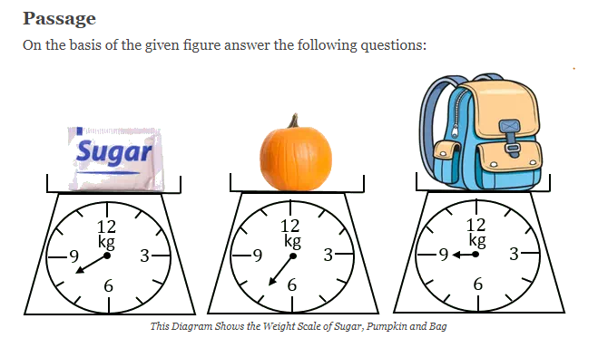

[Copyright © www.www.doorsteptutor.com](https://www.www.doorsteptutor.com/)

* 1. [Copyright © www.www.doorsteptutor.com](https://www.www.doorsteptutor.com/)  
     What is the weight of sugar bag?
  2. How many is school bag heavier than pumpkin?
  3. [Copyright © www.www.doorsteptutor.com](https://www.www.doorsteptutor.com/)  
     How many is school bag heavier than sugar bag?

1. 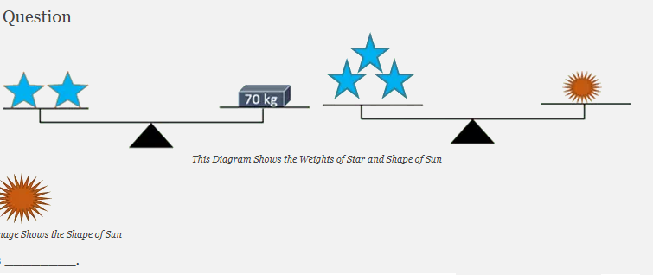
2. 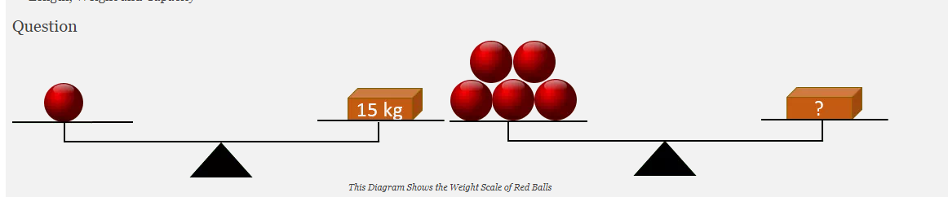
3. 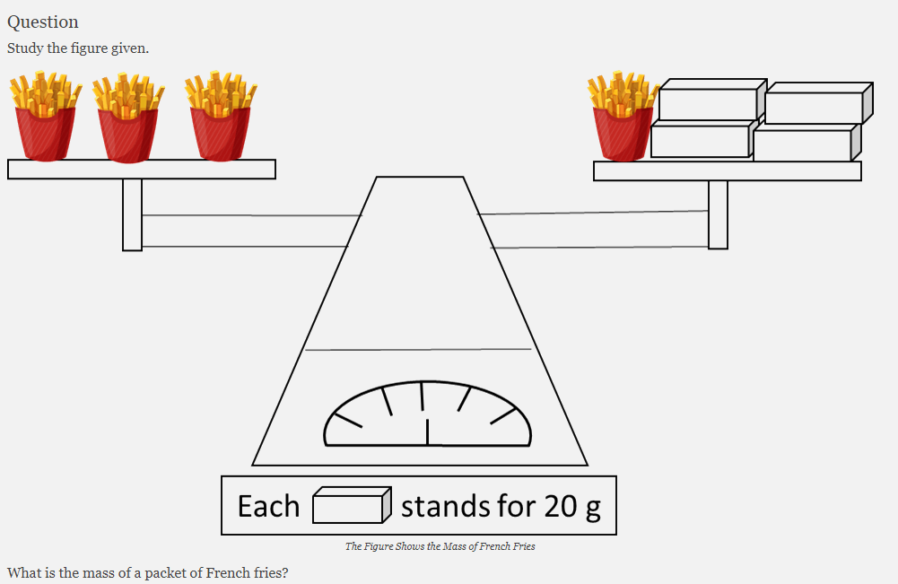
4. 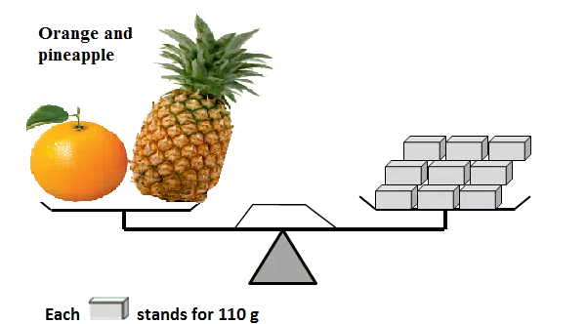
5. [Copyright © www.www.doorsteptutor.com](https://www.www.doorsteptutor.com/)  
   If the mass of the pineapple is 470 g, then the mass of the orange is ________ g.
6. 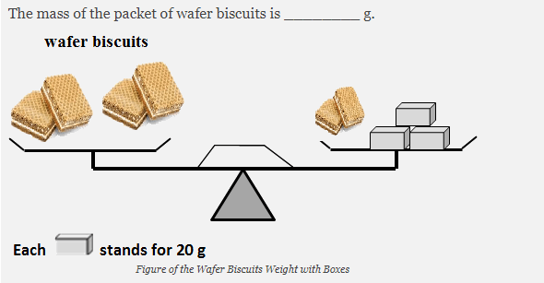
7. 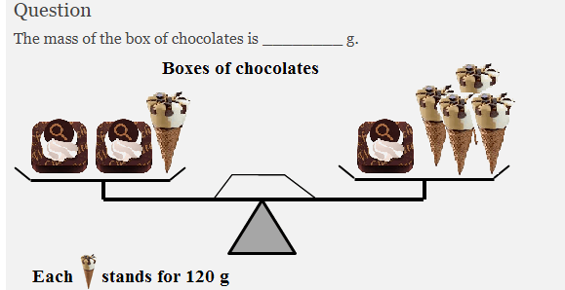
8. 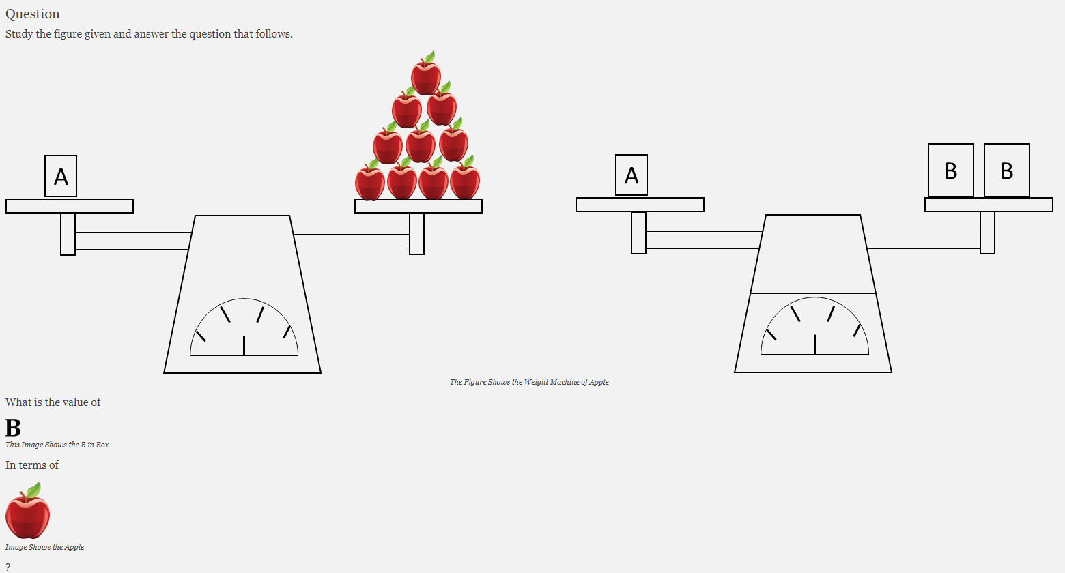
9. 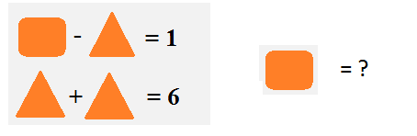
10. 
11. 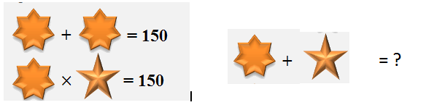
12. 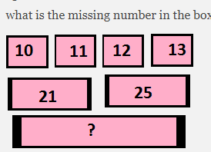
13. 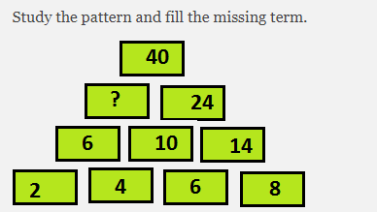
14. 