1. Krisha read 3/6 of a book on the first day and 2/6 of it on the second day. What fraction of it is not read?
2. Sunil had 12 cakes. He gave 4 of them to his friend and ate some. He now has the 1/2 number of cakes. How many cakes did Sunil eat?
3. What fraction of the figure is shaded?

 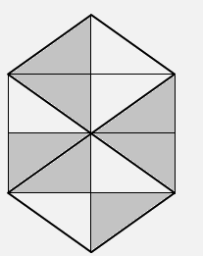

________ ________

[Copyright © www.www.doorsteptutor.com](https://www.www.doorsteptutor.com/)  
Copyright 4. Write the fraction of the shaded part.

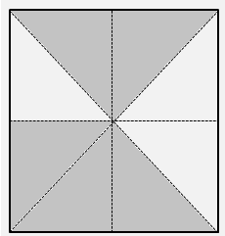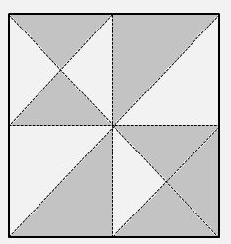

[Copyright © www.www.doorsteptutor.com](https://www.www.doorsteptutor.com/)  
5. For the following figure, write fraction of the unshaded part.

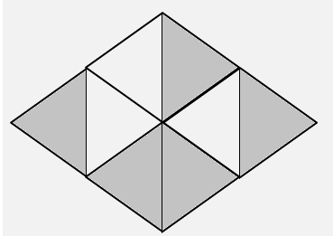 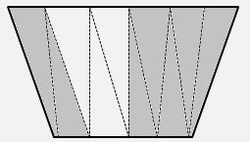

________ ________

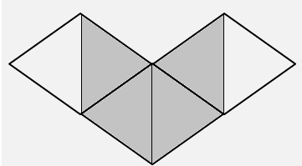

[Copyright © www.www.doorsteptutor.com](https://www.www.doorsteptutor.com/)  
________ of the figure is unshaded.