AVS

[**https://avsatweb.eur.ad.sag/AVS/index.jsp**](https://avsatweb.eur.ad.sag/AVS/index.jsp)

deflt(5)18

ESB INT SERV - 888599  
Kein Eintrag - 100890

B515632741

Allsec Epayslip facility at <https://www.Allsechro.com/memberlogin>

User Id SAG50006278

Password Def6Lt^

ruylo19

Chatter

Login – SAG mail id

to locate lost device:

www.mi.com/micloud

login - jnu.manish@gmail.com

deflt1

Nf3g6e4Bg7!

PYBOM00346540000011368_7244594

UAN - 100808231624

<https://netbanking.hdfcbank.com/netbanking/CCLogin.html>

manish2sem - Def1Lt! - 30Nov

PF

<https://ess.excelityglobal.com/>

old - 0032814697 / new - 0108455915  
Ruylop1@

stock : 0708fina/Mitu1234

UAN – 100241264598

Xero:

DM3551

Def1Lt!

Defltt1-brthYr(6)

ICICI-Bank - b515632741

NPS:

<https://enps.nsdl.com/eNPS/NationalPensionSystem.html>

110154001604

Ruylop1@

<https://passbook.epfindia.gov.in/MemberPassBook/Login>

<https://www.unifiedportal-mem.epfindia.gov.in/memberinterface/>

AKGH – 100435664152 : Def1Lt!0

IGate -  100808231624 : Def1Lt!0

KN/18616/12918 : BGBNG00186160000012918

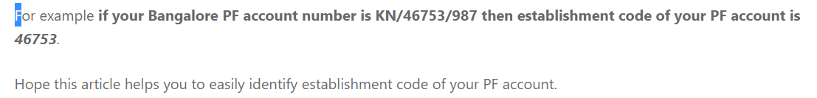

<https://makum.logging.saglive.com/>

[manish.kumar@softwareag.com](mailto:manish.kumar@softwareag.com)

Def1Lt!

Git

Amazon Associates account:

https://affiliate-program.amazon.in/

manish.bm90@gmail.com

Def1Lt!

mobile: 89716 45174

Google-Site : https://sites.google.com/view/best-review-mrmk/home

Associate ID is mrmk150982-21

<https://affiliate-program.amazon.in/help/operating/schedule>

If your affiliate links have not referred the minimum qualified sales after 180 days, your application and access to the Associates Program will be withdrawn.