Next hearing date is march 17 2020.

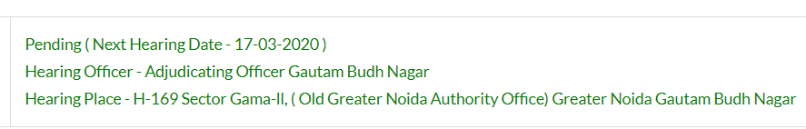

Here I am quoting the response made by builder’s lawyer on last hearing dated March 6 2020 (check the attachment-file page 2 #6)

"The complainant has admitted failed in making timely payment of invoice which was admittedly failed in making timely payment of invoice which was admittedly received by 30.12.2017. The said amount was paid on 19.04.2018 and till date the interest for delayed payment is not made. In the given situation the respondent can't be made liable for the delay."

In short, they are claiming that we are not liable for compensation as we delayed the payment by 3-4 months. i.e. we are supposed to pay on 30.12.2017 but we cleared the payment on 19.04.2018.

Here I am again repeating all the events during the period of 30.12.2017 to 19.04.2018. That will clear that builder was responsible for the “delay in payment” so there is no question of interest.

1. Invoice of final demand letter which they sent on 3012.2017 was faulty.(find the invoice in attachment - DemandLetter-30Dec2017.pdf)

it has calculation mistake.

Total Amount payable was 4,006,177.00

And they were asking to pay 4,104,553.00 + 37,024.00 (towards TDS)

1. When this was brought in their notice they accepted the error and assured me that within 2, 3 days they would send the new invoice with correcting the above error.
2. They sent new invoice dated 10th March 2018 (invoice is attached - DemandLetter_March10_2018.pdf) but again added the interest part for delay.
3. When I asked the reason of interest charges (it was already communicated to me that there would not by any interest charges because error was at their end – check attachment mail-communication dated 20th march builder’s reply), They replied back with fresh invoice (print date 20th March 2018 – find in attachment - DemandLetter-20March2018.pdf) and reverted all the interest.
4. After receiving this new correct invoice all the payment was done within a month i.e. by 19th April 2018. So, there is no question of interest here.

In Summary,

They generated faulty invoice

They accepted their fault and took 3 months of time to correct it.

Meantime, they admitted that no interest would be charged for the delay as they were responsible for delay of sending corrected invoice.

Once all payment is done, they again started asking interest amount which is totally wrong.

Even though all the payment are made 2 years back(19 April 2018) they are not releasing NOC and trying to harass us and get some extra money in the name of interest.

Since they are at fault so they are liable for the compensation for their wrong doing, in terms of all the losses caused and mental harassment.

Following documents are attached in this mail

* Builder’s reply on March 06 2020 -
* All the three invoice – Invoice.zip
* Mail-Communication during the period Jan 2018 to May 2018 - Mail-Communication.doc