Creating test-patch

Step1 : Using fixbuilding pkg.

Goto C:\IS_srcCode\103oct2018\tests\utils\FixBuilding

Zip whole content of FixBuilding folder as FixBuilding.zip (Strictly .zip format not .7z)

Note – Don’t just zip Fixbuilding folder it won’t work.

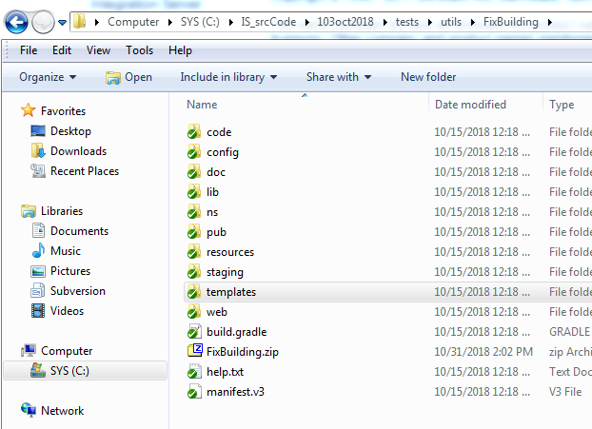

Use this as package and deploy into IS

Copy FixBuilding.zip to the inboumd folder (C:\IS_srcCode\Ver-10_1\staging\installs\IntegrationServer\instances\default\replicate\inbound) and then goto **Packages > Management > Install Inbound Releases** and activate/archive the package FixBuilding.

Then use <http://localhost:5555/FixBuilding/> to access Fixbuilding tool for creating test-patch.

Q -> IS version for creating test patch should be same as destination IS version (Customer IS where it need to be applied) or can be any version?

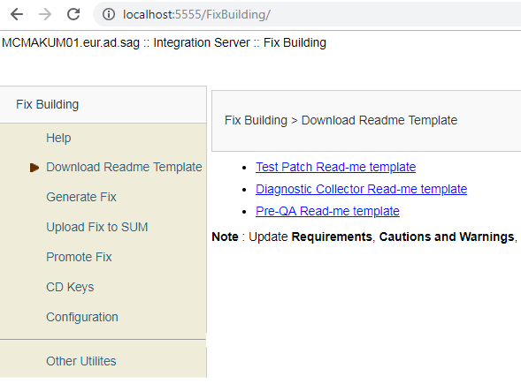

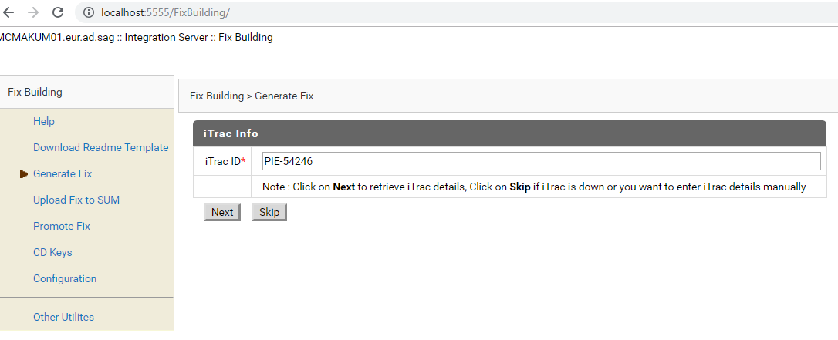

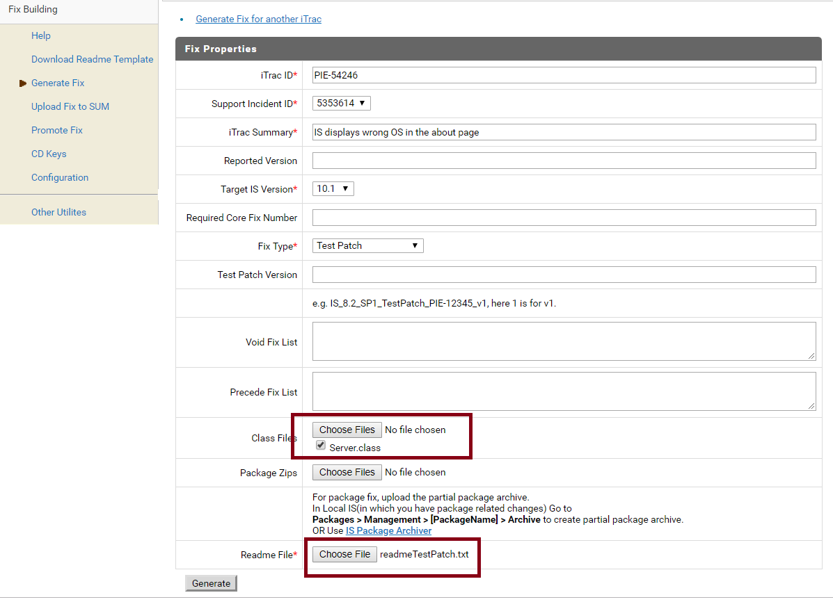

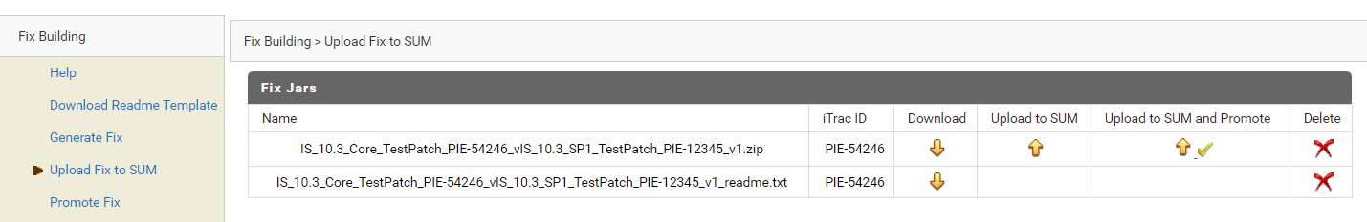

**How to upload package (i.e. wmroot)**

Include the changes into develop branch

Start the IS and goto Packages > Management in Is-Admin and click Archive for the corresponding package

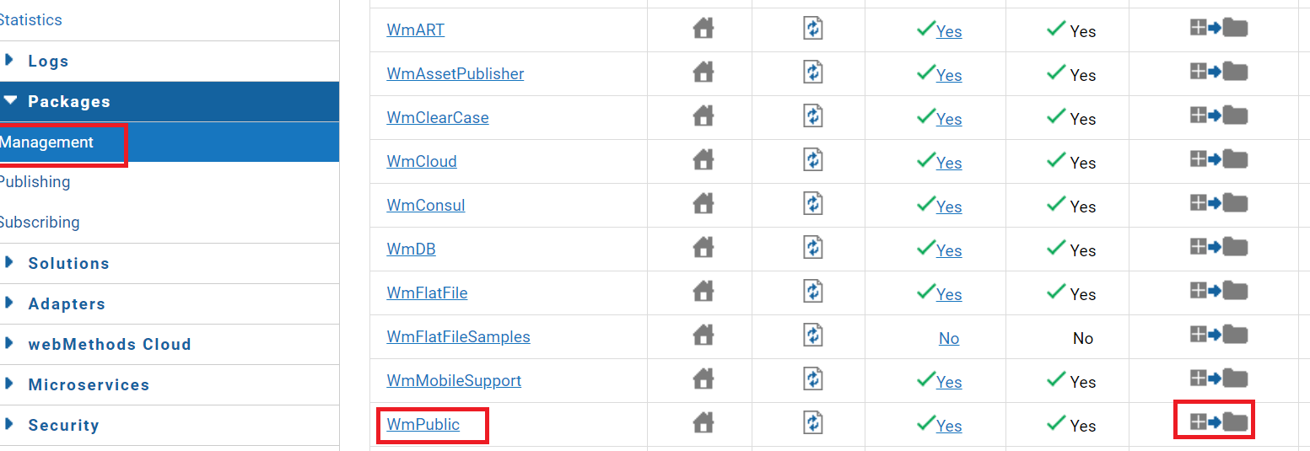

Select the files to be included and create the archive by giving following info accurately :

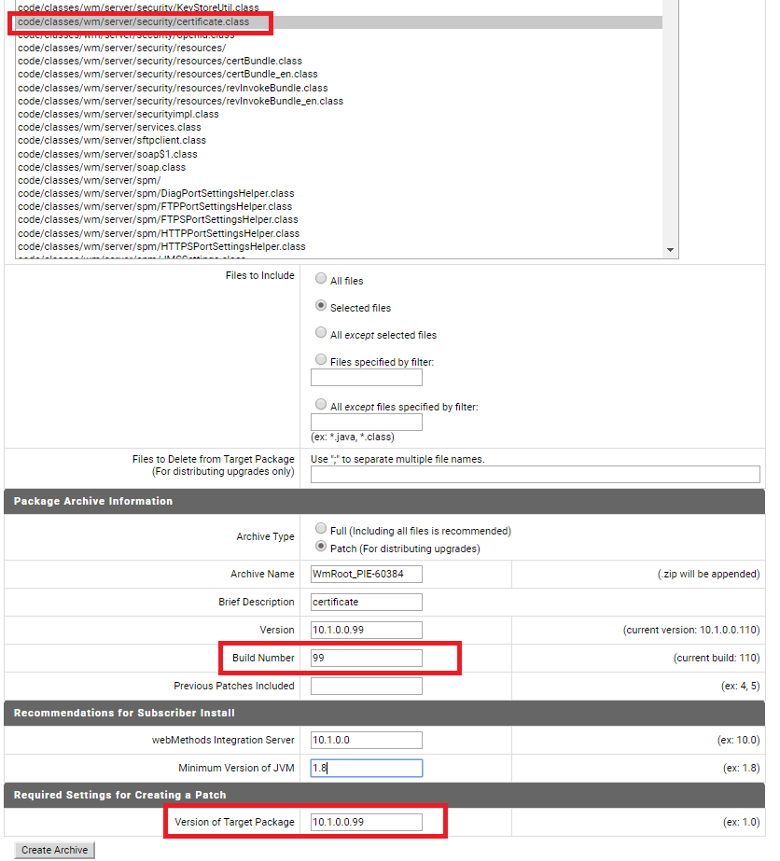

Build no. – Should be same as product

You can find the archive at outbound folder - C:\SAG_src\IS_101\staging\installs\IntegrationServer\instances\default\replicate\outbound

Finally upload this archive into Test-patch/fix using generate fix tab.

Investigate

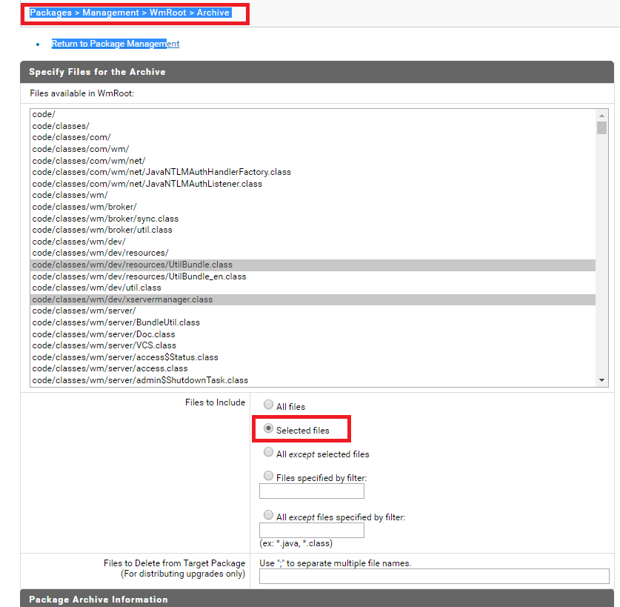

**How to update the Patch (CD Repo)**

Go to - <http://aquarius-va.ame.ad.sag:8088/reposervice/repoadmin/welcome>

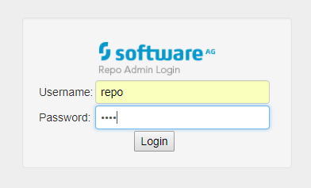

Download your patch

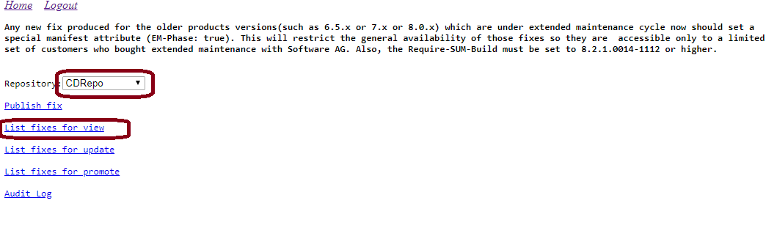

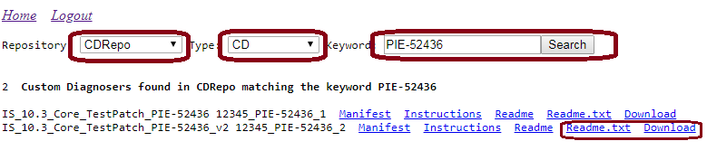

Now down load readme.txt and patch file both

Patch will be named as 12345_PIE-52436_1.0.0.0002-0001

Rename it like 12345_PIE-52436_1.0.0.0002-0001.zip so that it can be opened using 7z

Once done open it in 7z and modify your all class files.

Change the manifest file : Display-Fix-Name

* Location :C:\Users\makum\Downloads\back\5365445_PIE-59525_1.0.0.0001-0001.zip\META-INF\MANIFEST.MF
* Display-Fix-Name: IS_10.5_SPM_TestPatch_PIE-59525_v3 (example)

Now upload this zip file (with zip extension) into Fix-building using publish-fix

Publishing the patch

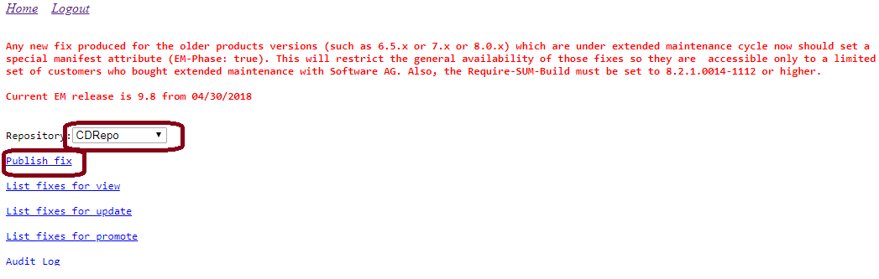

Upload both patch and readme file

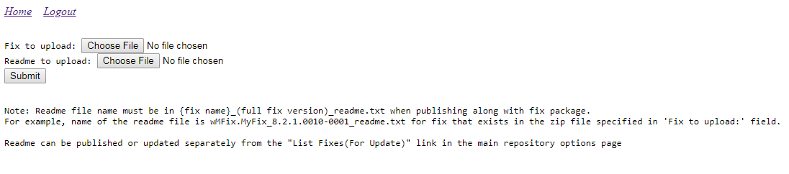

Applying the patch:

C:\SAG_install\UpdateManager\bin>UpdateManagerGUI.bat -server aquarius-va.ame.ad.sag:CDRepo

