<https://portswigger.net/burp/help/suite_gettingstarted.html>

Burp functions as an HTTP proxy server, and all HTTP/S traffic from your browser passes through Burp.

**Starting burp:**

**C:\SAG_Apps\burpsuite_v1.4.01>java -jar burpsuite_v1.4.01.jar**

Firstly, you need to confirm that Burp's Proxy listener is active and working.

Go to the Proxy tab, then the Options sub-tab, and look in the Proxy Listeners section. You should see an entry in the table with the checkbox ticked in the Running column, and "127.0.0.1:8080" showing in the Interface column.

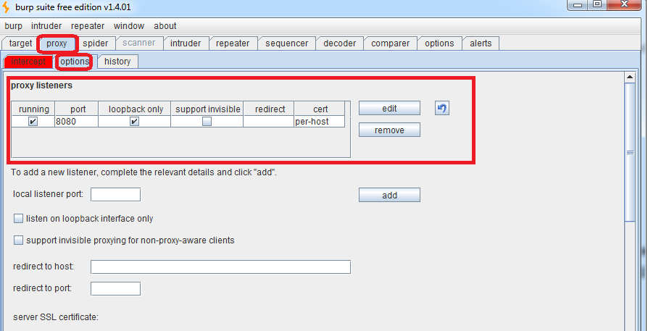

To do any kind of testing with Burp, you need to configure your browser to work with it.

Settings ->Advanced -> Open Proxy Settings

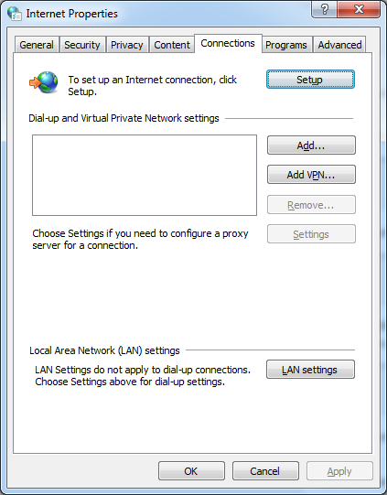

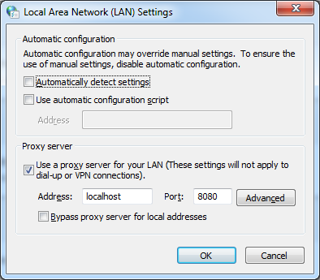

Once you have Burp running, and have configured your browser to work with Burp, go to the Proxy Intercept tab, and ensure that interception is turned on.

Each HTTP request made by your browser is displayed in the Intercept tab. You can view each message, and edit it if required. You then click the "Forward" button to send the request on to the destination web server. If at any time there are intercepted messages pending, you will need to forward all of these in order for your browser to complete loading the pages it is waiting for. You can toggle the "Intercept is on / off" button in order to browse normally without any interception, if you require