Local Service Development:

Make sure below is installed (with all dependency) through SAG installer:

* **Service Development 10**.0 . (Not sure)
* **Local Version control Integration 10**.0

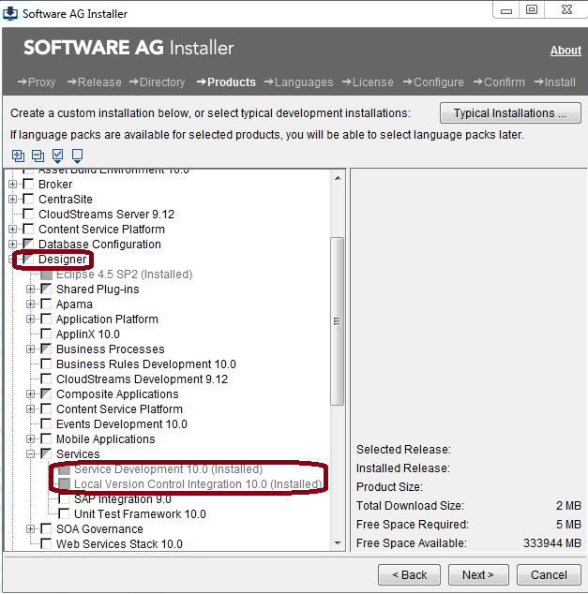

Once installed properly you can find **IntegrationServer** folder inside designer.

This is Local IS for this designer.

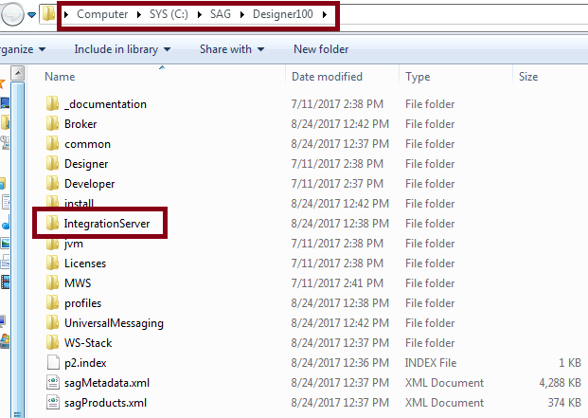

* Now start this local IS
* Start designer as administrator
* Once both started successfully configure local IS for this designer(see below picture).

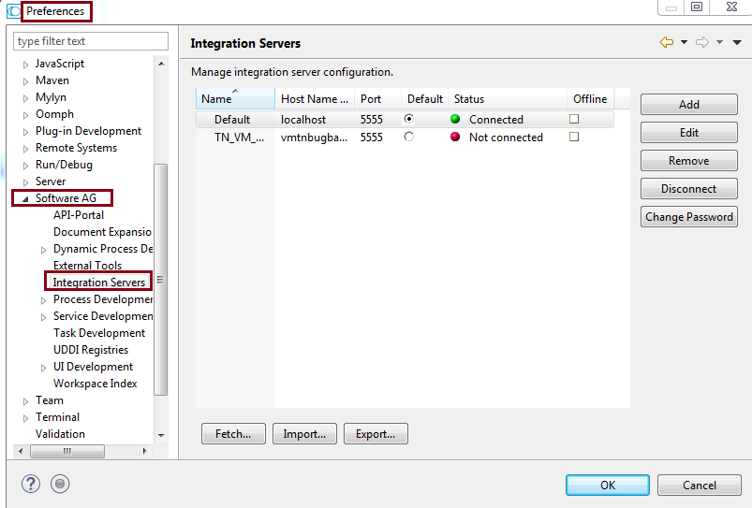

Issues:

<https://itrac.eur.ad.sag/browse/PIE-46513>

wm.server.packages:packageDelete service should not delete the contains of package if the package folder is symbolic linked from external folder. In this case the service should delete only the linked folder.

Reproducing Steps:

* Go to default(IS) in package navigator.
* Create Package(TestPag), Folder(TestFolder) and a flowService inside it.
* Then right-click on package and click on **Create Local Service Development Project**.

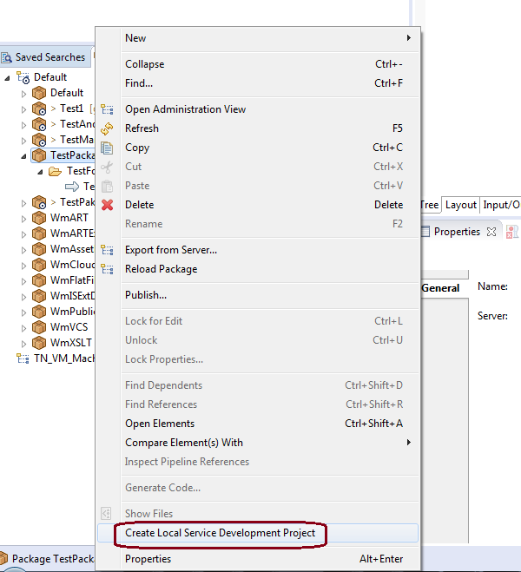

It will ask for creating new git repository or selecting an existing git repository. Provide any file system path (C:\Users\makum\git1) (Need to understand it’s workings – check GIT)

Once done, you can see the package with all the necessary folder/files are created in above given path.

And it’s symbolic linked is created at package location C:\SAG\Designer100\IntegrationServer\instances\default\packages

If it is not LSD then actual files and folder (not just symbolic linked) are created inside package folder.

Actual Issue:

Once you delete this symbolic linked actual folder linked with this symbolic link is deleted.

Expected behavior: Only symbolic link should be deleted.