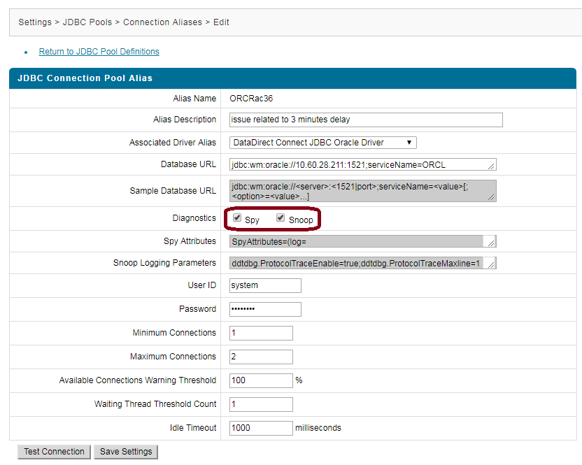

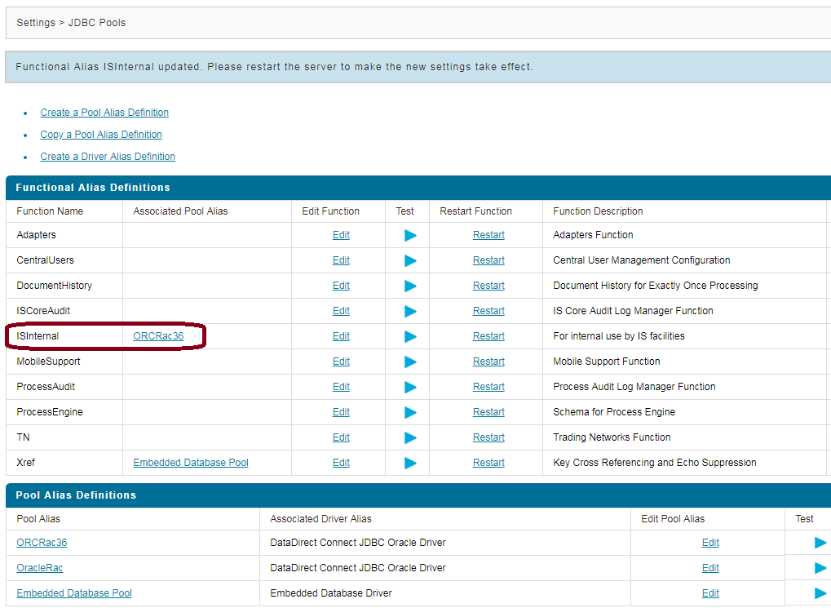

Is internal tables :

C:\SAG\SAG_103\common\db\scripts\derby\isinternal\70\create\dby_isi_c_ddl.sql

-- Create tables and related objects for core IS functions.

-- DataStore for the pub.storage services.

CREATE TABLE IS_DATASTORE (

ALTER TABLE IS_DATASTORE

ADD CONSTRAINT ISDATSTR_PKX PRIMARY KEY (DATASTORE_ID);

CREATE UNIQUE INDEX ISDATSTR_AK1

ON IS_DATASTORE (STORAGE_CONTEXT, STORAGE_KEY);

-- User Scheduler table

CREATE TABLE IS_USER_TASKS (

-- Guaranteed Delivery tables

CREATE TABLE IS_GD_TRANSACTIONS_OUT (

ALTER TABLE IS_GD_TRANSACTIONS_OUT

ADD CONSTRAINT GDTRANSOUT_PKX PRIMARY KEY (TRANSACTION_ID);

CREATE TABLE IS_GD_TRANSACTIONS_IN (

ALTER TABLE IS_GD_TRANSACTIONS_IN

ADD CONSTRAINT GDTRANSIN_PKX PRIMARY KEY (TRANSACTION_ID);

CREATE TABLE IS_GD_LOCKS (

ALTER TABLE IS_GD_LOCKS

ADD CONSTRAINT GDLOCKS_PKX PRIMARY KEY (TRANSACTION_ID);

-- Join Management tables

CREATE TABLE IS_TRIGGER_STATE (

ALTER TABLE IS_TRIGGER_STATE

ADD CONSTRAINT TRIGSTATE_PKX PRIMARY KEY (TRIGGER_ID);

CREATE INDEX TRGDOC_EXPIRY_INDX

ON IS_TRIGGER_STATE (TRIGGER_EXPIRE_TIME, TRIGGER_STATE);

CREATE TABLE IS_TRIGGER_DOC (

ALTER TABLE IS_TRIGGER_DOC

ADD CONSTRAINT TRIGDOC_PKX PRIMARY KEY (TRIGGER_DOC_ID);

ALTER TABLE IS_TRIGGER_DOC

ADD CONSTRAINT TRGDOC_FK_TRGSTATE FOREIGN KEY (TRIGGER_ID)

REFERENCES IS_TRIGGER_STATE (TRIGGER_ID)

ON DELETE CASCADE;

-- Certificate Map table

CREATE TABLE IS_CERTIFICATE_MAP (

ALTER TABLE IS_CERTIFICATE_MAP

ADD CONSTRAINT ISCERTMAP_PKX PRIMARY KEY (ISSUER_SERIAL_NUM, CERT_USAGE);

CREATE INDEX ISCERTMAP_AK1

ON IS_CERTIFICATE_MAP (CERT_SKI);

CREATE INDEX ISCERTMAP_AK2

ON IS_CERTIFICATE_MAP (CERT_THUMBPRINT);

CREATE INDEX ISCERTMAP_AK3

ON IS_CERTIFICATE_MAP (CERT_USAGE);

-- OAuth tables

CREATE TABLE IS_OAUTH_SCOPE (

ALTER TABLE IS_OAUTH_SCOPE

ADD CONSTRAINT IS_OAUTH_SCOPE_PK PRIMARY KEY (SCOPE_NAME);

CREATE TABLE IS_OAUTH_CLIENTS (

ALTER TABLE IS_OAUTH_CLIENTS

ADD CONSTRAINT ISOAUTH_CLIENTS_PK PRIMARY KEY (CLIENT_ID);

CREATE UNIQUE INDEX ISOAUTHCLIENT_UNQIDX1

ON IS_OAUTH_CLIENTS (APPL_NAME, APPL_VERSION);

CREATE TABLE IS_OAUTH_CLIENT_REDIR (

ALTER TABLE IS_OAUTH_CLIENT_REDIR

ADD CONSTRAINT ISOAUTH_CLNT_REDIR_PK PRIMARY KEY (CLIENT_ID, REDIRECT_URI);

ALTER TABLE IS_OAUTH_CLIENT_REDIR

ADD CONSTRAINT ISOAUTHCLIREDIR_FK_CLNT FOREIGN KEY (CLIENT_ID)

REFERENCES IS_OAUTH_CLIENTS(CLIENT_ID);

CREATE TABLE IS_OAUTH_CLIENT_SCOPE (

ALTER TABLE IS_OAUTH_CLIENT_SCOPE

ADD CONSTRAINT ISOAUTH_CLNT_SCOPE_PK PRIMARY KEY (CLIENT_ID, SCOPE_NAME);

ALTER TABLE IS_OAUTH_CLIENT_SCOPE

ADD CONSTRAINT ISOAUTHCLISCOP_FK_CLNT FOREIGN KEY (CLIENT_ID)

REFERENCES IS_OAUTH_CLIENTS(CLIENT_ID);

ALTER TABLE IS_OAUTH_CLIENT_SCOPE

ADD CONSTRAINT ISOAUTHCLISCOP_FK_SCOP FOREIGN KEY (SCOPE_NAME)

REFERENCES IS_OAUTH_SCOPE(SCOPE_NAME);

CREATE TABLE IS_OAUTH_TOKEN (

ALTER TABLE IS_OAUTH_TOKEN

ADD CONSTRAINT IS_OAUTH_TOKEN_PK PRIMARY KEY (TOKEN_ID);

ALTER TABLE IS_OAUTH_TOKEN

ADD CONSTRAINT ISOAUTHTOKEN_FK_CLNT FOREIGN KEY (CLIENT_ID)

REFERENCES IS_OAUTH_CLIENTS(CLIENT_ID);

CREATE TABLE IS_OAUTH_TOKEN_SCOPE (

ALTER TABLE IS_OAUTH_TOKEN_SCOPE

ADD CONSTRAINT ISOAUTHTOKSCOP_PK PRIMARY KEY (TOKEN_ID, SCOPE_NAME);

ALTER TABLE IS_OAUTH_TOKEN_SCOPE

ADD CONSTRAINT ISOAUTHTOKSCOP_FK_TOK FOREIGN KEY (TOKEN_ID)

REFERENCES IS_OAUTH_TOKEN(TOKEN_ID) ON DELETE CASCADE;

ALTER TABLE IS_OAUTH_TOKEN_SCOPE

ADD CONSTRAINT ISOAUTHTOKSCOP_FK_SCOP FOREIGN KEY (SCOPE_NAME)

REFERENCES IS_OAUTH_SCOPE(SCOPE_NAME);

CREATE TABLE IS_OAUTH_ACCESSTOKEN (

ALTER TABLE IS_OAUTH_ACCESSTOKEN

ADD CONSTRAINT ISOAUTH_ACCTOK_PK PRIMARY KEY (ACCESSTOKEN_ID);

ALTER TABLE IS_OAUTH_ACCESSTOKEN

ADD CONSTRAINT ISOAUTH_ACCTOK_FK_TOK FOREIGN KEY (TOKEN_ID)

REFERENCES IS_OAUTH_TOKEN(TOKEN_ID) ON DELETE CASCADE;

CREATE TABLE IS_OAUTH_REFRESHTOKEN (

ALTER TABLE IS_OAUTH_REFRESHTOKEN

ADD CONSTRAINT ISOAUTH_REFTOK_PK PRIMARY KEY (REFRESHTOKEN_ID);

ALTER TABLE IS_OAUTH_REFRESHTOKEN

ADD CONSTRAINT ISOAUTH_REFTOK_FK_TOK FOREIGN KEY (TOKEN_ID)

REFERENCES IS_OAUTH_TOKEN(TOKEN_ID) ON DELETE CASCADE;

-- WS-RM SERVER tables

CREATE TABLE IS_WSRM_SENDER_SERVER (

CREATE TABLE IS_WSRM_RMD_SERVER (

CREATE TABLE IS_WSRM_RMS_SERVER (

CREATE TABLE IS_WSRM_INVOKER_SERVER (

CREATE TABLE IS_WSRM_MSGCTX_SERVER (

-- WS-RM CLIENT tables

CREATE TABLE IS_WSRM_SENDER_CLIENT (

CREATE TABLE IS_WSRM_RMD_CLIENT (

CREATE TABLE IS_WSRM_RMS_CLIENT (

CREATE TABLE IS_WSRM_INVOKER_CLIENT (

CREATE TABLE IS_WSRM_MSGCTX_CLIENT (

CREATE TABLE IS_ACCOUNT_LOCKING_DETAILS (

These tables must present in Database (OraRac36)

Below is the SQL Developer view of OraRac36 database.

