Configuration Steps:

* Connect designer to CC
* Connect designer to cloud
* Deploy to cloud.
* Open LandScape Navigator view in designer
  + This will bring the navigator tab with hyperlink
  + window -> show view -> others -> Software AG comman central ->LN
* Click the hyper-link for connecting Designer to Command-central
  + Configure CC to designer by providing CCE URL, User name and password.
* Add cloud to designer:
  + Click to “add/modify Integration servers” button
  + Configure the cloud to designer by providing cloud URL (SAG live), User name and password.
* Now go to IS in designer and deploy to cloud
  + Deployabale configuration screen will popup where you select the configurations to be deployed.
  + Next variable substituation screen will come up where you can substitute the values for selected variables.
  + Finally screen will come up where you can select the cloud-solution where configuration is deployed.

To look cloud-deploy template:

C:\Users\makum\workspace105\lartmp\local\designer\DesignerSolution\CC\Localhost-OSGI-IS_default.zip\

Issue regarding White-listing : C:\Users\MAKUM\workspace105\.metadata\.plugins\com.softwareag.designer.landscape.core\ DeployableRuntimeConfigurations.json

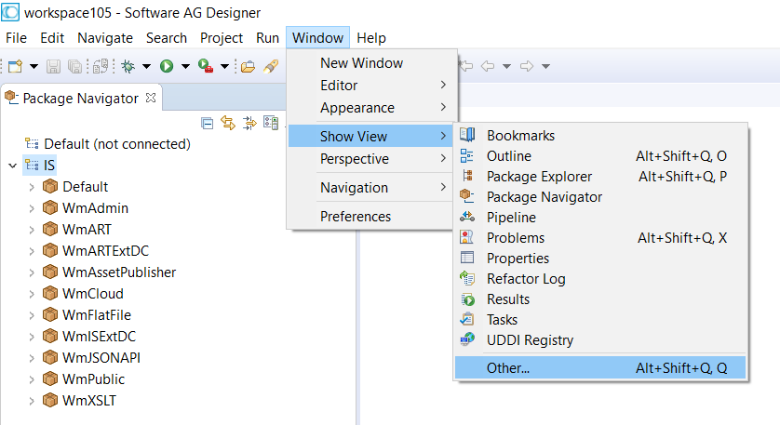

This bring below screen

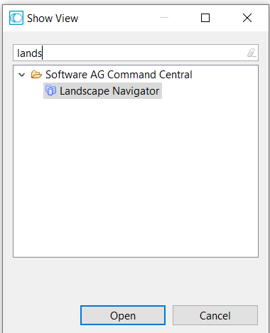

Type landscape and open LandScape Navigator

This will bring the navigator tab with hyperlink

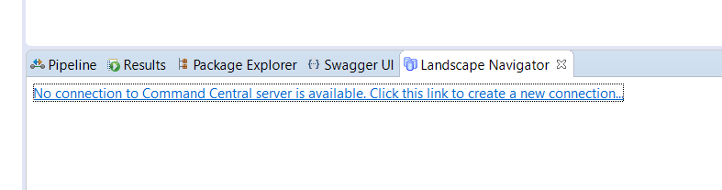

Click the hyper-link for Designer to Command-central connection

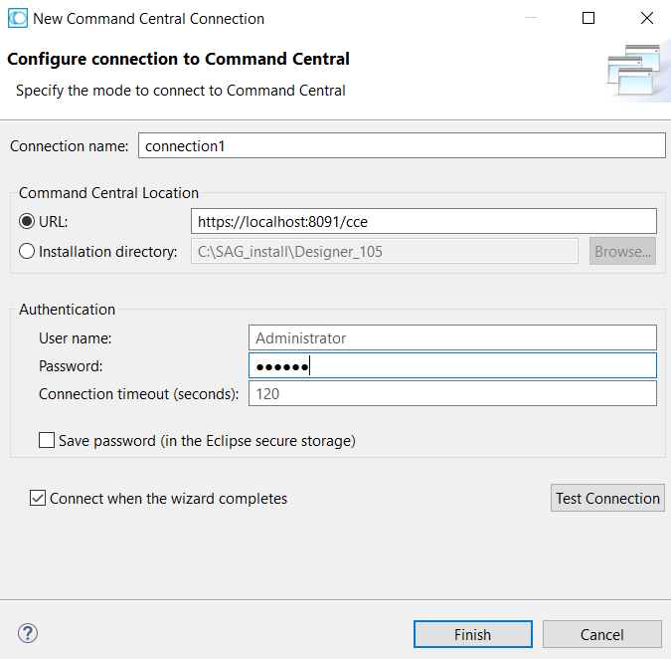

Provide Command-central related information in above screen

Once connection is successful, the Landscape Navigator tab will change into below screen

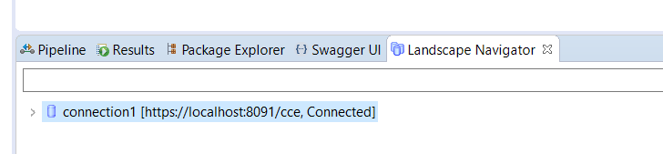

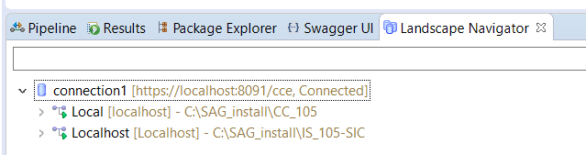

Adding cloud to designer: Click to “add/modify Integration servers” button

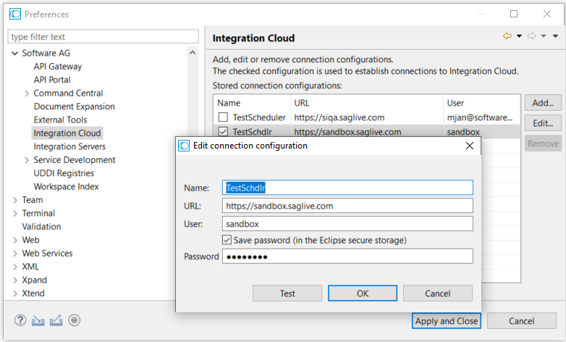

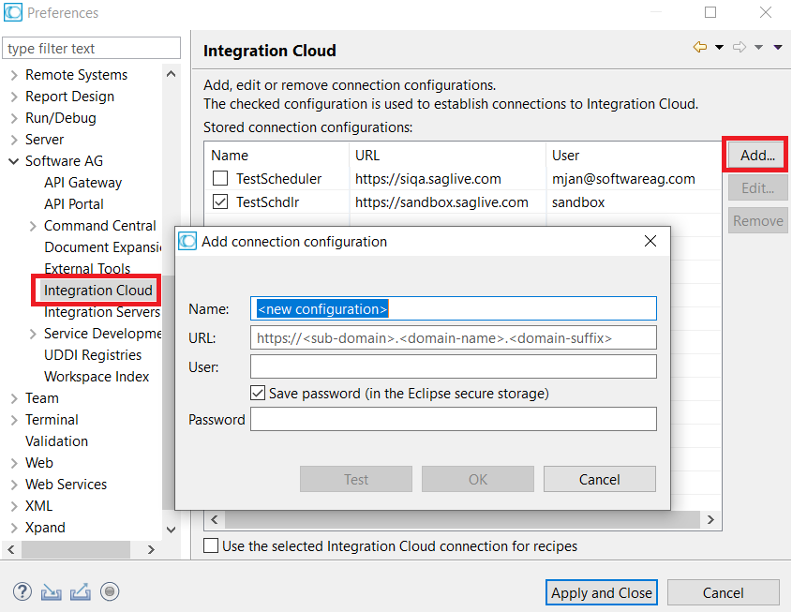

Now go to IS in designer and deploy to cloud

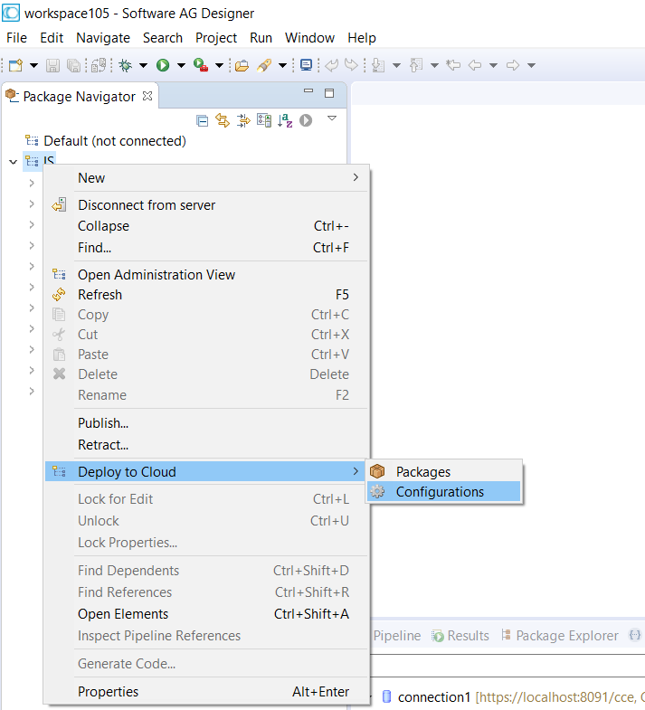

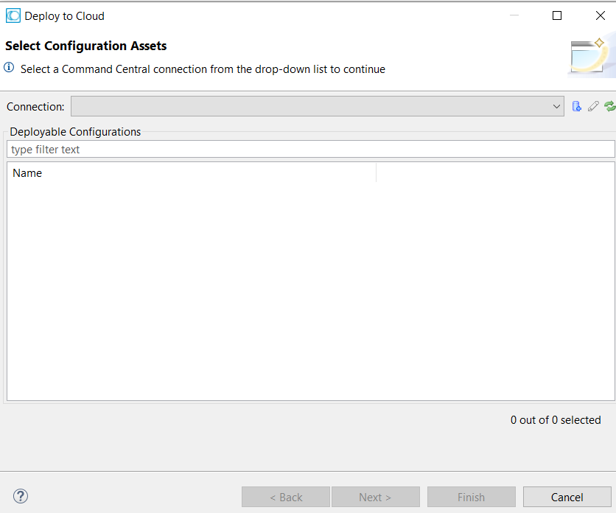

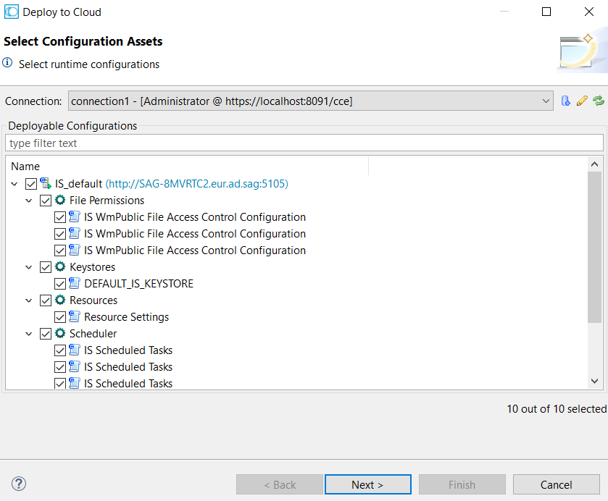

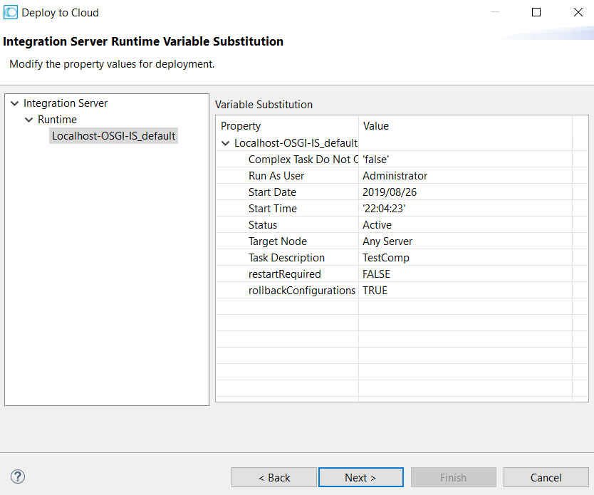

Some imp path :

C:\Users\makum\workspace105\lartmp\local\designer\DesignerSolution\CC\Localhost-OSGI-IS_default.zip\