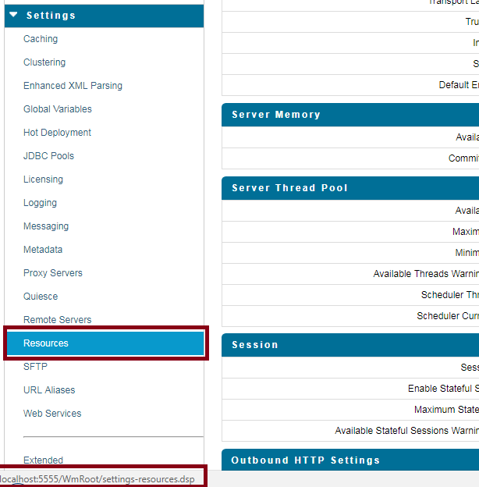

When you bring your mouse pointer to Resources it displays settings-resources.dsp

This implies clicking on resource will bring you to the page settings-resources.dsp

Dsp interact with java code as service.

Now look snippet of settings-docstores-edit.dsp file

<FORM NAME="editform" ACTION="settings-docstores.dsp" METHOD="POST" onsubmit="return confirmEdit('%value isBrokerConfigured encode(javascript)%')">

<input type**="hidden"** name="action" value="edit" />

<TR>

<TD class="heading" colspan=3>Default Document Store</TD>

</TR>

.

.

.

<TR>

<TD class="action" colspan=3>

<input type="**submit**" name="submit" value="Save Changes"/>

</TD>

</TR>

</FORM>

Now notice few important points from above DSP

* ACTION="settings-docstores.dsp"
* A hidden variable action="edit"
* input type="submit

If we combine all these three, it implies on click of button "Save Changes", control goes to another DSP file settings-docstores.dsp and before going there it sets hidden variable action as edit.

Now have a look into settings-docstores.dsp file

* It is a dsp file without Form/Action property.
* It has normal tags to form UI for docstore
* It has some if condition (on value of action) which decide which java code (web service) to be called.

<BODY onLoad="setNavigation('settings-docstores.dsp', '/WmRoot/doc/OnlineHelp/wwhelp.htm?context=is_help&topic=IS_Settings_DocStoresScrn');">

<TABLE width="100%">

<!-- update the Message Store Settings -->

%ifvar action equals('edit')%

%invoke wm.server.dispatcher.adminui:setDocStoreSettings%

%ifvar message -notempty%

<script>writeMessage("%value message encode(html_javascript)%");</script>

%else%

<script>writeMessage('Settings changed successfully');</script>

%endif%

%onerror%

<script>writeMessage("%value errorMessage

encode(html_javascript)%");</script>

%endinvoke%

%endif%

<!-- update the XA Recovery Settings -->

%ifvar action equals('editXA')%

%invoke wm.server. xarecovery:setXARecoveryStoreSettings%

:

:

These if controls are executed as soon as this page is loaded. (Need to check this assumption)

How the value is returned from java and handled in Dsp.

Before loading the DSP page all invoke (i.e. public service) are executed. And because of this pipeline data (note services are called without param and they work on pipeline data) are modified or may be new are added. These pipeline data an be accessed in DSP using %value variable%, where variable is part of pipeline data. (Need to check this assumption)

How to display error msg/exceptions in DSP, thrown from java code.