DB-Configurator does not come by-default.

Using sag-installer you need to install it on top of is installation.

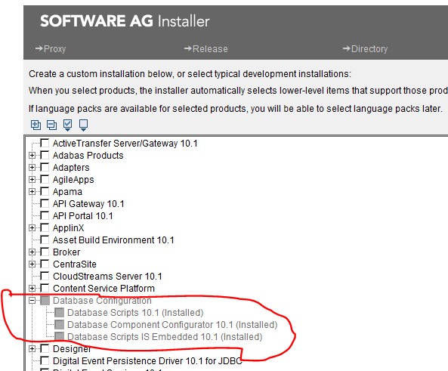

This will bring below folder structure :

Before installation :

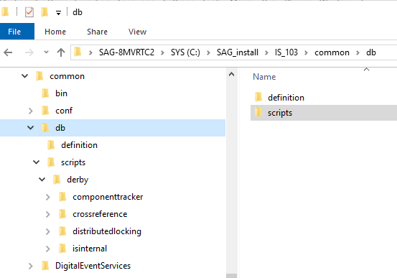

After Installation:

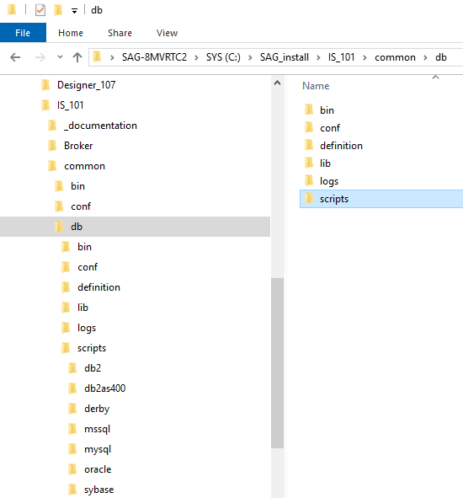

You can see newly added folders : bin, conf, lib, logs etc and various subfolders under script for each db.

To run dbconfigurator double click on : file **dbConfiguratorUI** under ~\common\db\bin.

Why dbconfigurator??

For creating internal IS-tables on fly. Like isinternal or iscoreAudit.

Using DbConfigurator for MySql (Community version):

Create DataBase(Is_DB) in MySql.

Copy the connector jar into ~\Is_install\common\lib\ext

set the classpath in setenv file - \common\db\bin

set CLASSPATH=%CLASSPATH%;%DCI_HOME%\..\lib\ext\mysql-connector-java.jar

 If above is not set properly you will get below error:

Database Connection error: [SoftwareAG][MySQL JDBC Driver]Connections to MySQL Community Server are not supported. Please contact MySQL to obtain a MySQL Enterprise or Commercial version.

Launch dbconfigurator UI by clicking **dbConfiguratorUI**

Now select the components (isinternal)

Give the url as : jdbc:mysql://<server>:<3306|port>/databaseName

jdbc:mysql://localhost:3306/IS_DB

IS_DB must be created under MySql.

Give the new user id/password – This is not existing currently, will be created.

Check Create Database and Database User

Under Administrator :

Adminid – this is “root”

Password - password of root user

Database – this is existing DB in mysql, and part of above connection URL

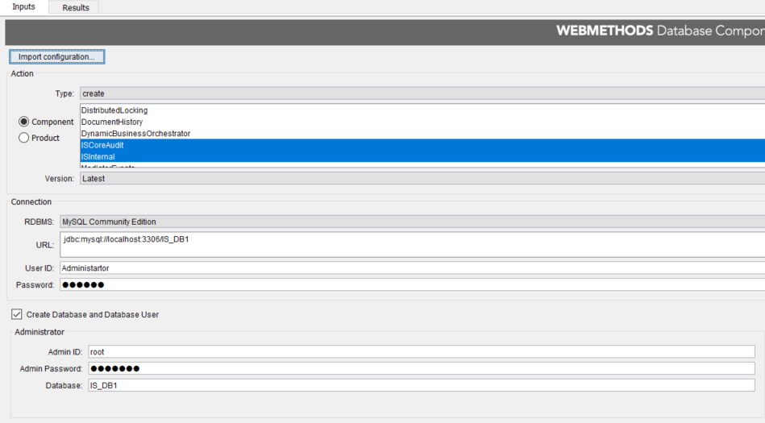

Database Connection error: Access denied for user 'root'@'localhost' (using password: YES)

Run below command in SQL developer for mySQL connection.

GRANT ALL PRIVILEGES ON * . * TO 'root'@'localhost'

