Gradlew startSPM

Fails with below error

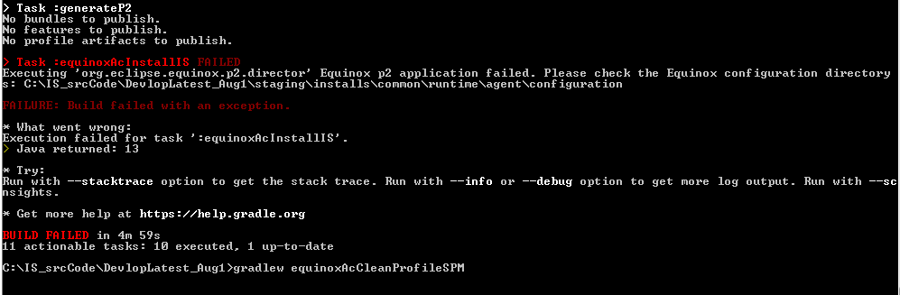

gradlew clean --refresh-dependencies

gradlew equinoxAcStartIS –x test –x Javadoc

gradlew startSPM

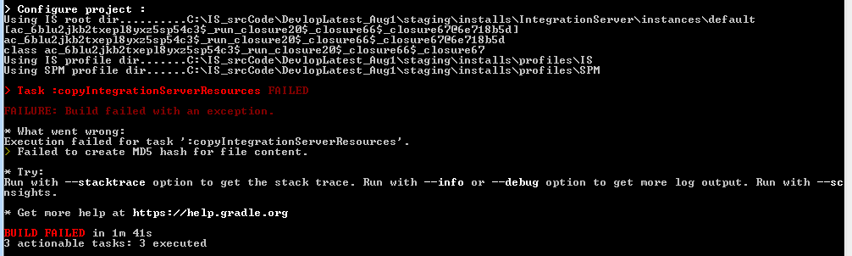

gradlew equinoxAcStopIS

gradlew startSPM

Now It was successful.

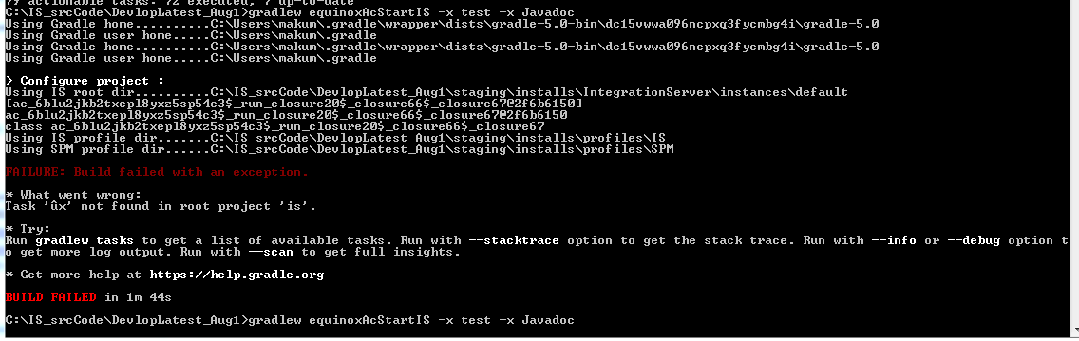

Type the command in cmd window instead of copy-paste.

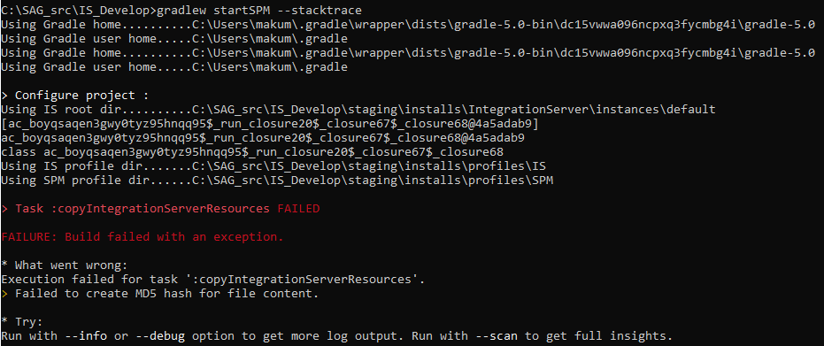

Running with Stack-Trace :

C:\SAG_src\IS_Develop>gradlew startSPM –stacktrace

* Exception is:

org.gradle.api.tasks.TaskExecutionException: Execution failed for task ':copyIntegrationServerResources'.

at org.gradle.api.internal.tasks.execution.CatchExceptionTaskExecuter.execute(CatchExceptionTaskExecuter.java:37)

at org.gradle.api.internal.tasks.execution.EventFiringTaskExecuter$1.run(EventFiringTaskExecuter.java:49)

at org.gradle.internal.concurrent.ThreadFactoryImpl$ManagedThreadRunnable.run(ThreadFactoryImpl.java:55)

Caused by: org.gradle.api.UncheckedIOException: Failed to create MD5 hash for file content.

at org.gradle.internal.hash.DefaultStreamHasher.hash(DefaultStreamHasher.java:37)

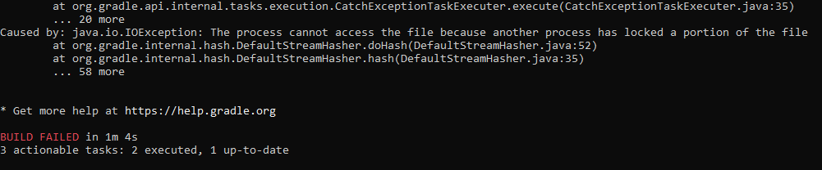

Solution:

Stop the IS and

then start SPM