Creating IS Instance:

C:\SAG\SAG_105_latest\IntegrationServer\instances>is_instance.bat create -Dinstance.name=ISinstance1

Executing ANT task. Please wait...

Buildfile: C:\SAG\SAG_105_latest\IntegrationServer\instances\is_instance.xml

validateInstanceName:

getOS:

extractTemplate:

validate:

[echo] Required property 'license.file' is not set. Integration Server instance will shutdown after 30 minutes.

[mkdir] Created dir: C:\SAG\SAG_105_latest\IntegrationServer\instances\ISinstance1

[unzip] Expanding: C:\SAG\SAG_105_latest\IntegrationServer\instances\template.zip into C:\SAG\SAG_105_latest\IntegrationS

erver\instances\ISinstance1

create:

getOS:

copyCorePackages:

[copy] Copying 5085 files to C:\SAG\SAG_105_latest\IntegrationServer\instances\ISinstance1\packages

[copy] Copied 2926 empty directories to 6 empty directories under C:\SAG\SAG_105_latest\IntegrationServer\instances\ISin

stance1\packages

getOS:

changeModeForAllScripts:

handlePackages:

validateInstanceName:

createServerCnfFile:

[propertyfile] Creating new property file: C:\SAG\SAG_105_latest\IntegrationServer\instances\ISinstance1\config\server.cnf

createSetEnvInstance-bat:

createSetEnvInstance-sh:

prepare-osgi:

getOS:

create-osgi-profile:

[echo]

[echo] Creating OSGi profile...

[echo]

When IS is created in this way there would be only one SPM. So we two IS IS_Instance1 and IS_Default in IS installation location C:\SAG\SAG_105_latest.

And when this SPM is configured in IS, it will shown up as below:

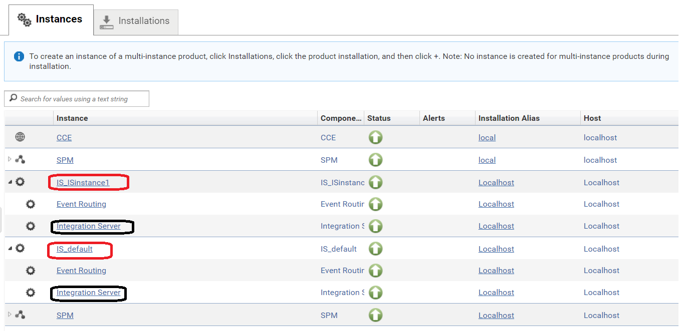

Now you can individually browseup different IS and find out respected configurations (for eg IS Schedule tasks.)

Cluster Setup:

Install the terracotta

Start the terracotta - C:\SAG\Teracotta\Terracotta\server\bin\start-tc-server.bat

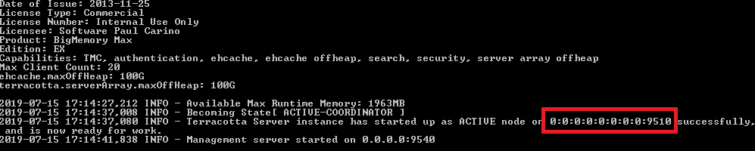

Provide the terracotta license to IS (all is in cluster)

Configure the same JDBC pool for all the IS in cluster

Configure the Cache Manager of all IS for Terracotta.

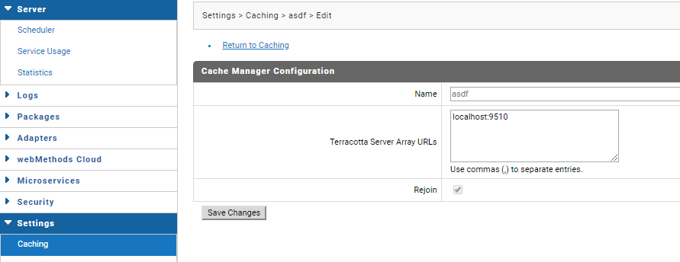

Configure the Terracotta for cluster

