Command Central

Installation

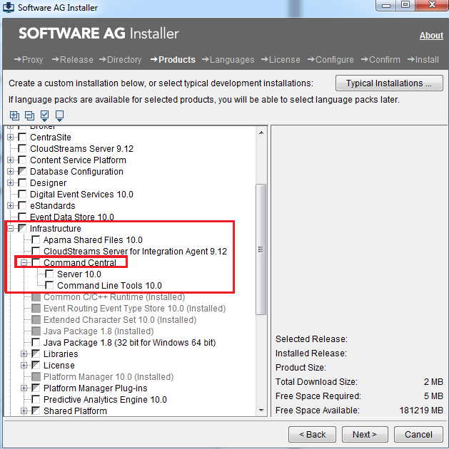

Start the command central by below command

C:\SAG\CC_IS_100\profiles\CCE\bin\ startup.bat

URL to access CC: [https://localhost:8201/cce/web/#](https://localhost:8201/cce/web/)

You can find the CC Port at

C:\SAG\CC_IS_100\profiles\CCE\configuration\com.softwareag.platform.config.propsloader\ com.softwareag.catalina.connector.https.pid-8201.properties

Now start IS and corresponding SPM

* (staging\installs)\profiles\IS\bin
* If this is already configured with CC you can manage them
* If not, configure it with IS
* I have already configured C:\SAG\SAG912 with above CC

Start SPM and IS for above IS.

* (staging\installs)\profiles\SPM\bin
* URL to access SPM : http://localhost:8092/spm/

Through SPM, CC talks (or manages) with IS

Debugging IS(Installed) in CC

* Start CC normally (installed one)
* Start IS in debugger mode (startDebugMode.bat)
* Start eclipse in debug mode at same port where IS is listening(10033).

Debugging IS(Src-code) in CC

* Start CC normally (installed one)
* Build IS and Start in debugger mode (Staging-startDebugMode.bat)
* Start eclipse in debug mode at same port where IS is listening(10033).
* Build SPM and Start

Adding new IS into CC

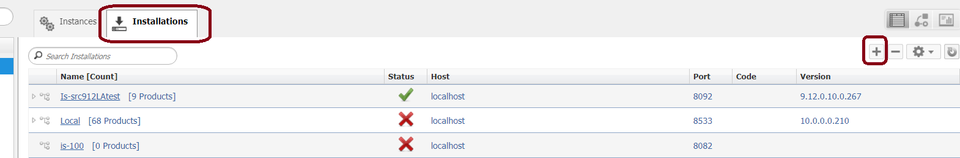

Provide SPM related info

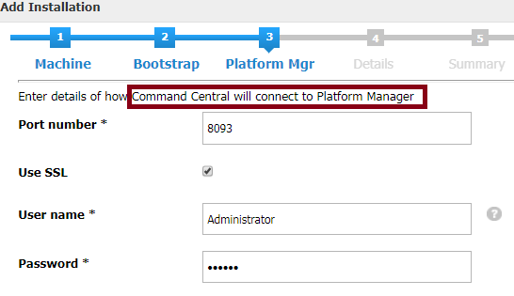

SPM build:

gradlew equinoxAcCleanProfileSPM

Manually delete this folder as it never gets cleaned with equinoxAcCleanProfileSPM

C:\Project\Code\branches\develop\features\spm

gradlew startSPM

C:\Project\Code\branches\develop\features\spm\staging\p2\plugins

Now copy this jar to (installed IS)

C:\SoftwareAG\SAG_910\common\runtime\bundles\spm-is\eclipse\plugins\com.softwareag.plm.spm.is.impl_9.10.0.0000-0106.jar

When IS is from dev : Where to copy this jar?

IS-SPM

* gradlew stopSPM
* gradlew equinoxAcStopIS -x Javadoc
* gradlew clean
* gradlew build
* gradlew equinoxAcStartIS -x javadoc -x test
  + Stop IS and start from bin/
* gradlew startSPM
  + Stop IS and start from bin/

Command Central 9.9 Fix 2 Bootstrap Installer (not SAG installer!) installation:

C:\SAG_Apps\CC_BootStrapInstaller\Unzipped>cc-def-10.1-release-w64.bat -p manage123 --accept-license -c 9090 -C 9091 -s 9092 -S 9093

Port is changed as it is used by CC installed by SAG installer.

Update connection to local SPM: <http://MCMAKUM01:9092>

You can logon to Command Central Web UI as Administrator/manage123

<https://MCMAKUM01:9091/cce/web>

Configuration Metadata

C:\SAG_install\IS_103\profiles\SPM\configuration\ConfigurationTypeMetadata