Start Designer

Set "Service Development" Perspective

Window -> Perspective -> Open Perspective -> Other -> Service Development

Connect to IS

Click the button "Add or Modify Integration Server"

Provide - IS Name (Deault), Host (Localhost), Port (5555), User (Administrator), Password (manage)

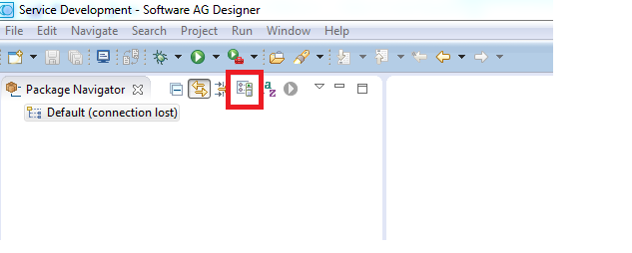

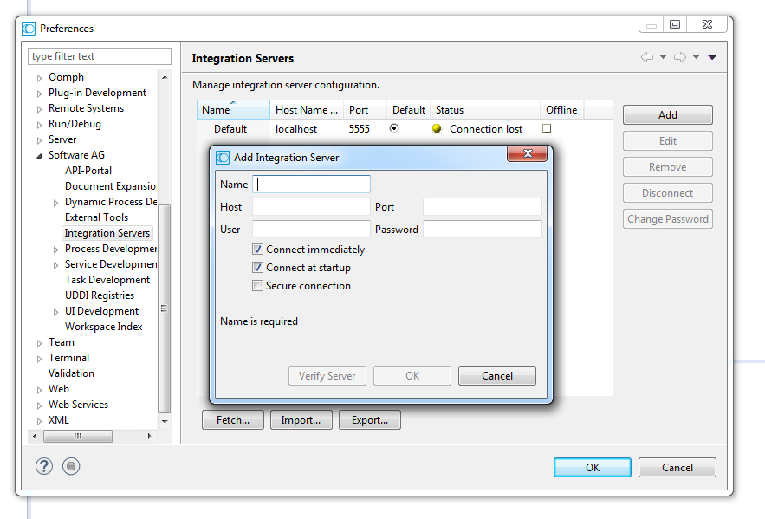

Create Package-> RootFolder -> SubFolder

Package Name adn Root Folder name should be same.

Create Flow-Service under Sub-Folder

Provide input/Output for the flow-service

Inser Flow steps by dropping service

Creating Package and Folders

Can be created only under Default ( IS instance connected to designer)

* + Right Click Default -> New -> Package/Folder
  + Package can be created under default only, not under any package/folder.
  + Folder can be created under folder/package.

Service :

* We can create our own service
  + Right Click work(folder location) -> New -> Flow/Java Service
  + These can be
    - c service
    - java service
    - flow service
* We can use services provided in other packages for creating our service.
  + In service(our new) editor switch to the tree tab and drag the service from desired package.

Data-flow through service.

* You can define input and output for any new service you create.
  + In service(our new) editor switch to the Input/Output tab
  + IO can be of type String, Document or Object.
* If your service uses other services you can map the output of one to the input of next using pipeline window.
  + Pipeline-in (General input flow) to input (Service-in) of this service.
  + Output of this service (Service-out) to the Pipeline Out(General Output flow) .

Element of Flow-Service:

Branch

Loop

Repeat

Sequence

Exit

Start the following services from administrative tool:

* SQL Server
* SQL Server Full Text Search
* Software AG webMethods Broker Monitor 10.0
  + This service is installed in windows as automatic service
  + It is responsible to start Software AG webMethods Broker Server 10.0
  + Wait till Software AG webMethods Broker Server 10.0 started
* Check the entry for Software AG webMethods Integration Server 10.0
  + It should start automatically, if not started start them manually.
  + Verification : <http://localhost:5555>
* Check the entry for Software AG MWS 10.0
  + It should start automatically, if not started start them manually.
  + Verification : <http://localhost:8585>

Issues:

* Issue_1: At least one service or driver failed during startup …
* Reason: Lock implemented as Lockfile. This lockfile is used to prevent two instances of IS to run from same directory tree.
* Solution: delete the lockfile and start the service again.
* lockfile location : ~/Integration Server/LOCKFILE.

Doubt:

Why is the Broker Monitor set to automatic start, but not Broker Server.

Creating Package and Folders at Acme:

Open the designer

* Create a **new package** called Acme
  + Right Click Default -> New -> Package
  + Package can be created under default only, not under any package/folder.
* In the Acme package create **new folder acme**
  + Right Click Acme(under default) -> New -> Folder
  + Folder can be created under folder/package.
* In the acme folder create a folder PurchaseOrder
* In the acme.PurchaseOrder folder create 7 new folders
  + Adapters
  + Docs
  + Maps
  + Notifiers
  + Utils
  + Work
  + Ws
* In the acme.PurchaseOrder.ws folder create 2 new folders
  + Consumer
  + Provider

How to correct folder location if you placed in wrong Parent folder

Right click on the folder and rename it.

Creating a Service:

* In the acme.PurchaseOrder.work folder create a flow service customWriteToLog
  + Right Click work -> New -> Flow Service
* Add two string input to the new service: inMsg1, inMsg2
* Add three service steps to the new service
  + Pub.flow:debugFlow
  + pub.toString:toUpper
  + pub.toString:concat
* To Insert these services, switch to the tree tab
* Drag in three services from WmPublic package.
* Map The data-flow of your input through services
  + For pub.toString:concat Map inMsg1 to inString1. For this
  + In pub.toString:concat editor select pub.toString:concat service
  + switch to pipeline view at the bottom
  + Then drag inMsg1 argument to the inString1 parameter of the concat service.

Similarly for pub.toString:toUpper map value to inString parameter. And

for Pub.flow:debugFlow map value to message parameter

Save and run the service

Choose the Run as -> Run flow service.

Confirm service execution

Check the service result view in Designer

Check the server log.

Once you are done with development, unlock your service.

Right click service (customWriteToLog) -> Unlock.

Document types

Document types represent complex structures inside IS.

Then we can write services to deal with these complex structures.

In the acme.PurchaseOrder.docs folder create a new Document Type called Order Canonical.

Save your Document Types.

IMP-Process

Installing packages:

~\IntegrationServer\instances\default\replicate\inbound

Copy pakage (in zip format) in above location.

GO to IS-Server/Packages/Management and this package will be listed here.

Install it and it will be the part of your package.