Project Setup in eclipse:

* Check out the project from repo (svn) at C:\IS_srcCode\ver_912
* Run gradlew eclipse command to generate necessary files
  + C:\IS_srcCode\ver_912>**gradlew eclipse**
* Import the required modules one by one.
  + For ex : modules\proxy
  + File -> Import | General->Existing Projects into Workspace.
  + Provide the path for proxy module.
    - EX- C:\IS_srcCode\version_100\modules-osgi\launcher
    - client
    - server
    - modules-osgi\launcher
    - modules\proxy
    - modules\migration
    - modules\migration-framework
    - command-central\spm-impl
    - monitors\cmp-impl
    - server\product\packages\WmPublic
    - server\product\packages\WmRoot
* Set the java if not set properly
  + Right click to project->java build path->libraries->Add library->jre system library and select desire jre.
* Set eclipse class path for variable GRADLE_CACHE
  + Window->preferences->java->Build Path->Classpath Variables-> New and
  + Set GRADLE_CACHE.= C:\Users\makum\.gradle\caches\modules-2\files-2.1
  + Required - GRADLE_CACHE is referred as classpath entry in projects **.classpath** file.

Eclipse search high-level view (Folder level)

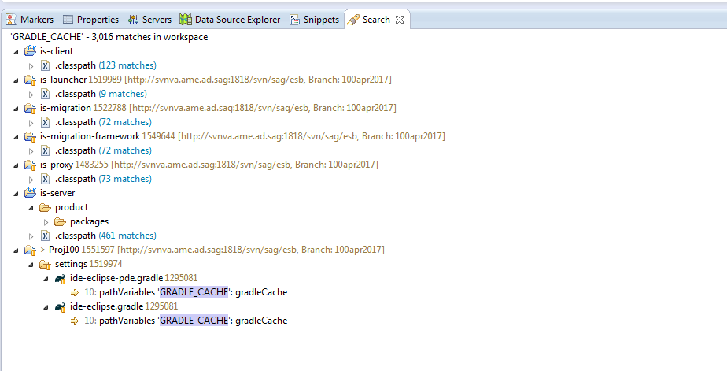

Eclipse search view (File level)

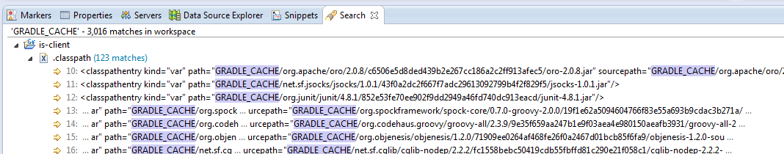

Setting GRADLE_CACHE as Classpath variable:

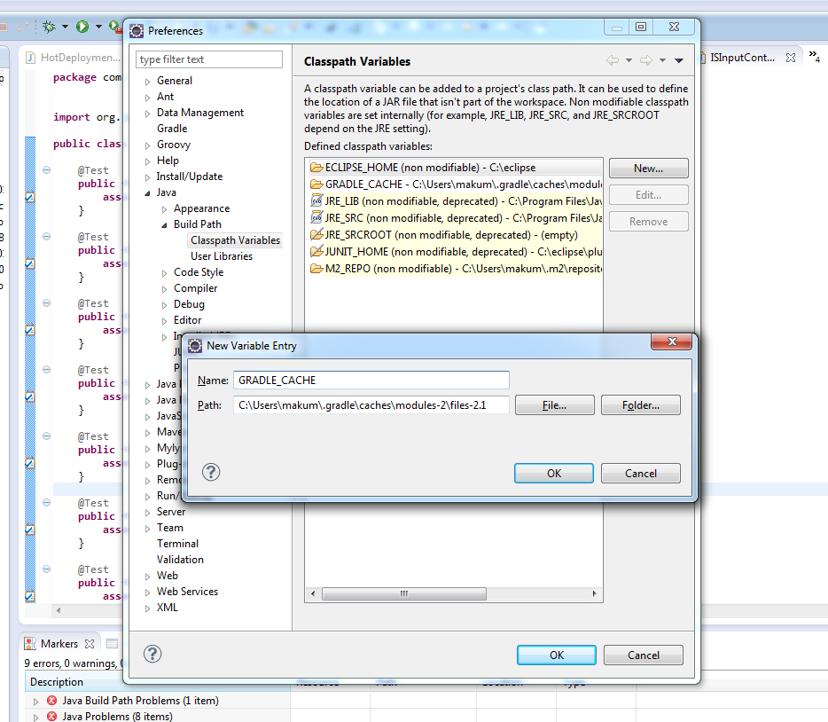

C:\Users\makum\.gradle\caches\modules-2\files-2.1

<https://www.mkyong.com/maven/how-to-configure-m2_repo-variable-in-eclipse-ide/>

**Adding different module** to the current project build path.

Java Build Path -> Projects -> Add -> Check required modules.

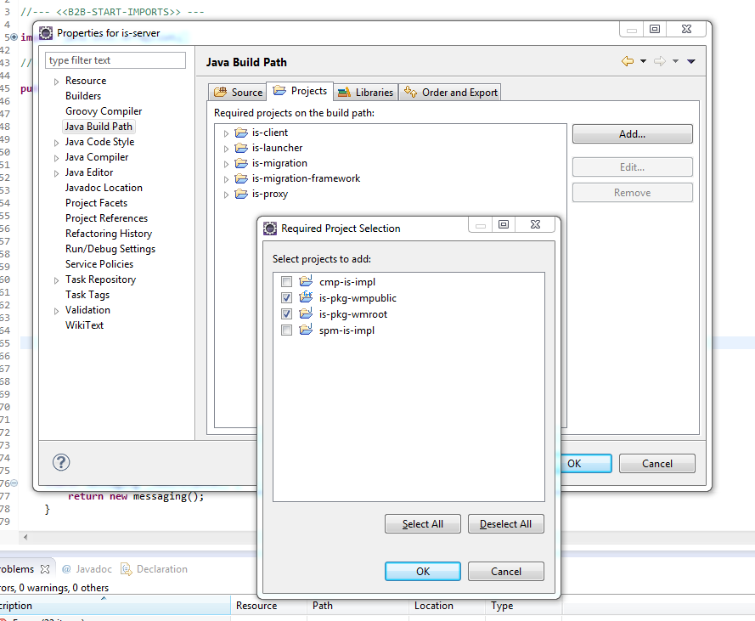

Issues when these modules are not added:

Source code is not found while debugging.

Some times adding project (just as above) in runtime, resolves the issue “Source code is not found” while debugging.

Installing products: IS, UM, Designer etc.

Running in Debug mode

gradlew equinoxAcStartDebugIS

Open /912oct2016/settings/ac.gradle

Look for below task

equinoxAcStartDebugIS {

dependsOn ':features:is-main:equinoxAcInstallIS'

//Required for running the integration tests

dependsOn copyPolicies, copySSOPropertiesToIS

configure project.setupConfigIS

configure runConfigIS

cmdArgs 'suspend', 'n', 'address', '9081', '-debug', 'Info'

}

Change last line as

cmdArgs 'suspend', 'y', 'address', '9081', '-debug', 'Info'

This will start the application as

**java -Xdebug -Xrunjdwp:transport=dt_socket,address=9081,server=y  suspend=y -jar stockTradingGUI.jar**

**Setup in eclipse:**

Goto debug configuration window: **Run-> Debug Configurations**

Create new “Remote Java Application configuration” as “is server”

With port provided in gradle task - **9081**

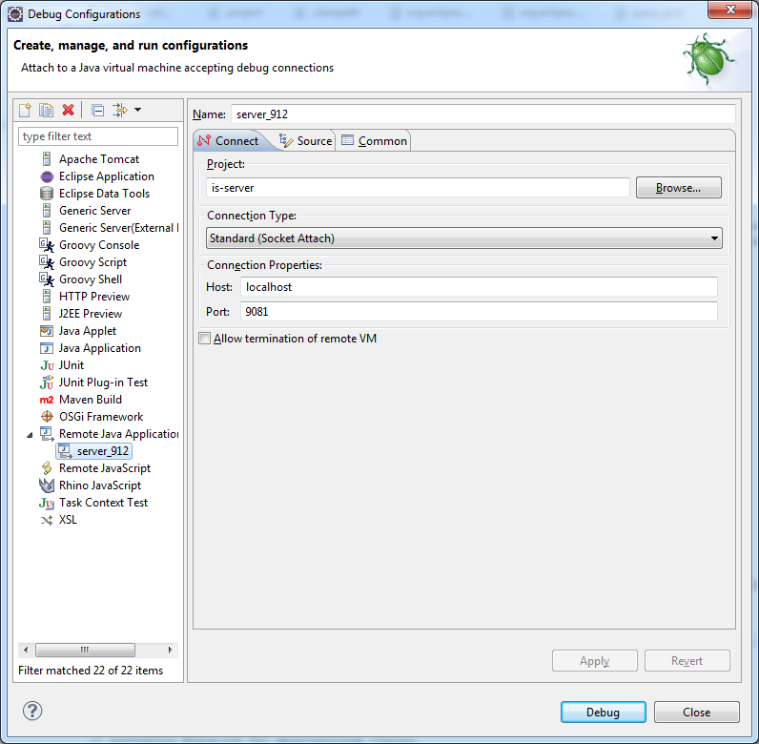

Now setting are done

Before starting to debug make sure your Java process is started with Java remote debug settings and listening on the same host and port, otherwise eclipse will not able to connect successfully.

To debug just click the "Debug" button in the last screen where we have set up host and port.

You can also debug by going to "Debug Configurations" selecting your project in "Remote Java Application” and clicking on "DEBUG".

<http://javarevisited.blogspot.in/2011/02/how-to-setup-remote-debugging-in.html#axzz4lpel1Tv5>

Another way of Debug:

This is recommended when project is already built and staging folder is generated.

Execute below command.

staging\installs\profiles\IS\bin>startDebugMode.bat

For this to work configure your debug-configuration in eclipse for Remote java application at port 10033.

DEBUG_PORT=10033