**Installing IS in Linux**

Get Installer jar from SAG installer: <http://aquarius_blr.eur.ad.sag/>

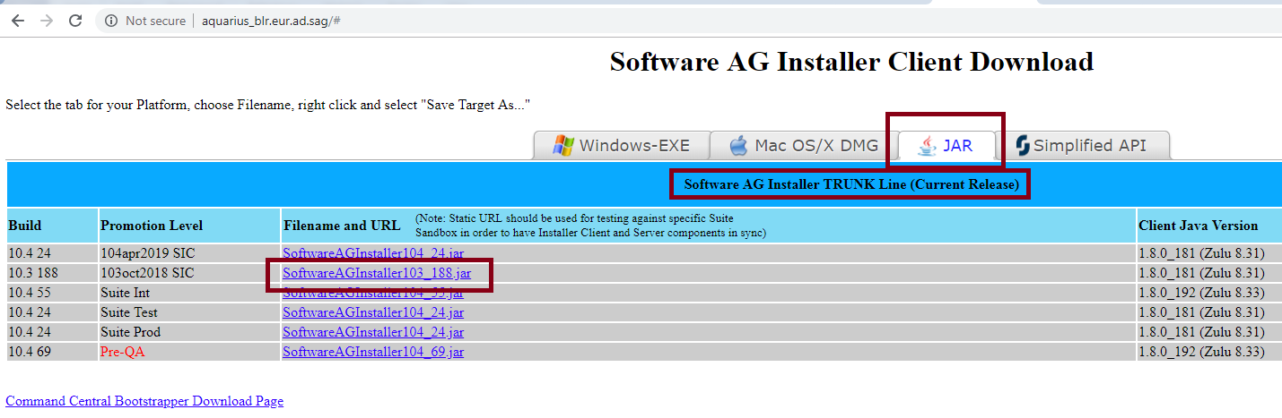

Execute this jar in Linux machine just like windows type of interface will pop-up

Java –jar SoftwareAGInstaller103_188.jar [Remember!! this is just installer.]

Installer window will pop up.

Provide the License file (same as windows license):

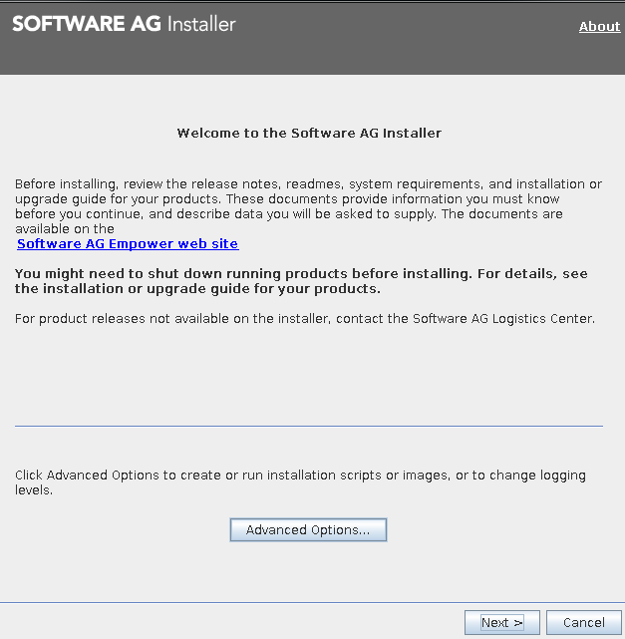

Starting IS:

[root@usvacc1 bin]# pwd

/opt/softwareag_is101/profiles/IS_default/bin

[root@usvacc1 bin]# ./startup.sh

[root@usvacc1 bin]# tail -f ../logs/wrapper.log

**Update Manager Installation:**

Download sh file form <http://aquarius-va.ame.ad.sag:8092/sumv2/api/core/bootstrapper/all/latest>

Put it into linux location

Run the following command:

./SAGUpdateManagerInstaller-all-10.1.0.0000-0096.sh --accept-license -d /opt/makum/updateManager -j /usr/lib/jvm/java-1.8.0/bin/java

It will install update manager at /opt/makum/updateManager

This folder must be empty

Once installed it will be like:

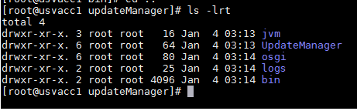

Running updatemanager in Linux machine:

[root@usvacc1 bin]# pwd

/opt/makum/updateManager/bin

[root@usvacc1 bin]# ./UpdateManagerGUI.sh

**Linux machine details:**

Name : usvacc1

Username/password : root/Sell.it

IS running : <http://usvacc1:5566/>

Install Dir : /opt/softwareag/IntegrationServer/instances

IS locations:

/opt/softwareag_is103/ - Port:5103

/opt/softwareag_is101/ - Port:5555

UpdateManager locations:

/opt/makum/updateManager/