**C:\SAG_Apps\MsgDbJar**>java -jar **E4Launcher.jar**

**And select for Integration Server** for DB connection

This will provide following UI for messages in message-DB

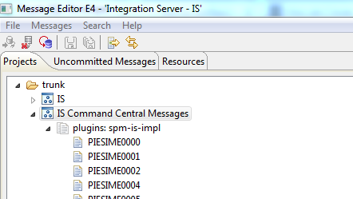

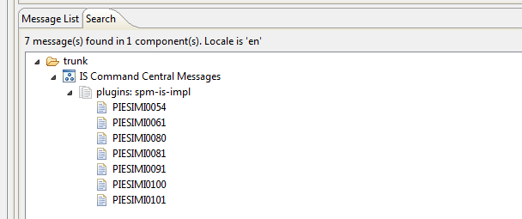

Send a mail to DL - **RnD-ROS-G11N-ENG** [RnD-ROS-G11N-ENG@softwareag.com](mailto:RnD-ROS-G11N-ENG@softwareag.com) for getting write-permission.

Messages are of 4 types

* PIESIME – Error
* PIESIMI – Information
* PIESIMW – Warning
* PIESIMC – Critical Error

To insert a new message into message-DB SVN right click to plugins: … and provide following information:

Select message type and its no. then click ok and provide following info:

Message Id : PIESIMI0151

Message Text :General Properties

Explanation : General Properties

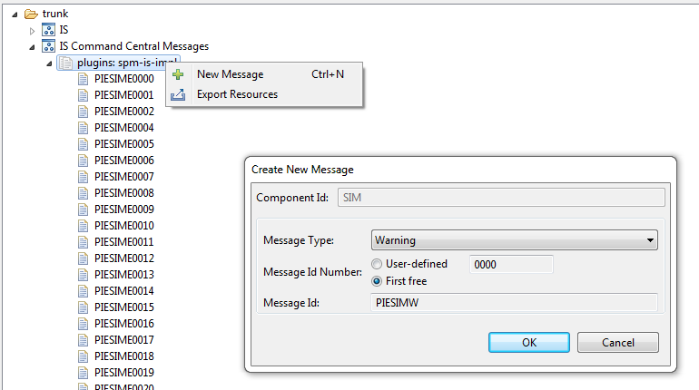

Once done message will be added to the SVN tree and then commit them.

For review provide this no. to the doc team.

Once this process is followed the message will be available from next (IS) installation onwards.

When you build local dev build during build time message db is interacted and xml file is generated out of this messages (keys) which will be used for messages display. ---Need to check.