Latest Dev Installation

Suiint Installation

Latest Trunk Installation

Any particular IS version installation

Command central Installation

Designer Installation

SAG installer installation

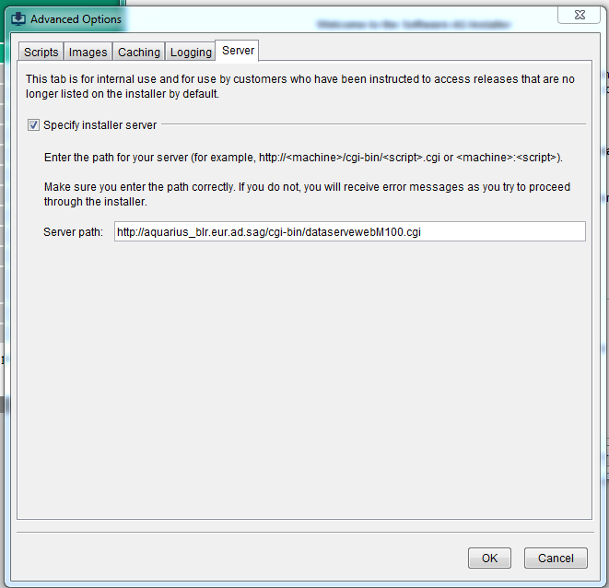

http://aquarius_blr.eur.ad.sag/cgi-bin/dataservewebM100.cgi

Latest Dev build - <http://aquarius_blr.eur.ad.sag/cgi-bin/dataserveIS_PI_TR_DEV.cgi>

<http://aquarius-va.ame.ad.sag/cgi-bin/dataserveIS_PI_TR_DEV.cgi>

After installation you can find build no. in IS–

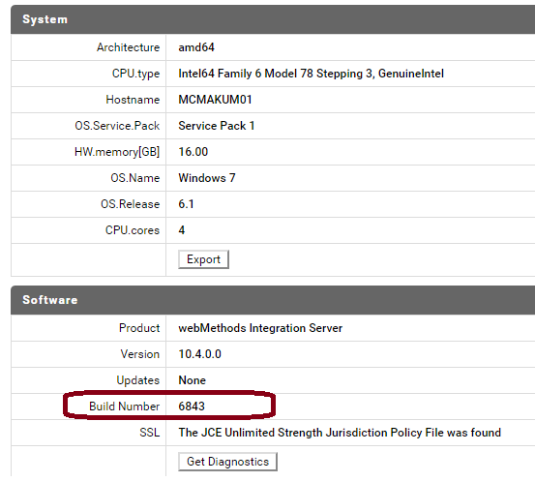

Latest Dev : http://aquarius_blr.eur.ad.sag/cgi-bin/dataserveIS_PI_TR_DEV.cgi

For suiteint - aquarius_blr.eur.ad.sag:SuiteInt

FOR SIC - aquarius_blr.eur.ad.sag:105oct2019_SIC

For latest Trunk - dataserveIS_PI_105oct2019 dataserveIS_PI_107oct2020

<http://aquarius-va.ame.ad.sag/cgi-bin/dataserveIS_PI_TR_DEV.cgi>

<http://aquarius-va.ame.ad.sag/cgi-bin/dataserveIS_PI_105oct2019.cgi>

<http://aquarius-va.ame.eur.ad.sag/cgi-bin/dataserveIS_PI_107oct2020.cgi>

<http://aquarius-va.ame.eur.ad.sag/cgi-bin/dataserveIS_PI_1011oct2021.cgi>

aquarius-va:IS_PI_1011oct2021

 user/password - latest/latest

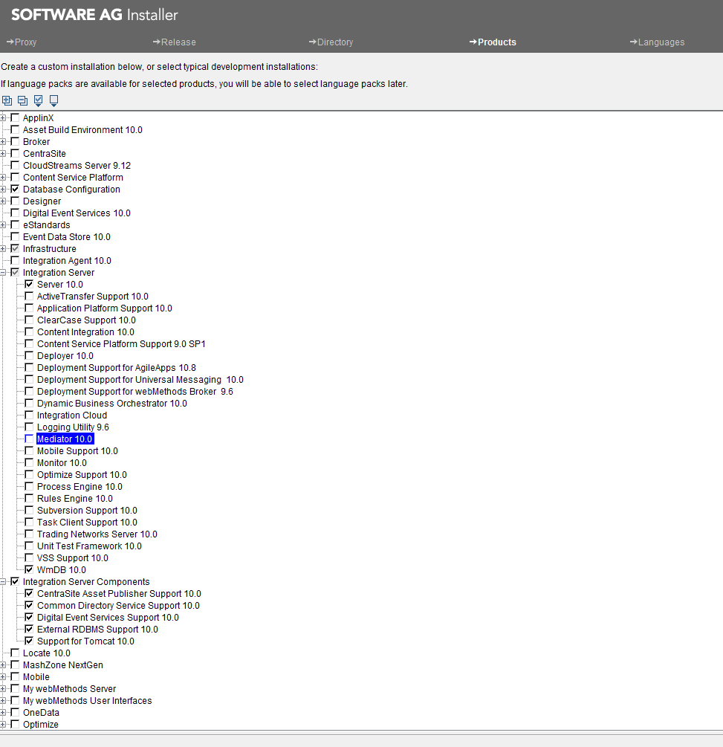

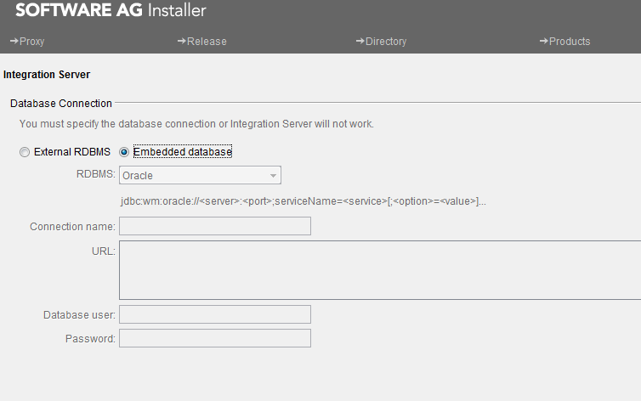

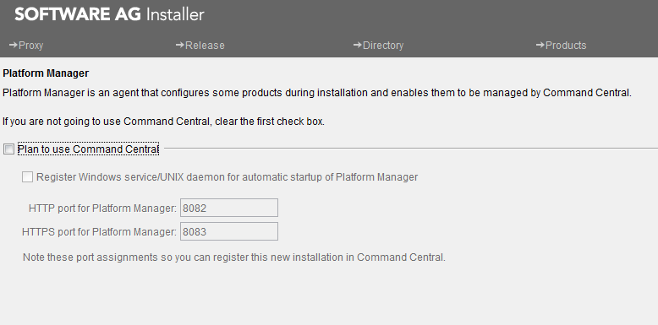

IS Version installation

aquarius_blr.eur.ad.sag:webM910

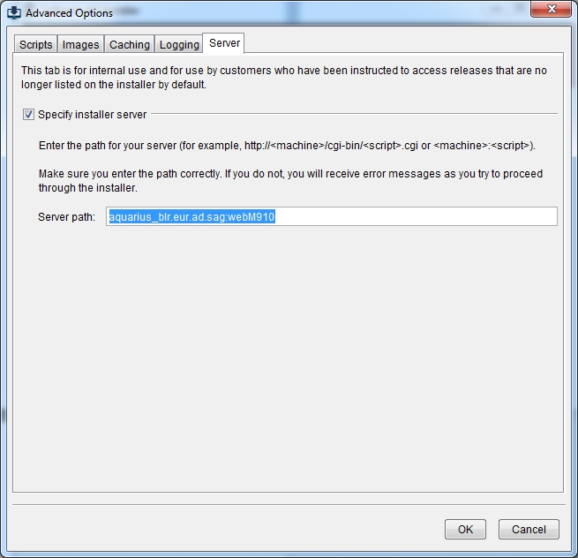

For suiteint - aquarius_blr.eur.ad.sag:SuiteInt

http://aquarius_blr.eur.ad.sag/cgi-bin/dataserveSuiteInt.cgi

You can use any version of “Software AG installer” to install any other version of products.

Just remember, you can’t install higher version of product using lower version of installer.

Using 10.1 installer you can install 10.1 10.0 or 9.7 vs of IS CC etc but you can’t install 10.2 version.

**Installing-Designer:**

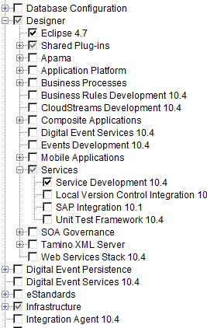

You need to select only :

Designer-> Eclipse4.7

Designer->Services->Service Development

Some component of infrastructure

Some component of Designer->shared Plugins

Infrastructure is selected automatically by SAG products

**Command central installation:**

Command central has been moved to infrastructure 9.12 onwards.

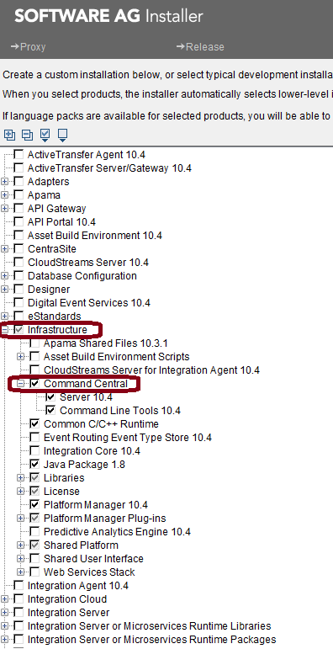

Installing SAG installer:

You can install the installer from : [http://aquarius_blr.eur.ad.sag/#](http://aquarius_blr.eur.ad.sag/)

You can provide the products version (ISO file, sandbox) in server tab of advanced option of installer. See above

You can get the list of sandboxes

<https://iwiki.eur.ad.sag/pages/viewpage.action?spaceKey=RNDWMSE&title=Aquarius+Install+Server+Locations%2C+URLs+and+Archive+Sandboxes>

For further documentation see :

<https://iwiki.eur.ad.sag/display/RNDWMSE/Getting+Started+with+Install+Tools+API>

Note: these URL’s are listed in Aquarius home page.