**Software AG Update Manager**

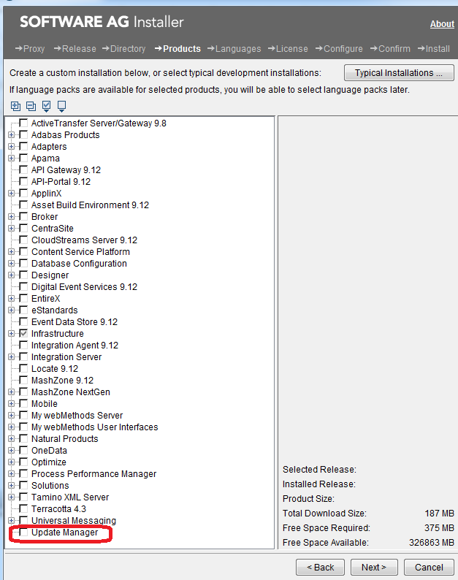

Once update manager is installed you can see a new folder UpdateManager under root folder C:\SAG\SAG912.

C:\SAG\SAG912\UpdateManager

Now open “Software AG Update Manager” by executing

C:\SAG\SAG912\UpdateManager\bin>UpdateManagerGUI.bat -server aquarius-blr.eur.ad.sag:GA_Fix_Repo

UpdateManagerGUI.bat -server aquarius-blr.eur.ad.sag:GA_Fix_Repo

C:\SAG\SAG912\UpdateManager\bin>UpdateManagerGUI.bat -server aquarius-blr.eur.ad.sag:GA_Fix_Repo -showAll true

You can see all the versions installed, not just latest.

Qa Repo - >UpdateManagerGUI.bat -server aquarius-blr.eur.ad.sag:QARepo

CDRepo -> UpdateManagerGUI.bat -server aquarius-va.ame.ad.sag:GA_Fix_Repo

You will find below screen

LIST of Repo - GA_Fix_Repo, CDRepo, QARepo

* **QARepo**: once you check-in the code for fixes (and link it to related fix-itrac) it is built on scheduled date (this you can find on respective iTrac) and then after successful build it will be available on QARepo and you can apply the fix using update-manager.
* **GA_Fix_Repo** (GA: Go Alive) : After core fix is reached to QA Fix repo, it need to go through extensive process and finally reach to GA_Fix_Repo. This is the repo from where Customer can apply the fix.
* **CDRepo**: This is the repo where pathes are released for customer. Once tested locally (from CDRepo), the patch is promoted to GA_Fix_Repo using fix building tool.

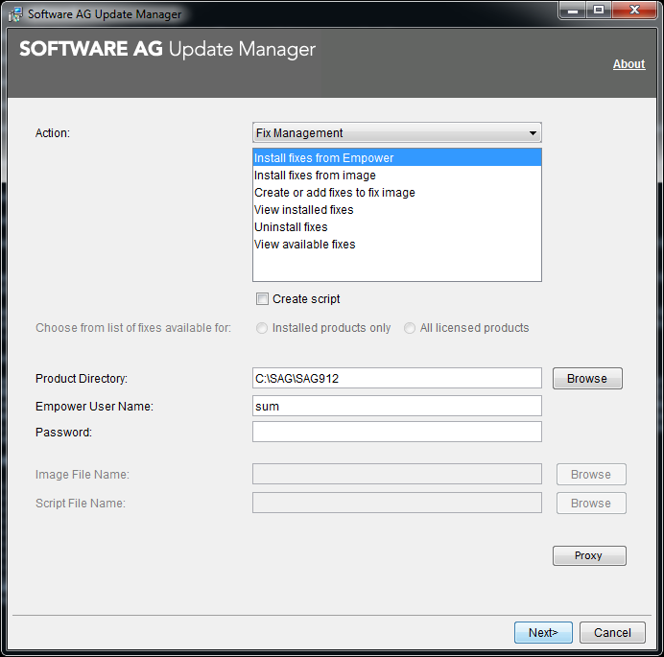

Input the password sum and proceed

<https://iwiki.eur.ad.sag/display/GSW/SAG+Update+Manager>

SAG Update Manager (SUM) is the utility for installing (and uninstalling) product fixes (currently for webMethods product family).

NEW-Way

Following is the new way of installing and using UpdateManager 10.0 onwards.

Get the latest version of SUM Update Manager launcher using following links:

Win: <http://aquarius-va.ame.ad.sag:8092/sumv2/api/core/bootstrapper/windows-x64/latest>

OSX: <http://aquarius-va.ame.ad.sag:8092/sumv2/api/core/bootstrapper/macosx-x64/latest>

Unix/all: <http://aquarius-va.ame.ad.sag:8092/sumv2/api/core/bootstrapper/all/latest>

You will get installer:

SAGUpdateManagerInstaller-windows-x64-10.1.0.0000-0081.exe

C:\SAG_Apps\Inhouse\UpdateManager

Double click and install it.

Currently installed location - C:\SAG\UpdateManager

This is very similar to old way of installed UpdateManager C:\SAG\SAG912\UpdateManager

From here onwards it is similar to old way of updating core fixes.

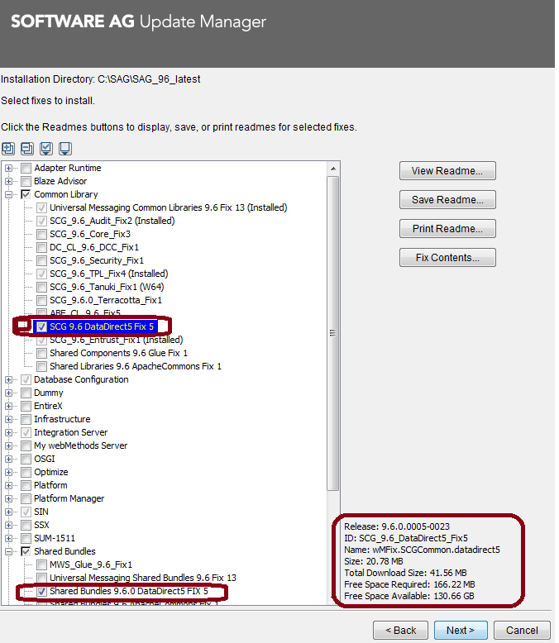

C:\Users\MAKUM\SAG_Install\UpdateManager105\bin – for 10.5

C:\SAGUpdateManager\bin – for 10.3

**Linux Installation:**

Download sh file form <http://aquarius-va.ame.ad.sag:8092/sumv2/api/core/bootstrapper/all/latest>

Put it into linux location

Run the following command:

./SAGUpdateManagerInstaller-all-10.1.0.0000-0096.sh --accept-license -d /opt/makum/updateManager -j /usr/lib/jvm/java-1.8.0/bin/java

It will install update manager at /opt/makum/updateManager

This folder must be empty

Once installed it will be like:

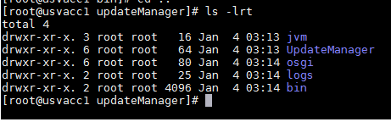

Running updatemanager in Linux machine: