ServiceInterceptor

C:\IS_srcCode\DevlopLatest_Aug1\tests\utils\ServiceInterceptor

Copy this package to the inbound and install it to the IS as package.

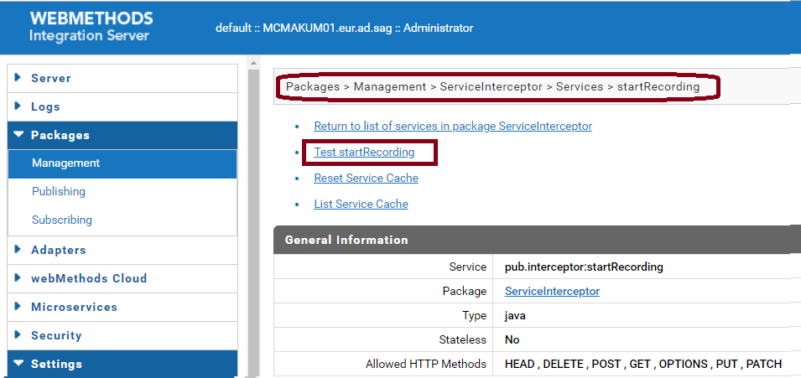

Now click on “Test startRecording”

Provide the scenario name (For e.g. test) and click on “Test (with inputs)”

Do some activity. Like

Go to “Settings > Logging > View Security Logger Details” and “Edit Security Logger”

Finally click on “Test stoptRecording”

Now go to “C:\SAG\SAG_105_new\IntegrationServer\instances\default\packages\ServiceInterceptor\resources”

You can find test.java is created, open this file and look for the thing you want.

In my case it was :

public void testTest() {

svcWmServerAuditingSetAuditLoggerDetails_0();

}

And after searching SetAuditLoggerDetails

We arrived to

public void svcWmServerAuditingSetAuditLoggerDetails_0() {

IData outputPipeline = null;

try {

outputPipeline = runService("wm.server.auditing:setAuditLoggerDetails", getWmServerAuditingSetAuditLoggerDetails_0_Input());

assertEquals(getWmServerAuditingSetAuditLoggerDetails_0_Output(), outputPipeline);

} catch (RuntimeException t) {

fail("Unexpected exception: ", t);

}

}

And respective input and output methods.