Step 1:

Complete your venus test case in designer

Checkout the package

<http://svnva.ame.ad.sag:1818/svn/sag/esb/bvt/trunk/venus>

in location say

C:\Users\MAKUM\SAG_Src\Venus-full-pkg

install the package ~/packages/venusSPMRestTests and ~/packages/venusUtilities to the IS (which is connected to the designer)

venusSPMRestTests – You need to write the test-case in this pkg

venusUtilities – contains utilities services for writing venus test cases.

Prerequisites

Download Ant 1.9

Set ANT_HOME, and in PATH set ANT_BIN.

Make sure you have java 1.8 set in PATH

Write the test case as flow service in designer (Service Development Perspective):

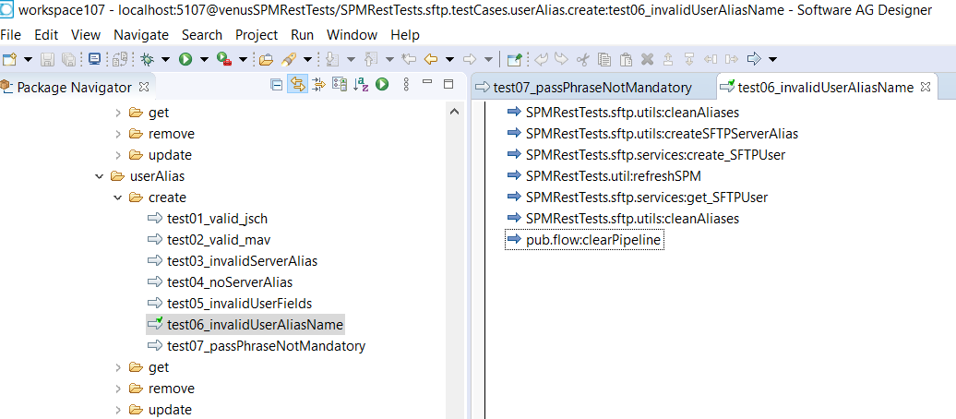

Generating TCML output need to be recorded:

***************************************************************

C:\Users\MAKUM\SAG_Src\Venus-full-pkg\source\code>ant tcmlbatchgen

[java] Working directory ignored when same JVM is used.

SPMRestTests.globalVariables.testCases.tmp

test

.

manish

[java] Enter TCML file <path/filename>:

C:\Users\MAKUM\SAG_Src\Venus-full-pkg\source\manish.tcml

************************************************************

Generated tcml text need to be copied into respective location in tcml file.

For example, for SFTP open the file

C:\Users\MAKUM\SAG_Src\Venus-full-pkg\tcml\venusSPMRestTests\ sftp_serverAlias_create.tcml

And copy record into this file from manish.tcml.

Check-in process:

Delete all the .*bak* files from package.

Copy the test-cases from working package venusSPMRestTests to checked-out package.

Check-in both TCML file and venusSPMRestTests with proper comments.

Some useful commands :

For running all the test-case under folder sftp/userAlias/create

ant tcml -Dvenus.package="venusSPMRestTests" -Dvenus.test="sftp_userAlias_create"

For running one particular test-case under folder sftp/userAlias/create with id 40

ant tcid -Dvenus.package="venusSPMRestTests" -Dvenus.test="sftp_serverAlias_create" -Dtest.tcid="40"

ant config -Dvenus.package=venusSPMRestTests

Before running above command delete the pkg venusSPMRestTests from IS using IS Admin.

This command will reinstall the package venusSPMRestTests and execute all the test cases of this package.

You will get the output report in folder - C:/Users/MAKUM/SAG_Src/Venus-full-pkg/source/code/results/

Just double click to open latest web-page.