Fixed Build tool:

You can get it from IS code base, - C:\IS_srcCode\Ver_103_july17\tests\utils\FixBuilding

Now zip the content of this folder and use it as a package.

Deploy this package into IS

Once done use the url <http://aquarius-va.ame.ad.sag:8088/reposervice/repoadmin/index.jsp> to access it.

Above is one of the machine where in IS, fix build tool is already installed.

Once the url is open, you will get below UI

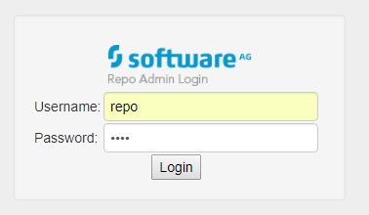

Use the password – repo

Once logged in you will get below screen:

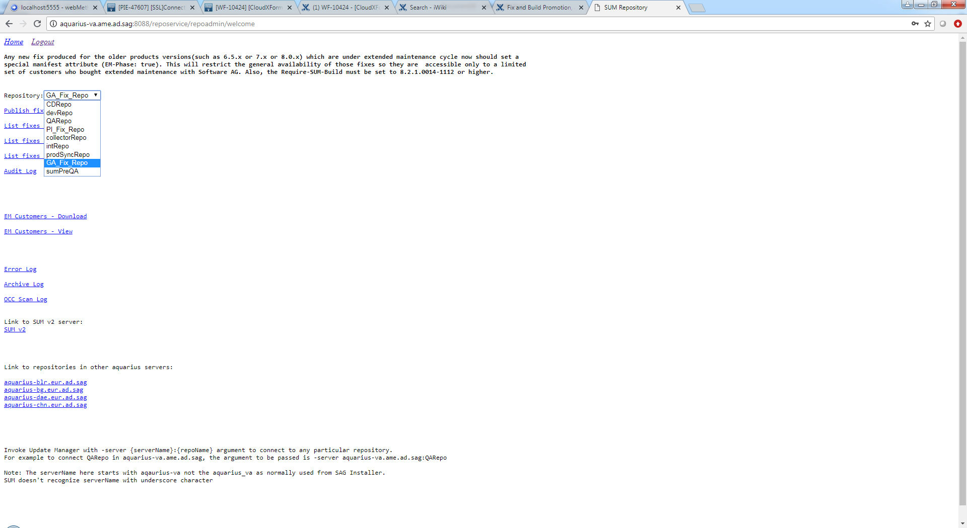

Now you can use this to view/Publish/update or Promote fixes.