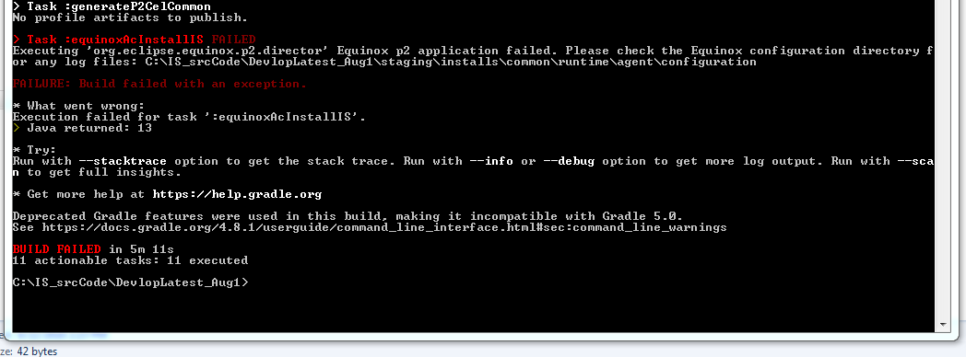

In this case

>gradlew clean --refresh-dependencies

This should successful If not and same issue persist try out

SVN Update and then the

>gradlew clean --refresh-dependencies

gradlew equinoxAcStartIS -x javadoc -x test

Once all of the above didn’t work. Then

* Installed jdk 8 192
* set JAVA_HOME="C:\Program Files\Java\jdk1.8.0_192"
* this worked but debug mode (startDebugMode.bat) was not working.

Near to day

Timezone

Database access takes time

