Connecting to VM

run mstsc.exe

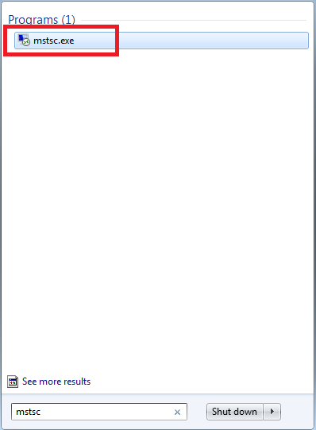

From the popup window select vm machine to connect.

You need three things for connection

VM address

Username

Password

VM Name : vmfixtest01.eur.ad.sag

VM Credential :

VMFIXTEST01\is_user

Drpepper@1234

VMFIXTEST01\is_user

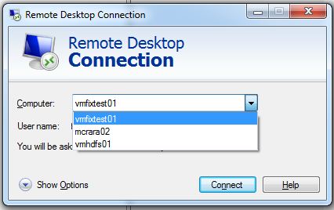



File sharing to VM from your local.

Create shared folder at VM, and use it.

For vm vmisusbvt02

Credentials : (Administrator/Sell.it)

Shared folder : \\VMISUSBVT02\SM-Shared

SM-Shared is shared folder.