Steps for creating QA repo/ CD Repo or QA Patch

DownLoad Read me

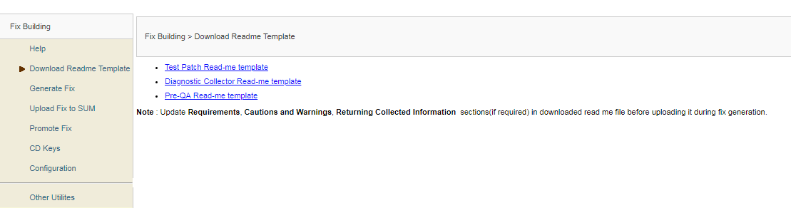

Generate Fix

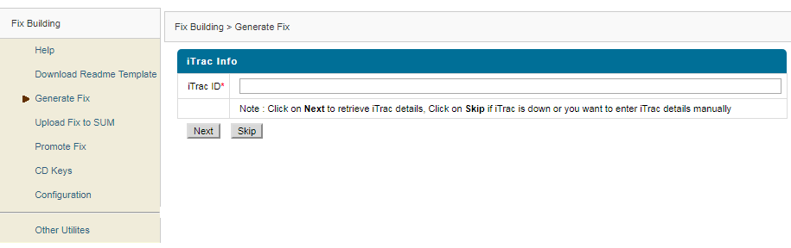

Upload Fix to SUM

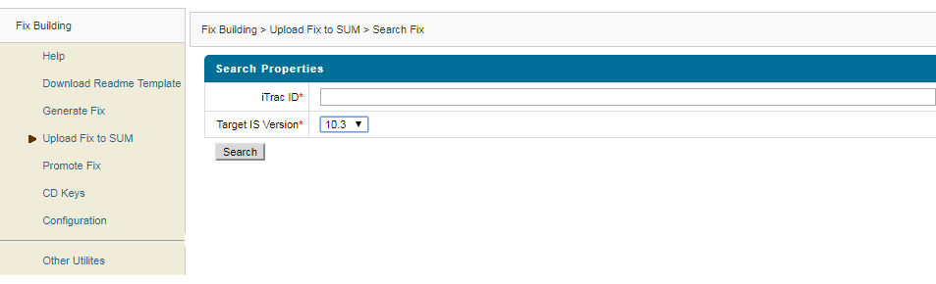

Configuration:

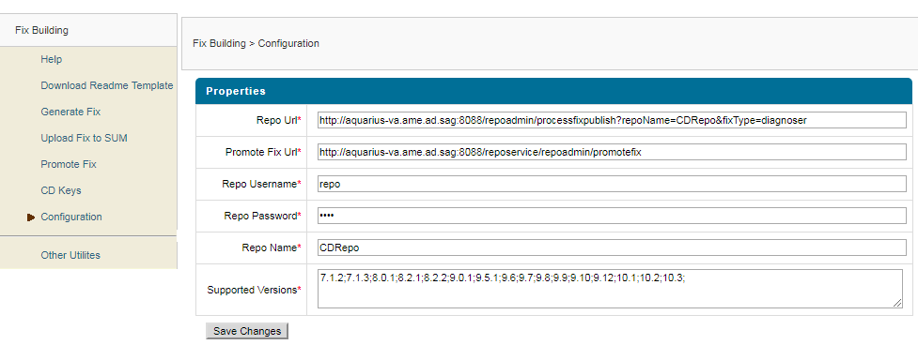

Apply the patch

C:\SAGUpdateManager\bin>UpdateManagerGUI.bat -server aquarius-va.ame.ad.sag:CDRepo

Update Manager GUI will come up

Use this for installing CDRepo using key