Creating test-patch

Step1 : Using fixbuilding pkg.

Goto C:\IS_srcCode\103oct2018\tests\utils\FixBuilding

Zip whole content of FixBuilding folder as FixBuilding.zip

Note – Don’t just zip Fixbuilding folder it won’t work.

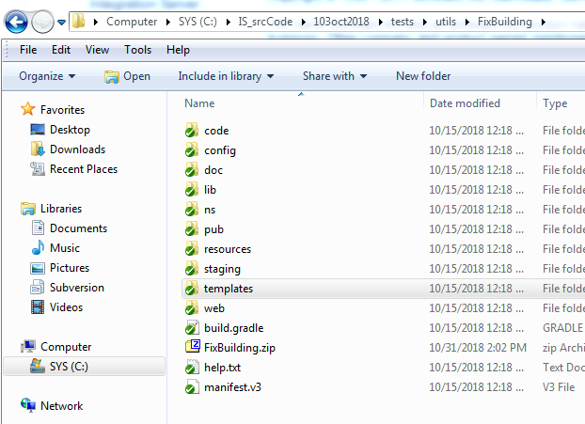

Use this as package and deploy into IS

Copy FixBuilding.zip to the inboumd folder (C:\IS_srcCode\Ver-10_1\staging\installs\IntegrationServer\instances\default\replicate\inbound) and then goto **Packages > Management > Install Inbound Releases** and activate/archive the package FixBuilding.

Then use <http://localhost:5555/FixBuilding/> to access Fixbuilding tool for creating test-patch.

Q -> IS version for creating test patch should be same as destination IS version (Customer IS where it need to be applied) or can be any version?

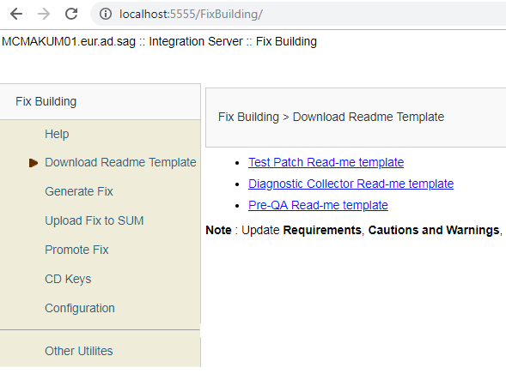

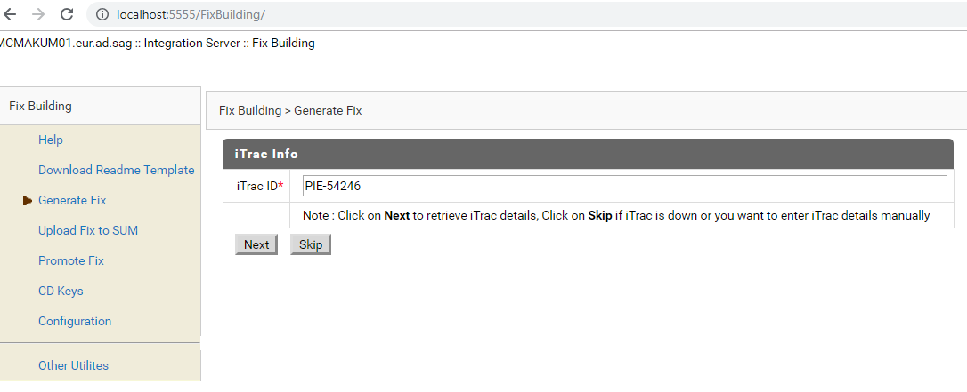

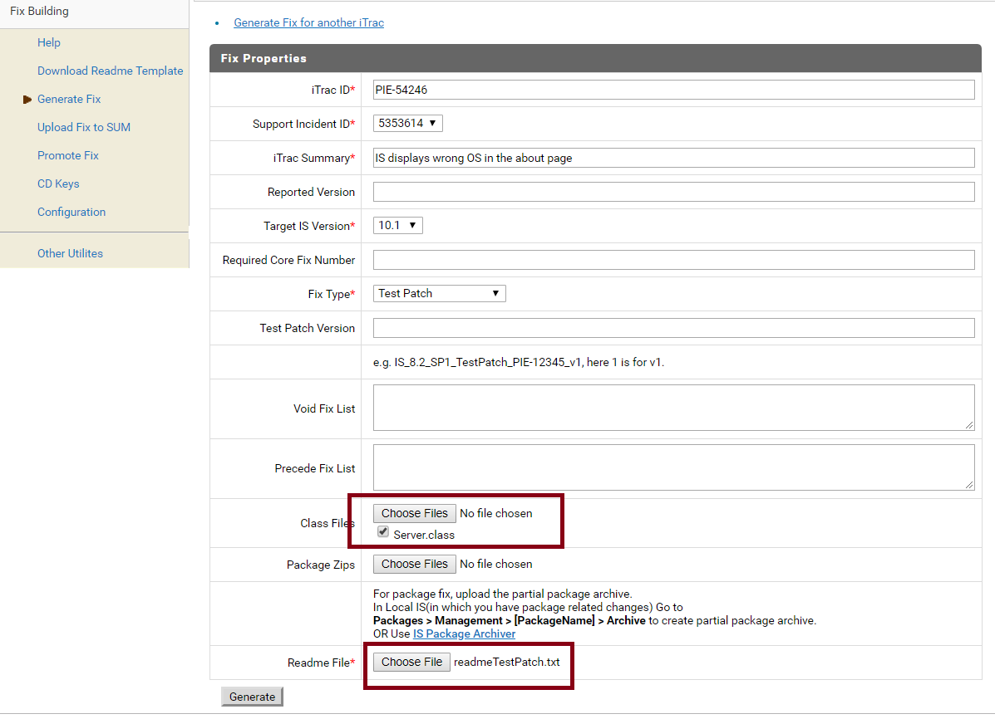

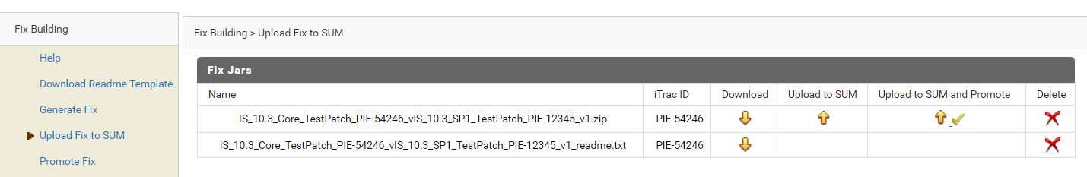

Sometimes while promoting the test-patch to GA-Fix Repo you get exception :

java.lang.IllegalArgumentException: Invalid uri 'http://aquarius-va.ame.ad.sag:8088/reposervice/repoadmin/promotefix?fixVersion=1.0.0.0001-0001">Promote</a> IS_10.3_Core_TestPatch_PIE-78482&fixName=481974_PIE-78482&repoName=CDRepo': Invalid query

In this case promote manually using following steps:

Step 1:

Go to <http://aquarius-va.ame.ad.sag:8088/reposervice/repoadmin/welcome>

repo/repo and click “list fixes for promote”

search your test-patch in CD-Repo

and click promote.

If you face promotion issue: download the uploaded fix.

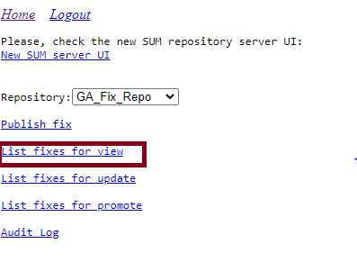

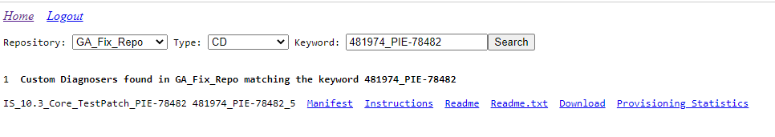

Click download and readme txt.

Now rename the downloaded stuffs

481974_PIE-78482_1.0.0.0005-0001 -> IS_10.3_Core_TestPatch_PIE-78482.zip

481974_PIE-78482_1.0.0.0005-0001_readme.txt -> IS_10.3_Core_TestPatch_PIE-78482_readme.txt

Name of the file is from uploaded Test-Patch

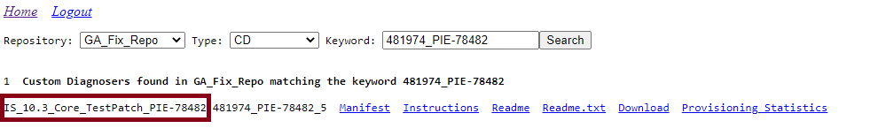

Modify the \IS_10.3_Core_TestPatch_PIE-78482.zip\META-INF\MANIFEST.MF for

Require-SUM-Build: 10.0.0.0019-3931

Now upload the renamed zip file by clicking “publish fix”.

Test-patch will be uploaded CD-Repo and then promote the Test-Patch

**How to update the Patch (CD Repo)**

Go to - <http://aquarius-va.ame.ad.sag:8088/reposervice/repoadmin/welcome>

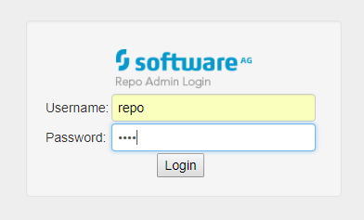

Download your patch

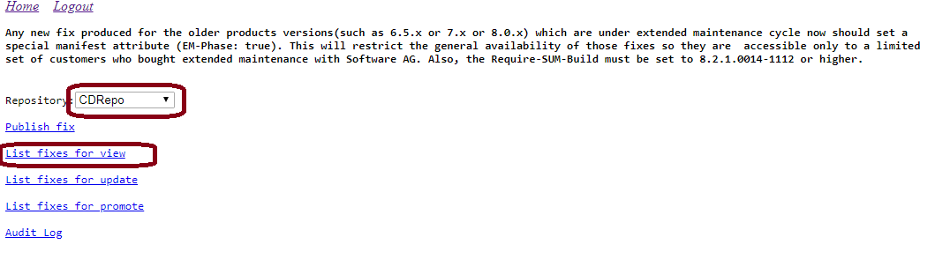

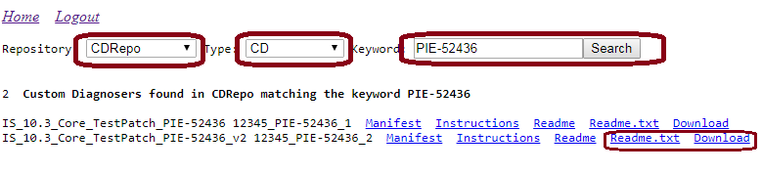

Now down load readme.txt and patch file both

Patch will be named as 12345_PIE-52436_1.0.0.0002-0001

Rename it like 12345_PIE-52436_1.0.0.0002-0001.zip so that it can be opened using 7z

Once done open it in 7z and modify your all class files.

Publishing the patch

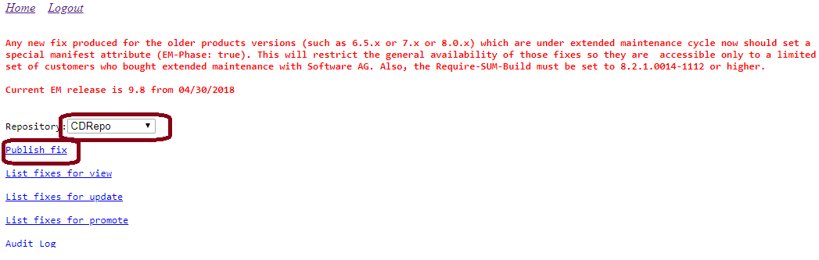

Upload both patch and readme file

