SVN snapshot :

We check-in into esb/ mostly in branches.

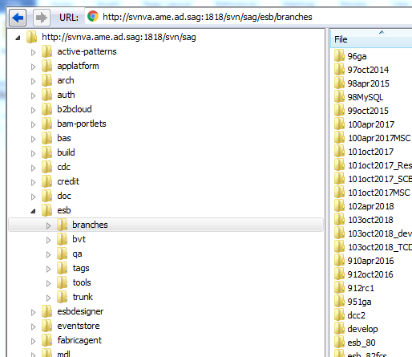

Check-ins are done in seb/develop branch for current development.

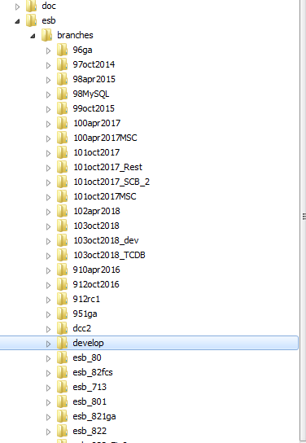

In case of backporting check-ins are done in maintenance branch.

For example if you need to backport the issue (for customer issue, say core-fix 7) in 912 (and 10.3 is current development) then you need to do two check-ins one is in 10.3 develop branch and other is 9.12 (maintenance) branch.

You should not check-out esb/tags/IS_9.12_Core_fix7 and check-in (with only one exception). You should just check-in into 912oct2016 branch. When tag (esb/tags/IS_9.12_Core_fix7) is created out of this your changes will be there.

Only exception is, when tag is already created before your check-in and core-fix7 is scheduled for build. In this case you need to do two check-ins. One is in tag, second is in branch and third is in current develop branch.

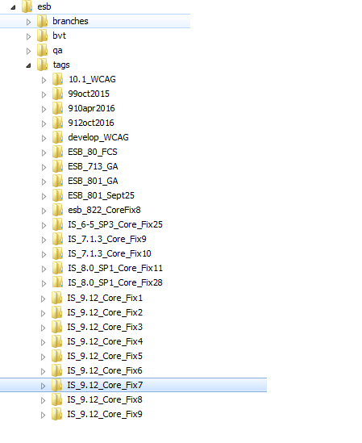

How to trac check-ins into SVN: