Below is the usage of IS-SYSPROPS with template:

**IS-SYSPROPS:**

**IS-SYSPROPS:**

**Settings:**

**watt.server.compile=~jvm\jvm\bin\javac -classpath {0} -d {1} {2}**

**watt.net.jsse.client.enabledCipherSuiteList=SSL_DH_anon_WITH_3DES_EDE_CBC_SHA**

**UpdateSettings:**

**watt.core.template.enableFilterHtml1=false**

**watt.core.template.enableSecureUrlRedirection1=false**

**DeleteSettings:**

**watt.art.page.size=10**

**watt.art.tmgr.timeout=-1**

Correct usage of IS- SYSPROPS meta-data.

* “**UpdateSettings**”  updates the values in target if present or adds/appends to the target if not present.
* “**DeleteSettings**”  removes the values from target if present or ignores if not present in target.
* “**Settings**” works exactly same as COMMON-SYSPROPS i.e. it overwrites the target.

 If all the three are configured for one single run then "Settings" takes the precedence over “UpdateSettings” and “DeleteSettings”, i.e. IS-SYSPROPS behaves as COMMON-SYSPROPS.

Currently IS-SYSPROPS configuration type is available in version 9.12 with "9.12 Core Fix 16" and "9.12 SPM Fix 5".

It was created with 10.1 and later backported to 9.12 on customer demand.

**Issues:**

**https://itrac.eur.ad.sag/browse/PIE-49988** : Fix check-in 10 Feb 2018

After adding "watt.12=test12", the property "watt.1" is not added in extended properties list.

Code changes - WmRoot/code/source/wm/server/admin.java

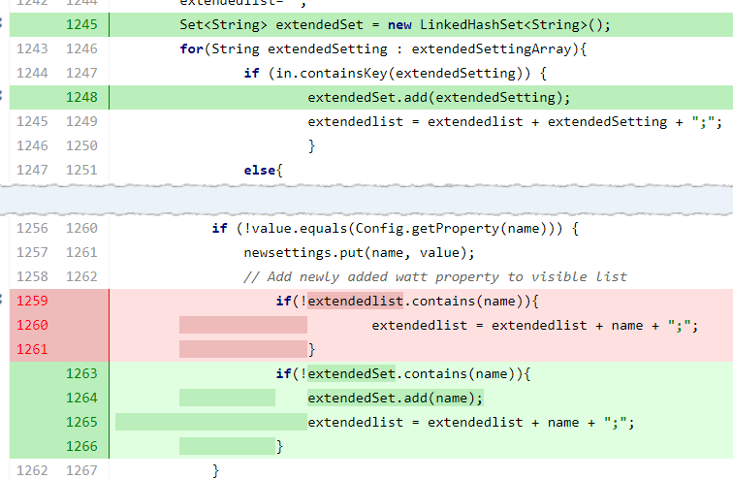

**https://itrac.eur.ad.sag/browse/PIE-53368** : Fix check-in 6 nov 2018

IS extended setting are not visibile - updated using composite templates

When the server configuration properties are updated through Command Central

or using a YAML template, the extended configuration properties are not visible

in Integration Server Administrator. This happens with only those configuration

properties that use the default values for update.

The reason of this issue - In updateExtendedSettings method, system properties (watt properties) are skipped from adding to extendedlist if its value is not changed.

The solution for this issue is to remove the condition on this check.

Before Fix: When watt properties were provided from command central or template files by keeping their values as default then they were not showing up into IS Admin UI.

After Fix : When watt properties are provided from command central or template files then all of them are showing up into IS Admin UI irrespective of their values.

Code changes - WmRoot/code/source/wm/server/admin.java

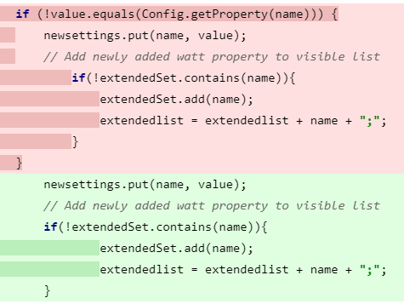

Back porting

IS_9.12_Core_Fix20

IS_10.1_Core_Fix10

IS_10.3_SPM_Fix3

**https://itrac.eur.ad.sag/browse/PIE-56395 :** Fix check-in 23 April 2019

Customer : Johnson & Johnson Services, Inc.

All extended settings visible using CCE templates

Integration Server Administrator displays extra server configuration parameters

when a server configuration parameter is updated through a template file.

After updating a server configuration parameter through Command Central

template file using the IS_SYSPROPS configuration type, Integration Server

Administrator displays multiple non-existent server configuration parameters in

the Extended Settings screen.

This issue has been resolved by invoikng wm.server.query.getExtendedSettings from SPM plugin instead of invoking wm.server.query.getSettings.

Code changes - /is/configuration/impl/ISExtendedSettingsConfigurationManager.java

Back porting

IS_9.12_SPM_Fix7

IS_10.1_SPM_Fix5

IS_10.3_SPM_Fix3

**https://itrac.eur.ad.sag/browse/PIE-57882** : Fix check-in 10 March 2020

Cannot update IS Sysprops configuration via Command Central

IExtended settings that have a white space in the value cannot be applied using a Command Central template.

Example:

watt.server.compile=C:\softwareag\jvm\jvm\bin\javac -classpath \{0} -d \{1} \{2}

As the value contains white spaces, the property cannot be applied using a Command Central template.

File changes :

is/configuration/impl/ISExtendedSettingsConfigurationManager.java

command-central/spm-impl/src/main/xsd/ISExtendedSettings.xsd

is/configuration/impl/ISExtendedSettingsValidator.java

Logic Used:

This method will Analyze each property of extended list

Valid properties:

- if property starts with watt and includes "="

- if property does not start with watt and don't include "="

In this case property is appended to the previous property, separated with space.

In all other case it throws an exception containing all invalid properties.

Also xsd file is changed to accept space:

<xs:list>

<xs:simpleType>

<xs:restriction base="xs:string">

**<xs:pattern value="\S.*" />**

</xs:restriction>

</xs:simpleType>

</xs:list>

Earlier it was

<xs:list>

<xs:simpleType>

<xs:restriction base="xs:string">

<xs:pattern value="([a-zA-Z0-9\.])+=\S.*" /

</xs:restriction>

</xs:simpleType>

</xs:list>

Back porting

IS_10.3_SPM_Fix6

IS_10.5_SPM_Fix3